Exploratory Data Analysis
For the Higher Education Students Performance Evaluation dataset, the following eight histograms display the distribution of data points analyzed in the models below. There did not appear to be any outliers in the dataset since most columns are represented as survey values ranging from 1-3, or 1-5.

In Figure 1, column 29 indicates cumulative grade point average in the last semester with values 1-5 being identified as 1: <2.00, 2: 2.00-2.49, 3: 2.50-2.99, 4: 3.00-3.49, 5: above 3.49.
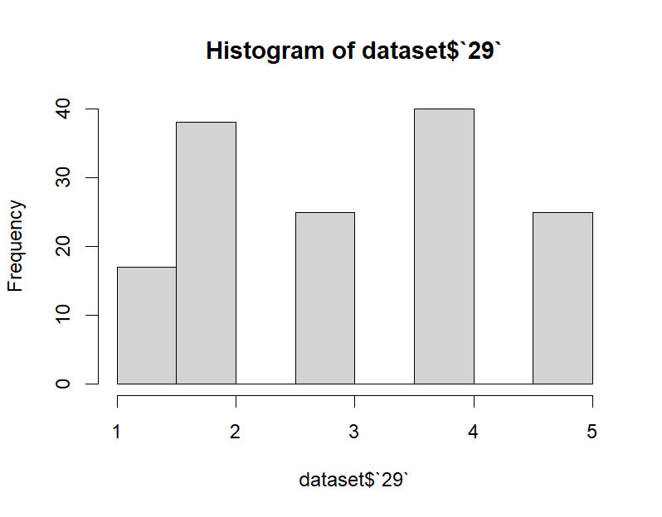
Figure 1: Histogram of Students’ Cumulative Grade Point Average

In Figure 2, column 13 indicates the number of siblings a student has as an integer with 5 including 5+ siblings.
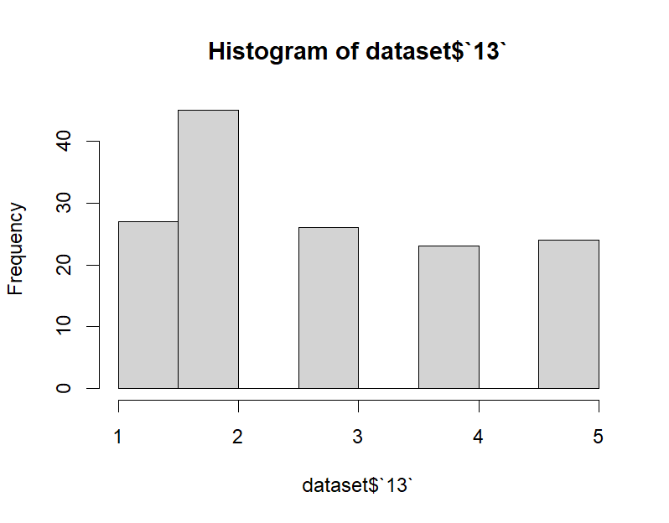
Figure 2: Histogram of Students’ Number of Siblings
In Figure 3, column 25 indicates whether a student takes notes in classes with values 1-3 being identified as 1: never, 2: sometimes, 3: always.
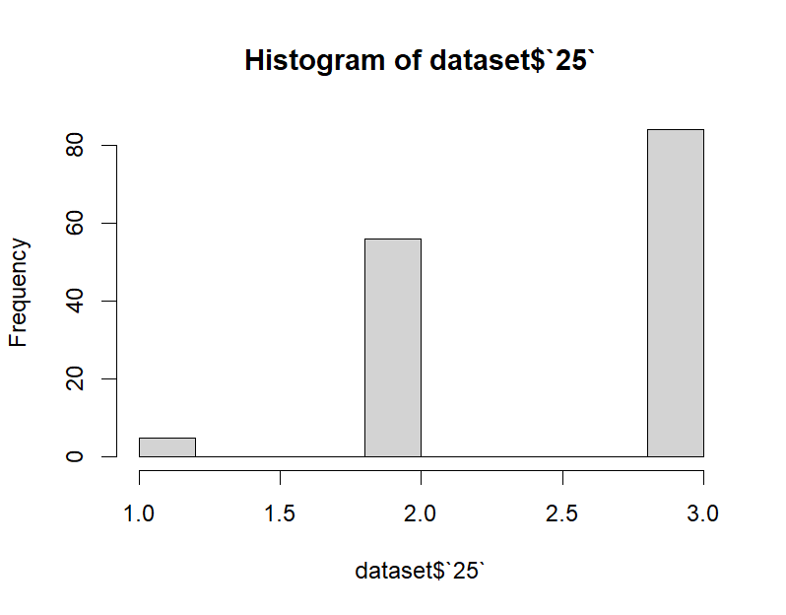
Figure 3: Histogram of Students Taking Notes

In Figure 4, column 26 indicates whether a student listened in class with values 1-3 being identified as 1: never, 2: sometimes, 3: always.
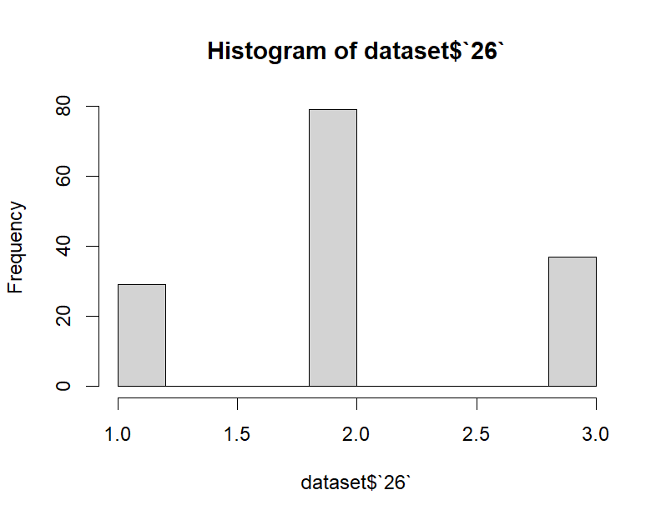
Figure 4: Histogram of Students Listening in Class

In Figure 5, column 11 indicates a student’s Mother’s highest level of education with values 1-6 being identified as 1: primary school, 2: secondary school, 3: high school, 4: university, 5: MSc., 6: Ph.D.
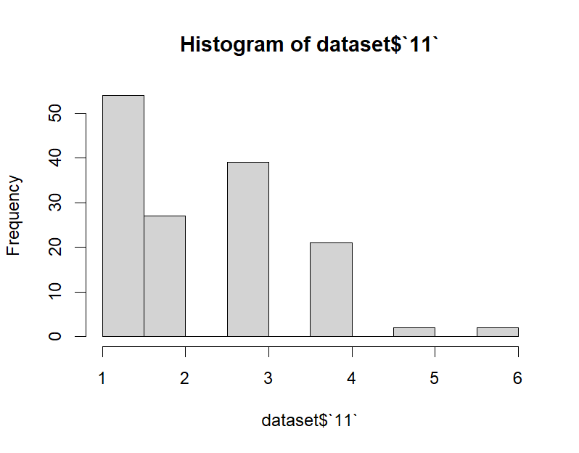
Figure 5: Histogram of Students’ Mother’s Highest Level of Education

In Figure 6, column 12 indicates a student’s Father’s highest level of education with values 1-6 being identified as 1: primary school, 2: secondary school, 3: high school, 4: university, 5: MSc., 6: Ph.D.
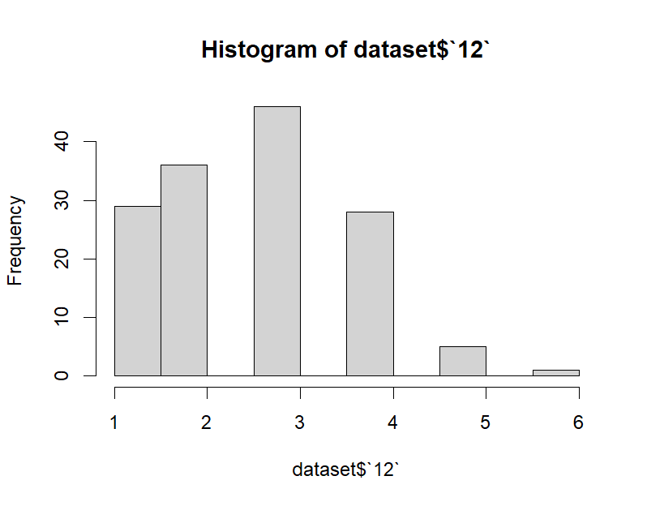
Figure 6: Histogram of Students’ Father’s Highest Level of Education

In Figure 7, column 17 indicates a student’s weekly study hours with values 1-5 being identified as 1: None, 2: <5 hours, 3: 6-10 hours, 4: 11-20 hours, 5: more than 20 hours.
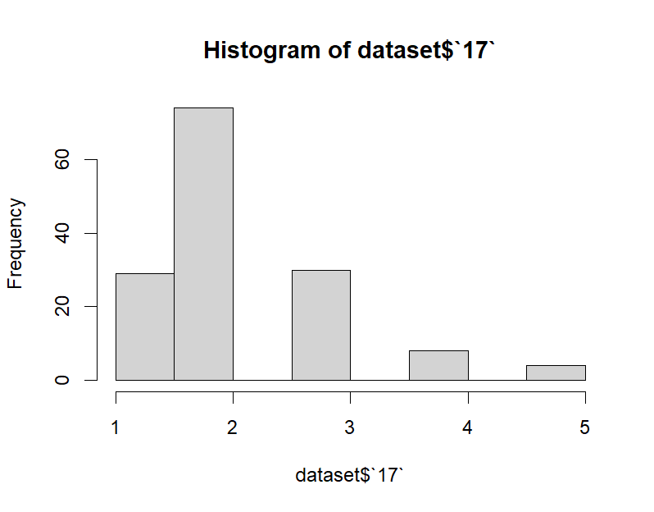
Figure 7: Histogram of Students’ Weekly Study Hours

In Figure 8, column 22 indicates a student’s attendance to classes with values 1-3 being identified as 1: always, 2: sometimes, 3: never.
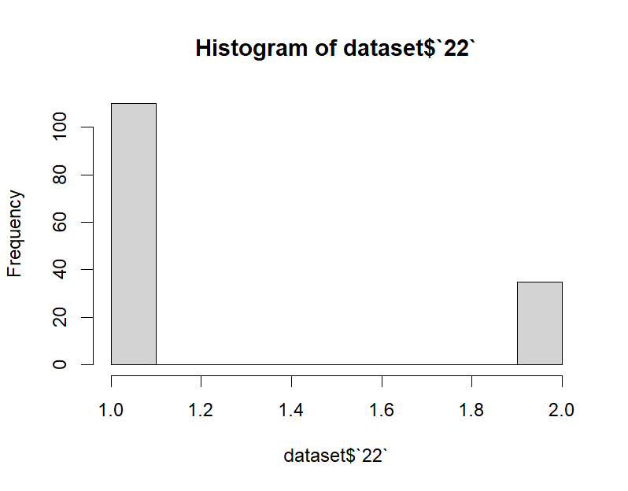
Figure 8: Histogram of Students’ Attendance to Classes

Model Development, Validation, and Optimization
In Figure 9, the linear regression displays a slight positive correlation between having more siblings and having a higher cumulative GPA. Figure 10, highlights that this correlation is not statistically significant because the p-value is 0.1 which is greater than 0.05. The residual plot, Figure 11, shows a high variance for some data points from the best fit line.

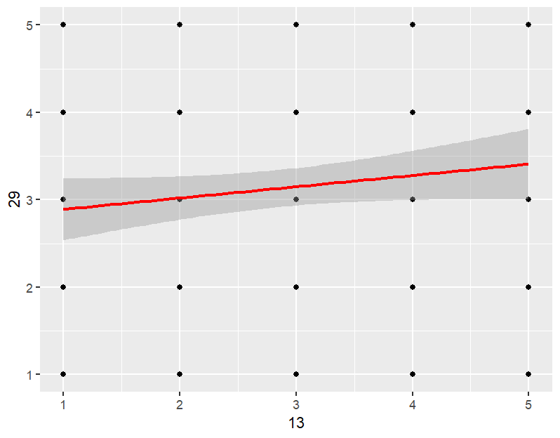
Figure 9: Number of Siblings VS Cumulative GPA

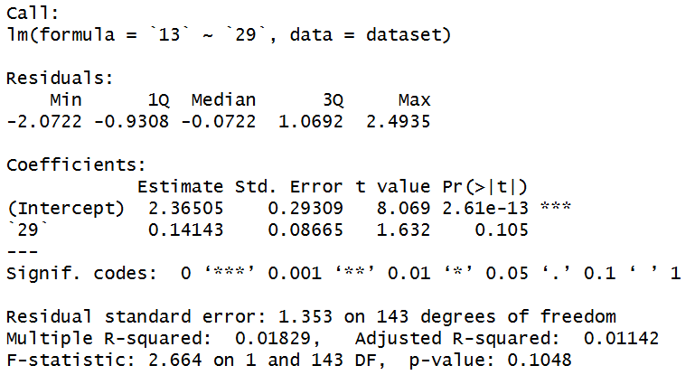
Figure 10: Linear Regression Statistics
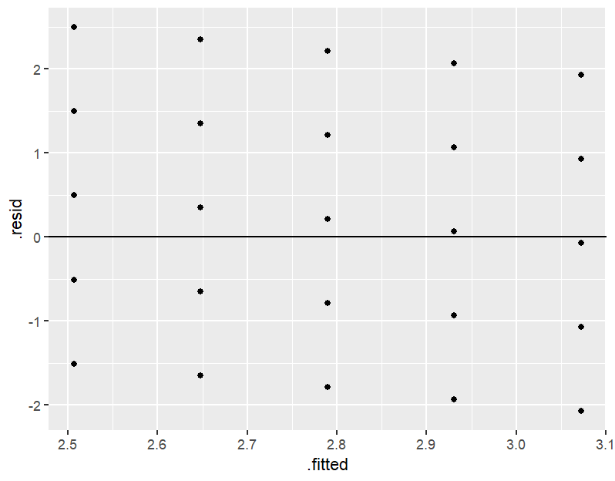
Figure 11: Linear Regression Residual Plot

In Figure 12, K-Means Model 1 displays clusters predicting a student’s cumulative GPA based on if they take notes and listen during classes. Figure 13 shows an average silhouette width of 0.68 which indicates that the model was able to generate clusters with a strong distinction between them. The average balanced accuracy for predictions from each class is 51% which reveals that there is not a strong correlation between taking notes and listening in class and GPA.

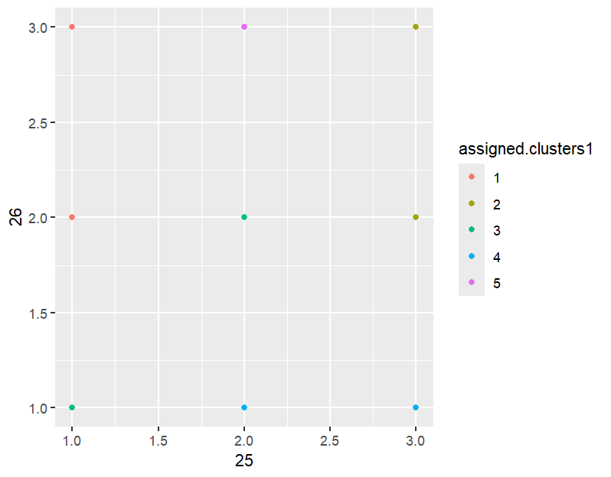
Figure 12: K-Means Model 1, Note Taking and Listening During Class Predict GPA

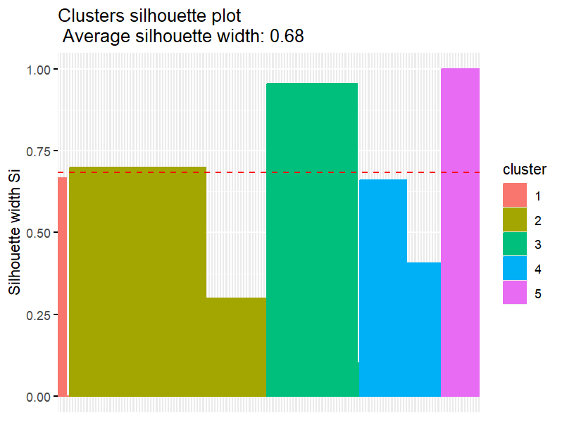
Figure 13: Silhouette of K-Means Model 1
In Figure 14, K-Means Model 2 displays clusters predicting a student’s cumulative GPA based on their parents’ highest levels of education. Figure 15 shows an average silhouette width of 0.44 which indicates that the model was able to generate clusters with a below average distinction between them. The average balanced accuracy for predictions from each class is 50% which reveals that there is not a strong correlation between parents’ highest level of education and GPA.

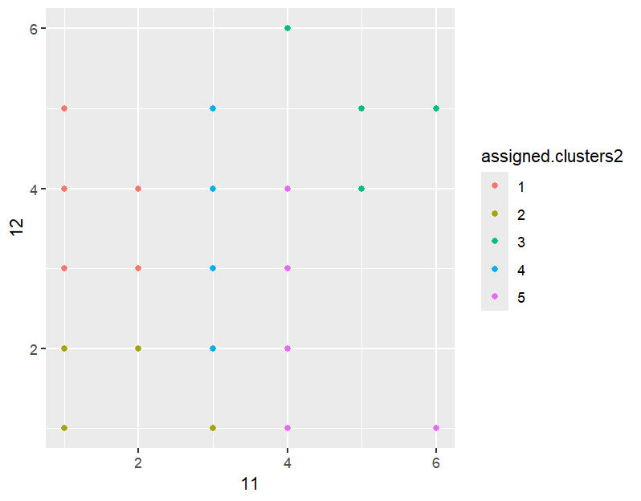
Figure 14: K-Means Model 2, Mother’s Education and Father’s Education Predict GPA

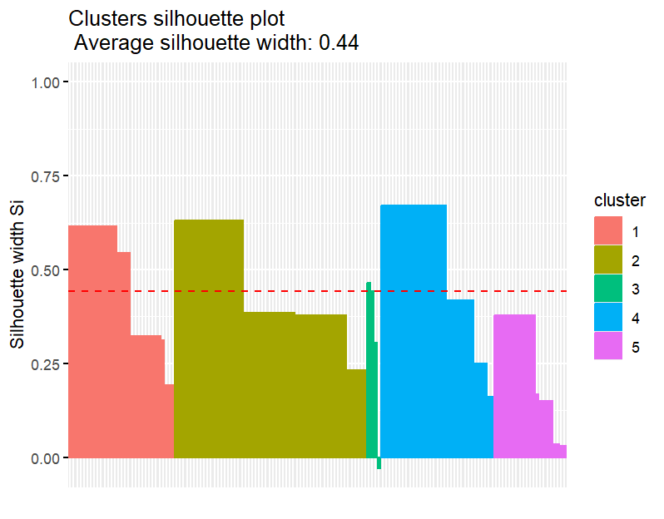
Figure 15: Silhouette of K-Means Model 2
In Figure 16, K-Means Model 3 displays clusters predicting a student’s cumulative GPA based on their weekly study hours and attendance in classes. Figure 17 shows an average silhouette width of 0.69 which indicates that the model was able to generate clusters with a strong distinction between them. The average balanced accuracy for predictions from each class is 48% which reveals that there is not a strong correlation between weekly study hours and attendance to classes and GPA.

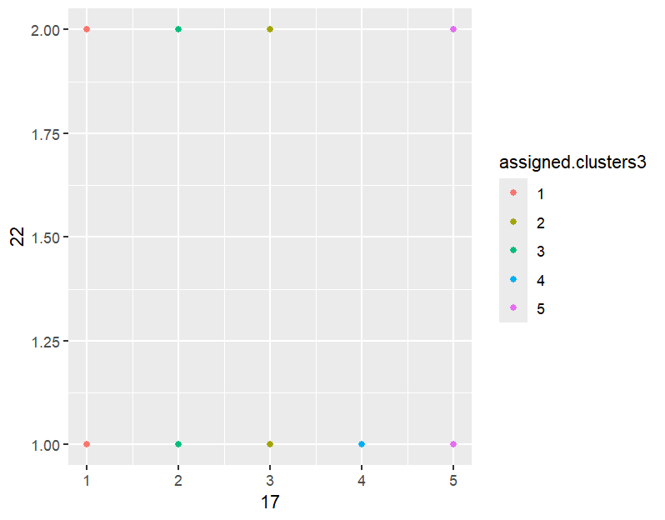
Figure 16: K-Means Model 3, Weekly Study Hours and Attendance to Classes Predict GPA

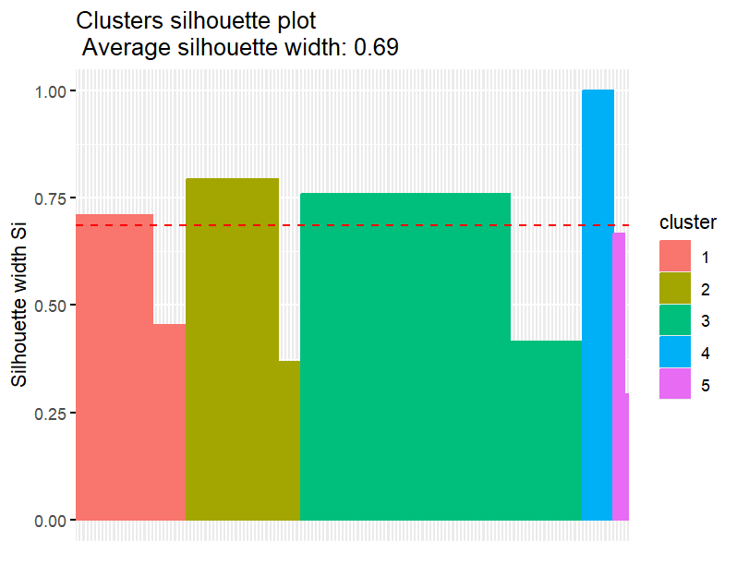
Figure 17: Silhouette of K-Means Model 3
Decisions
The linear regression of number of siblings vs cumulative GPA is not statistically significant, which means its results, a slight positive correlation, could exist due to random chance. Thus, this model should not be used to make decisions.

K-means models 1 and 3 have average silhouette widths of 0.68 and 0.69 respectively indicating that there are distinct clusters of students based on note taking and listening in class as well as weekly study hours and attendance in class. The accuracy of these factors when predicting GPA are lacking with model 1 having a 51% accuracy and model 2 a 48% accuracy. These models should not be used to accurately predict a student’s cumulative GPA, but the factors the models are based on could be investigated further to better understand and support each cluster of students represented in the models.

K-means model 2 has an average silhouette width of 0.44 and an accuracy of 50% making it lacking in both distinct clusters and accuracy. This model should not be used to make decisions and suggests that parents’ education level is not a good indication of a student’s cumulative GPA despite both data points often being asked in college applications.

