A Short Guide to P-OSRA
by Bryn Reinstadler
(Summer Student 2014)

Contact information: br6@williams.edu or bryn.marie.r@gmail.com
Don't hesitate to get in touch if anything is confusing.

Table of Contents for P-OSRA Documentation
[short introduction to p-osra] 1
[p-osra: the website] 2
[the programming behind the webpages: html and css] 3
[the programming behind the functionality: servlets, javabeans, and jsp] 4
[more relevant packages and things we use] 6
[p-osra: the database] 6
[simple example 1] 7
[simple example 2] 9
[populating the database] 10
[p-osra: the image recognition software] 11
[open issues in p-osra] 12

[short introduction to p-osra]

So first off, what does p-osra mean? P-osra stands for Polymer Optical Structure Recognition Application. It does just that. P-osra is essentially an open-source software that is used to process images of polymers, output structural results, and then store those results in a database on user request. P-osra can refer both to the software which does the image recognition and to the website/database functionality themselves. Below is a (very rough) schematic of how this works:
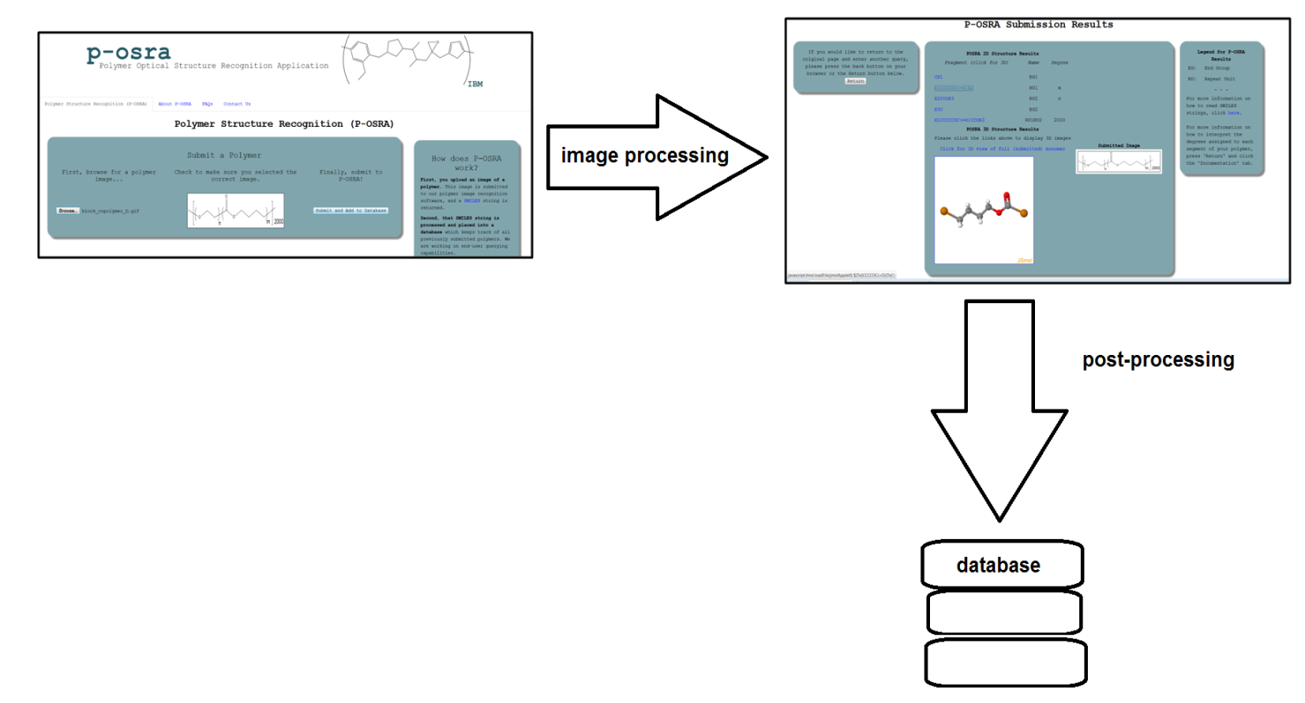
As you can see, the end user is directed to an index page where she or he uploads a polymer image (shown in the thumbnail on the first image). Then the image is processed by means of p-osra, and some structural results are obtained (the 3D results, the SMILES string, etc). Then the user can upload information to the database (button for that functionality not shown in these images, but is there in the final product). We'll go through each of these steps semi-sequentially in the next few subsections and talk about what's going on 'under the hood'. However, this document is mostly meant as a reference guide, not to be read all the way through. Different sections may be useful at different times.

[p-osra: the website]

We'll start with the outer shell of the website and then move towards the website architecture. By this point, you have probably gotten set up with all of the code currently in the infrastructure. It should be in your machine and onto your Eclipse projects. If this is not the case, it will likely be very helpful for you to accomplish this before we move ahead.

Unfortunately I am writing this before you will be reading this, but it is useful to note that some of the file names that I share with you may have changed. I apologize for this, but I will do the best to be as accurate as I can currently and to give you some idea of the contents of each file so that even if the name of the file is changed, you can tell (and maybe update this document?)

We'll start with the least complicated parts of the website first. The “Contact Us” page should be reasonably self-explanatory. Code should be found under contactsPage.html, with the php for the contact form under contact.php (note: the php form will NOT work locally; it MUST be hosted on a proper web server in order to function. I.e., not Tomcat). We'll talk about the formatting later when we get into the code of the webpage.

For future reference, I used php for the contact form because that is current standard practice. It is easy to send an email through programming using php; if you look through the code (which is easy to understand even if you do not know php), you will see that this is a much easier implementation to allow an email to send from the code than you would find in Java. php is best used sparingly as it's not a very 'well-put together' language in general (it was made by a self-described amateur), but I think for this specific purpose it is well-suited. I wouldn't worry about it too much.

FAQs: Again, reasonably self-explanatory. The drop-downs work slightly differently between browsers but in general work quite well. There is a link to a mailto: element at the bottom of the page. If you look at the code, it should be reasonably easy to figure out how to modify it to add more content to any of the tabs, or to add more tabs (again, we'll talk about code later.)

The “about p-osra” page has team members (or, um, stand-in team members) flowing on the left side (again, code is modular, so adding/removing members should not be difficult) and some textual information on p-osra below it. Right now the text is limited to lorem ipsum, though this may change very soon.

Now to the front page of the webpage! It asks the client to browse for an image, confirm it is the correct image by looking at the dynamic thumbnail provided, and then submit it to check the structural results before submitting it to the database. It also has a link on how to read SMILES information.

The results page will give fragment information (in the SMILES extension devised by Drs Horn and Rice) as well as a platform for 3D viewing of those structures as well as the full, submitted monomer. From this page, one should also be able to submit information to be added to the database. A successful addition to the database will be met with a addtodb.jsp success page, and any errors will (or should) redirect the user to an error.jsp page that is set up to give a rough idea of what the issue is (currently hard-coded; should be fixed at some point in the future, but since I'm still doing testing it's fine for now).

[the programming behind the webpages: html and css]

If you look inside your WebContent folder in the posra directory, you will see a whole bunch of subfolders and files. I will take you through them first so we can get an idea of the libraries that we are using in building the website.

But first, if you're a bit rusty on your web programming skill, you may want to look into brushing up on your http protocols, html, css, and maybe your javascript if you're feeling ambitious (w3schools and codecademy tend to be decent places to do this). Additionally, a cursory knowledge of servlets and jsp would not go awry. I suggest Murach's “Java Servlets and JSP” (which also has a crash course in HTML), or simply browsing the StackExchange pages on servlets and jsp.

Folders you'll see on your journey:

Bootstrap: bootstrap is a popular html, css, and js framework for developing cool web projects. Basically, it defines css classes and js responses to allow for dynamic, programmable elements that 'look awesome' (technical term). We used bootstrap (see it imported on nearly every page!) Basically, if you see an html class or id that is not defined in the “myStyle.css” file, it is from bootstrap almost universally (exception: the JSmol div... we'll get to that eventually).

Images: this folder holds the images that you reference as you go through the webapp. Most of these images are currently in the FAQ section, but of course you can add to this folder as you see necessary. We also have a cdx subfolder which holds the ChemDraw files for some of the images. If you make your images in ChemDraw, please save a copy of the ChemDraw file here and save ONLY the gif/png in the actual images directory.

Jmol-14.0.1: (or possibly an updated version) This directory holds the reference to JSmol (despite being called Jmol). Jmol is a molecular modeling program, essentially, that shows 3D version of molecules. For examples of full functionality, go to the JSmol subfolder and run jsmol.htm on the server. Many of those html files are demos (read the README to figure out what they all do if you don't want to waste your time turning the server off and then on and then off and then on and then...). If you want to change how JSmol works, this is a good place to figure out the capabilities of the software. We only use JSmol in the results.jsp page that shows structural results of the image recognition process. It simply takes an argument of the SMILES string that we want produced and it shows the molecule with 'placeholder atoms' at the ends (Tellurium, used because it is bivalent).

JSDraw3.1.7 and JSDrawWS3.1.8 and MolEngine3.1.8: These directories may or may not be in your folder. They are deprecated, from when we thought we would be able to use JSDraw WebServices in order to provide a drawing board. However, we had issues porting images from JSDraw. We could not hook up the WebServices to the actual platform, basically, and that was causing all sorts of issues. We did not pursue this path further, although if you choose to, the support desk at scintelligence is surprisingly quick on the email response.

META-INF: Self-explanatory. I don't think I've ever even needed to open this folder.

Plugins: Another part of the failed JSDraw attempt (see JSDraw3.1.7 above)

WEB-INF: Houses web.xml and some jars used for some jsp/jstl tags. I wouldn't worry about this folder too much – we no longer have to manually change the web.xml file due to having maven deal with dependencies for us.

The rest of the pages do essentially what you would think they do. They are all sensibly named. Run on server from index.html.

[the programming behind the functionality: servlets, javabeans, and jsp]

This section mostly covers the servlets and javabeans that can be found in the src/posra.servlets directory of the posra folder (again, consider refreshing your knowledge on these; links are above to help you understand the basics. Ctrl-f servlets, but you knew that). Here you will see some major classes, the functionality of which will be laid out below, from most important to least:

PolymerServlet/PolymerBean: This servlet is the workhorse of the operation. It takes in the image, submits it to p-osra (the image recognition software part that we'll talk about later), then cleans up the SMILES string until we get something presentable for the user to see. It's kind of a hairy class and some parts of it are done clumsily (should've used more abstraction/recursion). I'm not sure if it's worth the time to rework, though. It is well-commented at the least, so you should be able to puzzle out anything if you need to.

DBServlet: This servlet takes information from the request from the results.jsp page and stores the information it gets into the database (at least, in theory). At present, this class is not operating at full capacity and adds only a 'hard-coded' polymer into the database, which can only happen once because also at present, duplicate entries are not allowed. THIS CLASS IS A WORK-IN-PROGRESS. More information on the database set-up can be found in the 'database' section – check out the table of contents.

ImageServlet/ImageBean: On the results page, you see a picture of the image that was submitted to p-osra. This is possible due to the ImageServlet reading through the request for the image and returning the image. Read up on image servlets here (this site, in addition to StackExchange, is generally helpful, despite appearances). You shouldn't need to mess with these.

TestingClass: This class is essentially here as a place where you can write test code and run it before you slice it into one of the main servlets/beans. I generally write code here with a test harness, run it, and when it works, splice it into one of the bigger classes (commented out, of course). It may or may not be empty; be considerate if it looks like someone is working on a project in there, but I think I'm the only one who uses it and so anything in there should be safe to clear out.

The jsp. I'm not going to talk about each page in specific, but rather give you a general overview of what jsp means. If you understand html, you should be fine. Just look through the jsp files provided and the information below:

jsp (java server pages) are a way of creating dynamic web pages. They are essentially HTML with some fancy functionality thrown in. In the past, servlets used to write an html file to the output stream and then execute it. This old way of writing servlets had programmers doing a lot of this:
out.write(“<html>”);
out.write("<body><p>I am a very annoying way to write html</p></body>");
That way of writing servlets is now deprecated. Now, the servlet forwards the HTTP request along with any pertinent information to a jsp page, which again, is just a fancy html page. The html prints out, and anything that you want to change depending on the request parameters, you code in with jsp tags. Please note that some places will have you believe that it is ok to have 'scriptlets' in your jsp code, which is where you basically write a little bit of java between some tags that look like this: <% %>
This is heavily frowned upon by current web best practices. Current best practices say to do all of the logic and processing on the servlet with Java, and then print out stuff in the html using jsp tags. A quick foray through the code should show you what's going on. Bear in mind that you will be using JSTL tags. This is the "Java Server pages Tag Library", and I have linked to it here. Use tags from here. There is also a tutorial in here which is useful if you are just starting out with jsp.
Again, as with most things, reading through the links and the code and making sure you understand what each line does should clear up any confusion.

[more relevant packages and things we use]

This project uses Maven and Hibernate. Maven essentially resolves dependencies within the Java project; more details at the link. Hibernate is an object-relational mapping library for Java, which basically helps with database resources. Again, more information in the 'database' section (see next)

[p-osra: the database]

Right now, p-osra's database is built using MySQL. We are using Hibernate to interface between the Java code in the DBServlet and the database itself. Hibernate basically just supplies a nice library so that we as programmers don't have to write [too much] SQL. Currently, the database is set up in a rather complicated fashion...

Here I'm going to suggest that you open the file “PolymerSample.xlsx”, which you should be able to find under the UCSC-IBM-POSRA-CORE/doc directory. I will be giving instructions in this file as though you have a split screen or a dual monitor and can look at both files simultaneously.

The best way to learn how to use the complicated data structure is to go through examples. However, if you understand complicated database diagrams, look through the rest of the documentation in the /doc directory (or try the doc_bryn directory for even more resources). I have copy-pasted the most relevant figures, but I personally find them impossible to unentangle (I also know/knew approximately squat about databases, but if you know a lot about databases, then this is for you!).
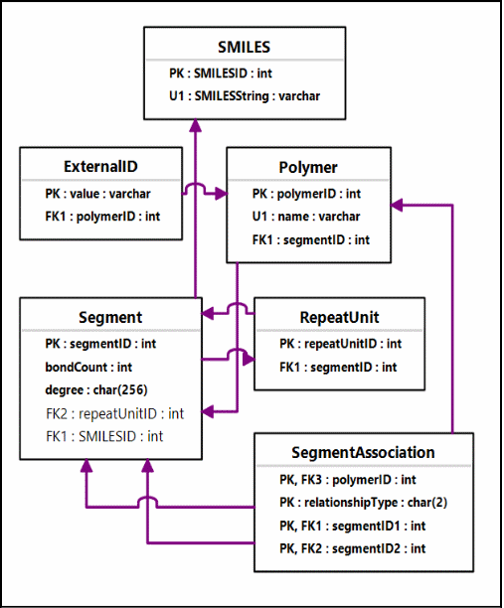

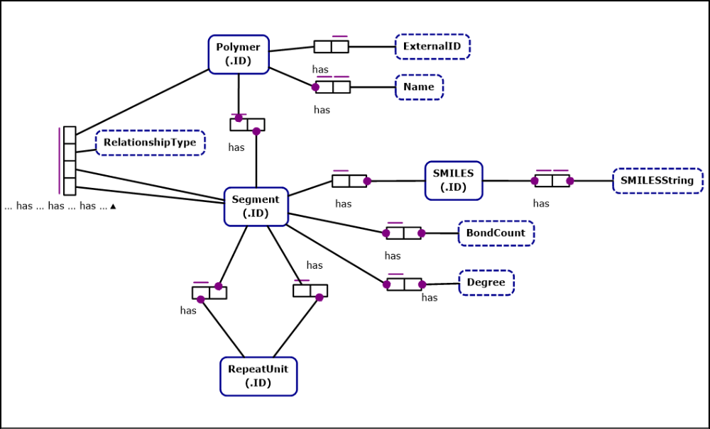

Yeah, so if you want to base your knowledge on those, you're kind of on your own. I'll still go through the examples in the PolymerSample excel sheet. The first example (which is simpler) is in Sheet 1.

[simple example 1]

The SMILES string is given in the upper right hand corner “C[Po:n]CC(c1ccccc1)[Lv:n]C”. The first thing that we do is put information into the Polymer table. The Polymer_ID should auto-increment (unverified information from UCSC... from now on if something is hearsay that I have not confirmed myself, I will star it with a double asterisk **). The name will come from the end user, and in this case is “Poly”. The external ID is 'null' in this table, but I think that we should implement it such that the External_ID should be identical to the SMILES string itself. This may or may not be implemented by the time you see p-osra.

We then start to dismantle the SMILES string. Thinking about implementation for a second, we have passed an array that would look something like this to the DBServlet, and so it is easy to see how the next part happens:

SMILES | NAME | DEGREE
CX1 | EG1
X1CC(c1ccccc1)X2 | RU1 | n
X2C | EG2

You'll notice that it uses the polymer SMILES extension devised by Dr Horn and Dr Rice. This “smiles extension” really only means that any place where a parenthesis or bracket would be is replaced with an X_, where the _ is filled with a number. Not that difficult.

Anyway, so first thing we do is we add the first “Segment”. A segment is just a piece of a polymer, and includes repeat units and end groups. (Not familiar with polymeric terminology? Try this Wikipedia page or this page. The latter is VERY simplified but useful for a cursory once-over).

Segment_ID auto-increments**, the bond-count is equal to the number of X___'s we have (for the first one, 1 bond), the degree count is 1 because there's 1 of the end group, it's not a repeat unit so we leave that null, the SMILES ID is 1 (again, starts from 1 and auto-increments**). The 'type' is e. The types are as such:

e | End group
r | Repeat unit
s | Segment

After each segment you add, you add a SMILES string if applicable. In this case we add SMILES (SMILES_ID auto-increments**) and you add the string, in this case, “C”.

Move to the next segment. Normally we add the SMILES string first, so let's do that. SMILES_ID 2 is “CC(c1ccccc1)”. We could actually probably add all of the SMILES all at once, so why don't we consider that done.

Then we add to the Segment table The Segment_ID auto-increments**, the bond count is 2 because the middle part is bonded to two different segments, the degree count is n (for obvious reasons – see the SMILES string), the repeat unit id here is 1! This is our first repeat unit. Add that number to the RepeatUnit Table (just the 1 is fine). However, the SMILES_ID is null (type is r for obvious reasons). Why is this?

The most complicated part of this database is the part where repeat units are more like containers for the segments that repeat. This is to allow appropriate nesting (or something... I wasn't here when they designed this part, but this is what we got). So, Segment 2 is a repeat unit container and the actual segment that repeats goes in the next segment. It's already had its SMILES string added so:

Segment_ID 3, bond count 2, degree count 1 (because this segment is INSIDE a repeat unit container which already covers the n repetitions!). RepeatUnit_ID is null because this is not a 'repeat unit container', the SMILES ID is 2, and the type is 's' for segment (neither a repeat unit nor an end group).

Add the last Segment as seen. Everything should be understandable.

Try the SegmentAssociation table next. The ID does not need to be filled. This table should be self-explanatory. 1 and 2 are segments that are bonded to each other (relationship type b = bonded) and their parent polymer is polymer 1. Segments 2 and 3 are related in a strange way, though. Segment 2 is the RU container, and segment 3 is the actual segment that repeats. We say that Relationship Type c = child, and 3 is the child of 2. In fact, those are the only two types of relationships:

b | Bonded
c | Child

Another item of note: repeat unit containers (the things with the degrees) are 'bonded' to end groups and other structures. The segments inside are not necessarily bonded to anything. Schematically, polystyrene looks like this inside the database:

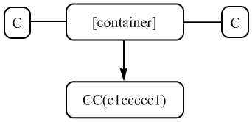
The PolymerRepeatUnitSegmentAssociation table is extremely redundant and I believe we have decided to deprecate it. I have included it in case you were wondering what the java classes were for, and in case you decide you want to un-deprecate this table for whatever reason.

[simple example 2]

The example on the second sheet one is a little more complicated. However, it has the advantage of having little numbers to the left of the tables which tell you the order. See if you can work out this example. As an aid, to the right of the tables, a schematic of how the polymer looks in the database is given. Good luck! If you run into too much trouble and you can't figure it out (and no one else can, either) then please email me at br6@williams.edu or bryn.marie.r@gmail.com.

[In other words... this is left as an exercise to the reader!]

[populating the database]

Populating the database is non-trivial. For one thing, I think the code needs to be re-done so that a 'transaction' wraps all around the insertion of information into the database. (See the Hibernate documentation) You can find the code for this in the PolymerHome persist() method. Some of the logic for the addition of the information also needs to be done, as this will be difficult as well. For future reference, this is the information that you are passed in the DB servlet:

- The name of the polymer
- The SMILES string of the polymer
- The SMILES string of the polymer (with no polymeric information)
- The smiles array (see below)
- the “pure” smiles array (see below)

Here's what the smiles array and the pure smiles array look like on the 'inside,' using block copolymer D as an example:

'SMILESArray'
“CX1” | “EG1” | “”
“X1CCCCOC(=O)X2” | “RU1” | “m”
“X2CCOX3” | “RU2” | “n”
“X3C | “RU3” | “”
“X1CCCCCOC(=O)CCOX3” | “RU1RU2” | “2000”

'pureSMILESArray'
“C[Te]” | “EG1” | “”
“[Te]CCCCOC(=O)[Te]” | “RU1” | “m”
“[Te]CCO[Te]” | “RU2” | “n”
“[Te]C | “RU3” | “”
“[Te]CCCCCOC(=O)CCO[Te]” | “RU1RU2” | “2000”

Using these 2D ArrayList<ArrayList<String>>, hopefully you can figure out a way to recursively add the polymeric information to the database.

One last note. While you are in testing, you will probably occasionally want to clear out the database. The best way to do this is to use the commands below (with the example of the polymer table) in the MySQL workbench:

DELETE FROM posra.polymer;
ALTER TABLE posra.polymer AUTO_INCREMENT=1;

Also note that if a process gets 'stuck', the best way to stop the process is to go to the MySQL command line, log in, and type the following:
SHOW PROCESSLIST;

(Remember the semicolon!)

You'll see a list of running processes. If you see one you do not want running, type:

KILL ###
Where ### is the number of the process you want to kill.

~ ~ ~
And now on to something completely different...

[p-osra: the image recognition software]

Alright, so now we're going to talk about what happens when the PolymerServlet passes the image that we get from the end-user to the osra executable. OSRA is the optical structure recognition software of which p-osra is an extension (we are the polymer optical structure recognition software). Basically, you pass in an image and you get a SMILES string, which is a textual representation of the structure (follow that link for a pretty good explanation). So for polystyrene, you get something like this: “C[Po:n]CC(c1ccccc1)[Lv:n]C”.

The Polonium and Livermorium are used as placeholder atoms (occasionally we also use Tellurium, Te). They are used in place of the parentheses/brackets that are found in the images, and they are attached to the degree information so that that information can be harvested easily (this information is harvested in PolymerServlet). These atoms suit themselves well to this purpose because they are bivalent, so they can stick themselves in the middle of a bond, but they are also unusual atoms that are unlikely to be found in a normal polymer (which would potentially ruin our ability to parse the SMILES string... but that's another issue entirely, and unlikely at that).

The inner workings of OSRA are probably best learned by looking through the code. Essentially, osra looks for lines and edges and angles in the image, marks where it thinks atoms will be, and them tries to construct an inner representation of the structure that makes chemical sense. In the process, it tries to put images into greyscale (getting rid of colors), tries to thin the image so that the bracket recognition won't get messed up. (Bracket recognition works by passing a compass over the entirety of the image and looking for places where there is white on three sides and black on one side, calling that an 'endpoint', and then looking for endpoints).

I really didn't spend too much time in the C++ code here. You will learn as you go along, and it is very well-commented.

Again, good luck with p-osra and if you have any questions, email!

[open issues in p-osra]

Below are some open issues to begin working on. Critical issues are in bold.

Potential Problems (from least abstract to most):

  - Pixel width on search for end points – how much of this is hard-coded?
  - Problem with brackets (PMMA) – Zappa
  - Issue with side chain/ backbone interpretation – OSRA (e.g. PMMA)... polymer short, sidechain long.
  - Transparent backgrounds – if need be, make bg white.
  - Bracket Matching, especially with vertical brackets
  - Resolution/Size issues – too big doesn't see. (e.g. PEG.png [the original, not the 50% reduced])
  - totally fails for pdfs (despite what OSRA's documentation says)

Web Interface Issues:
  - Query Interface (not yet implemented)
  - Some of the logic for populating the database not yet implemented (see the database population part of this document)

My SQL needs some changes as well when you try to set it up:

Change the socket it uses (or something). First log into your mysql from the mysql server 5.6/bin directory (from cygwin):

$ mysql -u root -p -h 127.0.0.1

Then, grant permissions with:

mysql > GRANT ALL PRIVILEGES ON *.* TO 'root'@'localhost' IDENTIFIED BY 'root-password-here' WITH GRANT OPTION;

OR

mysql > GRANT ALL PRIVILEGES ON *.* TO 'root'@'127.0.0.1' IDENTIFIED BY 'root-password-here' WITH GRANT OPTION;

Make sure to CREATE your database:

mysql > create database posra

