Bodymons

By Domink Trixl, Köstenbaumer Dominic, Hannes Zelger

Contributions:



Ein Bild, das Text enthält.

Note: domitrixl made the graphics, hanneszelger and doKoestenbaumer often worked on the same device

Repository:

https://github.com/hanneszelger/SWP_Bodymons

Unity Version: 2021.2.2f1

Unity Project Folder: SWP_Bodymons/Bodymon

if error CS0103: The name 'PlayerBodymon' (or else) does not exist in the current context appear

-> right click in the assets folder -> reimport all

if error spites are missing/not showing

-> right click in the assets folder -> reimport all

START GAME WITH MenuOpen scene!

Scenes can be tested separately and a ScriptableObjects loads (alter the values for testing purpose

-> Assets/Resources/Player.asset)

Controls:

Movement = WASD control or arrows

Training = E or Space

fighting = click buttons with left click on the mouse

esc = open menu or leave shop scene

r = open menu

1 - 9 use item in Inventory

b - recall to base (only in MainScene)

I – toggle Buff-Icon visibility

Buttons need to be pressed with left mouse click!

Gym-Machines (activate with E or Space):

On Bench confirm with E or Space

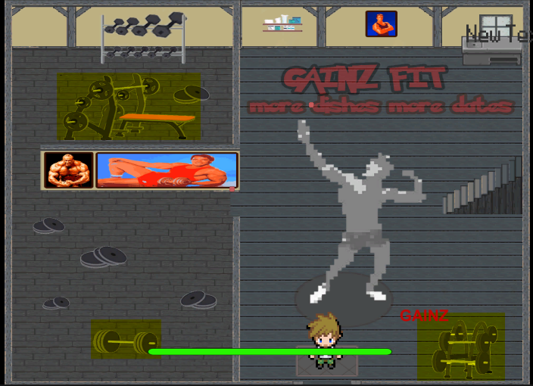

Arena:

Press E in the highlighted Area to start the fight

Ein Bild, das Text enthält.

Purple Dots: Interactable Places

Ein Bild, das Karte enthält.
