ACOTACIONES

LISTADO Y ETIQUETADO DE CADA UNO DE LOS COMPONENTES UTILIZADOS PARA EL DISEÑO DE LA INTERFAZ

|  |  |
| --- | --- |
| No. | COMPONENTES |
| 1 | jPanelGeneral |
| 2 | jPanelPerfil |
| 3 | jLabelFotoPerfil |
| 4 | jLabelTitulo1 |
| 5 | jPanelDiseño1 |
| 6 | jPanelDiseño2 |
| 7 | jLabelNombre |
| 8 | jLabelAPaterno |
| 9 | jLabelAMaterno |
| 10 | jLabelCurp |
| 11 | jTextFieldNombre |
| 12 | jTextFieldAPaterno |
| 13 | jTextFieldAMaterno |
| 14 | jTextFieldCurp |
| 15 | jButtonConsultar |
| 16 | jButtonAgregar |
| 17 | jSeparator1 |
| 18 | jSeparator2 |
| 19 | jSeparator3 |
| 20 | jSeparator4 |
| 21 | jPanelEncabezado |
| 22 | jButtonEsconder |
| 23 | jButtonminimizar |
| 24 | jButtoncerrar |
| 25 | jButtonInico |
| 26 | jButtonregresar |
| 27 | jPanelDiseño3 |
| 28 | jScrollPaneHistorial |
| 29 | jPanelHistorial |
| 30 | jScrollBarHistorial |

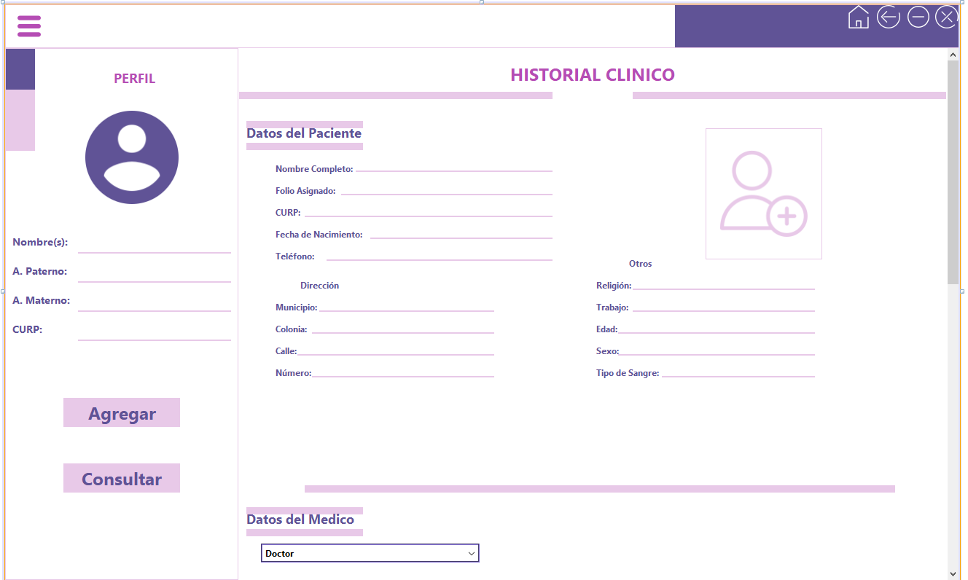

30

28

29

27

25,26,23,24

22

21

15

16

8,12,18

9,13,19

10,14,20

7,11,17

2

3

1

4

5,6

|  |  |
| --- | --- |
| 31 | jLabelTitulo2 |
| 32 | jLabelTitulo3 |
| 33 | jLabelTitulo4 |
| 34 | jLabelTitulo5 |
| 35 | jLabelTitulo6 |
| 36 | jLabelTitulo7 |
| 37 | jLabelTitulo8 |
| 38 | jLabelTitulo9 |
| 39 | jLabelTitulo10 |
| 40 | jLabelTitulo11 |
| 41 | jLabelTitulo12 |
| 42 | jPanelDiseño4 |
| 43 | jPanelDiseño5 |
| 44 | jPanelDiseño6 |
| 45 | jPanelDiseño7 |
| 46 | jPanelDiseño8 |
| 47 | jPanelDiseño9 |
| 48 | jPanelDiseño10 |
| 49 | jPanelDiseño11 |
| 50 | jPanelDiseño12 |
| 51 | jPanelDiseño13 |
| 52 | jLabelNomComPac |
| 53 | jTextFieldNomComPac |
| 54 | jLabelFolio |
| 55 | jTextFieldFolio |
| 56 | jLabelCurp2 |
| 57 | jTextFieldCurp2 |
| 58 | jLabelFecNac |
| 59 | JTextFieldFecNac |
| 60 | jLabelTelefono |
| 61 | jTextFieldTelefono |
| 62 | jLabelMunicipio |

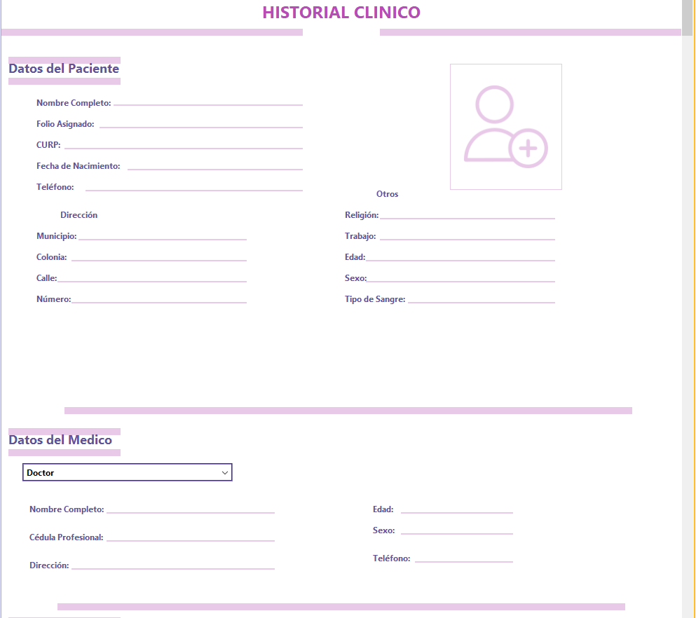

43

42

31

44 y45

51

32

52, 53

97

54, 55

56, 57

60, 61

58, 59

72, 73

34

33

74, 75

62, 63

76, 77

64, 65

66, 67

78, 79

68, 69

70, 71

46

47 y48

35

96

86, 87

80, 81

82, 83

88, 89

84, 85

90, 91

49

|  |  |
| --- | --- |
| 63 | jTextFieldMunicipio |
| 64 | jLabelColonia |
| 65 | jTextFieldColonia |
| 66 | jLabelCalle |
| 67 | jTextFieldCalle |
| 68 | jLabelNumero |
| 69 | jTextFieldNumero |
| 70 | jLabelTipSangre |
| 71 | jTextFieldTipSangre |
| 72 | jLabelReligion |
| 73 | jTextFieldReligion |
| 74 | jLabelTrabajo |
| 75 | jTextFieldTrabajo |
| 76 | jLabelEdad |
| 77 | jTextFieldEdad |
| 78 | jLabelSexo |
| 79 | jTextFieldSexo |
| 80 | jLabelNomComDoc |
| 81 | jTextFieldNoComDoc |
| 82 | jLabelCedulaProfesional |
| 83 | jTextFieldCedulaProfesional |
| 84 | jLabelDireccionDoc |

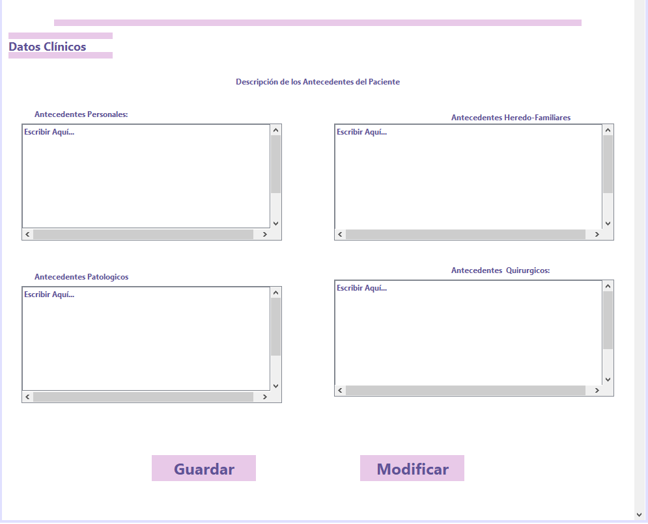

99

98

95

93

94

92

50 y 51

41

39

40

38

37

365

|  |  |
| --- | --- |
| 85 | jTextFieldDireccionDoc |
| 86 | jLabelEdadDoc |
| 87 | jTextFieldEdadDoc |
| 88 | jLabelSexoDoc |
| 89 | jTextFieldSexoDoc |
| 90 | jLabelTelefonoDoc |
| 91 | jTextFieldTelefonoDoc |
| 92 | jTextAreaAntPer |
| 93 | jTextAreaAntFam |
| 94 | jTextAreaAntPat |
| 95 | jTextAreaAntQuir |
| 96 | jComboBoxDoctores |
| 97 | jButtonInsertImg |
| 98 | jButtonGuardar |
| 99 | jButtonModificar |