Biostatistics Homework 3 (revised)

參考資料
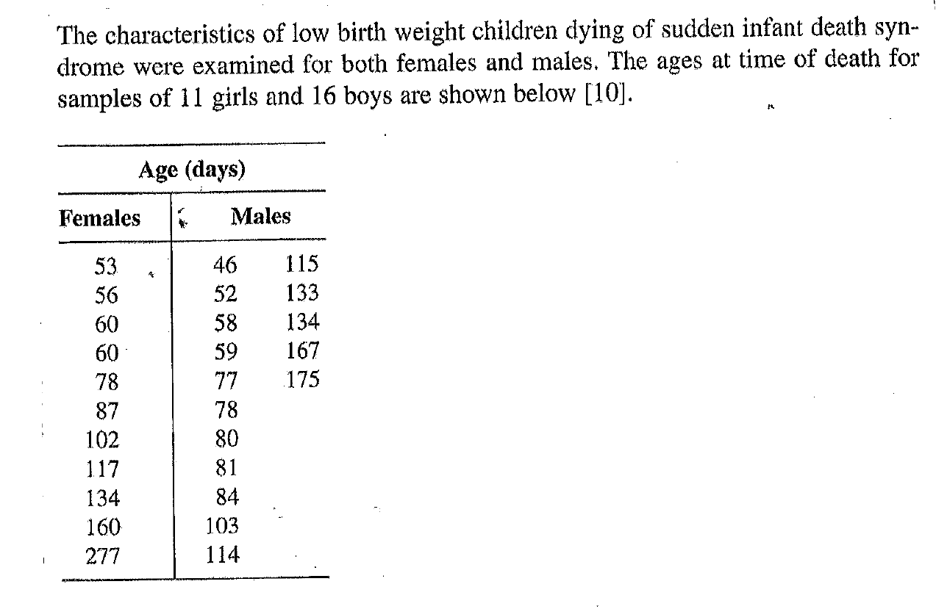
- 約略敘述問題的醫學背景 (簡單說明即可)
- 畫出兩組資料分佈 (自行選要畫哪種圖), 討論 two-sample t test 是否適合.
- 用 software 跑雙樣本 t test, 並論述結果
- 用 software 跑 Wilxoxon Rank-Sum test, 並論述其結果 (與 t test 比較)
- 用上課所教的公式算 Wilxoxon Rank-Sum test 的 normal approximation 分析結果, 並與 d 做比較.

- Consider a clinical trial of 49 patients for the treatment of Dukes' C colorectal
cancer. The data for the two treatments, linoleic acid or control, are given in the
table below:
Case group: treatment with Linoleic acid (n = 25)
1+, 5+, 6, 6, 9+, 10, 10, 10+, 12, 12, 12, 12, 12+, 13+, 15+, 16+, 20+, 24, 24+, 27+, 32, 34+, 36+, 36+, 44+
Control group (n = 24)
3+, 6, 6, 6, 6, 8, 8, 12, 12, 12+, 15+, 16+, 18+, 18+, 20, 22+, 24, 28+, 28+, 28+, 30, 30+, 33+, 42
The + sign indicates right-censored data.
- Use R to plot the Kaplan-Meier curves for the two groups together. Comment on their difference.
- Then use R to perform Log-rank test and Gehan test for the two datasets. Comment on the results based on the two tests.
- Denote as the failure time of interest. Let 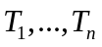 be random replications of . Let 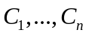 be replications of the right censoring variable . Under right censoring, one observes 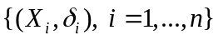 where 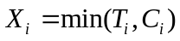 and 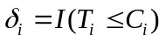.
Consider following an exponential distribution with the density:
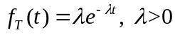.
- Please derive the explicit form for the MLE of based on right censored data .
- Denote the MLE as .
- Then derive the variance of .

4. Suppose there is a sequence of independent Bernoulli trials, each trial having two potential outcomes called “success” and “failure”. In each trial the probability of success is p and of failure is (1 − p). We are observing this sequence until a predefined number r of failures has occurred. Then the random number of successes we have seen denoted as will have the negative binomial distribution:
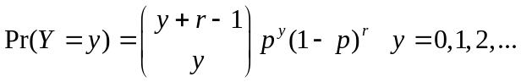
- Find the canonical parameter and link function
- Derive the mean and variance for Y using the properties that you just learned from the course. (You need to express the probability function as a form of the exponential family)

