**Definition: Student Management System**

**Code:**

using System;

using System.Collections.Generic;

using System.ComponentModel;

using System.Data;

using System.Drawing;

using System.Linq;

using System.Text;

using System.Threading.Tasks;

using System.Windows.Forms;

using System.Data.SqlClient;

namespace Student_Management_System

{

public partial class Form1 : Form

{

public Form1()

{

InitializeComponent();

}

private void btnInsert_Click(object sender, EventArgs e)

{

SqlConnection conn = new SqlConnection("Data Source=(LocalDB)\\MSSQLLocalDB;AttachDbFilename=\"C:\\Users\\Amit Rawal\\source\\repos\\dotnet\\Student_Management_System\\Database1.mdf\";Integrated Security=True");

conn.Open();

SqlCommand cmd = new SqlCommand("INSERT INTO [StudentInfo](id,name,age,address,branch) VALUES(@id,@name,@age,@address,@branch)", conn);

cmd.Parameters.AddWithValue("@id",int.Parse(textId.Text));

cmd.Parameters.AddWithValue("@name", textName.Text);

cmd.Parameters.AddWithValue("@age",int.Parse(textAge.Text));

cmd.Parameters.AddWithValue("@address", textAddress.Text);

cmd.Parameters.AddWithValue("@branch", textBranch.Text);

cmd.ExecuteNonQuery();

conn.Close();

textName.Clear();

textAge.Clear();

textAddress.Clear();

textBranch.Clear();

MessageBox.Show("Data inserted Successfully");

}

private void btnUpdate_Click(object sender, EventArgs e)

{

SqlConnection conn = new SqlConnection("Data Source=(LocalDB)\\MSSQLLocalDB;AttachDbFilename=\"C:\\Users\\Amit Rawal\\source\\repos\\dotnet\\Student_Management_System\\Database1.mdf\";Integrated Security=True");

conn.Open();

SqlCommand cmd = new SqlCommand("UPDATE [StudentInfo] SET name = @name, age = @age, address=@address ,branch=@branch WHERE id = @id", conn);

cmd.Parameters.AddWithValue("@id", int.Parse(textId.Text));

cmd.Parameters.AddWithValue("@name", textName.Text);

cmd.Parameters.AddWithValue("@age", int.Parse(textAge.Text));

cmd.Parameters.AddWithValue("@address", textAddress.Text);

cmd.Parameters.AddWithValue("@branch", textBranch.Text);

cmd.ExecuteNonQuery();

conn.Close();

textName.Clear();

textAge.Clear();

textAddress.Clear();

textBranch.Clear();

MessageBox.Show("Data Updated Successfully");

}

private void btnDelete_Click(object sender, EventArgs e)

{

SqlConnection conn= new SqlConnection("Data Source=(LocalDB)\\MSSQLLocalDB;AttachDbFilename=\"C:\\Users\\Amit Rawal\\source\\repos\\dotnet\\Student_Management_System\\Database1.mdf\";Integrated Security=True");

conn.Open();

SqlCommand cmd = new SqlCommand("DELETE [StudentInfo] WHERE id = @id", conn);

cmd.Parameters.AddWithValue("@id", int.Parse(textId.Text));

cmd.ExecuteNonQuery();

conn.Close();

MessageBox.Show("Data Deleted Successfully");

}

private void btnSearch_Click(object sender, EventArgs e)

{

SqlConnection conn = new SqlConnection("Data Source=(LocalDB)\\MSSQLLocalDB;AttachDbFilename=\"C:\\Users\\Amit Rawal\\source\\repos\\dotnet\\Student_Management_System\\Database1.mdf\";Integrated Security=True");

conn.Open();

SqlCommand cmd = new SqlCommand("SELECT * FROM [StudentInfo] WHERE id = @id", conn);

cmd.Parameters.AddWithValue("@id", int.Parse(textId.Text));

SqlDataAdapter da = new SqlDataAdapter(cmd);

DataTable dataTable = new DataTable();

da.Fill(dataTable);

dataGridView1.DataSource = dataTable;

cmd.ExecuteNonQuery();

conn.Close();

}

}

}

**Design:**

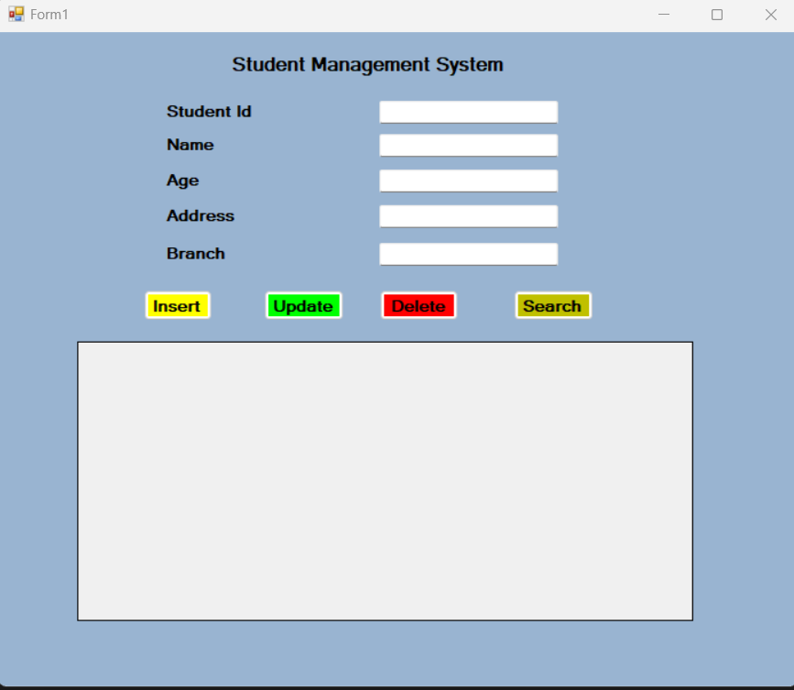

**Operation in My Project:**

