Maman12 – Eran Moshe
Code structure:
Maman12
docs
maman12.docx
notebooks
maman12.ipynb
src
maman12.py
my_math.py
test_my_math.py

First part – my_sampler:
Is implemented both in .py and notebooks. You can find it with the plots
- Tested for correct dist input
- Used dist to build a cumsum of probabilities – making it easier to search where a random number lies.
- Instead of using a for loop, where we sample a number from uniform distribution, and then use a binary search (since dist_cumsum is sorted), we used a vectorized operation using pytorch.searchsorted. So, we’ve generated `size` random numbers using torch.rand.
  - Saved us implementing binary search
  - Used torch search algorithm which will be much more optimized than anything I can implement in python
  - Operation is vectorized, which is another boost in performance.
  - Resulted plot:
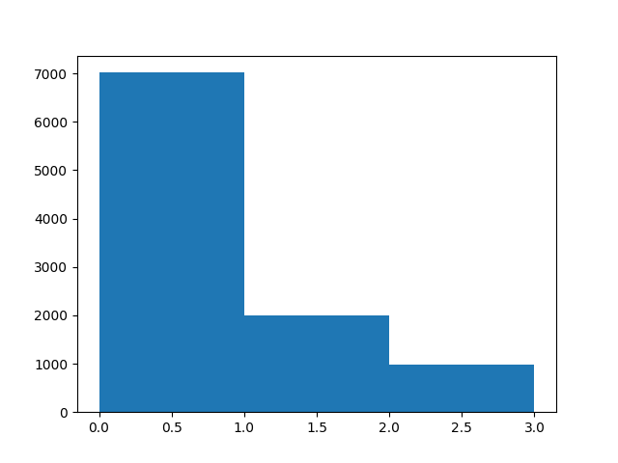

Second part – my_math:
This assignment was in the form of “writing a library”, which I find more suited for a .py with pytest suite of tests. However, there is a copy paste and a small example in the Jupyter notebook.
And yes, the test suite actually helped me find bugs and errors in my implementation.

my_math_py
- MyScalar was implemented as required, with a __repr__ for easy prints and debug.
- Most of the derivative’s implementations were easy and made with 1 or 0 lines. The less straight forward, we’re implemented using a nested function within the math operation (power for example).
- All functions are well typed.
- There are very small comments here as the work is simple and straight forward. Nothing to elaborate.
- get_gradient – work iteratively and in the end, we reverse the keys, and rename them into characters, as requested in the maman.

test_my_math.py
- we’ve implemented a function that check all gradiant values to see if they match between the custom math module and MyScalar (ms) and PyTorch (pt) implementation.
- We’ve defined a “values space”, for example for the plain scalar, the exponent and the multiplayers that used in a certain calculation.
- Using this search space, and itertools.product we can EASILTY create many test cases over our simple test function as one can see in the code
- Since we’re using a robust way to generate numbers, some may be impossible to calculate. Therefor we’ve added a condition to skip (pytest.skip) over those cases.
To run the test suite, simply go to code location and
>pytest test_my_math.py -v

Heres some lines from there with the summary line:
test_my_math.py::test_chain_exp_pow[-2.5-1.0] PASSED [ 0%]
test_my_math.py::test_chain_exp_pow[-2.5-2.0] PASSED [ 0%]
test_my_math.py::test_chain_exp_pow[2.0-3.0] PASSED [ 9%]
test_my_math.py::test_chain_log_sin[-2.5] SKIPPED (Invalid result: NaN or Inf in custom gradient.) [ 10%]
test_my_math.py::test_chain_log_sin[-2.0] SKIPPED (Invalid result: NaN or Inf in custom gradient.) [ 10%]
test_my_math.py::test_chain_mult_cos_exp_pow[2.0-3.0-1.5] PASSED [ 99%]
test_my_math.py::test_chain_mult_cos_exp_pow[2.0-3.0-2.0] PASSED [100%]
======= 304 passed, 6 skipped in 2.48s ========

