COMSATS UNIVERSITY ISLAMABAD
ATTOCK CAMPUS
Department of Computer Science

Mobile Application Development
Lab Report
Personal Profile App and Profile / Portfolio UI in Flutter

Submitted By: Hanan bin Saleh
Registration No: ______________________
Program: BS Software Engineering (Final Year)
Submitted To: ______________________
Date of Submission: 25 October 2026

1. Introduction
In this lab I made two mobile app screens using Flutter. The first task was a simple Personal Profile App that shows my name, profile picture, a short introduction, my contact details, my skills, a button and some icons. The second task was a proper Profile / Portfolio home screen that uses the basic layout widgets of Flutter, which are Row, Column, Container, Card and Padding.
Instead of making two separate apps, I put both tasks in one Flutter project. A bottom navigation bar is used to switch between the Profile screen (Task 1) and the Portfolio screen (Task 2). I used my own information and my own picture in the app, and I chose an olive, green, cream and light orange colour scheme for the whole app.

2. Objectives
- To create and run a Flutter project in Android Studio on an Android emulator.
- To understand how Row, Column, Container, Card and Padding are used to build a layout.
- To add an image from the assets folder and show it in a circular shape.
- To use icons, buttons, chips, cards and progress bars in a real screen.
- To apply a custom colour theme and keep proper spacing and alignment.

3. Tools and Technologies
Tool | Usage
Flutter SDK | Framework used to build the app
Dart | Programming language of Flutter
Android Studio | IDE used for writing and running the code
Android Emulator (Pixel 7a) | Virtual device used to run and test the app
Material 3 | Design system used for widgets and theme

4. Project Setup
The following steps were followed to set up and run the project:
- Created a new Flutter project named profile_app inside the folder D:\GDG\profile.
- Made a folder named assets in the project and placed my picture in it as profile.png.
- Registered the picture in pubspec.yaml under the flutter > assets section.
- Wrote the code of both tasks in lib/main.dart.
- Ran flutter pub get and then flutter analyze, which showed "No issues found".
- Started the Pixel 7a emulator and ran the app on it.
pubspec.yaml (assets part):
flutter:
uses-material-design: true

assets:
- assets/profile.png

5. Colour Scheme
All colours are kept in one class named AppColors so that the same colours are used everywhere in the app.
Colour Name | Hex Code | Where it is used
Olive | #6B7A3A | App bar, headings and icons
Dark Olive | #3F4A22 | Header gradient and dark text
Green | #4F7942 | Buttons and progress bars
Cream | #FAF6EC | Background of the screens
Off White | #FFFDF7 | Cards and bottom sheet
Light Orange | #F4B26B | Photo border, Contact button, highlights
Pale Orange | #FFE8CC | Chips, badges and icon boxes

6. Task 1: Personal Profile App
The first screen is a simple profile page. Everything is placed in a Column inside a SingleChildScrollView so the page can scroll on small phones. The screen contains the following parts:
- Profile picture: shown in a circle with an orange and green ring around it. ClipOval and OverflowBox are used so that the circle shows my face instead of the full photo.
- Name and title: my name in bold and "Software Engineering Student" under it.
- Role badges: two small badges for Google Developers COMSATS Attock and Media Team Co-Head of CHAS.
- About Me: a short introduction about myself.
- Contact: email, phone number and Instagram ID, each with an icon in a Row.
- Skills: shown as Chips inside a Wrap widget, so they move to the next line automatically.
- Button: a Contact Me button. When it is pressed a SnackBar appears at the bottom with my email.
I made small reusable widgets named SectionTitle, ContactRow and RoleBadge so that I did not have to repeat the same code again and again.

Output Screenshots (Task 1)
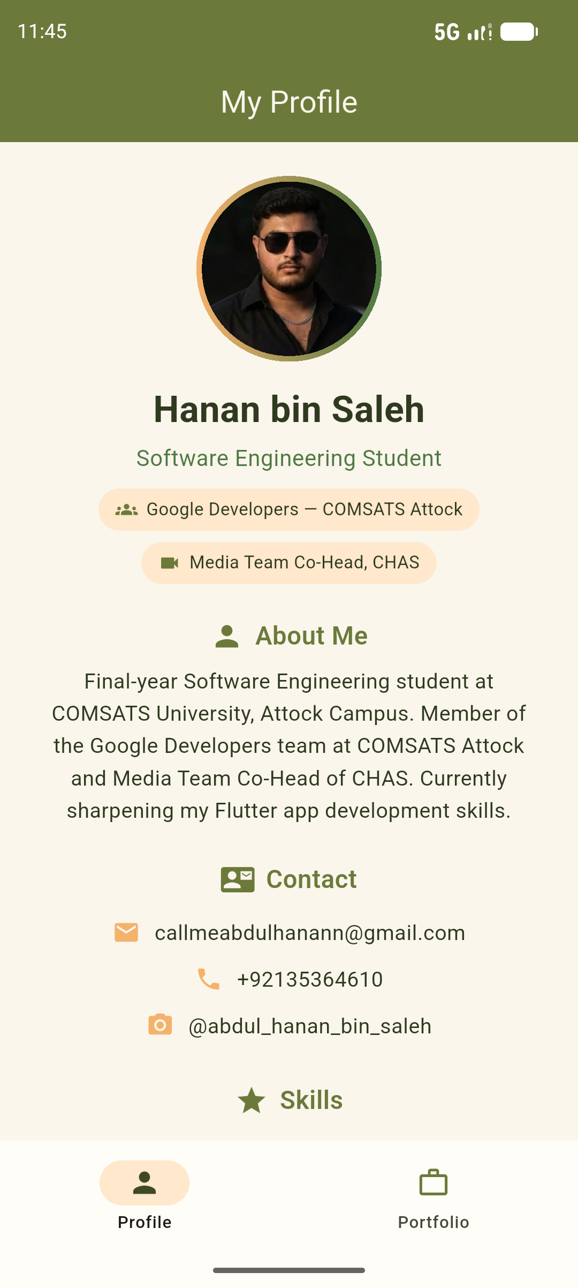  Figure 1: Profile screen | 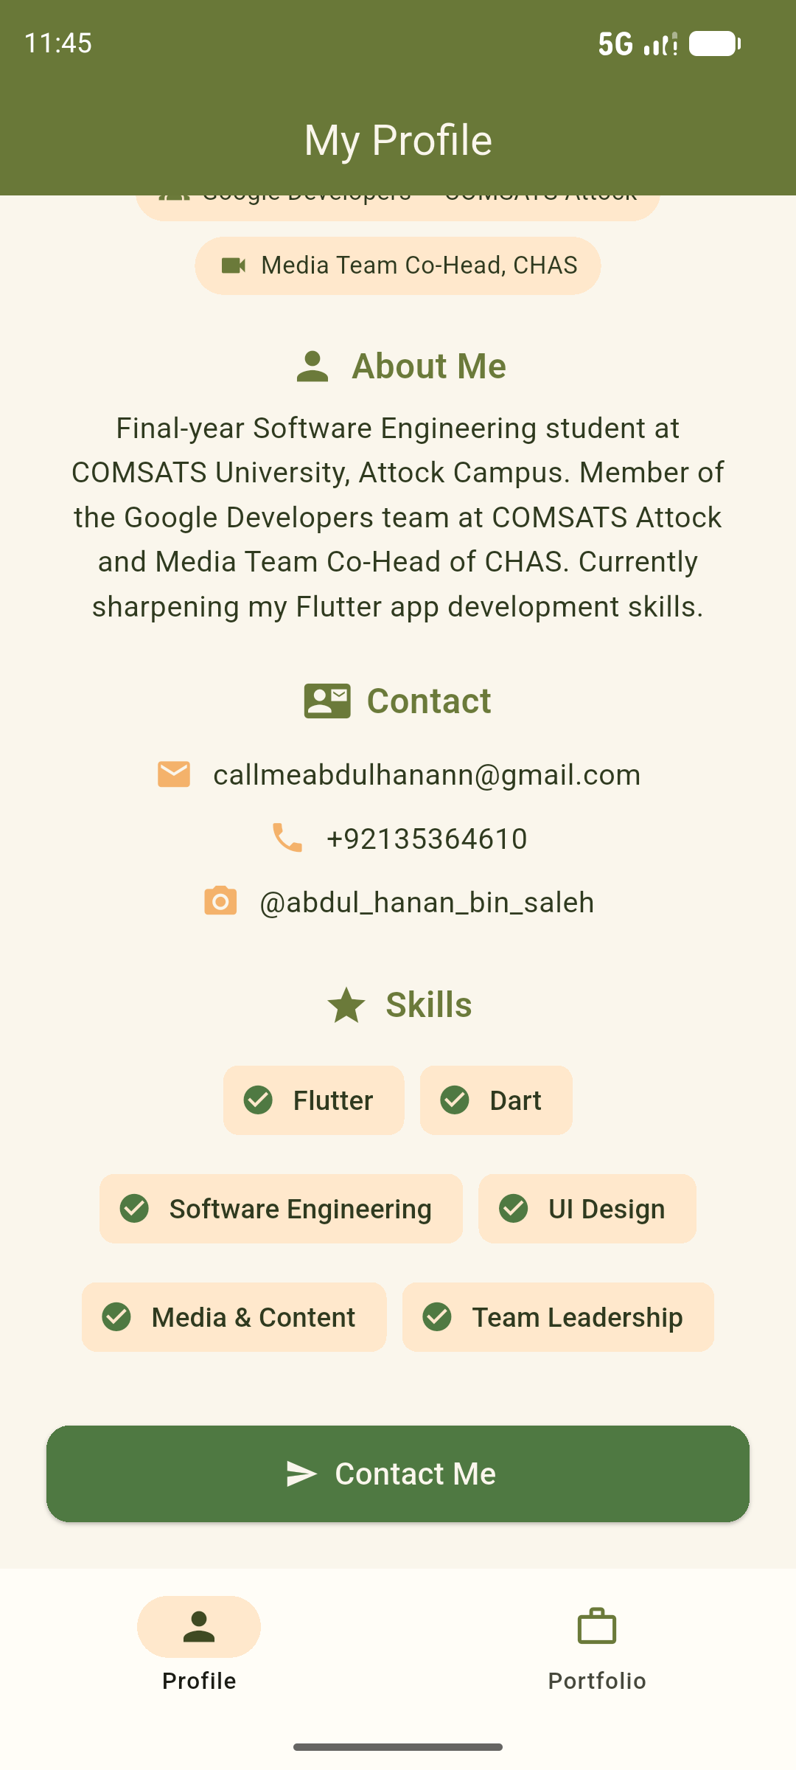  Figure 2: Contact and Skills | 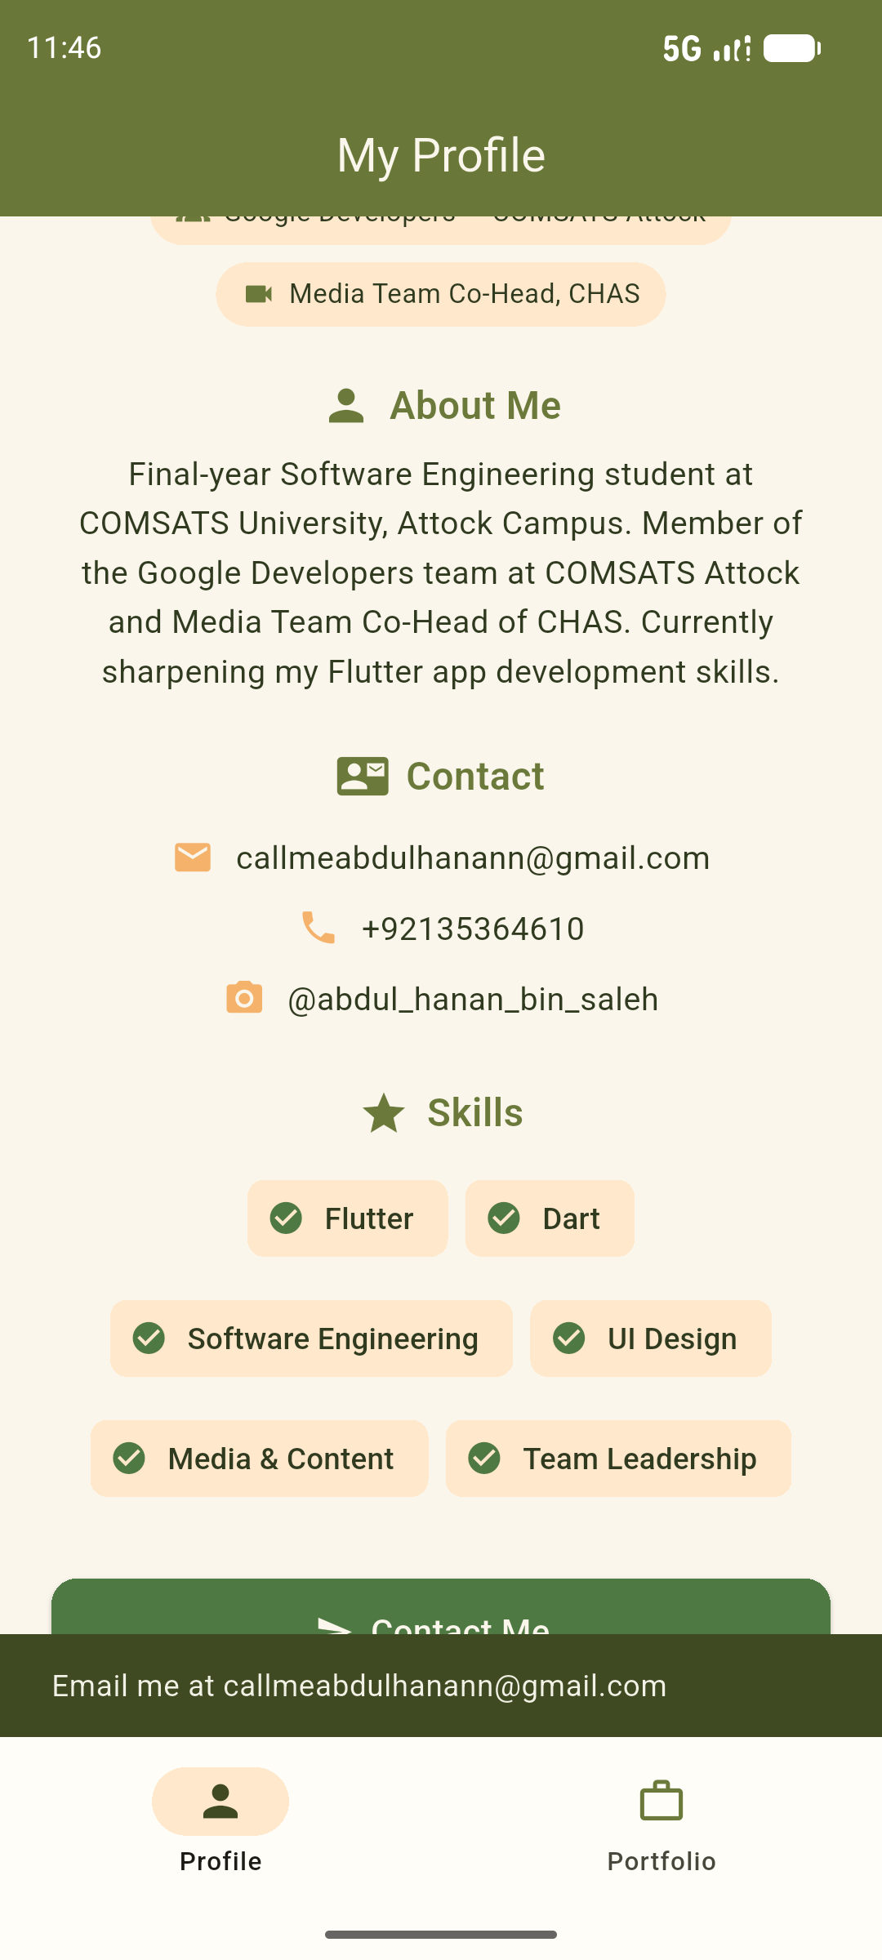  Figure 3: SnackBar on Contact Me

7. Task 2: Profile / Portfolio UI
The second screen is a more complete portfolio home screen. It has a header with a gradient, an About section, a Roles section, a Skills section and a Contact button. The table below shows how the required widgets are used in this screen.
Widget | How I used it
Column | The whole screen is a Column. Each card also uses a Column for its title, divider and content.
Row | Used for the profession line, the three highlight items in the header, and every skill and role item (icon on the left, text on the right).
Container | Used for the gradient header with rounded bottom corners, the orange circle around the photo and the small coloured boxes behind icons.
Card | About Me, Roles and Skills are each shown inside a Card with rounded corners and light shadow.
Padding | Used around every card, inside every card and around the button to keep proper spacing.

Sections of the Portfolio Screen
- Header: profile picture, name, profession and three highlights (Final Year, GDG, Co-Head).
- About Me card: a paragraph about my studies, my roles and my interest in Flutter.
- Roles card: Team Member at Google Developers COMSATS Attock and Media Team Co-Head at CHAS.
- Skills card: six skills, each with an icon, name, percentage and a LinearProgressIndicator.
- Contact button: opens a bottom sheet named "Get in touch" which shows my email, phone and Instagram.

Output Screenshots (Task 2)
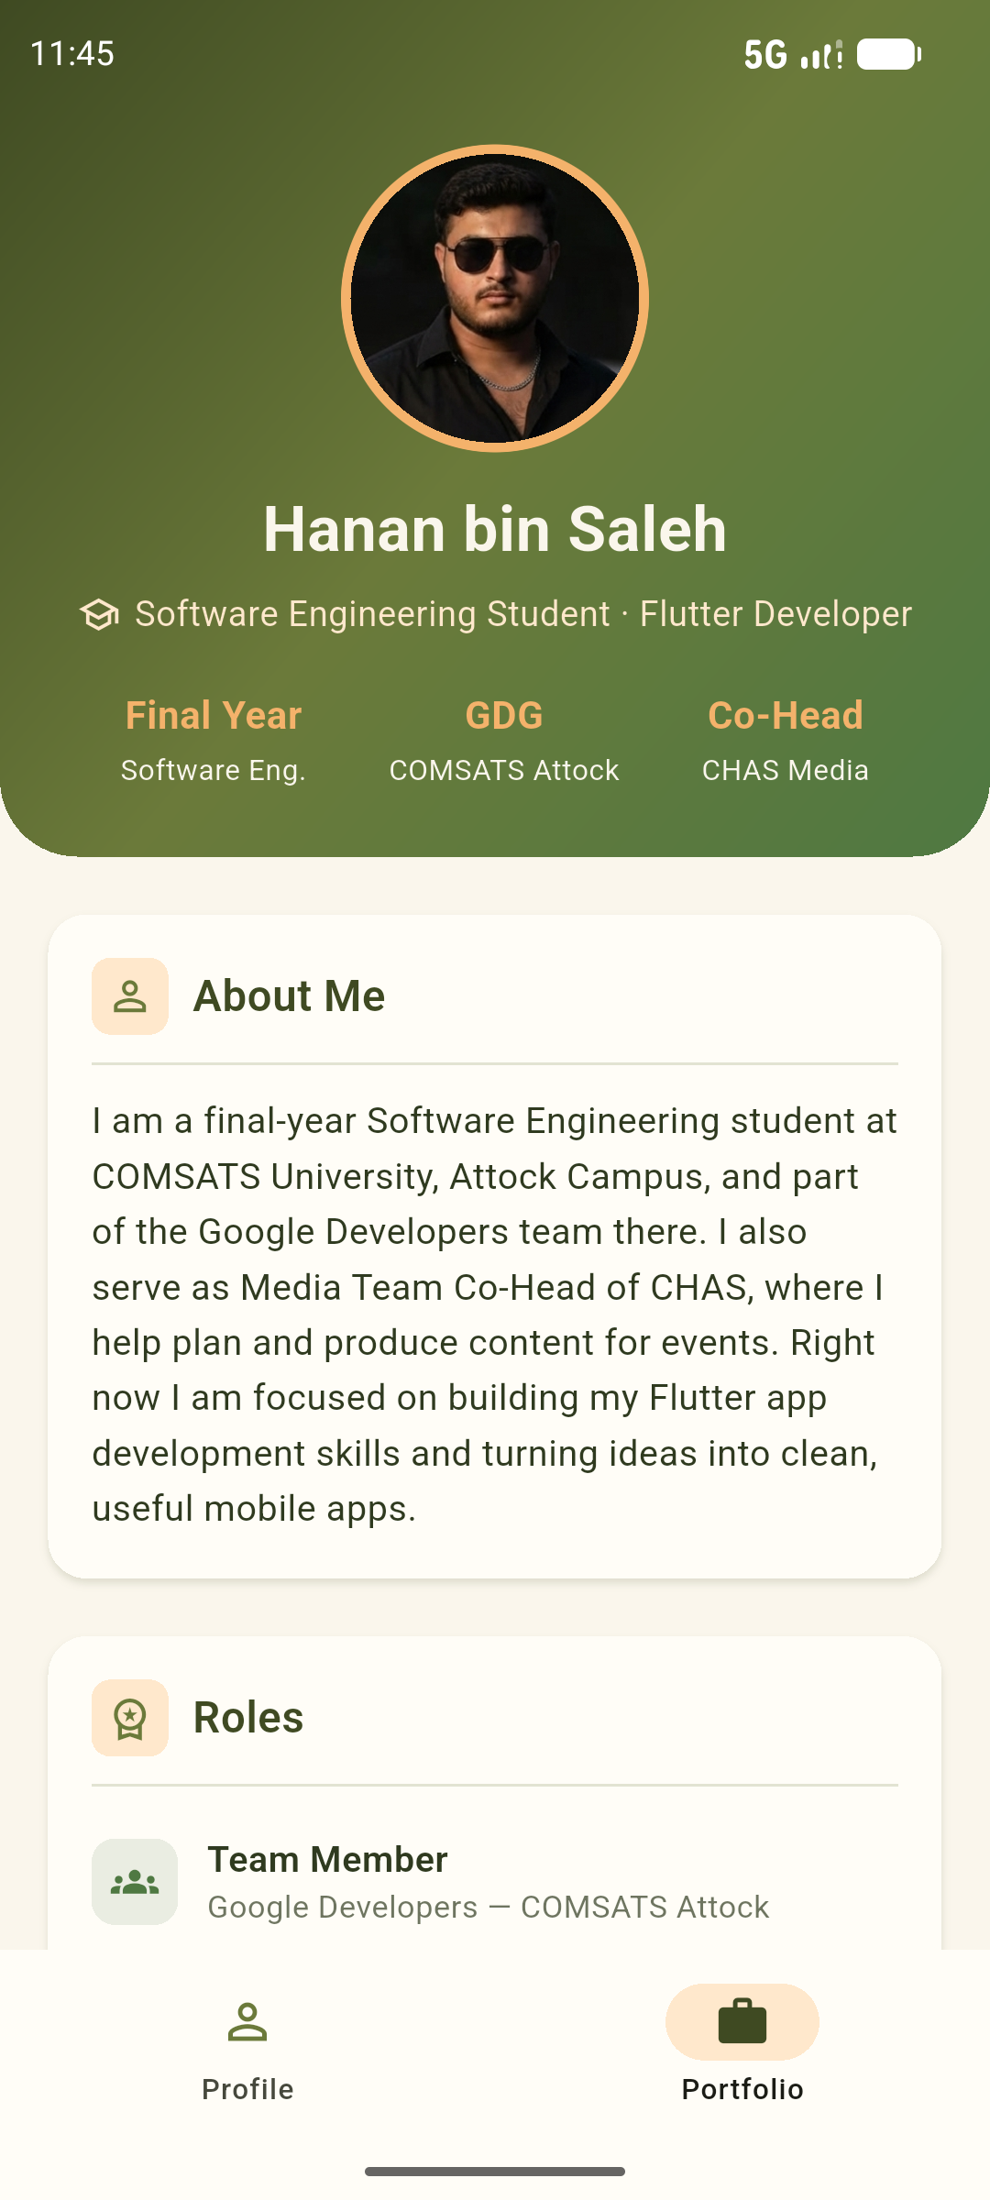  Figure 4: Portfolio header | 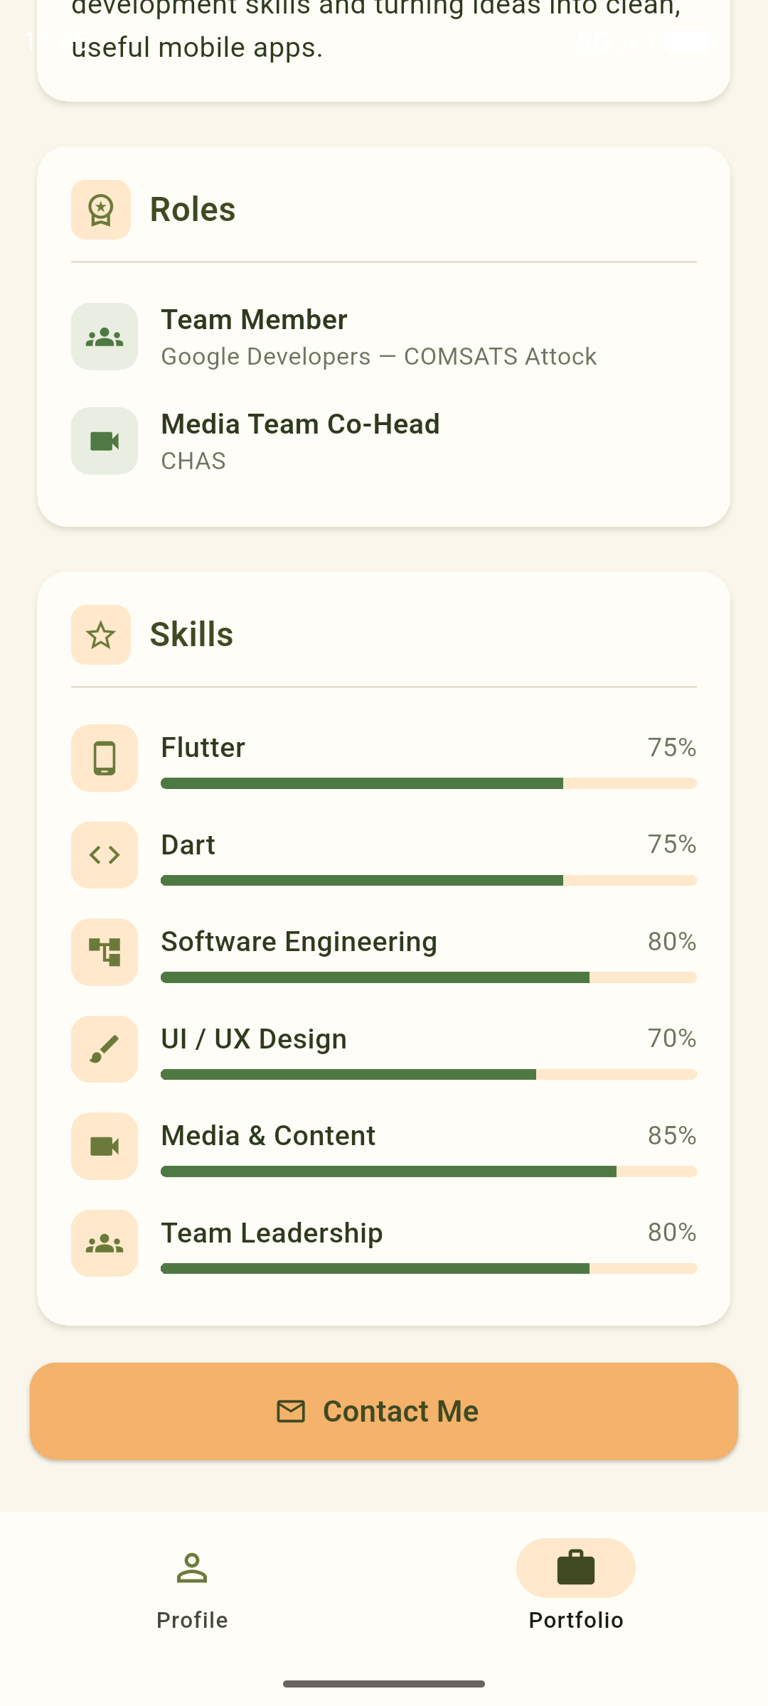  Figure 5: Roles and Skills | 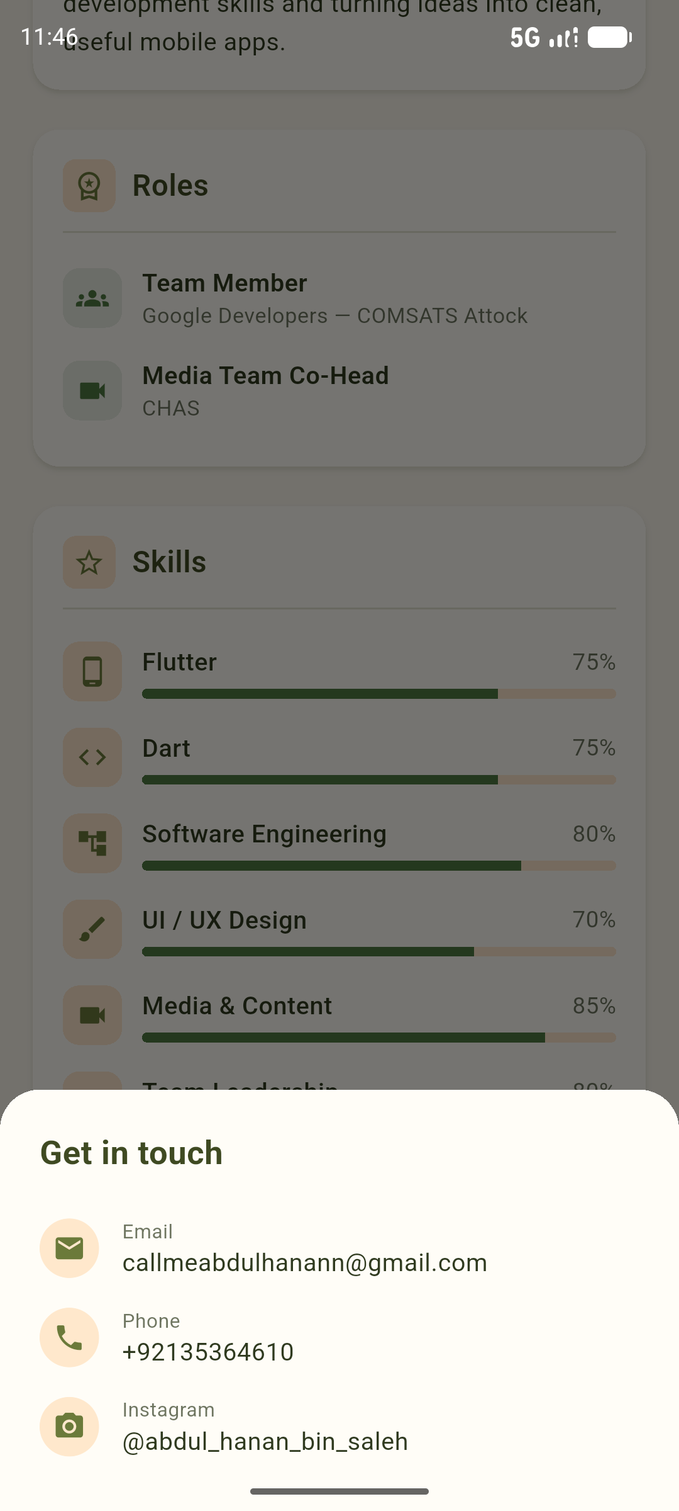  Figure 6: Contact bottom sheet

8. Project Structure
File / Folder | Description
lib/main.dart | Complete code of both tasks
assets/profile.png | My profile picture
pubspec.yaml | Project settings and assets list
test/widget_test.dart | Simple test that checks my name is shown on screen
android/ | Android files generated by Flutter

Main classes in main.dart:
- MyApp: sets the theme and colours of the app.
- MainShell: holds both screens and the bottom NavigationBar.
- ProfileScreen: screen of Task 1.
- HomeScreen: portfolio screen of Task 2.
- ProfilePhoto, SectionCard, SkillRow, RoleRow, ContactTile, StatItem: reusable widgets.

9. Problems Faced and Solutions
- Picture not showing: at first the code was looking for profile.jpg but my picture was saved as profile.png. I changed the name in main.dart and pubspec.yaml and the picture started showing.
- Wrong project folder: the first time, the Flutter project got created inside the android folder by mistake. I created a fresh project named profile_app and copied the code and assets into it.
- Default test file error: the default widget_test.dart was testing the counter app which does not exist anymore, so I replaced it with a small test that checks my name.
- Full photo in small circle: my photo is a full body picture, so the face was very small in the circle. I used OverflowBox with an alignment value to zoom in on the face.

10. Conclusion
In this lab I learned how to design a complete screen in Flutter using basic layout widgets. I understood that Column and Row are used for arranging widgets, Container is used for decoration like colours, gradients and rounded corners, Card is used to group related information, and Padding is used to give proper space. I also learned how to add images through assets, how to use a custom theme, and how to show a SnackBar and a bottom sheet. Both tasks ran successfully on the Android emulator without any errors.

Appendix: Source Code (lib/main.dart)
// main.dart - Hanan bin Saleh: Profile (Task 1) + Portfolio (Task 2)
// Switch between the two screens with the bottom navigation bar.
// Requires assets/profile.png listed in pubspec.yaml.

import 'package:flutter/material.dart';

void main() => runApp(const MyApp());

class MyApp extends StatelessWidget {
const MyApp({super.key});

@override
Widget build(BuildContext context) {
return MaterialApp(
title: 'Hanan bin Saleh',
debugShowCheckedModeBanner: false,
theme: ThemeData(
useMaterial3: true,
scaffoldBackgroundColor: AppColors.cream,
colorScheme: ColorScheme.fromSeed(
seedColor: AppColors.olive,
primary: AppColors.olive,
secondary: AppColors.lightOrange,
surface: AppColors.offWhite,
),
),
home: const MainShell(),
);
}
}

/// Holds both task screens and a bottom navigation bar.
class MainShell extends StatefulWidget {
const MainShell({super.key});

@override
State<MainShell> createState() => _MainShellState();
}

class _MainShellState extends State<MainShell> {
int _index = 0;

static const _screens = [
ProfileScreen(), // Task 1
HomeScreen(), // Task 2
];

@override
Widget build(BuildContext context) {
return Scaffold(
body: IndexedStack(index: _index, children: _screens),
bottomNavigationBar: NavigationBar(
selectedIndex: _index,
backgroundColor: AppColors.offWhite,
indicatorColor: AppColors.paleOrange,
onDestinationSelected: (i) => setState(() => _index = i),
destinations: const [
NavigationDestination(
icon: Icon(Icons.person_outline, color: AppColors.olive),
selectedIcon: Icon(Icons.person, color: AppColors.darkOlive),
label: 'Profile',
),
NavigationDestination(
icon: Icon(Icons.work_outline, color: AppColors.olive),
selectedIcon: Icon(Icons.work, color: AppColors.darkOlive),
label: 'Portfolio',
),
],
),
);
}
}

// =====================================================================
// TASK 1 - Personal Profile screen
// =====================================================================

class ProfileScreen extends StatelessWidget {
const ProfileScreen({super.key});

// ---- Your details ----
static const String name = 'Hanan bin Saleh';
static const String title = 'Software Engineering Student';
static const String intro =
'Final-year Software Engineering student at COMSATS University, Attock '
'Campus. Member of the Google Developers team at COMSATS Attock and '
'Media Team Co-Head of CHAS. Currently sharpening my Flutter app '
'development skills.';
static const String email = 'callmeabdulhanann@gmail.com';
static const String phone = '+92135364610';
static const String instagram = '@abdul_hanan_bin_saleh';
static const List<String> skills = [
'Flutter',
'Dart',
'Software Engineering',
'UI Design',
'Media & Content',
'Team Leadership',
];

@override
Widget build(BuildContext context) {
return Scaffold(
appBar: AppBar(
title: const Text('My Profile'),
centerTitle: true,
backgroundColor: AppColors.olive,
foregroundColor: AppColors.cream,
),
body: SingleChildScrollView(
padding: const EdgeInsets.all(24),
child: Column(
children: [
// Profile picture with orange ring
Container(
padding: const EdgeInsets.all(4),
decoration: const BoxDecoration(
shape: BoxShape.circle,
gradient: LinearGradient(
colors: [AppColors.lightOrange, AppColors.green],
),
),
child: const ProfilePhoto(size: 124),
),
const SizedBox(height: 16),

const Text(
name,
style: TextStyle(
fontSize: 26,
fontWeight: FontWeight.bold,
color: AppColors.text,
),
),
const SizedBox(height: 4),
const Text(
title,
style: TextStyle(fontSize: 16, color: AppColors.green),
),
const SizedBox(height: 10),
Wrap(
spacing: 8,
runSpacing: 8,
alignment: WrapAlignment.center,
children: const [
RoleBadge(icon: Icons.groups, label: 'Google Developers — COMSATS Attock'),
RoleBadge(icon: Icons.videocam, label: 'Media Team Co-Head, CHAS'),
],
),
const SizedBox(height: 24),

const SectionTitle(icon: Icons.person, title: 'About Me'),
const SizedBox(height: 8),
const Text(
intro,
textAlign: TextAlign.center,
style: TextStyle(fontSize: 15, height: 1.5, color: AppColors.text),
),
const SizedBox(height: 24),

const SectionTitle(icon: Icons.contact_mail, title: 'Contact'),
const SizedBox(height: 8),
const ContactRow(icon: Icons.email, text: email),
const ContactRow(icon: Icons.phone, text: phone),
const ContactRow(icon: Icons.camera_alt, text: instagram),
const SizedBox(height: 24),

const SectionTitle(icon: Icons.star, title: 'Skills'),
const SizedBox(height: 12),
Wrap(
spacing: 8,
runSpacing: 8,
alignment: WrapAlignment.center,
children: skills
.map((s) => Chip(
backgroundColor: AppColors.paleOrange,
side: BorderSide.none,
avatar: const Icon(Icons.check_circle,
size: 18, color: AppColors.green),
label: Text(s,
style: const TextStyle(color: AppColors.text)),
))
.toList(),
),
const SizedBox(height: 32),

SizedBox(
width: double.infinity,
height: 50,
child: ElevatedButton.icon(
style: ElevatedButton.styleFrom(
backgroundColor: AppColors.green,
foregroundColor: AppColors.cream,
shape: RoundedRectangleBorder(
borderRadius: BorderRadius.circular(12),
),
),
icon: const Icon(Icons.send),
label: const Text('Contact Me', style: TextStyle(fontSize: 16)),
onPressed: () {
ScaffoldMessenger.of(context).showSnackBar(
const SnackBar(
backgroundColor: AppColors.darkOlive,
content: Text('Email me at $email'),
),
);
},
),
),
],
),
),
);
}
}

class RoleBadge extends StatelessWidget {
final IconData icon;
final String label;
const RoleBadge({super.key, required this.icon, required this.label});

@override
Widget build(BuildContext context) {
return Container(
padding: const EdgeInsets.symmetric(horizontal: 12, vertical: 6),
decoration: BoxDecoration(
color: AppColors.paleOrange,
borderRadius: BorderRadius.circular(20),
),
child: Row(
mainAxisSize: MainAxisSize.min,
children: [
Icon(icon, size: 16, color: AppColors.olive),
const SizedBox(width: 6),
Flexible(
child: Text(label,
style: const TextStyle(fontSize: 12.5, color: AppColors.text)),
),
],
),
);
}
}

class SectionTitle extends StatelessWidget {
final IconData icon;
final String title;
const SectionTitle({super.key, required this.icon, required this.title});

@override
Widget build(BuildContext context) {
return Row(
mainAxisAlignment: MainAxisAlignment.center,
children: [
Icon(icon, color: AppColors.olive),
const SizedBox(width: 8),
Text(
title,
style: const TextStyle(
fontSize: 18,
fontWeight: FontWeight.w600,
color: AppColors.olive),
),
],
);
}
}

class ContactRow extends StatelessWidget {
final IconData icon;
final String text;
const ContactRow({super.key, required this.icon, required this.text});

@override
Widget build(BuildContext context) {
return Padding(
padding: const EdgeInsets.symmetric(vertical: 6),
child: Row(
mainAxisAlignment: MainAxisAlignment.center,
children: [
Icon(icon, size: 20, color: AppColors.lightOrange),
const SizedBox(width: 10),
Flexible(
child: Text(text,
style: const TextStyle(fontSize: 15, color: AppColors.text)),
),
],
),
);
}
}

// =====================================================================
// TASK 2 - Portfolio screen + shared colours/widgets
// =====================================================================

// ---------- App colours: olive, green, cream, light orange ----------
class AppColors {
static const olive = Color(0xFF6B7A3A);
static const darkOlive = Color(0xFF3F4A22);
static const green = Color(0xFF4F7942);
static const cream = Color(0xFFFAF6EC);
static const offWhite = Color(0xFFFFFDF7);
static const lightOrange = Color(0xFFF4B26B);
static const paleOrange = Color(0xFFFFE8CC);
static const text = Color(0xFF2F3A1F);
static const subtext = Color(0xFF6E7560);
}

class Skill {
final String name;
final IconData icon;
final double level; // 0.0 – 1.0
const Skill(this.name, this.icon, this.level);
}

class HomeScreen extends StatelessWidget {
const HomeScreen({super.key});

// ---- Your details ----
static const String name = 'Hanan bin Saleh';
static const String profession = 'Software Engineering Student · Flutter Developer';
static const String about =
'I am a final-year Software Engineering student at COMSATS University, '
'Attock Campus, and part of the Google Developers team there. I also '
'serve as Media Team Co-Head of CHAS, where I help plan and produce '
'content for events. Right now I am focused on building my Flutter app '
'development skills and turning ideas into clean, useful mobile apps.';
static const String email = 'callmeabdulhanann@gmail.com';
static const String phone = '+92135364610';
static const String instagram = '@abdul_hanan_bin_saleh';

static const List<Skill> skills = [
Skill('Flutter', Icons.phone_android, 0.75),
Skill('Dart', Icons.code, 0.75),
Skill('Software Engineering', Icons.account_tree, 0.8),
Skill('UI / UX Design', Icons.brush, 0.7),
Skill('Media & Content', Icons.videocam, 0.85),
Skill('Team Leadership', Icons.groups, 0.8),
];

@override
Widget build(BuildContext context) {
return Scaffold(
body: SingleChildScrollView(
child: Column(
children: [
// ---------- Header ----------
Container(
width: double.infinity,
padding: const EdgeInsets.only(top: 60, bottom: 28, left: 16, right: 16),
decoration: const BoxDecoration(
gradient: LinearGradient(
colors: [AppColors.darkOlive, AppColors.olive, AppColors.green],
begin: Alignment.topLeft,
end: Alignment.bottomRight,
),
borderRadius: BorderRadius.vertical(bottom: Radius.circular(32)),
),
child: Column(
children: [
Container(
padding: const EdgeInsets.all(4),
decoration: const BoxDecoration(
color: AppColors.lightOrange,
shape: BoxShape.circle,
),
child: const ProfilePhoto(size: 120),
),
const SizedBox(height: 14),
const Text(
name,
style: TextStyle(
fontSize: 26,
fontWeight: FontWeight.bold,
color: AppColors.cream,
),
),
const SizedBox(height: 6),
const Row(
mainAxisAlignment: MainAxisAlignment.center,
children: [
Icon(Icons.school_outlined, color: AppColors.paleOrange, size: 18),
SizedBox(width: 6),
Flexible(
child: Text(
profession,
textAlign: TextAlign.center,
style: TextStyle(fontSize: 14.5, color: AppColors.paleOrange),
),
),
],
),
const SizedBox(height: 20),
// Highlights row
const Row(
mainAxisAlignment: MainAxisAlignment.spaceEvenly,
children: [
StatItem(value: 'Final Year', label: 'Software Eng.'),
StatItem(value: 'GDG', label: 'COMSATS Attock'),
StatItem(value: 'Co-Head', label: 'CHAS Media'),
],
),
],
),
),

// ---------- About ----------
const Padding(
padding: EdgeInsets.fromLTRB(16, 20, 16, 0),
child: SectionCard(
icon: Icons.person_outline,
title: 'About Me',
child: Text(
about,
style: TextStyle(fontSize: 15, height: 1.55, color: AppColors.text),
),
),
),

// ---------- Roles ----------
const Padding(
padding: EdgeInsets.fromLTRB(16, 16, 16, 0),
child: SectionCard(
icon: Icons.workspace_premium_outlined,
title: 'Roles',
child: Column(
children: [
RoleRow(
icon: Icons.groups,
role: 'Team Member',
org: 'Google Developers — COMSATS Attock',
),
RoleRow(
icon: Icons.videocam,
role: 'Media Team Co-Head',
org: 'CHAS',
),
],
),
),
),

// ---------- Skills ----------
Padding(
padding: const EdgeInsets.fromLTRB(16, 16, 16, 0),
child: SectionCard(
icon: Icons.star_outline,
title: 'Skills',
child: Column(
children: skills.map((s) => SkillRow(skill: s)).toList(),
),
),
),

// ---------- Contact button ----------
Padding(
padding: const EdgeInsets.all(16),
child: SizedBox(
width: double.infinity,
height: 52,
child: ElevatedButton.icon(
style: ElevatedButton.styleFrom(
backgroundColor: AppColors.lightOrange,
foregroundColor: AppColors.darkOlive,
shape: RoundedRectangleBorder(
borderRadius: BorderRadius.circular(14),
),
),
icon: const Icon(Icons.mail_outline),
label: const Text('Contact Me',
style: TextStyle(fontSize: 16, fontWeight: FontWeight.w600)),
onPressed: () => _showContactSheet(context),
),
),
),
const SizedBox(height: 12),
],
),
),
);
}

void _showContactSheet(BuildContext context) {
showModalBottomSheet(
context: context,
backgroundColor: AppColors.offWhite,
shape: const RoundedRectangleBorder(
borderRadius: BorderRadius.vertical(top: Radius.circular(24)),
),
builder: (_) => const Padding(
padding: EdgeInsets.all(24),
child: Column(
mainAxisSize: MainAxisSize.min,
crossAxisAlignment: CrossAxisAlignment.start,
children: [
Text('Get in touch',
style: TextStyle(
fontSize: 20,
fontWeight: FontWeight.bold,
color: AppColors.darkOlive)),
SizedBox(height: 16),
ContactTile(icon: Icons.email, label: 'Email', value: email),
ContactTile(icon: Icons.phone, label: 'Phone', value: phone),
ContactTile(icon: Icons.camera_alt, label: 'Instagram', value: instagram),
],
),
),
);
}
}

// ---------- Reusable widgets ----------

/// Circular crop of assets/profile.png, framed on the face.
/// Shows initials if the image hasn't been added yet.
class ProfilePhoto extends StatelessWidget {
final double size;
const ProfilePhoto({super.key, required this.size});

@override
Widget build(BuildContext context) {
return SizedBox(
width: size,
height: size,
child: ClipOval(
child: OverflowBox(
maxWidth: size * 2.6,
maxHeight: size * 2.6 * 1200 / 896, // photo aspect ratio
alignment: const Alignment(-0.36, -0.59),
child: Image.asset(
'assets/profile.png',
fit: BoxFit.fill,
errorBuilder: (_, __, ___) => Container(
color: AppColors.olive,
alignment: Alignment.center,
child: const Text('HS',
style: TextStyle(
fontSize: 40,
color: AppColors.cream,
fontWeight: FontWeight.bold)),
),
),
),
),
);
}
}

class StatItem extends StatelessWidget {
final String value;
final String label;
const StatItem({super.key, required this.value, required this.label});

@override
Widget build(BuildContext context) {
return Column(
children: [
Text(value,
style: const TextStyle(
fontSize: 16,
fontWeight: FontWeight.bold,
color: AppColors.lightOrange)),
const SizedBox(height: 2),
Text(label,
style: const TextStyle(fontSize: 12, color: AppColors.cream)),
],
);
}
}

class SectionCard extends StatelessWidget {
final IconData icon;
final String title;
final Widget child;
const SectionCard(
{super.key, required this.icon, required this.title, required this.child});

@override
Widget build(BuildContext context) {
return Card(
elevation: 2,
color: AppColors.offWhite,
shadowColor: AppColors.olive.withAlpha(60),
shape: RoundedRectangleBorder(borderRadius: BorderRadius.circular(16)),
child: Padding(
padding: const EdgeInsets.all(18),
child: Column(
crossAxisAlignment: CrossAxisAlignment.start,
children: [
Row(
children: [
Container(
padding: const EdgeInsets.all(6),
decoration: BoxDecoration(
color: AppColors.paleOrange,
borderRadius: BorderRadius.circular(8),
),
child: Icon(icon, color: AppColors.olive, size: 20),
),
const SizedBox(width: 10),
Text(title,
style: const TextStyle(
fontSize: 18,
fontWeight: FontWeight.w600,
color: AppColors.darkOlive)),
],
),
Divider(height: 24, color: AppColors.olive.withAlpha(50)),
child,
],
),
),
);
}
}

class RoleRow extends StatelessWidget {
final IconData icon;
final String role;
final String org;
const RoleRow({super.key, required this.icon, required this.role, required this.org});

@override
Widget build(BuildContext context) {
return Padding(
padding: const EdgeInsets.symmetric(vertical: 8),
child: Row(
children: [
Container(
padding: const EdgeInsets.all(8),
decoration: BoxDecoration(
color: AppColors.green.withAlpha(30),
borderRadius: BorderRadius.circular(10),
),
child: Icon(icon, size: 20, color: AppColors.green),
),
const SizedBox(width: 12),
Expanded(
child: Column(
crossAxisAlignment: CrossAxisAlignment.start,
children: [
Text(role,
style: const TextStyle(
fontSize: 15,
fontWeight: FontWeight.w600,
color: AppColors.text)),
Text(org,
style: const TextStyle(fontSize: 13, color: AppColors.subtext)),
],
),
),
],
),
);
}
}

class SkillRow extends StatelessWidget {
final Skill skill;
const SkillRow({super.key, required this.skill});

@override
Widget build(BuildContext context) {
return Padding(
padding: const EdgeInsets.symmetric(vertical: 8),
child: Row(
children: [
Container(
padding: const EdgeInsets.all(8),
decoration: BoxDecoration(
color: AppColors.paleOrange,
borderRadius: BorderRadius.circular(10),
),
child: Icon(skill.icon, size: 20, color: AppColors.olive),
),
const SizedBox(width: 12),
Expanded(
child: Column(
crossAxisAlignment: CrossAxisAlignment.start,
children: [
Row(
mainAxisAlignment: MainAxisAlignment.spaceBetween,
children: [
Text(skill.name,
style: const TextStyle(
fontSize: 15,
fontWeight: FontWeight.w500,
color: AppColors.text)),
Text('${(skill.level * 100).round()}%',
style: const TextStyle(color: AppColors.subtext)),
],
),
const SizedBox(height: 6),
ClipRRect(
borderRadius: BorderRadius.circular(6),
child: LinearProgressIndicator(
value: skill.level,
minHeight: 6,
color: AppColors.green,
backgroundColor: AppColors.paleOrange,
),
),
],
),
),
],
),
);
}
}

class ContactTile extends StatelessWidget {
final IconData icon;
final String label;
final String value;
const ContactTile(
{super.key, required this.icon, required this.label, required this.value});

@override
Widget build(BuildContext context) {
return Padding(
padding: const EdgeInsets.symmetric(vertical: 8),
child: Row(
children: [
Container(
padding: const EdgeInsets.all(8),
decoration: const BoxDecoration(
color: AppColors.paleOrange,
shape: BoxShape.circle,
),
child: Icon(icon, color: AppColors.olive, size: 20),
),
const SizedBox(width: 14),
Expanded(
child: Column(
crossAxisAlignment: CrossAxisAlignment.start,
children: [
Text(label,
style: const TextStyle(fontSize: 12, color: AppColors.subtext)),
Text(value,
style: const TextStyle(fontSize: 15, color: AppColors.text)),
],
),
),
],
),
);
}
}

