GOOGLE DEVELOPER GROUPS (GDG)
COMSATS University Islamabad
Attock Campus

Flutter Task Report
Personal Profile App and Profile / Portfolio UI

Submitted By: Muhammad Abdul Hanan
Program: BS Software Engineering (Final Year)
Submitted To: GDG CUI Attock Campus
Date: 26 October 2026

1. Introduction
This report is for the Flutter task given by GDG CUI Attock Campus. Task 1 was a simple Personal Profile App and Task 2 was a Profile / Portfolio home screen using Row, Column, Container, Card and Padding. I made both tasks in one Flutter project, and a bottom navigation bar switches between the two screens. The app uses my own details and picture with an olive, green, cream and light orange colour scheme.
Tools used: Flutter, Dart, Android Studio and the Pixel 7a Android emulator.

2. Task 1: Personal Profile App
This screen is a simple profile page built with a Column inside a SingleChildScrollView. It contains:
- Profile picture in a circle with an orange and green ring.
- Name, title and role badges for GDG COMSATS Attock and CHAS Media Team.
- About Me section with a short introduction.
- Contact details (email, phone, Instagram), each with an icon.
- Skills shown as chips inside a Wrap.
- Contact Me button that shows a SnackBar with my email.

Output Screenshots
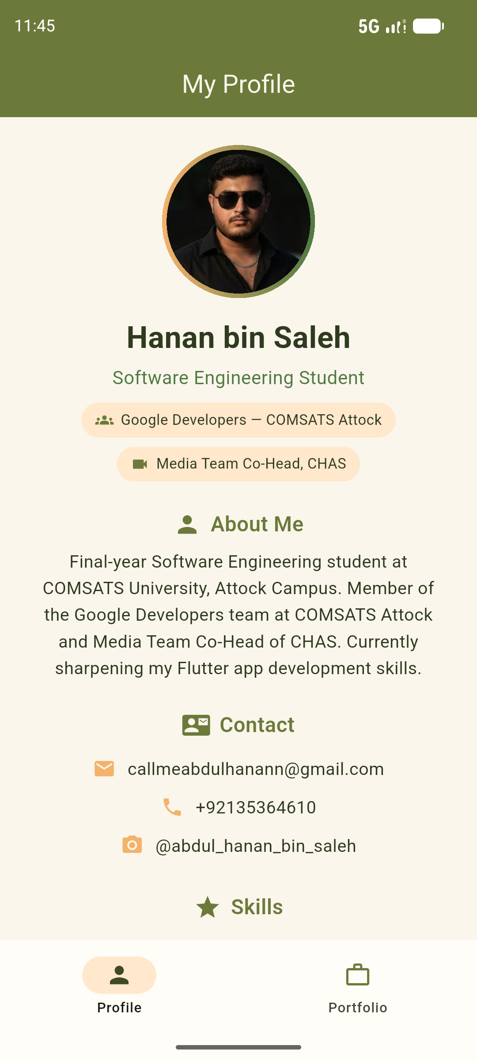  Figure 1: Profile screen | 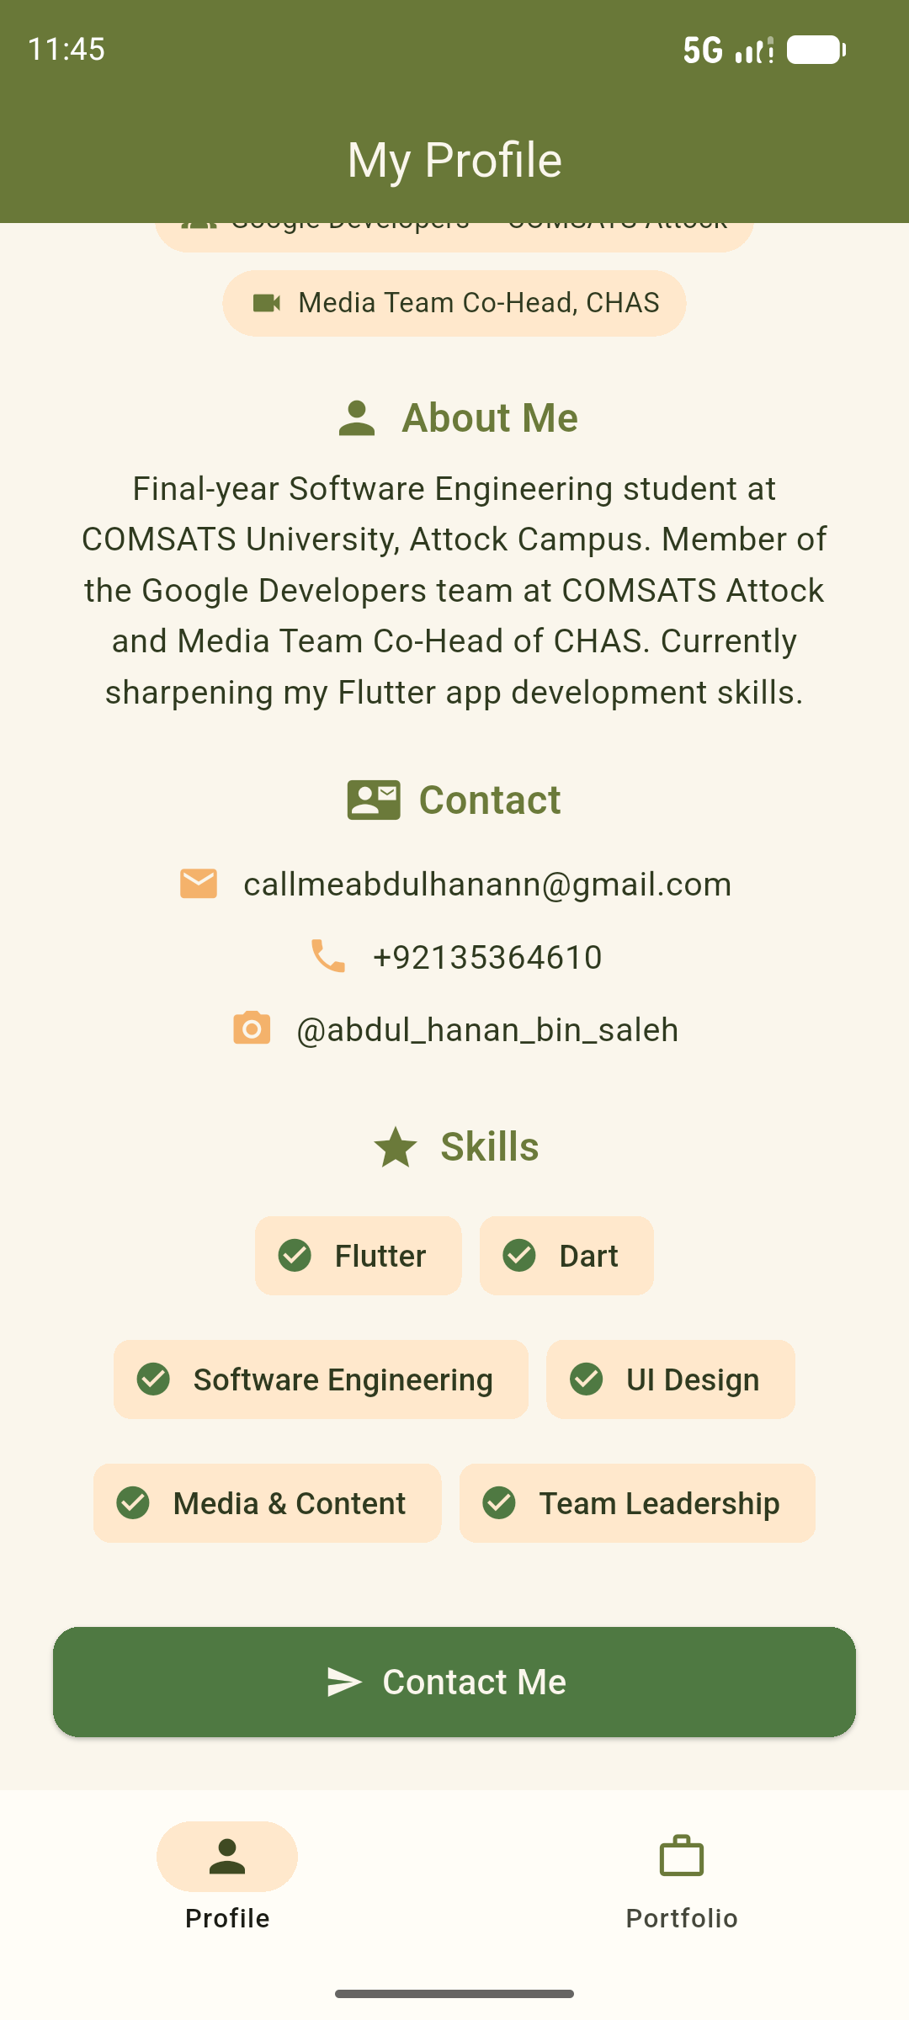  Figure 2: Contact and Skills | 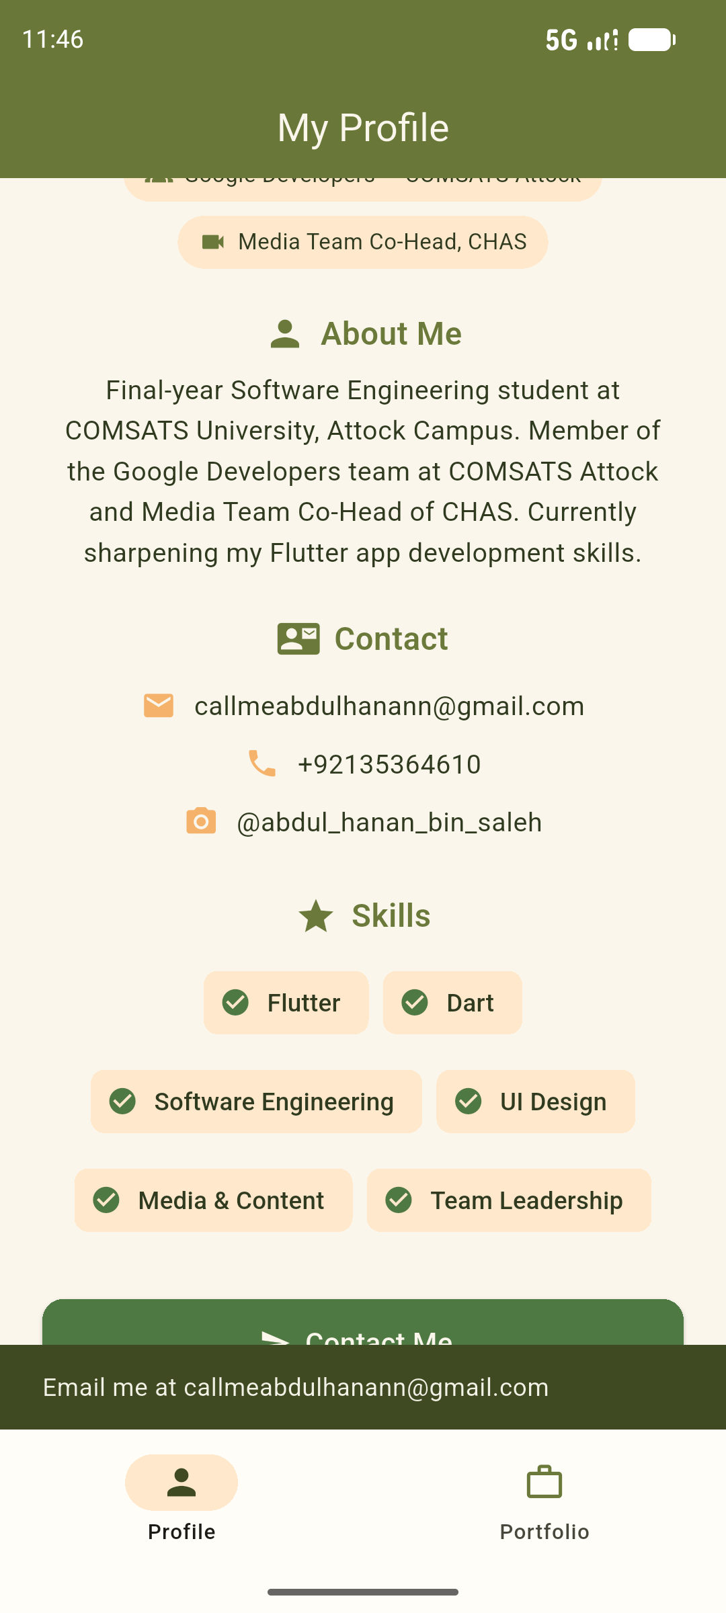  Figure 3: SnackBar on Contact Me

3. Task 2: Profile / Portfolio UI
This screen has a gradient header with my picture, name and profession, then About Me, Roles and Skills cards, and a Contact button that opens a bottom sheet with my contact details. The required widgets are used as follows:
Widget | How I used it
Column | Main layout of the screen and the inside of every card.
Row | Header highlights, and each skill and role item (icon with text).
Container | Gradient header, ring around the photo and boxes behind icons.
Card | About Me, Roles and Skills sections.
Padding | Spacing around and inside the cards and the button.

Output Screenshots
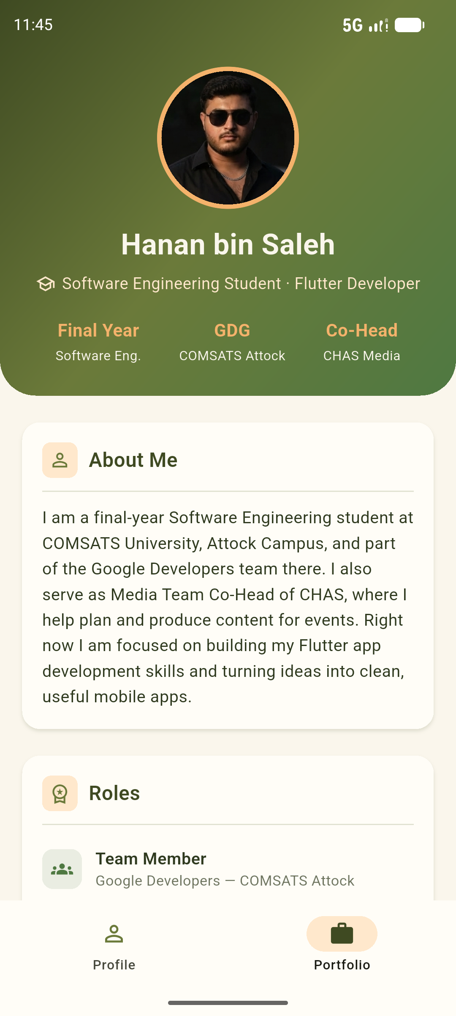  Figure 4: Portfolio header | 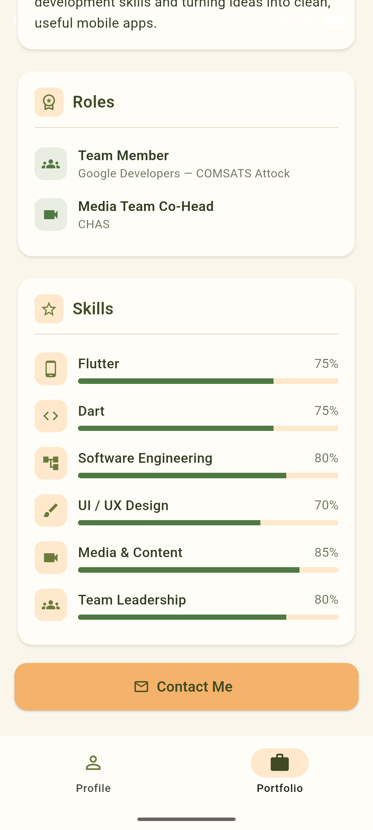  Figure 5: Roles and Skills | 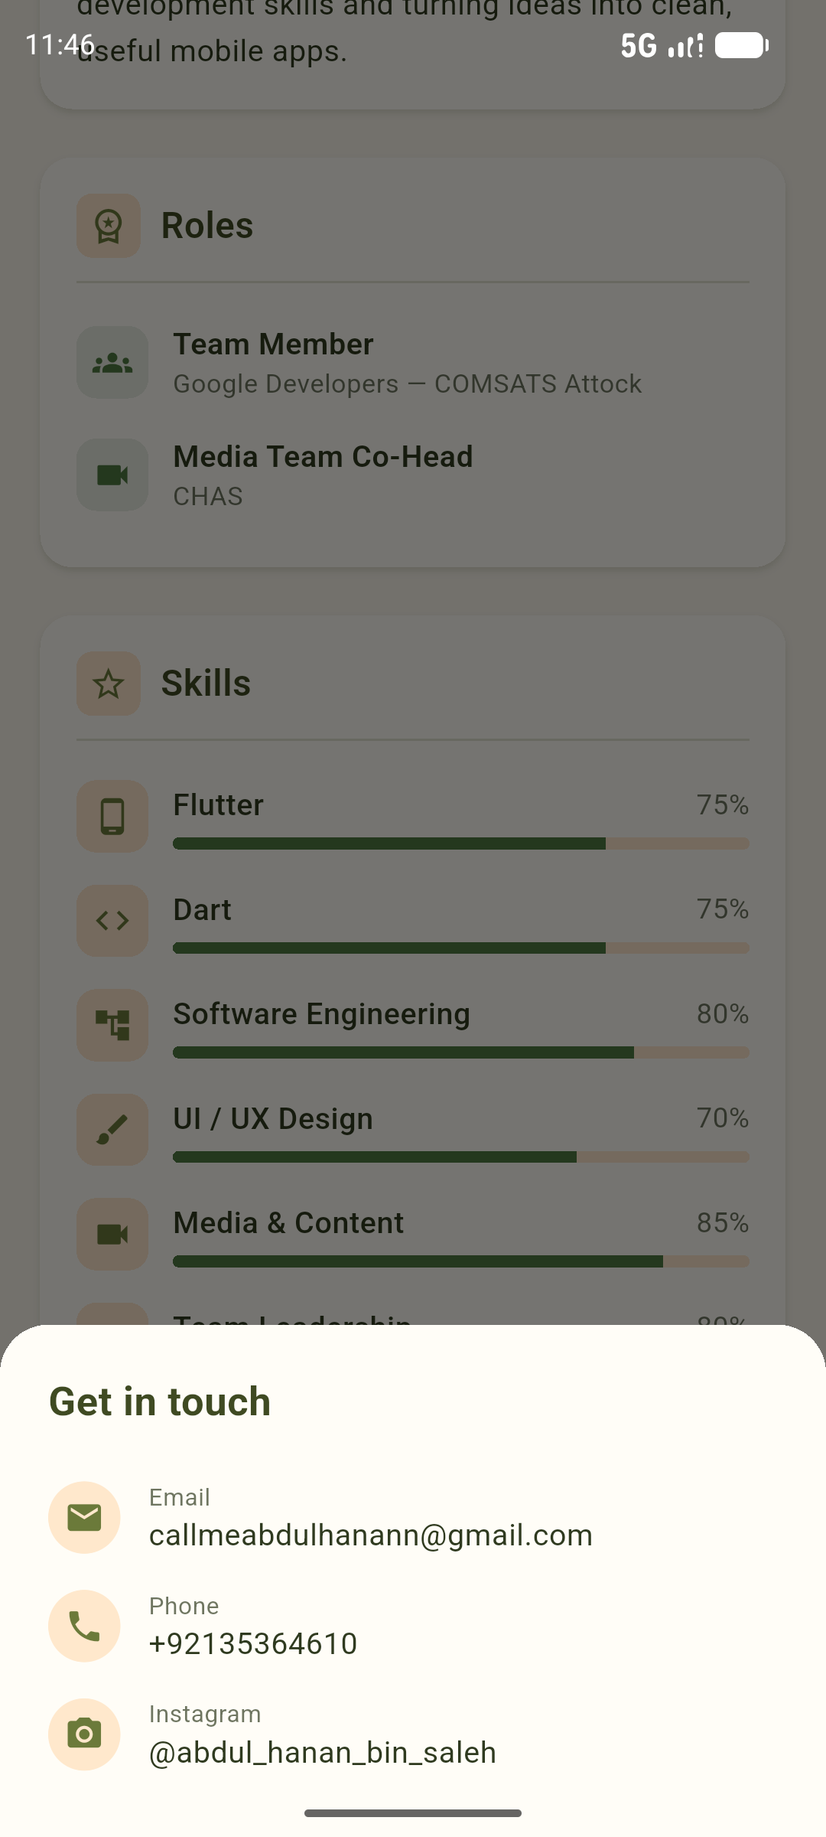  Figure 6: Contact bottom sheet

4. Conclusion
Through this task I learned how to build a complete screen in Flutter using basic layout widgets, add an image from assets, apply a custom colour theme, and use a SnackBar and a bottom sheet. Both screens ran successfully on the Android emulator.

