Post接口,参数直接跟在路径后面
localhost:8070/salePriceGet?uuid=8053f5c6-50fb-44c0-9496-c10eb9d9c376
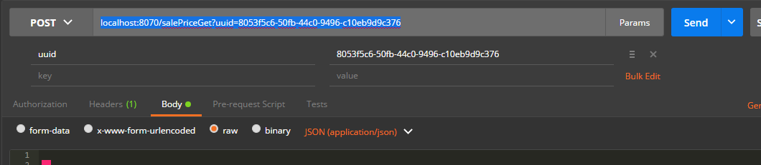
参数解释
uuid，就是 /d/dangqianyeData 接口中返回的那个id,是prdt_samp表的唯一键
返回结果放在了 objs:[] 数组中,objs为空的时候是[],其他为空的时候是null,
"objs"：[
{“updefBuyStr”:{ },” updefSaleStr”:{ } }, -----该对象就是页面的一行数据
{ “updefBuyStr”:{ },” updefSaleStr”:{ } },
“null”
]

{“updefBuyStr”:{ },” updefSaleStr”:{ } },
直接表示在页面的一行的采购和销售结果,里面的字段可以直接拿来用
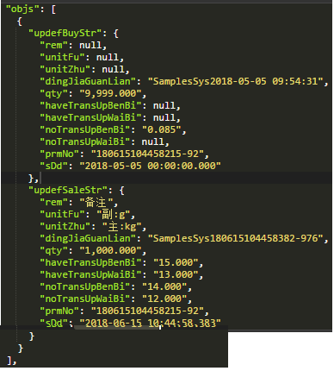
{
"data": null,
"status": "1",
"xiaoHaoShiJian": "",
"msg": "《成功》",
"chMsg": "",
"otherMsg": "",
"token": "",
"tenantId": "",
"tenantName": "",
"userEmail": "",
"notExsitThisPrdtNoInPrdtTab": "",
"weiNengChaRuHuoZheChaRuShiBaiDeSuoYouDingDanHao": "",
"objs": [
{
"updefBuyStr": {
"rem": null, ---备注
"unitFu": null, --副单位
"unitZhu": null, ---主单位
"dingJiaGuanLian": "SamplesSys2018-05-05 09:54:31", ---采购1到4组数据关联字段(前端看情况传给后端)
"qty": "9,999.000", ---数量
"haveTransUpBenBi": null, --有运费本币
"haveTransUpWaiBi": null, --有运费美元
"noTransUpBenBi": "0.085", ---无运费本币
"noTransUpWaiBi": null, ---无运费美元
"prmNo": "180615104458215-92", ---采购销售关联字段,(前端不用)
"sDd": "2018-05-05 00:00:00.000" --- 定价时间
},
"updefSaleStr": {
"rem": "备注",
"unitFu": "副:g",
"unitZhu": "主:kg",
"dingJiaGuanLian": "SamplesSys180615104458382-976",
"qty": "1,000.000",
"haveTransUpBenBi": "15.000",
"haveTransUpWaiBi": "13.000",
"noTransUpBenBi": "14.000",
"noTransUpWaiBi": "12.000",
"prmNo": "180615104458215-92",
"sDd": "2018-06-15 10:44:58.383"
}
}
],
"auth": {
"logistics": {
"salesorder": {
"page": "F"
},
"salesorderForSAP": {
"page": "F"
},
"salesDetail": {
"page": "F"
},
"productCode": {
"page": "F"
},
"purchasePricing": {
"page": "F"
},
"salesPricing": {
"page": "F",
"part": {
"purchasePrice": "F",
"salesPrice": "F"
}
},
"sampleConfirm": {
"page": "F"
}
},
"ai": {
"picture": {
"page": "F"
},
"uploadImg": {
"page": "F"
}
}
}
}

