Problem 1

a.

The “BaggedTrees.m” function is the original one to calculate the final out-of-bag error. We output the out-of-bag error as a function of the number of bags using our function “BaggedTreesPlot.m”, which is designed to track the error as the number of bags increases.

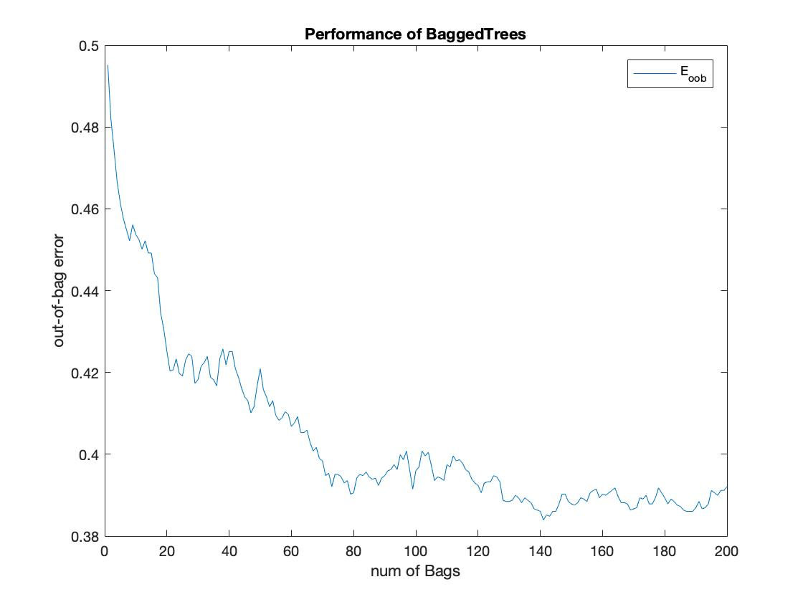

As the graph shows above, with the increasing of the number of the bags, the error decreases and the out-of-bag error for the whole ensemble of 200 trees is 0.3921. We could see that, with more trees in our ensemble, the performance will get improved.

b.

We run the provided code and get the results as following:

**One-vs-three problem:**

The cross-validation error of decision trees is 0.0072

The OOB error of 200 bagged decision trees is 0.3969

**Three-vs-five problem:**

The cross-validation error of decision trees is 0.0651

The OOB error of 200 bagged decision trees is 0.4683

As we could see, although the cross-validation error could be very small, the OBB error is relatively large. And the three-vs-five problem has larger errors than one-vs-three problem, which implies that the three-vs-five problem might be harder to learn with the same process.

c.

Now we learn a single decision tree model and a single ensemble of 200 trees and test their performance on the test data for one-vs-three and three-vs-five problems. We do the learning for 3 times and the results are showing below:

**One-vs-three problem:**

The test error of 1 tree is 0.4628

The test error of 200 trees is 0.3884

The test error of 1 tree is 0.4977

The test error of 200 trees is 0.3849

The test error of 1 tree is 0.5093

The test error of 200 trees is 0.3814

**Three-vs-five problem:**

The test error of 1 tree is 0.5000

The test error of 200 trees is 0.5015

The test error of 1 tree is 0.4755

The test error of 200 trees is 0.4877

The test error of 1 tree is 0.5706

The test error of 200 trees is 0.4785

We could see that for the one-vs-three problem, the learning becomes better with the increasing of the number of the trees. And the outcome is quite stable for several times. But for the three-vs-five problem, the learning with more tress is sometimes worse in some scenarios. But it doesn’t deviate very much, compared to the error of 1 tree. It may be because the number of trees we learn is not enough regarding to the complex of the three-vs-five problem. But the learning of more trees is a better way generally because it performs better when it’s better and perform not too worse when it’s worse.

4.

Generally speaking, the performance of the OOB error is getting better when we increase the bags. However, considering the specific problem, sometimes the performance with more trees will not get better, which is related to the total number of the trees we apply and the complex of the problem. But in all, the performance of learning with more trees is a stable way because it doesn’t give a very worse performance even if it doesn’t outperform the single-tree learning.