Analysis 1 iGluSnFR Analysis Pipeline for Paired Recordings at different [Ca2+]

Current version: 260517

1. Overview
This pipeline processes iGluSnFR image stacks acquired alongside WinWCP electrophysiology recordings. It runs in sequential stages, each writing its outputs into a dedicated folder so that any stage can be inspected or re-run independently.

Stage 0_1 is experiment-specific. Stages 0_3 and 1_1b were added for the paired Ca2+ recordings paradigm. All other stages are universal. Analysis_1_Results.mat will be used for Analysis 2 and beyond.

2. Software requirements
MATLAB R2020b or later (earlier versions may work but are untested)
Image Processing Toolbox
Parallel Computing Toolbox

3. Folder structure before you start
Set your MATLAB working directory to the root of the analysis folder (the folder containing pipeline_config.m). All paths in the scripts are relative to this location.

Required files and folders:
<analysis_root>/
pipeline_config.m ← edit this before running
run_pipeline.m ← runs all stages in sequence
Analysis_1_template.xlsx ← cell spreadsheet (see Section 4)
_paradigms/ ← paradigm definition files (see Section 5)
raw/ ← raw data
+A1_funs/ ← helper functions (do not modify)

Raw data layout: each cell has its own folder inside raw/. The folder name becomes the identifier used throughout the pipeline. Inside each cell folder, each imaging sweep/sub-sweep has its own subfolder containing the raw image stack (.tif) and WinWCP electrophysiology file(s) (.wcp).

For the VAMP experiments multi-part acquisitions, each run is split across several subfolders named <run_name>_1, <run_name>_2, etc. (up to 5 parts). The pipeline selects the latest version of each part automatically.

4. The template spreadsheet
All stages read experiment metadata from an Excel spreadsheet (default: Analysis_1_template.xlsx). Row 1 is the header — do not delete it. Each subsequent row describes one imaging run.

Column | Header | Description
1 | Cell number | Integer index identifying the cell. Used as the primary key into the Results_A1 struct in Stage 1_4. Multiple runs from the same cell share the same value here.
2 | Folder | Name of the cell folder inside raw/ (and all stage output folders).
3 | Run name | Name of the run subfolder inside the cell folder. Also used as the base filename for saved .mat and .tif files. Usually <ROI>_<run>_[Ca2+].
4 | Run index | Integer index of this run within the cell (e.g. 1, 2, 3…). Represents how many times the cell has been stimulated.
5 | ROI index | Index of the imaged area / field of view (if multiple FOVs were acquired for the same cell).
6 | Paradigm | Paradigm number corresponding to a file in _paradigms/. Use 0 if no alignment sub-sweeps are needed (Stage 0_2 will skip registration).
7 | Acquisition | 0 = 4 ms global shutter; 1 = 2 ms interleaving shutter. Determines which calculation module is used in Stage 1_4.

Additional columns (iGluSnFR variant, Construct, Background, Transfected, Data set, Rig, WCP format, etc.) may be present and are ignored by the pipeline scripts.

5. Paradigm files
Paradigm files define how the imaging acquisition is divided into sub-sweeps for motion correction (Stage 0_2) and baseline removal (Stage 1_1).
Location: _paradigms/par<N>.xlsx, where <N> matches the Paradigm column in the template.
Format: a single-column table where each row gives the number of frames in one sub-sweep. The rows are read in order and must sum to the total number of acquired frames.

Currently defined paradigms:
Number | Description | Total frames | Experiments
1 | 9× PPR, 1× 5 Hz train | 1700 | DKD and earlier
11 | 20× PPR, 5× 20 Hz trains | 6025 | EM
101 | 20× PPR, 1× 20 Hz 50-AP train, 5× recovery pulses | 8800 | VAMP2

To add a new paradigm, create _paradigms/par<N>.xlsx with the appropriate frame counts per sub-sweep.

6. How to run the pipeline
1. Open pipeline_config.m and set the three key fields, for example:
experiment = 'EM_825'; % 'EM_707', 'EM_825', or 'VAMP'
select_f = 2; % Excel row(s) to process
Analysis_template = 'Analysis_1_template.xlsx';

2. Set which stages to run (set to false to skip a stage already completed):
run_stage_0_1 = true;
run_stage_0_2 = true;
run_stage_0_3 = true;
run_stage_1_1 = true;
run_stage_1_1b = true;
run_stage_1_2 = true;
run_stage_1_4 = true;

3. Run run_pipeline.m

Analysis_0_1 Data organisation

Current version: 260517

Note: This part is different for different experiments
Input data structure:
Analysis_1_template.xlsx used to define which runs to analyse
All experimental data stored in raw/
Inside, data for each cell are in a unique folder
Subfolders – all images and WinWCP files, structure decided upon for each experiment

For EM_707 and EM_825, WCP files within each run folder are matched by filename pattern and concatenated in time order. The patterns expected are:
*_001.iGluSnFR_2ms_PPR_6025f_1.*.wcp
*_001.iGluSnFR_2ms_PPR_6025f_2*.wcp
*_001.iGluSnFR_2ms_train_6025f_3.*.wcp
Some recordings used an alternative pattern:
*_001.Prot1_10x_PPR_v2_5300f.*.wcp
*_001.Prot2_10x_PPR_v2.*.wcp
*_001.Prot3_20Hz_multiTrain.*.wcp

For VAMP, five sub-folders (<run_name>_1 through <run_name>_5) are stitched together. If a sub-folder has multiple versions (e.g. <run_name>_2_3), the latest version is selected automatically.

Channel assignments:
Channel in output (Y) | 707 rig source | 825 rig source
Column 1 — current (pA) | AI0 | AI0
Column 2 — command voltage | AI1 | AI1
Column 3 — camera exposure | AI3 | AI5
Column 4 — camera trigger | AI4 | AI3

Output data structure:
Outputs stored in Stage_1_organised/
Inside, data for each cell stored under same folder names
Inside the cell folder, ephys data stored under <run_name>.mat
Subfolders – individual runs
Each subfolder contains the concatenated image stack, named <run_name>.tif

Analysis_0_2 X-Y alignment of image stack

Current version: 260517
Input data structure:
Analysis_1_template.xlsx used to define which runs to analyse
Outputs of previous part stored in Stage_1_organised/
Paradigm information contained within folder _paradigms/

Output data structure:
Outputs stored in Stage_2_aligned/
Inside, data for each cell stored under same folder names
Inside the cell folder, ephys data stored under <run_name>.mat
Subfolders – individual runs
Each subfolder contains the aligned image stack, named aligned.tif
Also in the subfolder:
- aligned_averages.tif
- transforms.csv
- unaligned_averages.tif

Algorithm
- Average images of individual sub-sweeps Information taken from paradigm file
- Average of first sub-sweep used as anchor
- Sub-pixel transformations of other sub-sweeps w.r.t. anchor found using MATLAB function imregtform()
- Images translated using the MATLAB function imwarp(), which uses linear interpolation to deal with sub-pixel shifts
- Zero-padded border pixels are identified across the whole time series and the stack is cropped to the region valid in all frames.
- The ephys .mat file is copied forward to Stage_2_aligned/.
- If the Paradigm column is 0 for a run, alignment is skipped (the stack is copied through unchanged).
Parameters:
Parameter | Default | Description
optimizer.MaximumIterations | 300 | Registration convergence limit
optimizer.MaximumStepLength | 0.0625 | Largest step size
Gaussian blur for registration | σ = 2 px | Applied to sub-sweep means before registration to improve robustness

Analysis_0_3 Cross-run alignment
If the same ROI is recorded multiple times at different [Ca2+], this script registers the same ROI runs in 2D so they share a single coordinate frame.

Input data structure:
Analysis_1_template.xlsx
Output of previous part stored in Stage_2_aligned/

Output data structure:
In a new folder Stage_2b_cross_aligned with the same cell/run structure
aligned.tif cross-aligned, common coordinate frame image stack
transforms.csv X- and Y-shift, and NCC vs anchor

Algorithm
- Group runs in cell by ROI
- Load each run’s stack and compute whole-stack mean for each run
- First run is the anchor
- Register Gaussian-blurred mean to the anchor with same algorithm as Stage 0_2
- Crop all runs so they share same dimensions
- Groups with only one run are passed through without any editing
- Quality check of alignment via normalised cross correlation (NCC) to pick out any mislabelled runs.

Analysis_1_1 Max projection

Current version: 260517
Input data structure:
Analysis_1_template.xlsx used to define which runs to analyse
Outputs of previous part stored in Stage_2b_cross_aligned/
Paradigm information contained within folder _paradigms/

Output data structure:
In new folder Stage_3_A1 with same cell/run structure:
Img_filt.tif (optional)
Max_img_filt.tif
Cml_img_filt.tif (optional)
max_proj_unscaled.mat (See below)

Algorithm

Download image Original stack
Wiener filter 5 x 5
Median filter 3 x 3
Removing baselines Using SNIP algorithm
Smooth filter 3 points, binomial
A constant offset of +2000 is added before scaling to uint16 to prevent clipping at zero after baseline subtraction
Save filtered image Img_filt.tif
Save maximal projection Max_img_filt.tif
Save cumulative image Cml_img_filt.tif

The pre-scaling and forward transform of each scale16 call is saved in max_proj_unscaled.mat so they can be used in Stage 1_1b to put paired runs on a common deltaF scale before combining

Parameters:
Parameter | Variable | Default | Description
Wiener filter size | n | 5 | Window size (odd number ≥ 3)
Median filter size | m | 3 | Window size (odd number ≥ 3)
Binomial filter order | bi_order | 3 | Higher = smoother
Save full filtered stack | save_process | 'No' | Change to 'Yes' to save Img_filt.tif
Save cumulative max | save_process_cml | 'No' | Change to 'Yes' to save Cml_img_filt.tif

Analysis_1_1b Combined max projection

Input data structure:
Analysis_1_template.xlsx
max_proj_unscaled.mat (from previous output)

Output data structure:
Stage_3_A1/<cell_folder>/<run_name>/Max_img_combined.tif
Algorithm
- Group recordings taken at the same ROI and load each max_proj_unscaled.mat
- Invert each run’s Stage 1_1 forward transform
- Take pixel-wide maximum across all runs on this common scale
- Stretch histogram to take whole 16-bit image
- Write this result as Max_img_combined.tif, duplicated across all runs

Analysis_1_2 Active Bouton Detection

Input data structure:
Cross-aligned image stack in Stage_2b_cross_aligned/
Max_img_combined.tif in Stage_3_A1

Output data structure:
Stage_3_A1/<cell_folder>/<run_name>  Binary masks of detected boutons | mask.tif for all detected sites, boutons subfolder for individual
Bouton_metadata.csv | Metadata for each bouton, see below for description
Mean_traces.csv | Mean time trace for each detected site
Bouton_plots folder  Bouton_figs folder  Bouton_visualisation.tif | Contains png file for each mean time trace  Same as above but matlab figs  Image for visualisation of detected boutons. Also saved as matlab fig

Algorithm

- Download max projection
- Adaptive thresholding window: 15 x 15, threshold: 0.4
- Morphological cleaning — the mask is opened then closed with a disk structuring element (radius 2 px) to remove small speckles and fill gaps.
- Watershed separation — touching boutons are separated using a marker-controlled watershed. A combined image formed from the inverted intensity and the inverted distance transform (weighted 0.8 / 0.2). H-minima suppression (h: 0.02) prevents over-segmentation of noisy flat regions. The watershed ridge lines are applied as boundaries.
- Save masks
- Save bouton metadata
- Download original image stack
- Extract mean time traces and plots
- Creating bouton visualisation plot
- Label and extract — each connected component in the final mask is labelled, region properties are computed, and nearest-neighbour distances are calculated. The mean pixel intensity within each bouton mask is extracted for every frame of the aligned stack.

Note: bouton mask, metadata and visualisation will be same across all runs in each ROI group as they are done on the same combined max projection

Parameters:
Parameter | Variable | Default | Description
Threshold fraction | adaptive_threshold | 0.4 | Sensitivity of adaptive thresholding (0–1; increase to detect more boutons)
Threshold window | w | 15 | Neighbourhood size for adaptive threshold (pixels, odd)
Intensity/distance weight | weight | 0.8 | Balance between intensity and distance transform in the watershed input
H-minima depth | h | 0.02 | Minimum depth of a local minimum to be treated as a separate bouton; increase to merge more touching boutons

Bouton_metadata.csv

Col | Description
1 | Bouton number
2 | Area (pixels)
3 | Major axis (from fitting an ellipse to the shape of the mask)
4 | Minor axis
5 | Centroid – X coord
6 | Centroid – Y coord
7 | Nearest neighbour index (by minimum distance)
8 | Nearest neighbour distance (min dist)
9 | Nearest neighbour distance (centroid dist)

Analysis_1_2 a, optional Rings (used for analysing drift and crosstalk)

Note: not implemented yet in new data structure
Note: this code is quite slow in comparison to the previous modules. Be prepared to wait!

Input data structure:
Original image stack
Bouton masks from Analysis_1_2

Output data structure:
Mean_traces_plus_rings.mat 3d matrix storing mean trace + rings
Dimensions: 1: time, 2: ring number, 3: bouton number
Crosstalk folder Stores plots

Algorithm
Download masks and original stack
Extract mean trace
Dilate mask by increasing number of pixels
Extract trace for each dilation No. of rings can be specified
Plotting and saving data

Analysis_1_3 WCP to MatLab

Defunct. Migrated to Analysis_0_1 data organisation

Analysis_1_4 Merging data

Note: calculation unit modules placed in same directory
Note: calculation unit modules different for old vs new data. See below for description
Note: Ca paradigm only uses new calculation unit module, but the old description is also included here for completeness

Input data structure:
Analysis_1_template.xlsx used to define which boutons to analyse
Standard folder structure in Stage_3_A1/
Cell\Run
In each run
Mean_traces.csv
Bouton_metadata.csv
Mean_traces_plus_rings.mat Code will detect whether this is present
Stage_3_A1/<folder>/<run_name>.mat Ephys data for frame and AP timing

Output data structure:
Analysis_1_Results.mat

Each element corresponds to one cell (indexed by the Cell number column). Within each element:
Folder Cell folder name
Run_name Run name(s) for this cell
Run_index Run index number(s)
Imaged_area_index ROI index
Paradigm Paradigm number
Acquisition Acquisition mode
Frame_data
AP_data
Bouton_metadata
Bouton
Bouton_rings
See below complete description

Algorithm (FOR OLD DATA)

AP detection works only for escape currents in voltage clamp mode. The algorithm uses command pulse to look for AP peaks and therefore cannot detect any spontaneous firing (which is not applicable for voltage clamp recordings).

voltage_threshold_fraction=0.3; % fraction value of min of V trace to determine true AP and avoid capacitance transient

Istep_duration_scale=3; % scaling factor - how long after the current step for identifying peaks

See below figures for more details

Frame_data

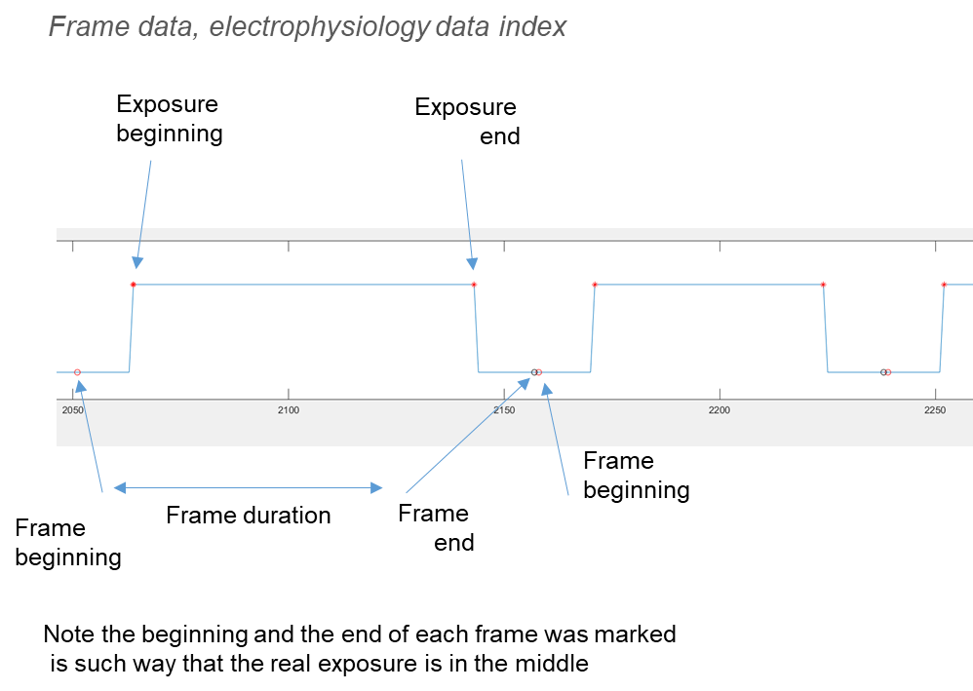

Results_A1(cell).Frame_data.data{1, 1}
Col | Description
1 | Frame index
2 | Frame period beginning, electrophysiology data index
3 | Frame period end, electrophysiology data index
4 | Frame period duration, electrophysiology data index
5 | Frame period beginning, s
6 | Frame period end, s
7 | Frame period duration, s
Note: columns 8–11 (t1, t2) are not present for old global-shutter acquisition data (Acquisition = 0).

Results_A1(cell).Frame_data.data{1, 2}
Mean frame period (seconds)

AP_data

Results_A1(cell).AP_data.data{1, 1}
Col | Description
1 | AP index
2 | Frame where AP belongs
3 | AP peak, electrophysiology data index
4 | AP peak, s
5 | AP amplitude, pA
6 | True frame (shifted by −1 when the number of processed imaging frames differs from the electrophysiology frame count — this occurs in some experiments where the first frame was removed during acquisition). Always use this column in downstream analysis.

Bouton_metadata

Same as bouton_metadata.csv

Bouton

Results_A1(cell).Bouton.data

Col | Description
1 | Frame index from image corrected (may contain -1 frame in comparison to electrophysiology frame readout)
2 + | Mean fluorescence intensity for each selected ROI

Bouton_rings (if exists)

Same as Mean_traces_plus_rings.mat

Algorithm (FOR NEW DATA)

For interleafing acquisition. Need to consider camera trigger as well as camera exposure in ephys data.

Frame_data

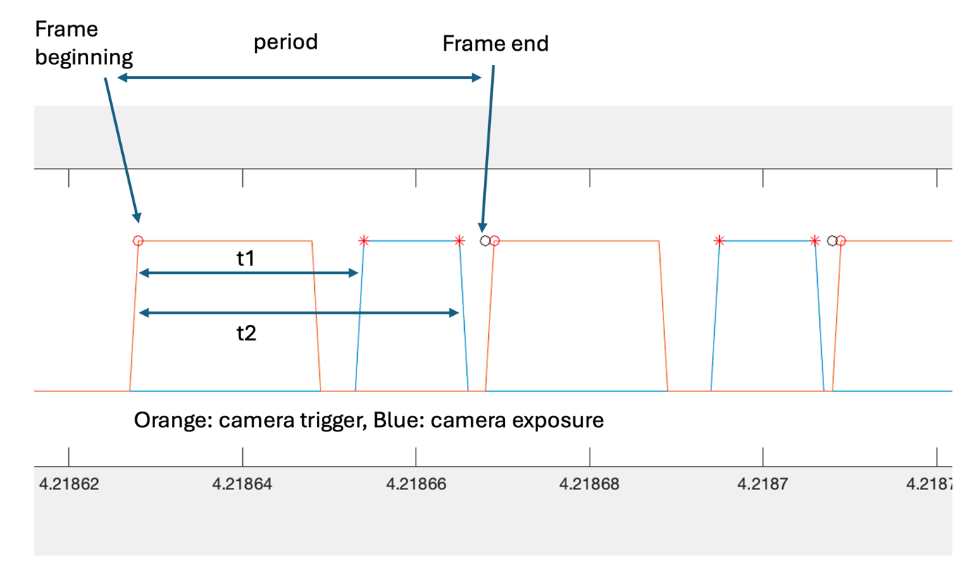

Frame beginning and end defined for the first row of acquisition only
t1, t2 and period required to determine positions of APs on subsequent rows in Analysis 2

Results_A1(cell).Frame_data.data{1, 1}
Col | Description
1 | Frame index
2 | Frame period beginning, electrophysiology data index
3 | Frame period end, electrophysiology data index
4 | Frame period duration, electrophysiology data index
5 | Frame period beginning, s
6 | Frame period end, s
7 | Frame period duration, s
8 | t1, electrophysiology data index
9 | t2, electrophysiology data index
10 | t1, s
11 | t2, s

Results_A1(cell).Frame_data.data{1, j}, j > 1
j | Description
2 | Mean period, s
3 | Mean t1, s
4 | Mean t2, s

AP_data
As before

Bouton_metadata
As before

Bouton
As before

Bouton_rings (if exists)
As before

12. Output file reference
Summary of all files produced across stages:

Highlighted rows are new for the Ca paradigm.

File | Stage | Location
<run_name>.mat | 0_1 | Stage_1_organised/<folder>/
<run_name>.tif | 0_1 | Stage_1_organised/<folder>/<run_name>/
aligned.tif | 0_2 | Stage_2_aligned/<folder>/<run_name>/
aligned_averages.tif | 0_2 | Stage_2_aligned/<folder>/<run_name>/
unaligned_averages.tif | 0_2 | Stage_2_aligned/<folder>/<run_name>/
transforms.csv | 0_2 | Stage_2_aligned/<folder>/<run_name>/
aligned.tif | 0_3 | Stage_2b_cross_aligned/<folder>/<run_name>/
transforms.csv | 0_3 | Stage_2b_cross_aligned/<folder>/<run_name>/
Max_img_filt.tif | 1_1 | Stage_3_A1/<folder>/<run_name>/
max_proj_unscaled.mat | 1_1 | Stage_3_A1/<folder>/<run_name>/
Max_img_combined.tif | 1_1b | Stage_3_A1/<folder>/<run_name>/
mask.tif | 1_2 | Stage_3_A1/<folder>/<run_name>/
bouton_metadata.csv | 1_2 | Stage_3_A1/<folder>/<run_name>/
mean_traces.csv | 1_2 | Stage_3_A1/<folder>/<run_name>/
bouton_visualisation.tif | 1_2 | Stage_3_A1/<folder>/<run_name>/
Analysis_1_Results.mat | 1_4 | Analysis root folder

