**Why do you want work here? Why did you apply for this position?**

The [name of company] reputation is certainly a factor.

[what the company do: products/services, *Company culture and values*

] I would be proud to work for a company with such impressive innovations in the industry.

And I'm also confident that my experience in [tech experience] makes me an excellent match for the job requirements. Also, the role excites me because

**what is my experience**

**Describe your past roles**

**what advice would you give a young dev to succeed**

**what programming languages I know**

**How do you handle conflict?**

**Tell me about a team project when you had to work with someone difficult.  
Tell me about a time you had a conflict at work.  
Give an example of a time you had to respond to an unhappy manager/customer/colleague.  
Tell me about a time that you disagreed with a rule or approach.**

specify dealing with conflict on a specific work related project or how you handle conflict with another person?

*answer in the****STAR****format by* SPECIFIC example *:*

* ***Situation/Task****- What was the situation or task in which conflict occurred*
* ***Action****- When the conflict did occur, what action did you take in order to resolve that conflict*
* ***Result****- After you took action what was the result, was it positive or negative?*

**Tell Me About Your Proudest Achievement**

**What was the challenging situation faced in your company?**

Some variations include: “What are you most proud of?”, “What were your biggest wins in your most recent role?,” “Tell me about a time when you went above and beyond the call of duty.”

* *Talk about skills that are most relevant to the job that you are interviewing for.*
* *Bring up skills that you had to use to reach that achievement like hard work, persistence, communication skills or networking.*
* *Mention coworkers that helped you achieve success. This will show the hiring manager that you are a team player.*
* *Explain what made this moment a proud one for you. Was there an award, promotion or other outcome that screamed achievement to you*

Make sure that whatever story you choose to tell highlights skills, experiences and qualifications that make you right for the job.

**Your weakness?**

*make sure the one you select is not critical to the job, and mention in your interview the ways you plan to improve upon this weakness.*

# **What Are Your Greatest Strengths?**

**What are your salary expectations?**

The average salary for this position in this area for a professional with my level of experience is between $110,000 and $115,000, so that would be my salary expectation for this role.

I am open to negotiate salary depending on benefits, bonuses, equity, stock options and other opportunities.

**One draw back about your current company.**

What do you like to do on your spare time?

What type of position are you looking for?

What are the biggest challenges you faced?

Why our company?

Tell me about a project you have done and what was challenging about it

What are the qualities that make a good supervisor?

Tell us about a time you went above and beyond your employers expectations.

Where do you see yourself in 5 years/ what are your future ambitions

Explain a moment when you exceed expectations

Tell me something about yourself

Describe your most recent web application

What I do to keep up with the latest technologies?

What is your weakness?

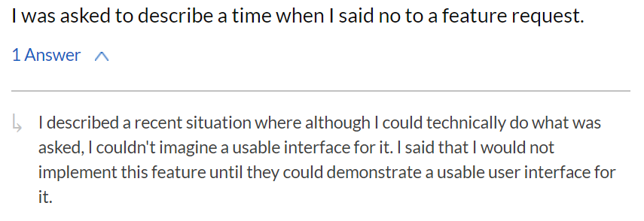

Why are looking to leave your current employer

For HR part; they asked me about the preferred work environment for me? and if I prefer to work as team member or team leader.

Why should we hire you?

Tell us about a project in depth, like as if you are handing it off to us to continue working on it?

Architecture of current project

Why did you apply for this position?

One major challenge that I faced at work and how did I resolve it..

the way that I would approach a situation

What was the most challenging work that you did at your previous workplace? Please explain in details.

What are your career goals and what are you hoping to get out of working at Street Contxt?

Show me a piece of code you are most proud of

Tell me about any problems faced and how did you solved it?

How would you handle dealing with a difficult coworker?

What are you biggest strengths and weaknesses?

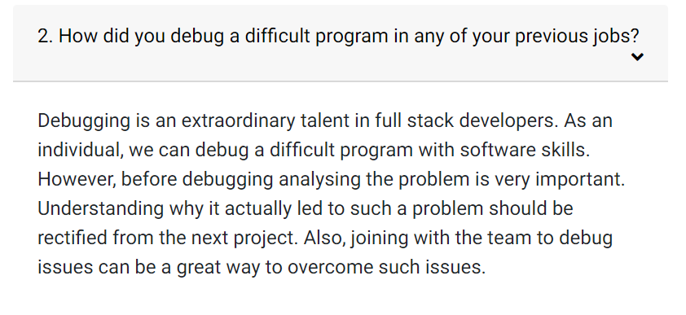

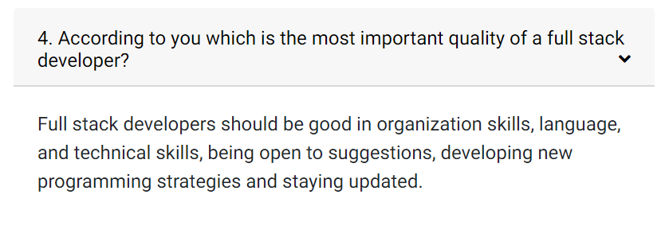

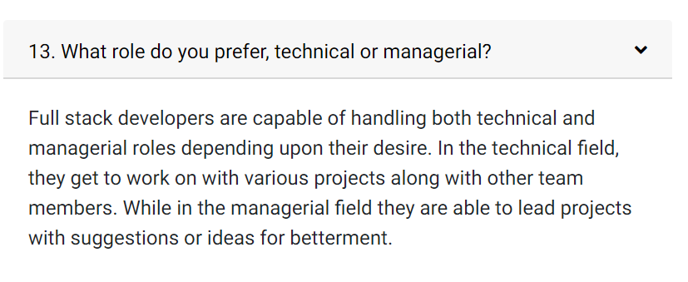

**1. What is the most essential programming language for your job?**

Candidates should list a variety of languages they find important to the job, not just one. Look for candidates who list the benefits and limitations of each language as it applies to their work.

**2. What coding projects are you currently working on?**

Good programmers are always coding, whether it be at work or for recreational reasons. Look for candidates who find creative uses for code outside of their work, as this is indicative of a highly skilled programmer.

**3. What, in your opinion, is the most important quality in a Full Stack Developer?**

Candidates should list good organization skills and attention to detail as the most important qualities in a Full Stack Developer.

**4. How do you stay abreast of developments in the technology industry?**

Candidates should list learning and practicing new languages, reading programming blogs and attending conferences as their means of staying informed.

**5. Describe a time when you made a mistake in your duties. How did you rectify it?**

Candidates should acknowledge the significance of diligence and how programming oversight can derail an entire company's business operations. Look for stories where candidates erred, rectified their error and learned a valuable lesson from it.

### 1. What is your favourite language and why?

**Ans:** Full Stack Web Developers work with a multitude of languages. Having just one loved coding language might be an alarm signal. Ideally, a candidate must have a few languages that he loves, preferably, some with which he can design the front end and others with which he can take care of the back end. A candidate should be able to demonstrate that well and remember to include the basic most used ones like HTML, CSS, Python etc.

### 2. How do you keep yourself updated about the new trends in the industry?

**Ans:**This is a typical question to understand your involvement in technology. A good way to demonstrate your involvement in continuous learning would be by speaking about the community meetups you visit. You can also talk about the webinars and the forums you regularly attend. If you have personal projects on which you apply your skills, this is a good time to showcase that as well.

### 3. What’s the most recent thing that you have learned?

**Ans:**This question is used to probe the authenticity of the information you furnished in your last question. It is important that you are aware of the latest in the industry and have a pulse of what’s happening. You might talk about a website that you tested recently, or talk about an obnoxious case study about a serious bug you recently read about. A point to note, never give the interviewer an impression that you have learned nothing in the past 6 months. This is a fast-changing tech game, and being up-to-date with the current trends is an absolute must.

### 4. What are the most important qualities that a Full Stack Developer must have?

**Ans:**A full stack web developer interview will surely be incomplete without this question, especially at a freshers level. A candidate should take time to talk about the competency required in various coding language being the foundation stone on which a good professional can be built. He should talk about coordination skills that he would need while working in a team and mark excellent observation skills as a prime factor in working well in this role.

### 5. Which technologies and languages would you need to develop a project from scratch?

**Ans:**This is a hypothetical question geared at understanding the level at which the hiring manager will gauge your readiness to start the job. It is an easy way to distinguish a good full stack developer from someone who is an amateur. People who have difficulty transmitting their thoughts will have bleak chances of getting through at this point.

## Full Stack Web Developer Interview Questions for Experienced

The difficulty level of web developer technical interview questions will not be the same as that of web developer job interview questions and answers for a newbie. The experienced professional has to show more expertise, achievements, and clarity of thought. It is ideal that an experienced full stack web developer would be asked to work on a small demonstrative project as well. It is common to ask the following full stack web developer interview questions for experienced professionals.

### 1. Give an example of a project you have worked on and the technologies involved. How did you make these choices?

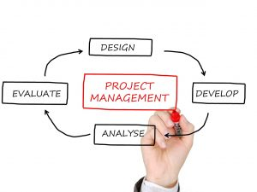

Project Management

**Ans:**This helps in knowing the methodology of the full stack web developer and also gives an idea of his sharpness and precision in choosing the right toolset. You need to be as specific as possible and go in depth while speaking about the reason of choosing a particular toolset. Show a balance between your ability to develop both on the front-end and the back-end of the web application. It is okay to show that you have more experience in one side of the development game than the other but to demonstrate that you have the ability to work on both the ends of the application.

### 2. Can you relate of an experience when you found your colleagues code to be inefficient? How did you deal with it?

**Ans:**This helps to determine a candidate’s quality standards and also gives an impression of his team playing skills. You must demonstrate that you have high-quality assurance standards, and show comfort in pointing out flaws or for that matter bugs to others. However, you must pay focus on portraying that you are good at giving positive feedback, getting the work done without creating resentment.

### 4. What is the best implementation or debugging you have done in the past?

**Ans:**This is a tricky question. This will actually give the hiring manager an idea of both the complexity and the style of projects you have done in the past. You should explicitly mention the issues you faced and the measures you took to overcome that roadblock. You can additionally speak about the learnings you earned from the issue.

### 5. Do you enjoy management or execution more?

**Ans:**Every senior professional will be asked this full stack web developer interview question. Recruiters want to know if you want to stay in a technical role or would want to switch to a managerial position. They also at times might push a bit and ask if you prefer to work alone or in paired groups. It’s important, to be honest here. The company’s requirements might be different from your interests, so it is ideal that the expectations are set straight from the get-go.

### 3. What is the biggest mistake you did in any of your projects? How did you rectify it?

**Ans:**As they say, ‘No man is an island’. Similarly, you can’t be working on technology and be right all the time. That is not imaginable. You need to be honest here and talk about a mistake that you think was serious. To add to it, speak about your learnings from this mistake and explain the procedure you adopted to minimize the damage done.