<https://www.javainuse.com/misc/elasticintvw>

**Q: What is ElasticSearch ?  
A:**Elasticsearch is a search engine based on Lucene. It provides a distributed, multitenant-capable full-text search engine with an HTTP web interface and schema-free JSON documents. Elasticsearch is developed in Java and is released as open source under the terms of the Apache License.  
  
**Q: What are the basic operations you can perform on a document ?  
A:** The following operations can be performed on documents  
a. INDEXING A DOCUMENT USING ELASTICSEARCH.  
b. FETCHING DOCUMENTS USING ELASTICSEARCH.  
c. UPDATING DOCUMENTS USING ELASTICSEARCH.  
d. DELETING DOCUMENTS USING ELASTICSEARCH.  
[Perform basic operations with Elasticsearch.](https://www.javainuse.com/elasticsearch/elastichello)   
  
**Q: What is inverted index in Elasticsearch ?  
A:**Inverted index is the heart of search engines. The primary goal of a search engine is to provide speedy searches while finding the documents in which our search terms occur. Inverted index is a hashmap like data structure that directs users from a word to a document or a web page. It is the heart of search engines. Its main goal is to provide quick searches for finding data from millions of documents.  
Usually in Books we have inverted indexes as below. Based on the word we can thus find the page on which the word exists.

Consider the following statements

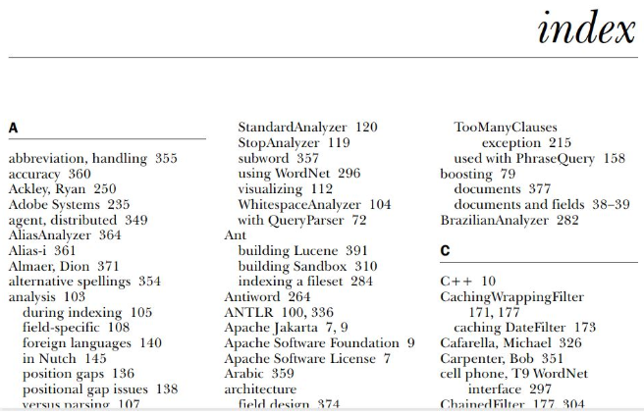

* javainuse is a good website
* javainuse is one of the good websites.

For indexing purpose the above text are tokenized into separate terms and all the unique terms are stored inside the index with information such as in which document this term appears and what is the term position in that document.  
So the inverted index for the document text will be as follows-

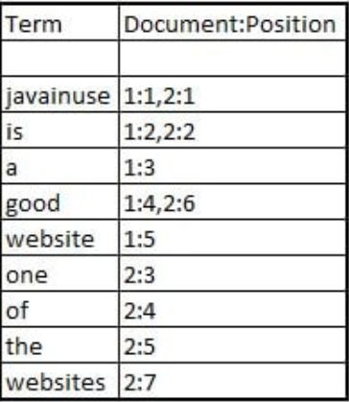

When you search for the term website OR websites, the query is executed against the inverted index and the terms are looked out for, and the documents where these terms appear are quickly identified.   
  
**Q: What is a cluster in ElasticSearch ?  
Q: What is a node in ElasticSearch ?  
Q: What is an index in ElasticSearch ?  
Q: What is a document in ElasticSearch ?  
Q: What is a type in ElasticSearch ?  
A:**Please refer-[Understanding Elasticsearch Cluster, Node, Index and Document using example.](https://www.javainuse.com/elasticsearch/elasticnode) 

* **Cluster** is a collection of one or more nodes (servers) that together holds your entire data and provides federated indexing and search capabilities across all nodes. A cluster is identified by a unique name which by default is "elasticsearch". This name is important because a node can only be part of a cluster if the node is set up to join the cluster by its name.
* **Node** is a single server that is part of the cluster. It stores the data and participates in the clusters indexing and search capabilities.
* **Index** is like a â€˜databaseâ€™ in a relational database. It has a mapping which defines multiple types. An index is a logical namespace which maps to one or more primary shards and can have zero or more replica shards.  
  MySQL => Databases  
  ElasticSearch => Indices
* **Document** is similar to a row in relational databases. The difference is that each document in an index can have a different structure (fields), but should have same data type for common fields.  
  MySQL => Databases => Tables => Columns/Rows  
  ElasticSearch => Indices => Types => Documents with Properties
* **Type** is a logical category/partition of index whose semantics is completely upto the user.

**Q: Does ElasticSearch have a schema ?  
A:** Yes, Elastic search can have a schema. A schema is a description of one or more fields that describes the document type and how to handle the different fields of a document. The schema in Elasticsearch is a mapping that describes the the fields in the JSON documents along with their data type, as well as how they should be indexed in the Lucene indexes that lie under the hood. Because of this, in Elasticsearch terms, we usually call this schema a â€œmappingâ€.  
Elasticsearch has the ability to be schema-less, which means that documents can be indexed without explicitly providing a schema. If you do not specify a mapping, Elasticsearch will by default generate one dynamically when detecting new fields in documents during indexing.

**Q: What is a shard in ElasticSearch ?  
A:**In most environments, each node runs on a separate box or virtual machine.

* index â€“ In Elasticsearch, an index is a collection of documents.
* **shard**â€“ Because Elasticsearch is a distributed search engine, an index is usually split into elements known as shards that are distributed across multiple nodes.

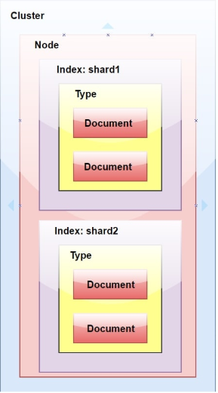  
  
**Q: What is a replica in ElasticSearch ? ?  
A:**An index is broken into shards in order to distribute them and scale. Replicas are copies of the shards. A node is a running instance of elastic search which belongs to a cluster. A cluster consists of one or more nodes which share the same cluster name.

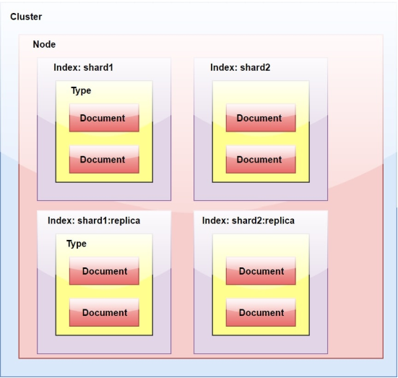

**Q: What is an Analyzer in ElasticSearch ?  
A:** While indexing data in ElasticSearch, data is transformed internally by the Analyzer defined for the index.   
Analyzers are composed of a single Tokenizer and zero or more TokenFilters. The tokenizer may be preceded by one or more CharFilters. The analysis module allows you to register Analyzers under logical names which can then be referenced either in mapping definitions or in certain APIs.  
Elasticsearch comes with a number of prebuilt analyzers which are ready to use. Alternatively, you can combine the built in character filters, tokenizers and token filters to create custom analyzers.   
  
**Q: What is a Tokenizer in ElasticSearch ?  
A:**Tokenizers are used to break a string down into a stream of terms or tokens. A simple tokenizer might split the string up into terms wherever it encounters whitespace or punctuation. Elasticsearch has a number of built in tokenizers which can be used to build custom analyzers.  
  
**Q: What is a Filter in ElasticSearch ?  
A:**After data is processed by Tokenizer, the same is processed by Filter, before indexing.

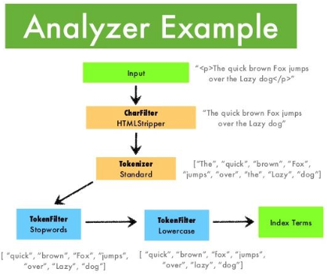  
  
**Q: What is the is use of attributes- enabled, index and store ?  
A:**

* The **enabled attribute** applies to various ElasticSearch specific/created fields such as _index and _size. User-supplied fields do not have an "enabled" attribute.
* **Store** means the data is stored by Lucene will return this data if asked. Stored fields are not necessarily searchable. By default, fields are not stored, but full source is. Since you want the defaults (which makes sense), simply do not set the store attribute.
* The **index** attribute is used for searching. Only indexed fields can be searched. The reason for the differentiation is that indexed fields are transformed during analysis, so you cannot retrieve the original data if it is required.

<https://www.educba.com/elasticsearch-interview-questions/>

### 1. What is Elasticsearch?

**Answers:**  
Elasticsearch is a search engine based on Apache Lucene that supports full-text search engine with scheme free [JSON](https://www.educba.com/course/json-training/) objects and HTTP web interface. This is s free and open source project developed in [Java](https://www.educba.com/course/online-java-script-training/) and licensed under Apache License terms. The key components of Elasticsearch are [Node](https://www.educba.com/course/node-js-training/), [Cluster](https://www.educba.com/cluster-analysis-vs-factor-analysis/), Index, Type, Document, Shard and Replicas. Elastic search has the capacity to perform a fast incisive search over large chunks of data.

Elasticsearch can be used to search different kinds of documents that provide scalable search, multi-tenancy, and [real-time](https://www.educba.com/real-time-analytics/) search. Elasticsearch is also available in [Amazon Cloud](https://www.educba.com/course/amazon-cloud-computing-hosting-asp-net-website-amazon-ec2/) as [Amazon Web Services](https://www.educba.com/course/amazon-web-services-aws-cloud-computing-training/) Elasticsearch Cloud. Elasticsearch is a distributed, RESTful search analytics engine that is capable of helping in solving numerous use cases for the business requirement in [big data](https://www.educba.com/big-data-vs-data-warehouse/) or [data science](https://www.educba.com/data-science-vs-software-engineering/) environment.

### 2. What is an index and inverted index in Elasticsearch?

**Answer:**  
Elasticsearch has a concept called index which is similar to that of a table in a relational [database structure](https://www.educba.com/course/data-structures-and-algorithms-in-java/). An index has mappings that define multiple types. An index maps one or more multiple shards and can have zero or many replica shards. Here Shard is an index which is split into multiple elements. Elasticsearch will have one replica for each index. The main reason for fast searching in elastic search is that index will be searched instead of content making it so faster.

The inverted index is an index which is used to make very fast full-text searches which is a key component. This is used to search and make a list of all unique words searched in all documents. To create the inverted index, first, the field of each document should be split into separate elements. In an inverted index, to store a mapping from content, words or numbers can be used in a database to its file location. The inverted index is a key component and structure of the elastic search to provide very fast full-text searches.

### 3. What is a document in Elasticsearch?

**Answer:**  
A document in elastic search is a top level or a root component object that is serialized into JSON object and will be stored in Elastic search under a unique id. The entities or objects in most of the applications can be serialized to [JSON](https://www.educba.com/course/web-service-parsing-json-api/) with keys and values where the key is the property or name of the field and value is the data present for that key such as String or Number or Boolean etc.,

Documents in elastic search are indexed and stored and will be available to search using the index. In the key-value pairs, the indexes can be generated using auto-generated id values. Inelastic search, document, and object are often interchangeable words. Mapping is the process to define a document, and the fields it contains which are stored and indexed. In a document, each index will have one mapping type that defines how mapping can be done and a document will be indexed. Each mapping type will have meta fields and fields, where meta fields can be used to customize the document’s metadata. Each field will have data types like Boolean, double, long, date or text etc.

### 4. What is a Node in Elasticsearch?

**Answer:**  
A node is an important component in an Elasticsearch which is needed before starting an instance of Elasticsearch. A group of nodes is called a cluster. If a single node of [Elasticsearch](https://www.educba.com/hadoop-vs-elasticsearch/)is running, then it is called a cluster of one node. In networking, the transport layer is used to establish communication between nodes of a cluster. Each and every node existing in a cluster can send client requests to each other and can establish communication with each other.

There are several types of nodes such as master node, data node, ingest node and tribe node. A Master node is a node that controls the entire cluster. A data node is a node that holds data in it and performs logical operations on the data. An ingest node is a node that can be used to ingest pipeline which means a series of processors to a document to perform some transformations before indexing the document. A tribe node is a node that performs some coordination to connect to multiple clusters across all the connected clusters and perform some logical operations or searches. By default, a node will always be a master node and a data node, but depending on the large requirements, node configurations should be carried out.

### 5. What is Schema in Elasticsearch?

**Answer:**  
A schema is a structure that describes multiple fields that provides the detailed overview of the document and its type and the way of handling the fields inside the document. The [schema](https://www.educba.com/course/xml-4/) is used for mapping in Elasticsearch which describes the fields in JSON documents with its data types. This process is called schema mapping in Elasticsearch. An Elasticsearch server usually contains zero or more indexes. An index contains multiple types which will have multiple documents in them. The other feature of elastic search is that it can also be schema-less by making the documents to be indexed without providing schema clearly.

If a mapping is not explicitly provided in elastic search, then a default mapping will be generated automatically while detecting fields during the process of indexing. This is the process of dynamic mapping generation. The mapping will be done in the form of JSON in elastic search and this will be the hierarchically structured format. Each level in the hierarchy will be having properties configuration to make it work flexibly as per requirement. This means each and every level and its child levels will be having each property set to the last level.

<https://www.onlineinterviewquestions.com/elasticsearch-interview-questions/>

* **Q1.**

### What is Elasticsearch?

Posted by [Sharad Jaiswal](https://www.onlineinterviewquestions.com/users/sharad-23836)

Elasticsearch is a search engine that is based on Lucene.It offers a distributed, multitenant – capable full-text search engine with as HTTP (Hyper Text Transfer Protocol) web interface and Schema-free [JSON](https://www.onlineinterviewquestions.com/json-interview-questions/)(JavaScript Object Notation) documents.It is developed in Java and is an open source released under Apache License.

[0](https://www.onlineinterviewquestions.com/what-is-elasticsearch/)

* **Q2.**

### What is a current stable version of Elasticsearch?

Posted by [Sharad Jaiswal](https://www.onlineinterviewquestions.com/users/sharad-23836)

As on March 2018, the version 6.2.2 is the latest and stable version of Elasticsearch.

[0](https://www.onlineinterviewquestions.com/what-is-a-current-stable-version-of-elas/)

* **Q3.**

### List the software requirements to install Elasticsearch?

Posted by [Sharad Jaiswal](https://www.onlineinterviewquestions.com/users/sharad-23836)

Since Elasticsearch is built using [Java](https://www.onlineinterviewquestions.com/java/), we require any of the following software to run Elasticsearch on our device.

* + The latest version of Java 8 series
  + Java version 1.8.0_131 is recommended.

[0](https://www.onlineinterviewquestions.com/list-the-software-requirements-to-instal/)

* **Q4.**

### How to start elastic search server?

Posted by [Sharad Jaiswal](https://www.onlineinterviewquestions.com/users/sharad-23836)

**Run Following command on your terminal to start Elasticsearch server:**

cd elasticsearch

./bin/elasticsearch

curl ‘http://localhost:9200/?pretty’ command is used to check ElasticSearch server is running or not.

[0](https://www.onlineinterviewquestions.com/how-to-start-elastic-search-server/)

* **Q5.**

### Can you list some companies that use Elasticsearch?

Posted by [Sharad Jaiswal](https://www.onlineinterviewquestions.com/users/sharad-23836)

**Some of the companies that use Elasticsearch along with Logstash and Kibana are:**

* + Wikipedia
  + Netflix
  + Accenture
  + Stack Overflow
  + Fujitsu
  + Tripwire
  + Medium
  + Swat.io
  + Hip chat
  + IFTTT

[0](https://www.onlineinterviewquestions.com/can-you-list-some-companies-that-use-ela/)

* **Q6.**

### What is a Cluster in Elasticsearch?

Posted by [Sharad Jaiswal](https://www.onlineinterviewquestions.com/users/sharad-23836)

It is a set or a collection of one or more than one nodes or servers that hold your complete data and offers federated indexing and search capabilities across all the nodes.It is identified by a different and unique name that is “Elasticsearch” by default.  
This name is considered to be important because a node can be a part of a cluster only if it is set up to join the cluster by its name.

[0](https://www.onlineinterviewquestions.com/what-is-a-cluster-in-elasticsearch/)

* **Q7.**

### What is a Node?

Posted by [Sharad Jaiswal](https://www.onlineinterviewquestions.com/users/sharad-23836)

Each and every instance of Elasticsearch is a node.And, a collection of multiple nodes which can work in harmony form an Elasticsearch cluster.

[0](https://www.onlineinterviewquestions.com/what-is-a-node/)

* **Q8.**

### What is an Index?

Posted by [Sharad Jaiswal](https://www.onlineinterviewquestions.com/users/sharad-23836)

An index in Elasticsearch is similar to a table in relational databases.The only difference lies in storing the actual values in the relational database, whereas that is optional in Elasticsearch.  
An index is capable of storing actual or analyzed values in an index.

[0](https://www.onlineinterviewquestions.com/what-is-an-index/)

* **Q9.**

### What is a type of Elastic search?

Posted by [Sharad Jaiswal](https://www.onlineinterviewquestions.com/users/sharad-23836)

A type in Elasticsearch is a logical category of the index whose semantics are completely up to the user.

[0](https://www.onlineinterviewquestions.com/what-is-a-type-of-elastic-search/)

* **Q10.**

### Please Explain Mapping?

Posted by [Sharad Jaiswal](https://www.onlineinterviewquestions.com/users/sharad-23836)

Mapping is a process which defines how a document is mapped to the search engine, searchable characteristics are included such as which fields are tokenized as well as searchable.  
In Elasticsearch an index created may contain documents of all “mapping types”.

[0](https://www.onlineinterviewquestions.com/please-explain-mapping/)

* **Q11.**

### What is Document?

Posted by [Sharad Jaiswal](https://www.onlineinterviewquestions.com/users/sharad-23836)

A document in Elasticsearch is similar to a row in relational databases.The only difference is that every document in an index can have a different structure or fields but having the same data type for common fields is mandatory.Each field with different data types can occur multiple times in a document.  
The fields can also contain other documents.

[0](https://www.onlineinterviewquestions.com/what-is-document/)

* **Q12.**

### What are SHARDS?

Posted by [Sharad Jaiswal](https://www.onlineinterviewquestions.com/users/sharad-23836)

There are resource limitations like RAM, vCPU etc., for scale out, due to which applications employ multiple instances of Elasticsearch on separate machines.  
Data in an index can be partitioned into multiple portions which are managed by a separate node or instance of Elasticsearch.Each such portion is called a Shard.And an Elasticsearch index has 5 shards by default.

[0](https://www.onlineinterviewquestions.com/what-are-shards/)

* **Q13.**

### What is REPLICAS?

Posted by [Sharad Jaiswal](https://www.onlineinterviewquestions.com/users/sharad-23836)

Each shard in elastic search has again two copies of the shard that are called the replicas.  
They serve the purpose of fault tolerance and high availability.

[0](https://www.onlineinterviewquestions.com/what-is-replicas/)

* **Q14.**

### How to add or create an index in Elastic Search Cluster?

Posted by [Sharad Jaiswal](https://www.onlineinterviewquestions.com/users/sharad-23836)

By using the command PUT before the index name, creates the index and if you want to add another index then use the command POST before the index name.  
**Ex:** PUT website

An index named computer is created

[0](https://www.onlineinterviewquestions.com/how-to-add-or-create-an-index-in-elastic/)

* **Q15.**

### How to delete an index in Elastic search?

Posted by [Sharad Jaiswal](https://www.onlineinterviewquestions.com/users/sharad-23836)

To delete an index in Elasticsearch use the command DELETE /index name.

**Ex:** DELETE /website

[0](https://www.onlineinterviewquestions.com/how-to-delete-an-index-in-elastic-search/)

* **Q16.**

### How to list all indexes of a Cluster in ES.?

Posted by [Sharad Jaiswal](https://www.onlineinterviewquestions.com/users/sharad-23836)

By using GET / _index name/ indices we can get the list of indices present in the cluster.

[0](https://www.onlineinterviewquestions.com/how-to-list-all-indexes-of-a-cluster-in/)

* **Q17.**

### How to add a Mapping in an Index?

Posted by [Sharad Jaiswal](https://www.onlineinterviewquestions.com/users/sharad-23836)

Basically, Elasticsearch will automatically create the mapping according to the data provided by the user in the request body. Its bulk functionality can be used to add more than one JSON object in the index.

**Ex:** POST website /_bulk

[0](https://www.onlineinterviewquestions.com/how-to-add-a-mapping-in-an-index/)

* **Q18.**

### How can you retrieve a document by ID in ES.?

Posted by [Sharad Jaiswal](https://www.onlineinterviewquestions.com/users/sharad-23836)

To retrieve a document in Elasticsearch, we use the GET verb followed by the _index, _type, _id.  
**Ex:** GET / computer / blog / 123?=pretty

[0](https://www.onlineinterviewquestions.com/how-can-you-retrieve-a-document-by-id-in/)

* **Q19.**

### How relevancy and scoring is done in Elasticsearch?

Posted by [Sharad Jaiswal](https://www.onlineinterviewquestions.com/users/sharad-23836)

The Boolean model is used by the Lucene to find the similar documents, and a formula called practical scoring function is used to calculate the relevance.  
This formula copies concepts from the inverse document/term-document frequency and the vector space model and adds the modern features like coordination factor, field length normalization as well.  
Score (q, d) is the relevance score of document “d” for query “q”.

[0](https://www.onlineinterviewquestions.com/how-relevancy-and-scoring-is-done-in-ela/)

* **Q20.**

### What are different ways of searching in Elasticsearch?

Posted by [Sharad Jaiswal](https://www.onlineinterviewquestions.com/users/sharad-23836)

We can perform the following searches in Elasticsearch:

* + **Multi-index, Multitype search:**All search APIs can be applied across all multiple indices with the support for the multi-index system.  
    We can search certain tags across all indices as well as all across all indices and all types.
  + **URI search:**A search request is executed purely using a URI by providing request parameters.
  + **Request body search:**A search request can be executed by a search DSL, that includes the query DSL within the body.

[0](https://www.onlineinterviewquestions.com/what-are-different-ways-of-searching-in/)

* **Q21.**

### List different types of queries supported by Elasticsearch?

Posted by [Sharad Jaiswal](https://www.onlineinterviewquestions.com/users/sharad-23836)

The Queries are divided into two types with multiple queries categorized under them.

* + **Full-text queries:** Match Query, Match phrase Query, Multi match Query, Match phrase prefix Query, common terms Query, Query string Query, simple Query String Query.
  + **Term level queries:** term Query, term set Query, terms Query, Range Query, Prefix Query, wildcard Query, regexp Query, fuzzy Query, exists Query, type Query, ids Query.

[0](https://www.onlineinterviewquestions.com/list-different-types-of-queries-supporte/)

* **Q22.**

### What is the difference between Term-based and Full-text queries?

Posted by [Sharad Jaiswal](https://www.onlineinterviewquestions.com/users/sharad-23836)

* + **Term-based Queries :**Queries like the term query or fuzzy query are the low-level queries that do not have analysis phase.A term Query for the term Foo searches for the exact term in the inverted index and calculates the IDF/TF relevance score for every document that has a term.
  + **Full-text Queries :**Queries like match query or query string queries are the high-level queries that understand that mapping of a field.As soon as the query assembles the complete list of items it executes the appropriate low-level query for every term, and finally combines their results to produce the relevance score of every document.

[0](https://www.onlineinterviewquestions.com/what-is-the-difference-between-term-base/)

* **Q23.**

### How does aggregation work in Elasticsearch?

Posted by [Sharad Jaiswal](https://www.onlineinterviewquestions.com/users/sharad-23836)

The aggregation framework provides aggregated data based on search query.It can be seen as a unit of work that builds analytic information over the set of documents.There are different types of aggregations with different purpose and outputs.

[0](https://www.onlineinterviewquestions.com/how-does-aggregation-work-in-elasticsear/)

* **Q24.**

### Where is Elasticsearch data stored?

Posted by [Sharad Jaiswal](https://www.onlineinterviewquestions.com/users/sharad-23836)

Elasticsearch is a distributed documented store with several directories.It can store and retrieve the complex data structures that are serialized as JSON documents in real time.

[0](https://www.onlineinterviewquestions.com/where-is-elasticsearch-data-stored/)

* **Q25.**

### Can Elasticsearch replace database?

Posted by [Sharad Jaiswal](https://www.onlineinterviewquestions.com/users/sharad-23836)

Yes, Elasticsearch can be used as a replacement for a database as the Elasticsearch is very powerful.  
It offers features like multitenancy, sharding and Replication, distribution and cloud Realtime get, Refresh, commit, versioning and re-indexing and many more, which make it an apt replacement of a database.

[0](https://www.onlineinterviewquestions.com/can-elasticsearch-replace-database/)

* **Q26.**

### How to check elastic search server is running?

Posted by [Sharad Jaiswal](https://www.onlineinterviewquestions.com/users/sharad-23836)

Generally, Elasticsearch uses the port range of 9200-9300.  
So, to check if it is running on your server just type the URL of the homepage followed by the port number.

**Ex:** mysitename.com:9200