<https://www.educative.io/courses/grokking-dynamic-programming-patterns-for-coding-interviews/RM1BDv71V60>

We'll cover the following

Introduction

Problem Statement

Basic Solution

Top-down Dynamic Programming with Memoization

Bottom-up Dynamic Programming

How to find the selected items?

Challenge

**Introduction**

Given the weights and profits of ‘N’ items, we are asked to put these items in a knapsack which has a capacity ‘C’. The goal is to get the maximum profit from the items in the knapsack. Each item can only be selected once, as we don’t have multiple quantities of any item.

Let’s take the example of Merry, who wants to carry some fruits in the knapsack to get maximum profit. Here are the weights and profits of the fruits:

**Items:** { Apple, Orange, Banana, Melon }  
**Weights:** { 2, 3, 1, 4 }  
**Profits:** { 4, 5, 3, 7 }  
**Knapsack capacity:** 5

Let’s try to put different combinations of fruits in the knapsack, such that their total weight is not more than 5:

Apple + Orange (total weight 5) => 9 profit  
Apple + Banana (total weight 3) => 7 profit  
Orange + Banana (total weight 4) => 8 profit  
Banana + Melon (total weight 5) => 10 profit

This shows that **Banana + Melon** is the best combination, as it gives us the maximum profit and the total weight does not exceed the capacity.

**Problem Statement**

Given two integer arrays to represent weights and profits of ‘N’ items, we need to find a subset of these items which will give us maximum profit such that their cumulative weight is not more than a given number ‘C’. Each item can only be selected once, which means either we put an item in the knapsack or we skip it.

**Basic Solution**

A basic brute-force solution could be to try all combinations of the given items (as we did above), allowing us to choose the one with maximum profit and a weight that doesn’t exceed ‘C’. Take the example of four items (A, B, C, and D), as shown in the diagram below. To try all the combinations, our algorithm will look like:

for each item 'i'

create a new set which INCLUDES item 'i' if the total weight does not exceed the capacity, and

recursively process the remaining capacity and items

create a new set WITHOUT item 'i', and recursively process the remaining items

return the set from the above two sets with higher profit

Here is a visual representation of our algorithm:

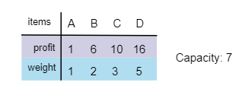

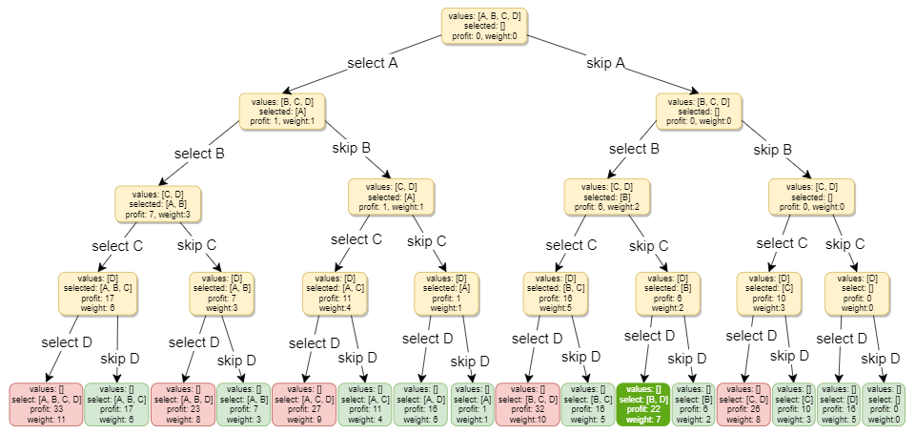

All green boxes have a total weight that is less than or equal to the capacity (7), and all the red ones have a weight that is more than 7. The best solution we have is with items [B, D] having a total profit of 22 and a total weight of 7.

#### Code

Here is the code for the brute-force solution:

class Knapsack {

public int solveKnapsack(int[] profits, int[] weights, int capacity) {

return this.knapsackRecursive(profits, weights, capacity, 0);

}

private int knapsackRecursive(int[] profits, int[] weights, int capacity, int currentIndex) {

// base checks

if (capacity <= 0 || currentIndex >= profits.length)

return 0;

// recursive call after choosing the element at the currentIndex

// if the weight of the element at currentIndex exceeds the capacity, we shouldn't process this

int profit1 = 0;

if( weights[currentIndex] <= capacity )

profit1 = profits[currentIndex] + knapsackRecursive(profits, weights,

capacity - weights[currentIndex], currentIndex + 1);

// recursive call after excluding the element at the currentIndex

int profit2 = knapsackRecursive(profits, weights, capacity, currentIndex + 1);

return Math.max(profit1, profit2);

}

public static void main(String[] args) {

Knapsack ks = new Knapsack();

int[] profits = {1, 6, 10, 16};

int[] weights = {1, 2, 3, 5};

int maxProfit = ks.solveKnapsack(profits, weights, 7);

System.out.println("Total knapsack profit ---> " + maxProfit);

maxProfit = ks.solveKnapsack(profits, weights, 6);

System.out.println("Total knapsack profit ---> " + maxProfit);

}

}

The time complexity of the above algorithm is exponential O(2^n), where ‘n’ represents the total number of items. This can also be confirmed from the above recursion tree. As we can see that we will have a total of ‘31’ recursive calls – calculated through (2^n) + (2^n) - 1, which is asymptotically equivalent to O(2^n).

The space complexity is O(n). This space will be used to store the recursion stack. Since our recursive algorithm works in a depth-first fashion, which means, we can’t have more than ‘n’ recursive calls on the call stack at any time.

Let’s visually draw the recursive calls to see if there are any overlapping sub-problems. As we can see, in each recursive call, profits and weights arrays remain constant, and only capacity and currentIndex change. For simplicity, let’s denote capacity with ‘c’ and currentIndex with ‘i’:

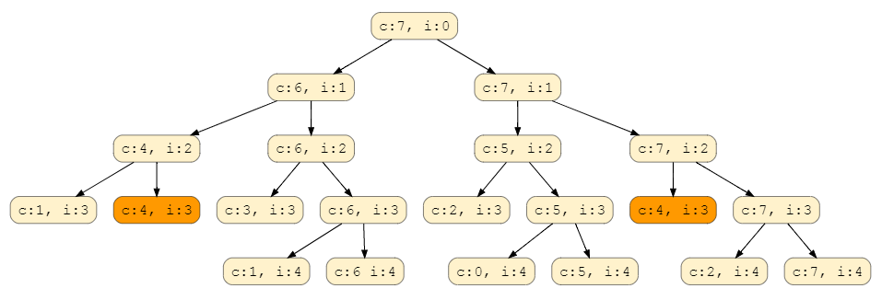

We can clearly see that **‘c:4, i=3’** has been called twice, hence we have an overlapping sub-problems pattern. As we discussed above, overlapping sub-problems can be solved through Memoization.

### Top-down Dynamic Programming with Memoization

We can use memoization to overcome the overlapping sub-problems. To reiterate, memoization is when we store the results of all the previously solved sub-problems and return the results from memory if we encounter a problem that has already been solved.

Since we have two changing values (capacity and currentIndex) in our recursive function knapsackRecursive(), we can use a two-dimensional array to store the results of all the solved sub-problems. As mentioned above, we need to store results for every sub-array (i.e. for every possible index ‘i’) and for every possible capacity ‘c’.

#### Code

Here is the code with memoization (see the changes in the highlighted lines):

class Knapsack {

public int solveKnapsack(int[] profits, int[] weights, int capacity) {

Integer[][] dp = new Integer[profits.length][capacity + 1];

return this.knapsackRecursive(dp, profits, weights, capacity, 0);

}

private int knapsackRecursive(Integer[][] dp, int[] profits, int[] weights, int capacity,

int currentIndex) {

// base checks

if (capacity <= 0 || currentIndex >= profits.length)

return 0;

// if we have already solved a similar problem, return the result from memory

if(dp[currentIndex][capacity] != null)

return dp[currentIndex][capacity];

// recursive call after choosing the element at the currentIndex

// if the weight of the element at currentIndex exceeds the capacity, we shouldn't process this

int profit1 = 0;

if( weights[currentIndex] <= capacity )

profit1 = profits[currentIndex] + knapsackRecursive(dp, profits, weights,

capacity - weights[currentIndex], currentIndex + 1);

// recursive call after excluding the element at the currentIndex

int profit2 = knapsackRecursive(dp, profits, weights, capacity, currentIndex + 1);

dp[currentIndex][capacity] = Math.max(profit1, profit2);

return dp[currentIndex][capacity];

}

public static void main(String[] args) {

Knapsack ks = new Knapsack();

int[] profits = {1, 6, 10, 16};

int[] weights = {1, 2, 3, 5};

int maxProfit = ks.solveKnapsack(profits, weights, 7);

System.out.println("Total knapsack profit ---> " + maxProfit);

maxProfit = ks.solveKnapsack(profits, weights, 6);

System.out.println("Total knapsack profit ---> " + maxProfit);

}

}

**What is the time and space complexity of the above solution?** Since our memoization array dp[profits.length][capacity+1] stores the results for all the subproblems, we can conclude that we will not have more than N*C subproblems (where ‘N’ is the number of items and ‘C’ is the knapsack capacity). This means that our time complexity will be O(N*C).

The above algorithm will be using O(N*C) space for the memoization array. Other than that we will use O(N) space for the recursion call-stack. So the total space complexity will be O(N*C + N)*,* which is asymptotically equivalent to O(N*C)

### Bottom-up Dynamic Programming

Let’s try to populate our dp[][] array from the above solution, working in a bottom-up fashion. Essentially, we want to find the maximum profit for every sub-array and for every possible capacity. **This means, dp[i][c] will represent the maximum knapsack profit for capacity ‘c’ calculated from the first ‘i’ items.**

So, for each item at index ‘i’ (0 <= i < items.length) and capacity ‘c’ (0 <= c <= capacity), we have two options:

1. Exclude the item at index ‘i’. In this case, we will take whatever profit we get from the sub-array excluding this item => dp[i-1][c]
2. Include the item at index ‘i’ if its weight is not more than the capacity. In this case, we include its profit plus whatever profit we get from the remaining capacity and from remaining items => profit[i] + dp[i-1][c-weight[i]]

Finally, our optimal solution will be maximum of the above two values:

dp[i][c] = max (dp[i-1][c], profit[i] + dp[i-1][c-weight[i]])

Let’s visually draw this and start with our base case of zero capacity:

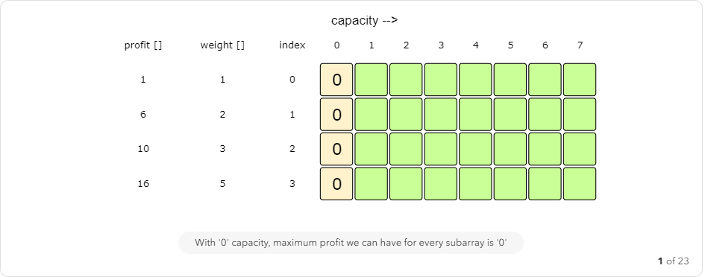

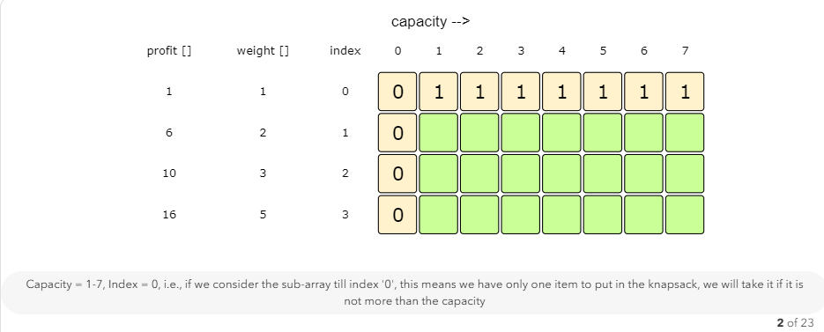

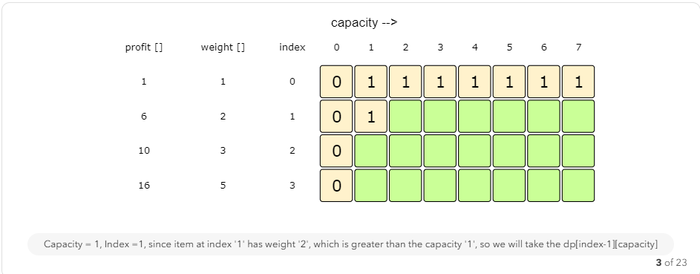

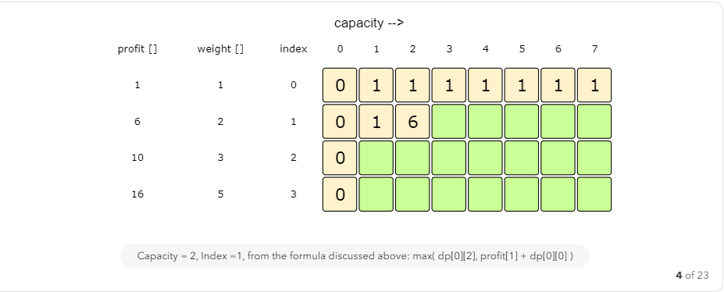

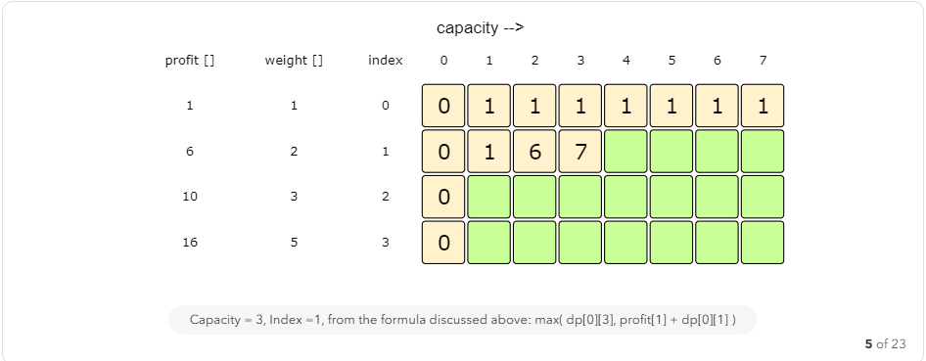

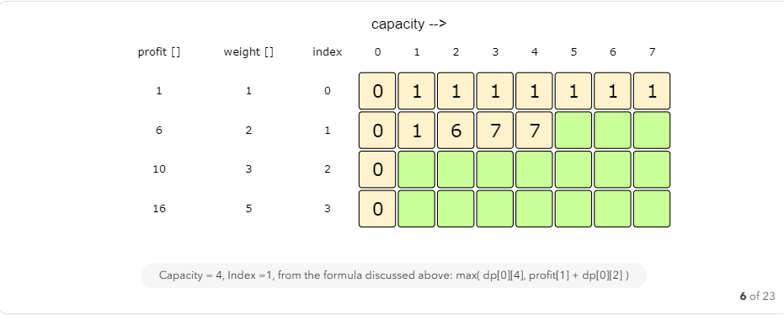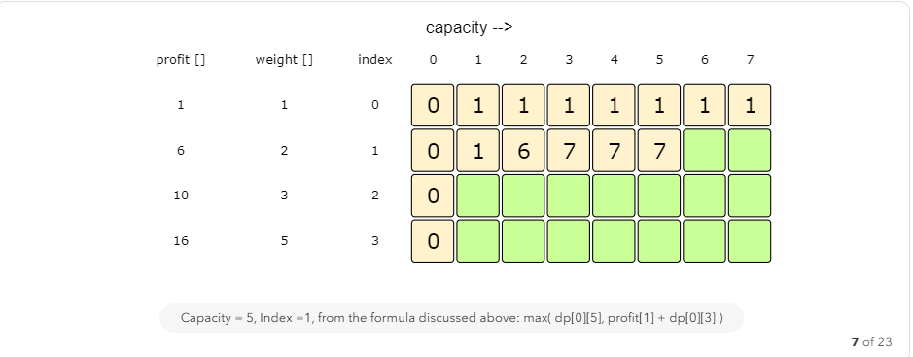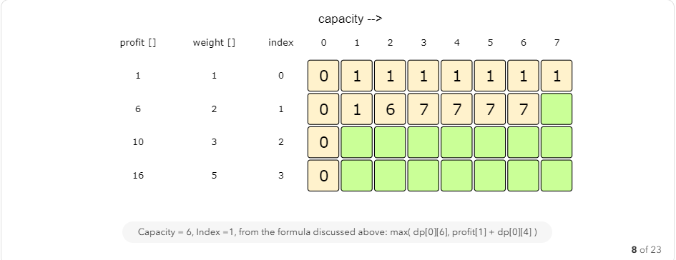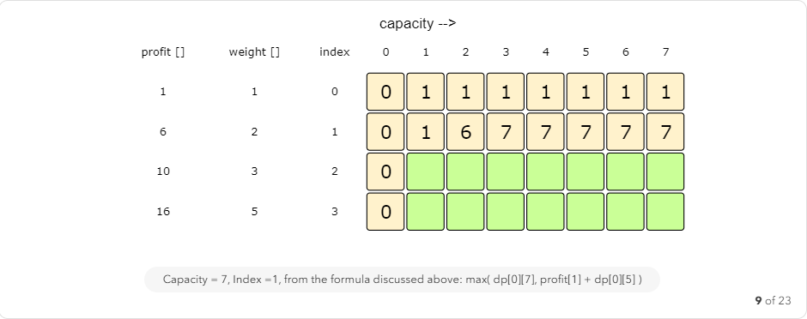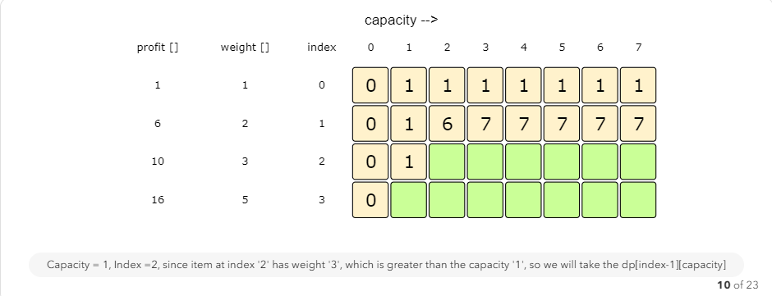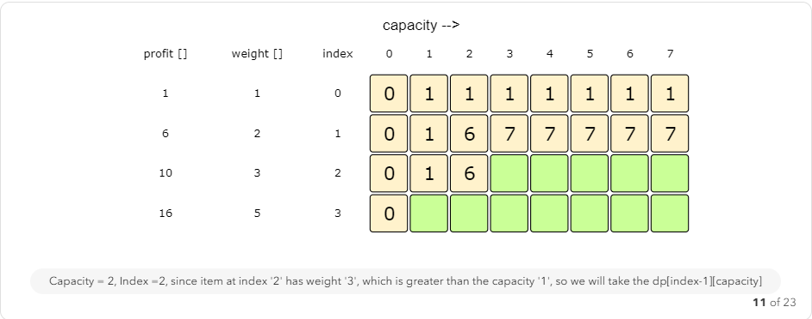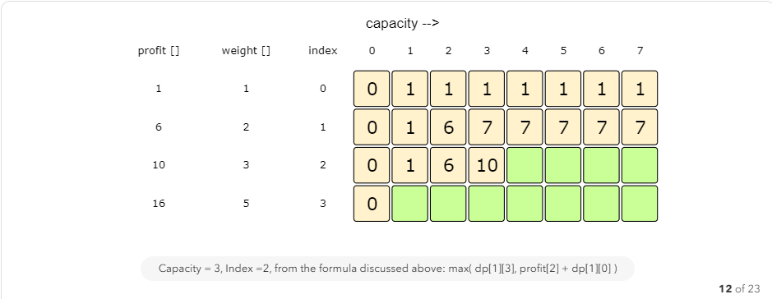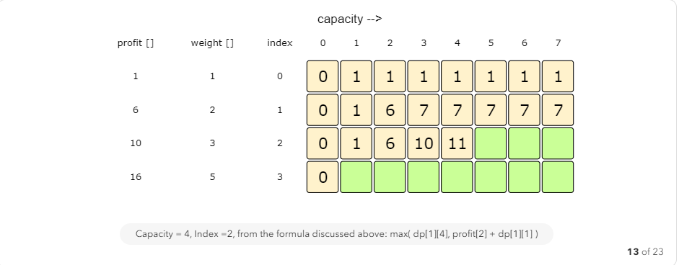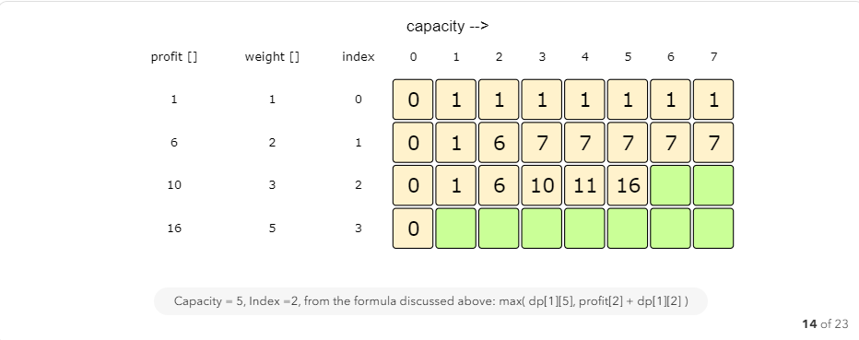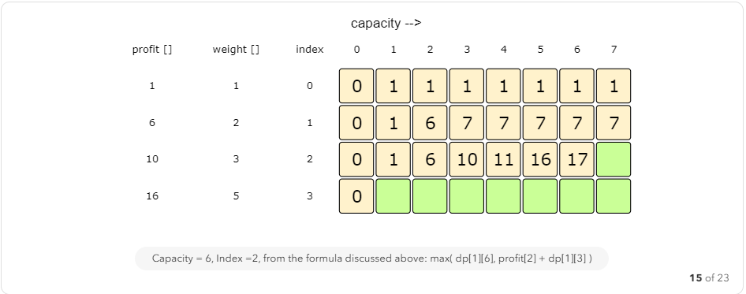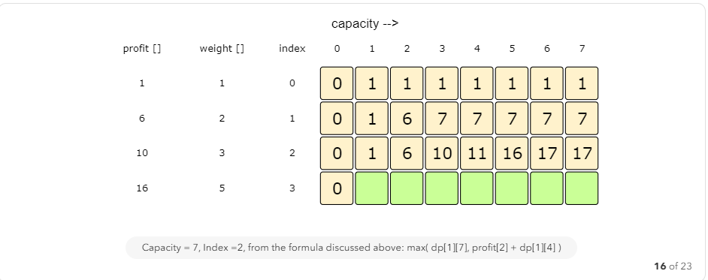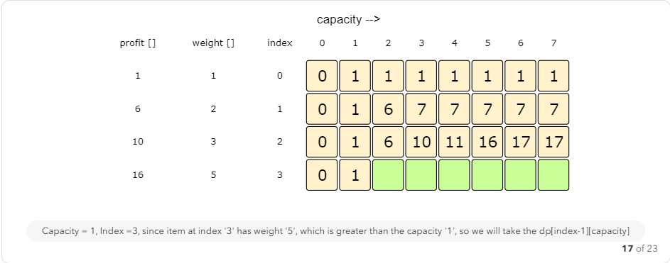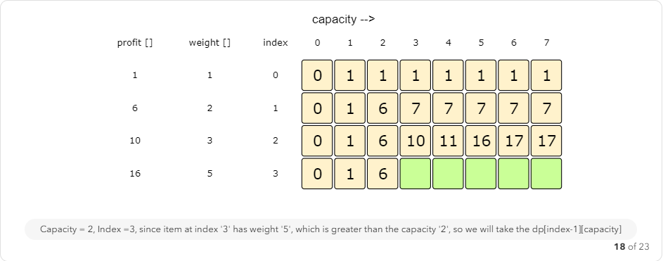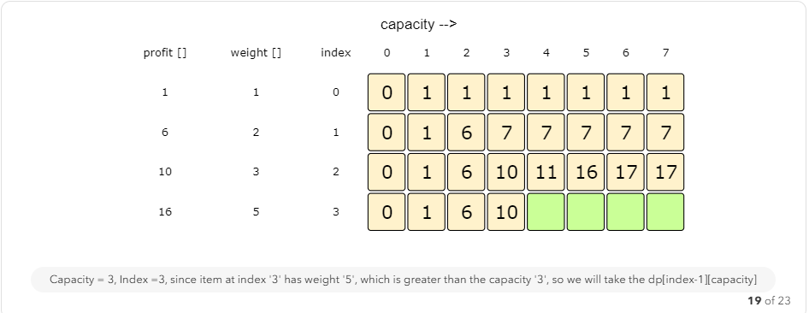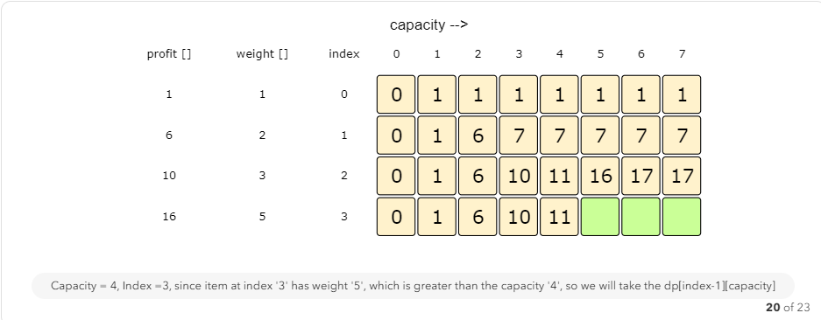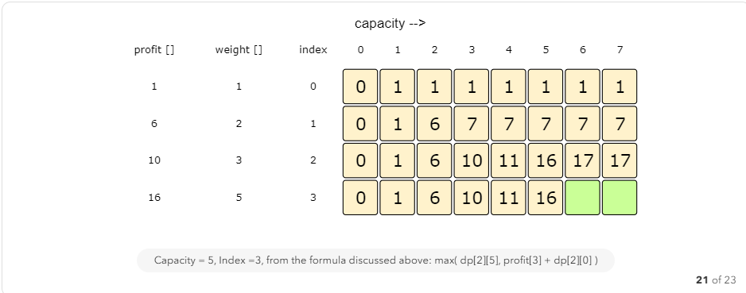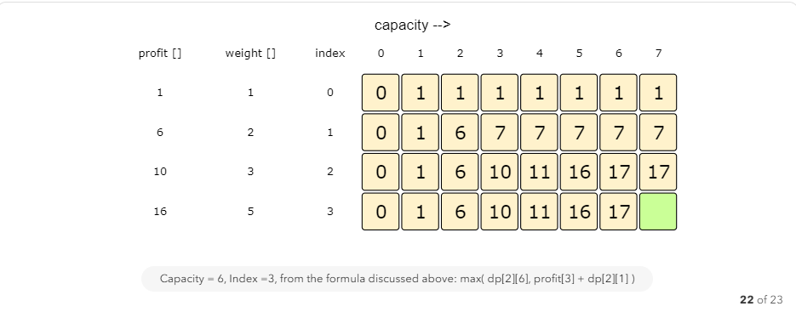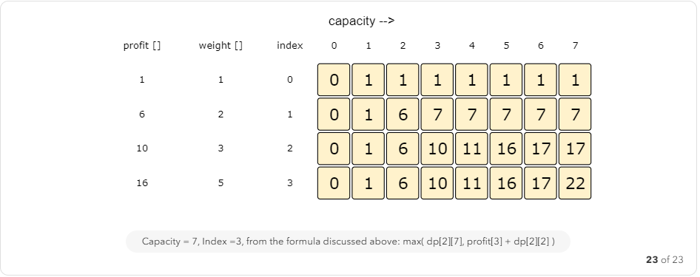

#### Code

Here is the code for our bottom-up dynamic programming approach:

class Knapsack {

public int solveKnapsack(int[] profits, int[] weights, int capacity) {

// basic checks

if (capacity <= 0 || profits.length == 0 || weights.length != profits.length)

return 0;

int n = profits.length;

int[][] dp = new int[n][capacity + 1];

// populate the capacity=0 columns, with '0' capacity we have '0' profit

for(int i=0; i < n; i++)

dp[i][0] = 0;

// if we have only one weight, we will take it if it is not more than the capacity

for(int c=0; c <= capacity; c++) {

if(weights[0] <= c)

dp[0][c] = profits[0];

}

// process all sub-arrays for all the capacities

for(int i=1; i < n; i++) {

for(int c=1; c <= capacity; c++) {

int profit1= 0, profit2 = 0;

// include the item, if it is not more than the capacity

if(weights[i] <= c)

profit1 = profits[i] + dp[i-1][c-weights[i]];

// exclude the item

profit2 = dp[i-1][c];

// take maximum

dp[i][c] = Math.max(profit1, profit2);

}

}

// maximum profit will be at the bottom-right corner.

return dp[n-1][capacity];

}

public static void main(String[] args) {

Knapsack ks = new Knapsack();

int[] profits = {1, 6, 10, 16};

int[] weights = {1, 2, 3, 5};

int maxProfit = ks.solveKnapsack(profits, weights, 7);

System.out.println("Total knapsack profit ---> " + maxProfit);

maxProfit = ks.solveKnapsack(profits, weights, 6);

System.out.println("Total knapsack profit ---> " + maxProfit);

}

}

The above solution has time and space complexity of O(N*C), where ‘N’ represents total items and ‘C’ is the maximum capacity.

#### How to find the selected items?

As we know that the final profit is at the bottom-right corner; therefore we will start from there to find the items that will be going in the knapsack.

As you remember, at every step we had two options: include an item or skip it. If we skip an item, then we take the profit from the remaining items (i.e. from the cell right above it); if we include the item, then we jump to the remaining profit to find more items.

Let’s understand this from the above example:

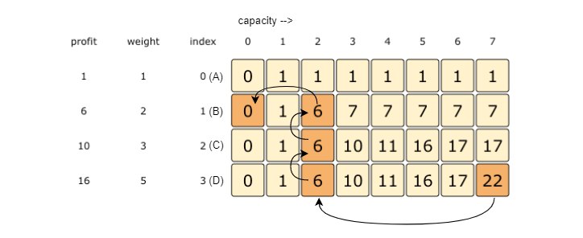

1. ‘22’ did not come from the top cell (which is 17); hence we must include the item at index ‘3’ (which is the item ‘D’).
2. Subtract the profit of item ‘D’ from ‘22’ to get the remaining profit ‘6’. We then jump to profit ‘6’ on the same row.
3. ‘6’ came from the top cell, so we jump to row ‘2’.
4. Again ‘6’ came from the top cell, so we jump to row ‘1’.
5. ‘6’ is different than the top cell, so we must include this item (which is item ‘B’).
6. Subtract the profit of ‘B’ from ‘6’ to get the profit ‘0’. We then jump to profit ‘0’ on the same row. As soon as we hit zero remaining profit, we can finish our item search.
7. So items going into the knapsack are {B, D}.

Let’s write a function to print the set of items included in the knapsack.

import java.util.*;

class Knapsack {

public int solveKnapsack(int[] profits, int[] weights, int capacity) {

// base checks

if (capacity <= 0 || profits.length == 0 || weights.length != profits.length)

return 0;

int n = profits.length;

int[][] dp = new int[n][capacity + 1];

// populate the capacity=0 columns, with '0' capacity we have '0' profit

for(int i=0; i < n; i++)

dp[i][0] = 0;

// if we have only one weight, we will take it if it is not more than the capacity

for(int c=0; c <= capacity; c++) {

if(weights[0] <= c)

dp[0][c] = profits[0];

}

// process all sub-arrays for all the capacities

for(int i=1; i < n; i++) {

for(int c=1; c <= capacity; c++) {

int profit1= 0, profit2 = 0;

// include the item, if it is not more than the capacity

if(weights[i] <= c)

profit1 = profits[i] + dp[i-1][c-weights[i]];

// exclude the item

profit2 = dp[i-1][c];

// take maximum

dp[i][c] = Math.max(profit1, profit2);

}

}

printSelectedElements(dp, weights, profits, capacity);

// maximum profit will be at the bottom-right corner.

return dp[n-1][capacity];

}

private void printSelectedElements(int dp[][], int[] weights, int[] profits, int capacity){

System.out.print("Selected weights:");

int totalProfit = dp[weights.length-1][capacity];

for(int i=weights.length-1; i > 0; i--) {

if(totalProfit != dp[i-1][capacity]) {

System.out.print(" " + weights[i]);

capacity -= weights[i];

totalProfit -= profits[i];

}

}

if(totalProfit != 0)

System.out.print(" " + weights[0]);

System.out.println("");

}

public static void main(String[] args) {

Knapsack ks = new Knapsack();

int[] profits = {1, 6, 10, 16};

int[] weights = {1, 2, 3, 5};

int maxProfit = ks.solveKnapsack(profits, weights, 7);

System.out.println("Total knapsack profit ---> " + maxProfit);

maxProfit = ks.solveKnapsack(profits, weights, 6);

System.out.println("Total knapsack profit ---> " + maxProfit);

}

}

### Challenge

Can we further improve our bottom-up DP solution? Can you find an algorithm that has O(C)space complexity?

We only need one previous row to find the optimal solution!

class Knapsack {

static int solveKnapsack(int[] profits, int[] weights, int capacity) {

// basic checks

if (capacity <= 0 || profits.length == 0 || weights.length != profits.length)

return 0;

int n = profits.length;

// we only need one previous row to find the optimal solution, overall we need '2' rows

// the above solution is similar to the previous solution, the only difference is that

// we use `i%2` instead if `i` and `(i-1)%2` instead if `i-1`

int[][] dp = new int[2][capacity+1];

// if we have only one weight, we will take it if it is not more than the capacity

for(int c=0; c <= capacity; c++) {

if(weights[0] <= c)

dp[0][c] = dp[1][c] = profits[0];

}

// process all sub-arrays for all the capacities

for(int i=1; i < n; i++) {

for(int c=0; c <= capacity; c++) {

int profit1= 0, profit2 = 0;

// include the item, if it is not more than the capacity

if(weights[i] <= c)

profit1 = profits[i] + dp[(i-1)%2][c-weights[i]];

// exclude the item

profit2 = dp[(i-1)%2][c];

// take maximum

dp[i%2][c] = Math.max(profit1, profit2);

}

}

return dp[(n-1)%2][capacity];

}

}

The above solution is similar to the previous solution, the only difference is that we use i%2 instead if i and (i-1)%2 instead if i-1. This solution has a space complexity of O(2*C) = O(C), where ‘C’ is the maximum capacity of the knapsack.

This space optimization solution can also be implemented using a single array. It is a bit tricky though, but the intuition is to use the same array for the previous and the next iteration!

If you see closely, we need two values from the previous iteration: dp[c] and dp[c-weight[i]]

Since our inner loop is iterating over c:0-->capacity, let’s see how this might affect our two required values:

1. When we access dp[c], it has not been overridden yet for the current iteration, so it should be fine.
2. dp[c-weight[i]] might be overridden if “weight[i] > 0”. Therefore we can’t use this value for the current iteration.

To solve the second case, we can change our inner loop to process in the reverse direction: c:capacity-->0. This will ensure that whenever we change a value in dp[], we will not need it anymore in the current iteration.

Can you try writing this algorithm?

class Knapsack {

static int solveKnapsack(int[] profits, int[] weights, int capacity) {

// basic checks

if (capacity <= 0 || profits.length == 0 || weights.length != profits.length)

return 0;

int n = profits.length;

int[] dp = new int[capacity + 1];

// if we have only one weight, we will take it if it is not more than the

// capacity

for (int c = 0; c <= capacity; c++) {

if (weights[0] <= c)

dp[c] = profits[0];

}

// process all sub-arrays for all the capacities

for (int i = 1; i < n; i++) {

for (int c = capacity; c >= 0; c--) {

int profit1 = 0, profit2 = 0;

// include the item, if it is not more than the capacity

if (weights[i] <= c)

profit1 = profits[i] + dp[c - weights[i]];

// exclude the item

profit2 = dp[c];

// take maximum

dp[c] = Math.max(profit1, profit2);

}

}

return dp[capacity];

}

}