**Deploy ASP.NET Application to Azure with SQL Database**

This blog guides you how to deploy your ASP.NET/MVC application to Microsoft Azure Cloud Server with Azure SQL database, and how to connect Azure DB server from local machine.

1. Create Web App in Azure.
2. Create SQL Database and DB Server in Azure.
3. Connect Azure DB from Local Machine.
4. Set DB Connection String of Azure Web App.
5. Deploy Local Application to Azure.
6. Create Web App in Azure
   1. Login Azure Portal

<https://portal.azure.com/>

* 1. Create Resource Group

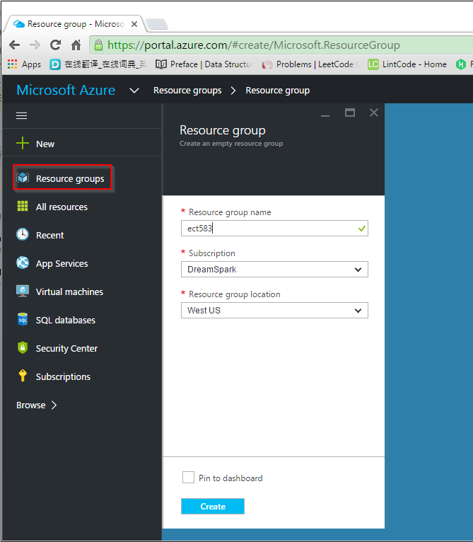

* 1. Create new Web APP

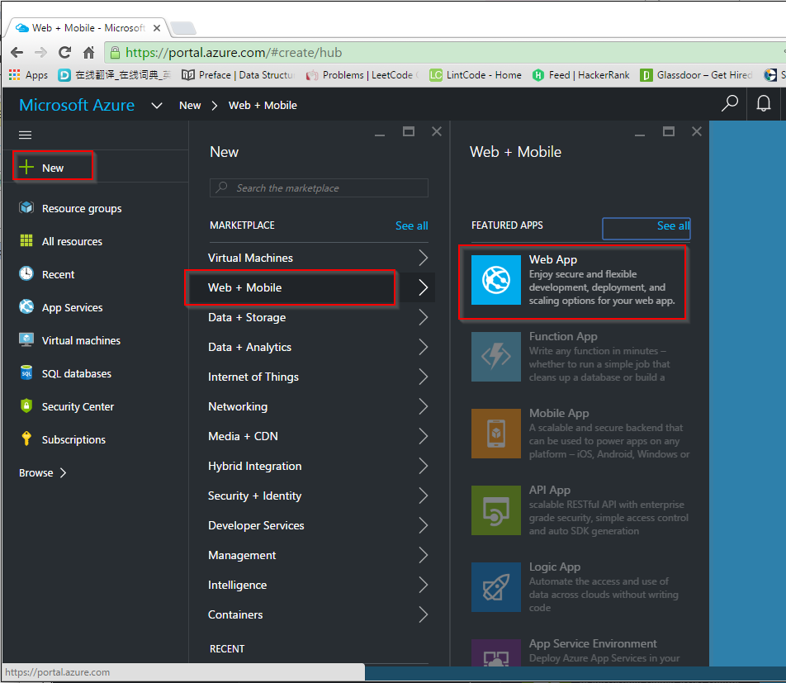

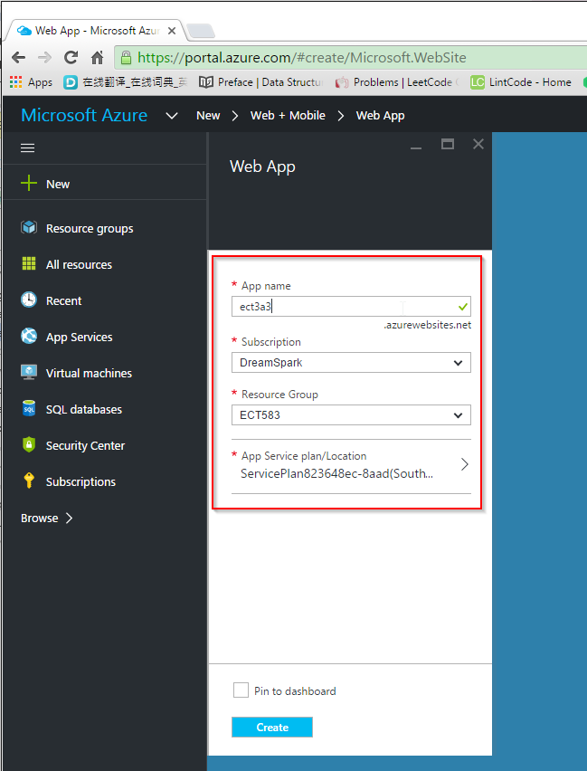

1. Create SQL Database in Azure
   1. New->Data+Storage->SQL Database(new database)

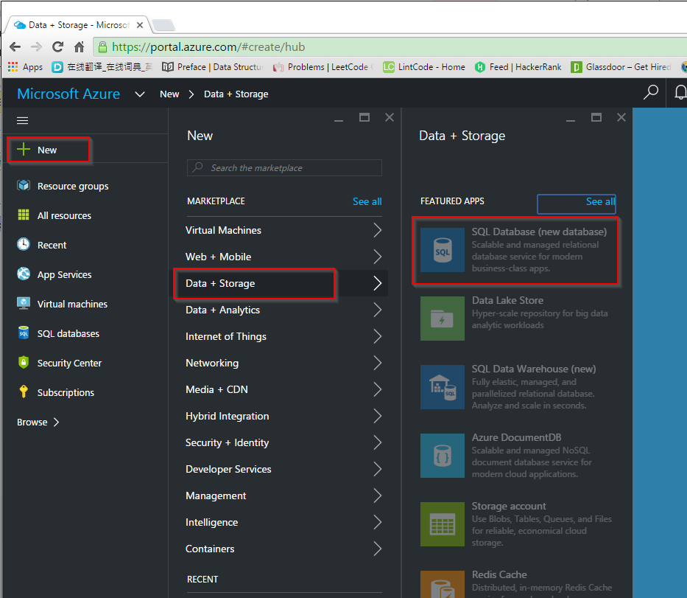

* 1. Provide DB Name, resource group, … to create a new SQL DB.

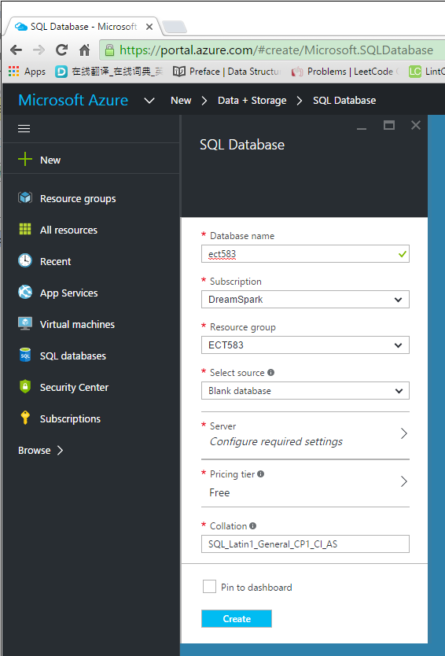

* 1. Create a new Server

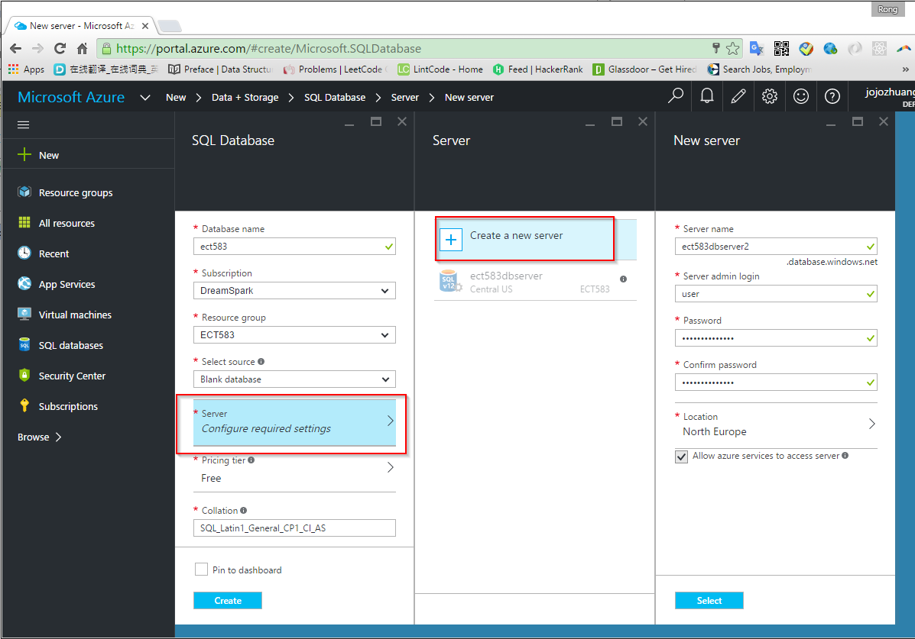

1. Connect Azure DB Server from Local Machine
   1. Find the new created SQL server(not SQL database)

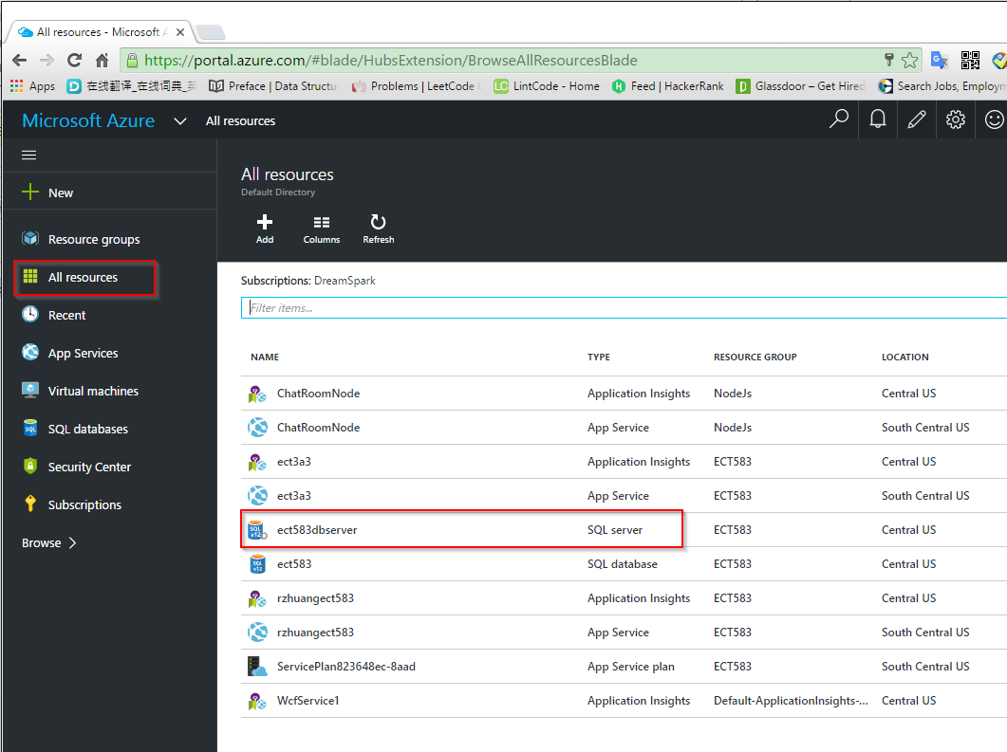

* 1. Add client IP address(your local machine) to firewall list of Azure SQL server.

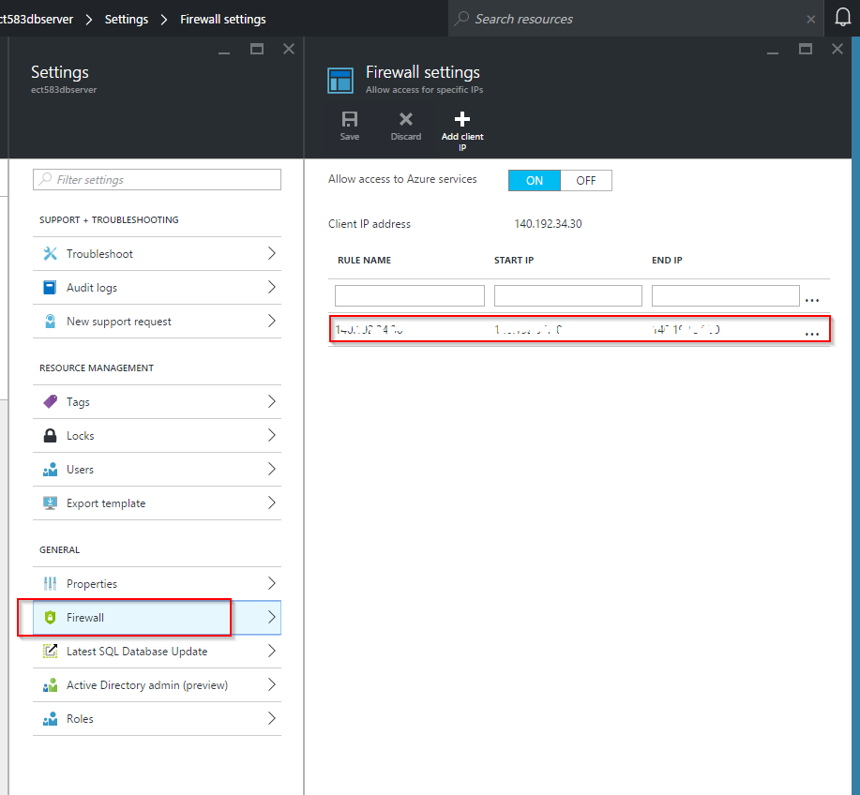

* 1. Find the connection string of the created database

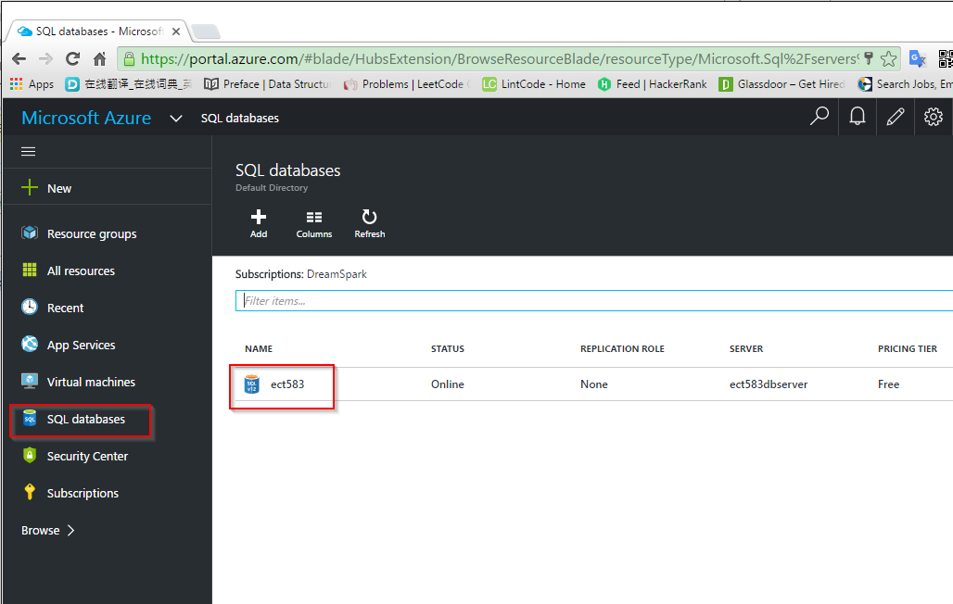

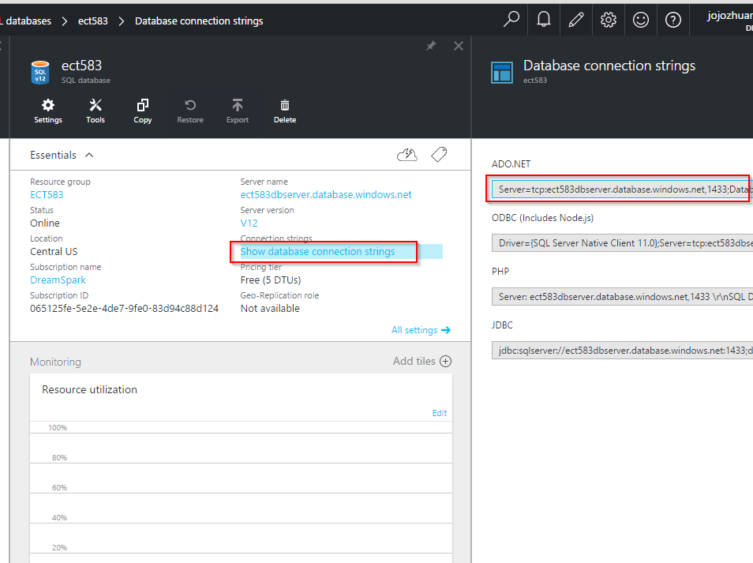

Note: The password is not provided in the connection string, you need to replace with your real password.

* 1. Replace the connection string in the web.config.

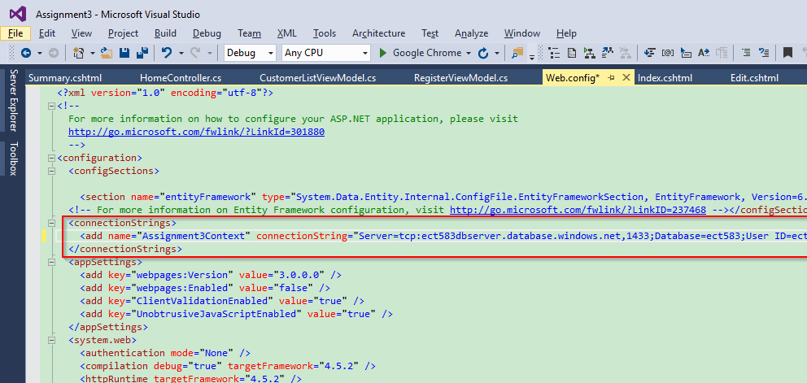

* 1. Launch application from visual studio, it should work.

1. Set DB Connection String of Azure Web App
   1. Find the new created web app.

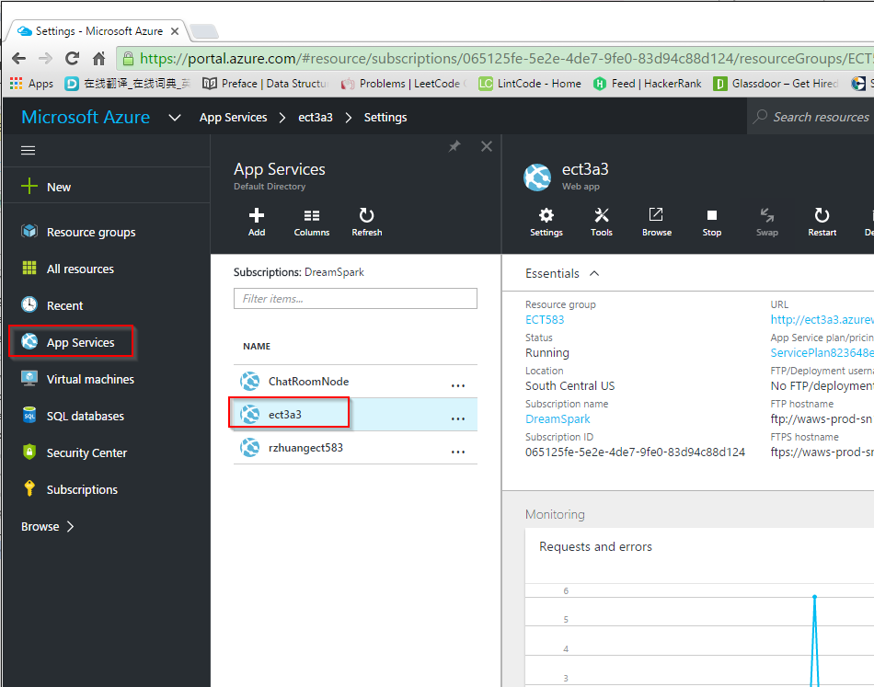

* 1. Application settings-> Connection strings.

Add new connection string with name and full connection string.

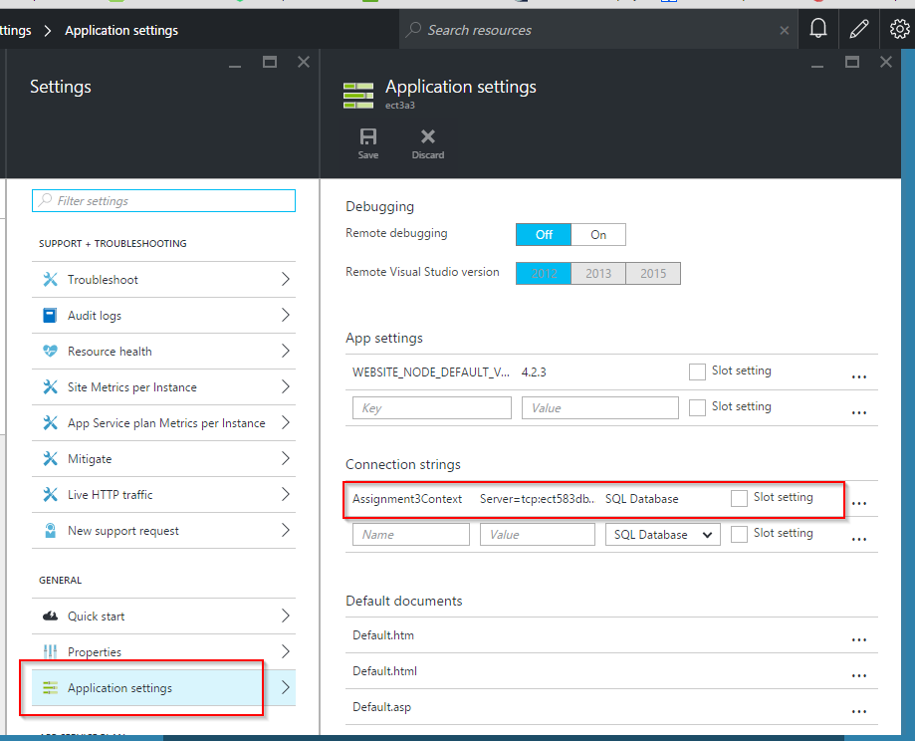

1. Deploy Local Application to Azure.
   1. Visual Studio -> Web Project -> Publish...
   2. Profile, choose Microsoft Azure App Service

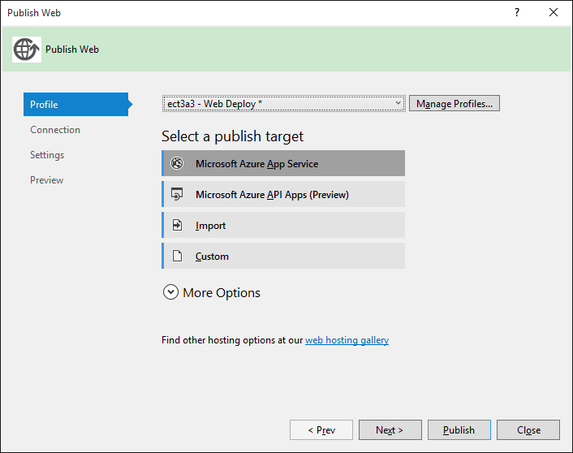

* 1. Connection, private the site name.

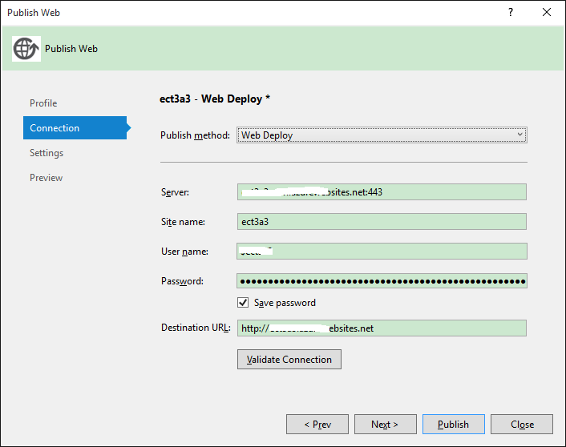

* 1. Settings, provide the connection string of Azure Database.

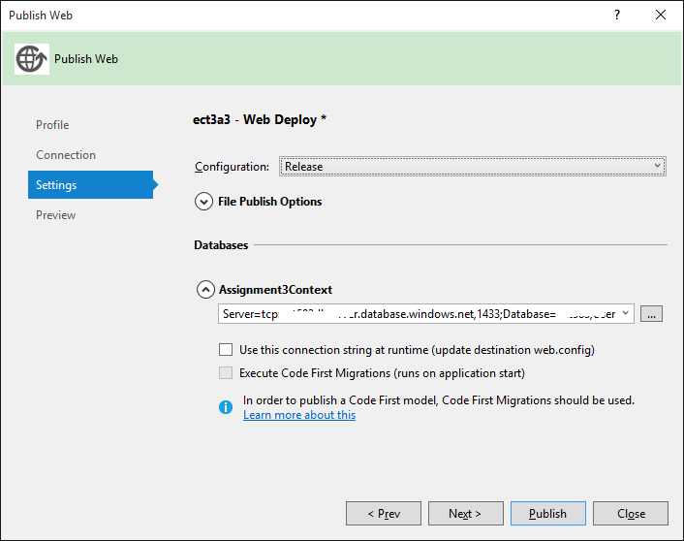

* 1. After publish, open your Azure website.

