**Online Game Store**

This web application is developed by Servlet and JSP(Two versions) in Java. Features are described as follows:

* Pages: Home, Consoles, Accessories, Games, Tablets
* General Functions: View Product, Search Product, View Comments of Product
* Membership: Register, Login, Logout
* Role Based Functions:
* Roles: Customer, Store Manager, Sales Manager
* Customer: Add Product to Cart, Checkout, View Own Orders
* Store Manager: Create/Edit/Delete Games, Create/Edit/Delete Accessories
* Salesman: View/Edit/Delete All Order, Create/Edit/Delete User

1. **Pages**
   1. Home Page

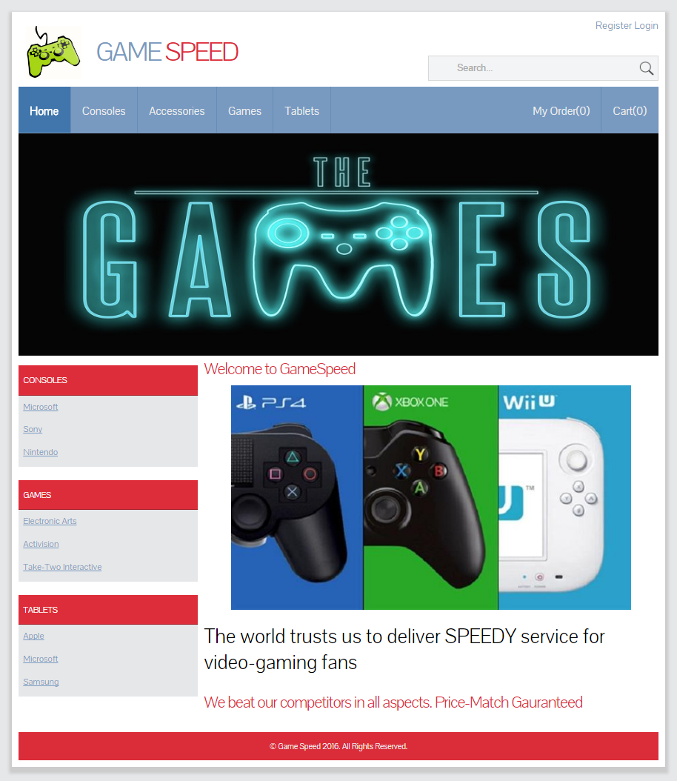

* 1. Consoles

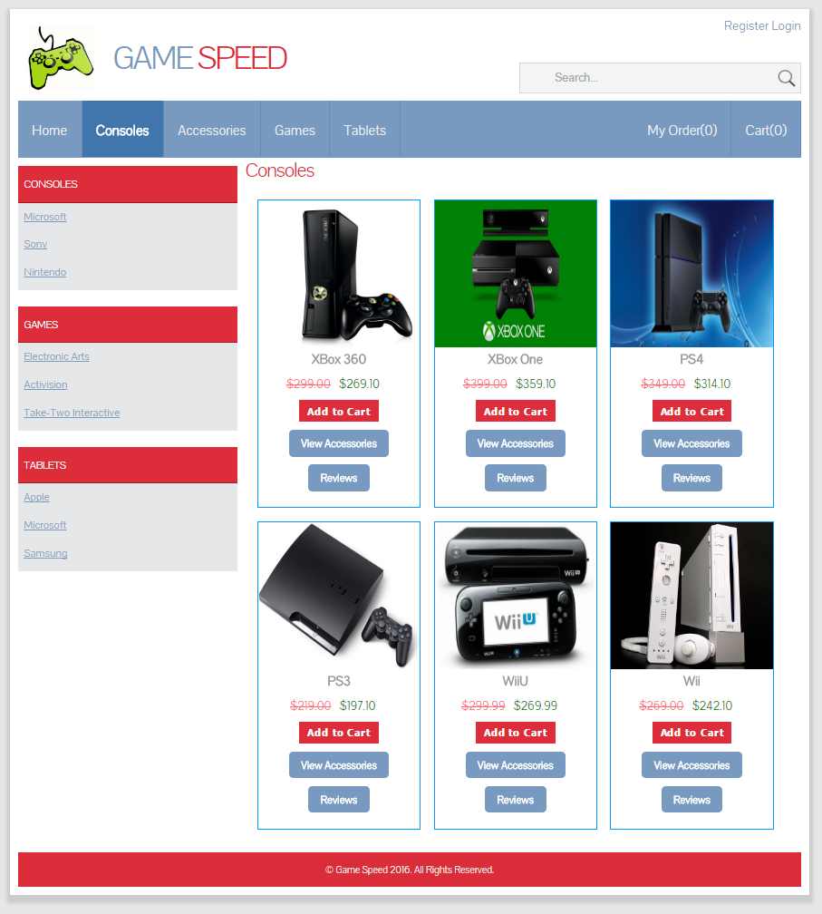

* 1. Accessories

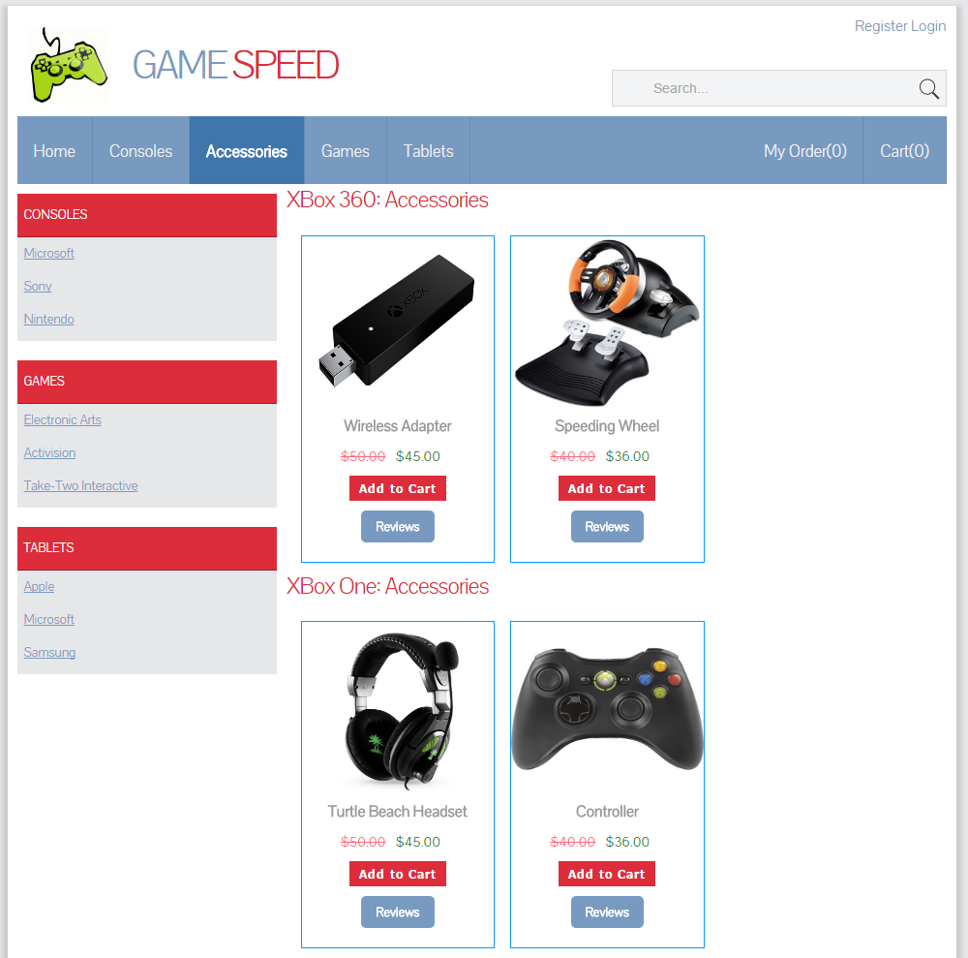

* 1. Games

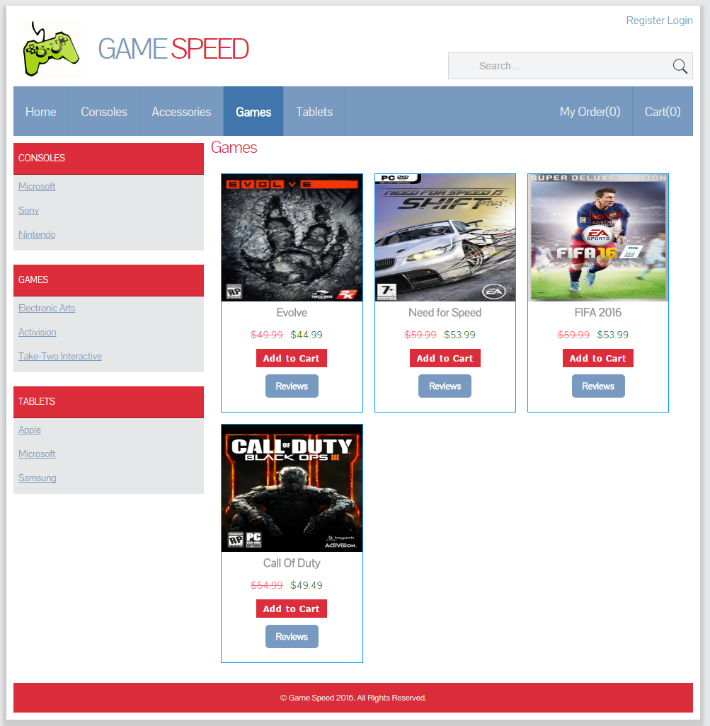

* 1. Tablets

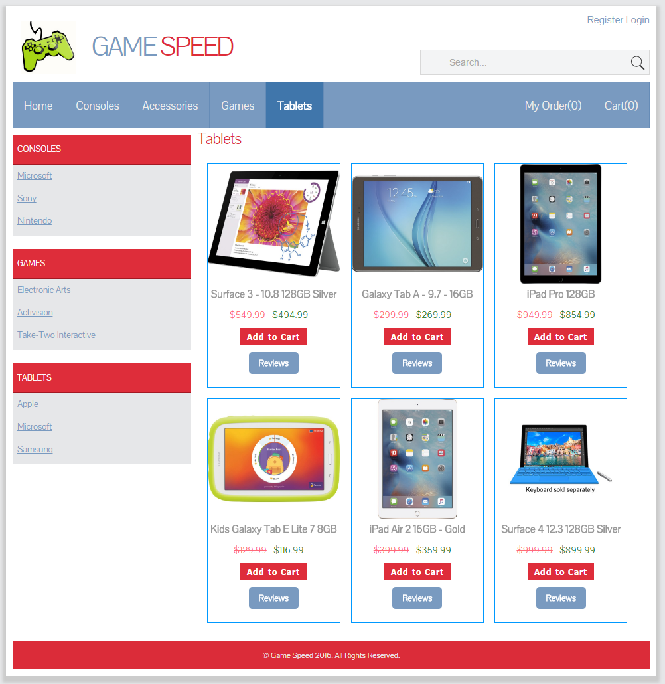

1. **General Functions**
   1. View Product
   2. Search Product

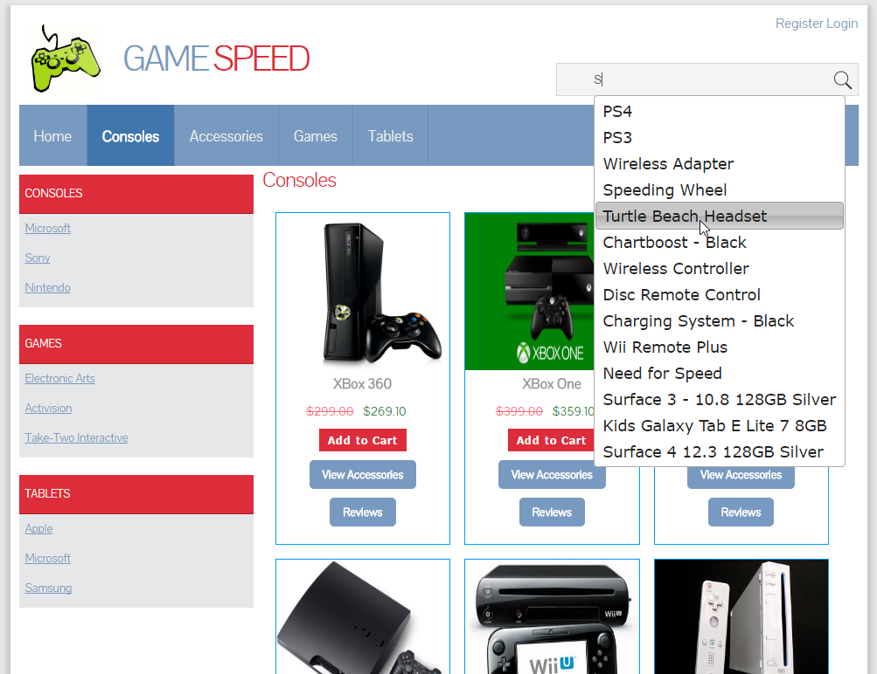

Search Result.

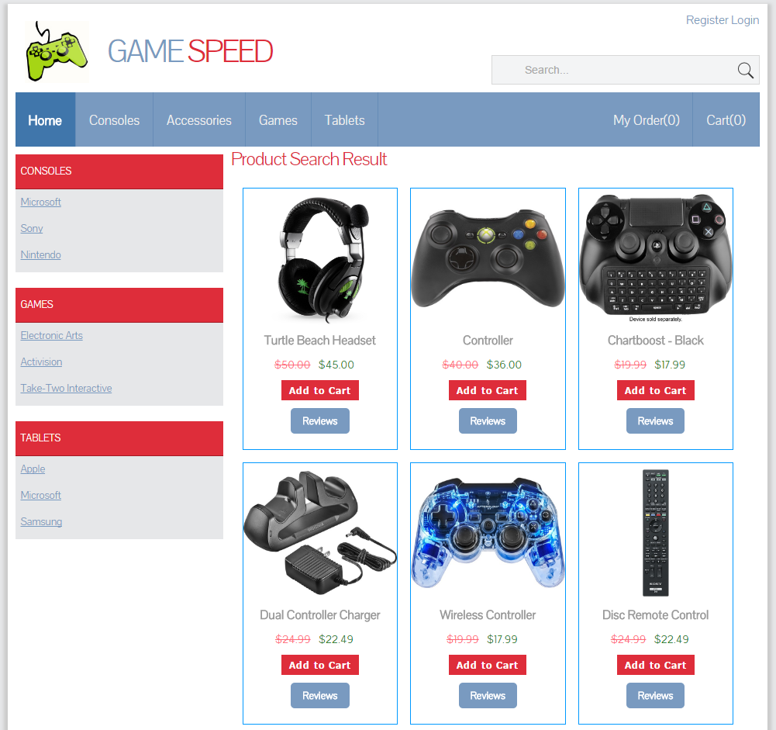

* 1. View Comments of Product

You can check the reviews/comments for any product.

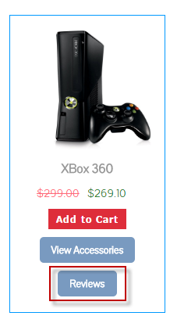

All of the review comments are displayed at the bottom of the page. Customer can submit new comments after login.

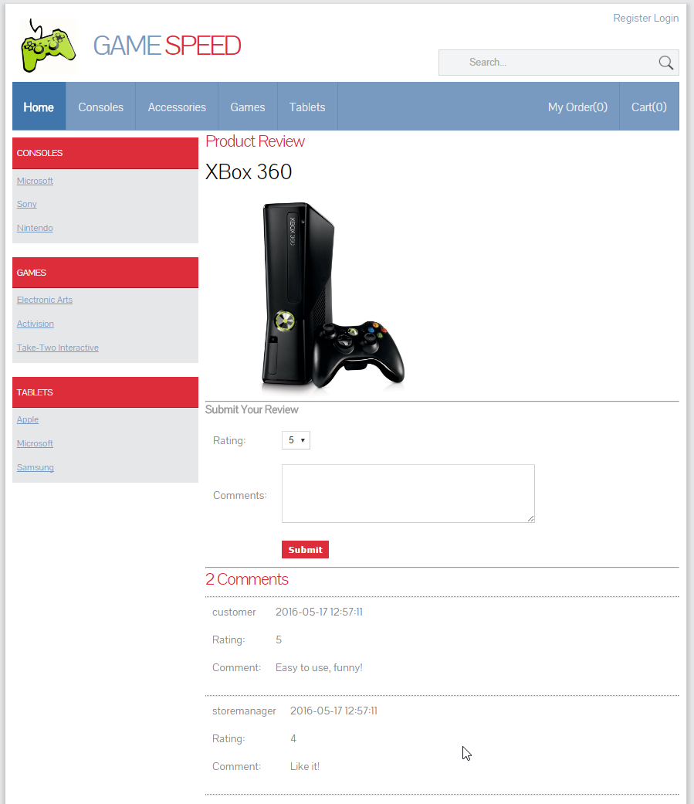

1. **Membership**
   1. Register

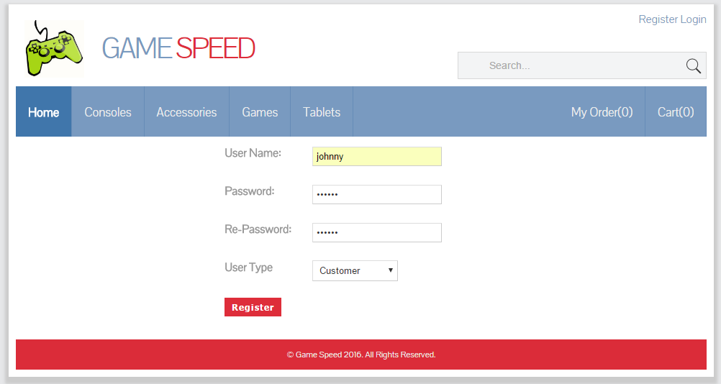

* 1. Login

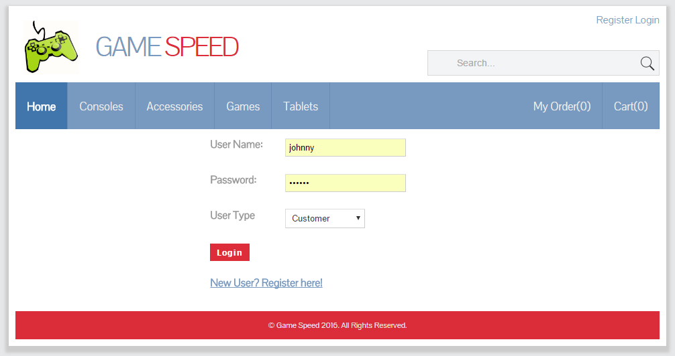

* 1. Logout

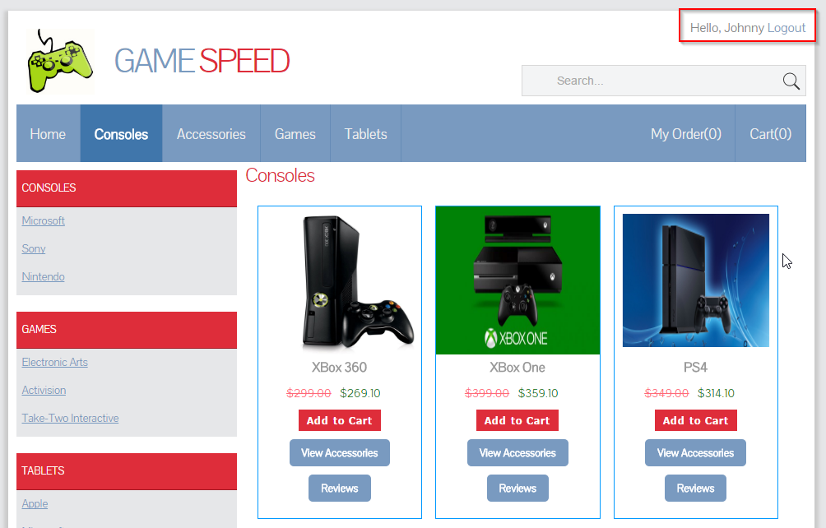

1. **Role Based Functions**
   1. Customer

Customer can purchase products, add them to the shopping cart and place order finally. And they can edit the quantity of the items in the cart.

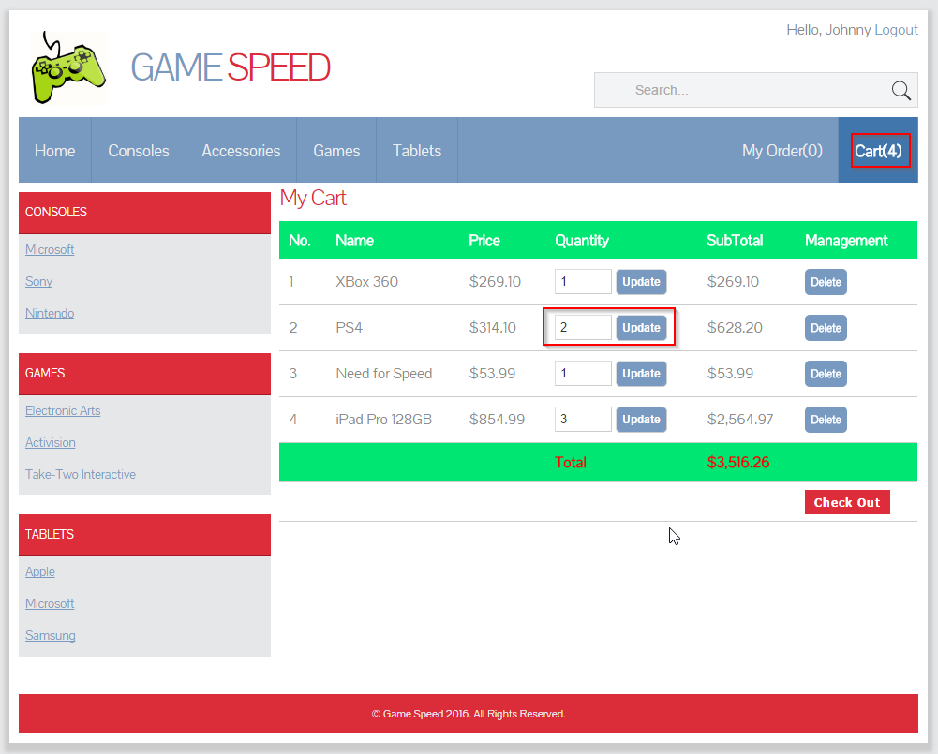

Provide address and credit card information.

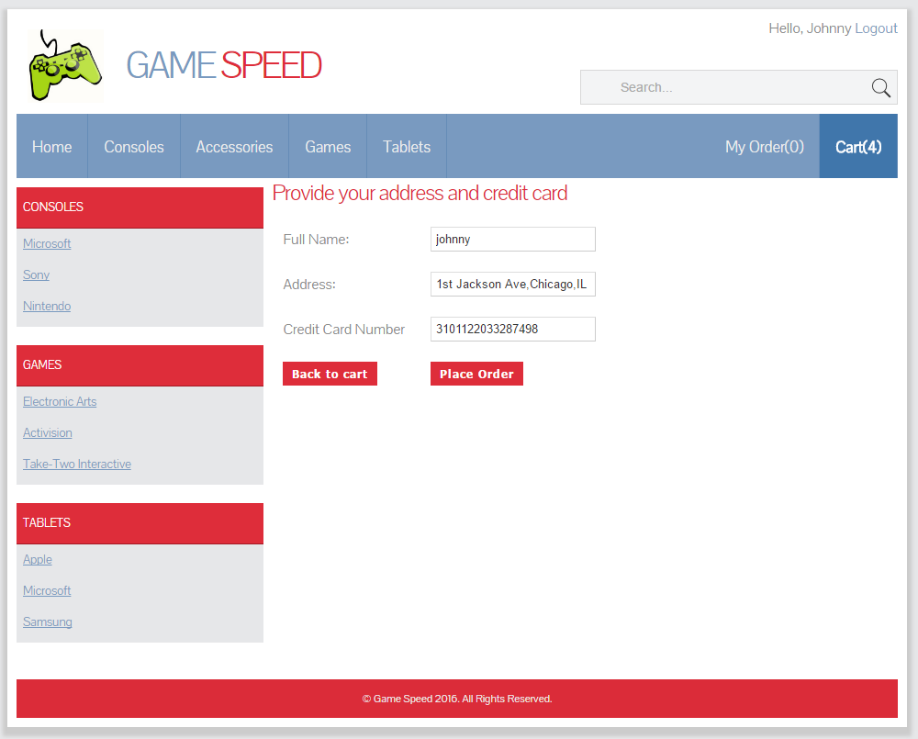

Order is generated.

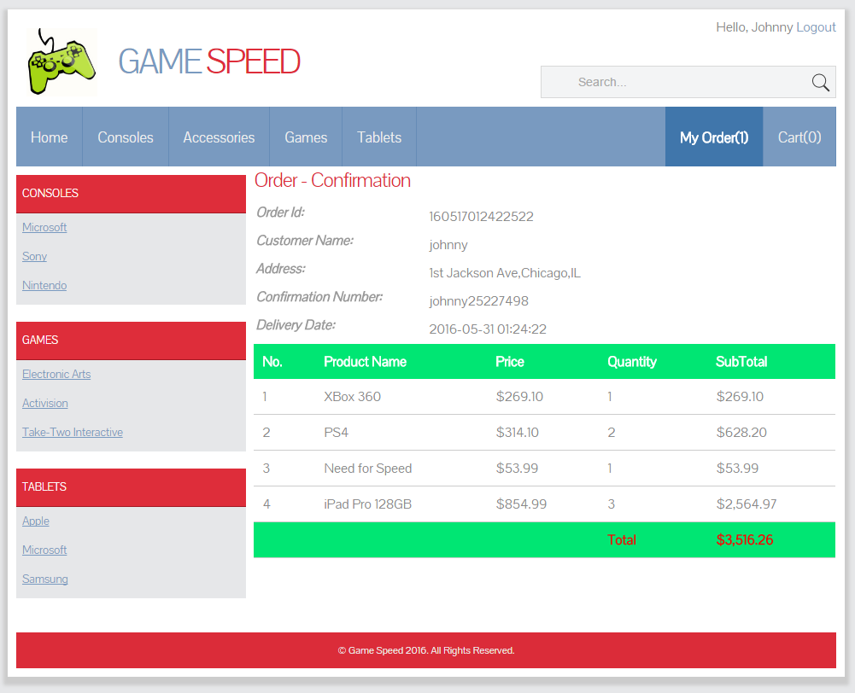

View My Order list. Here, you can cancel your order.

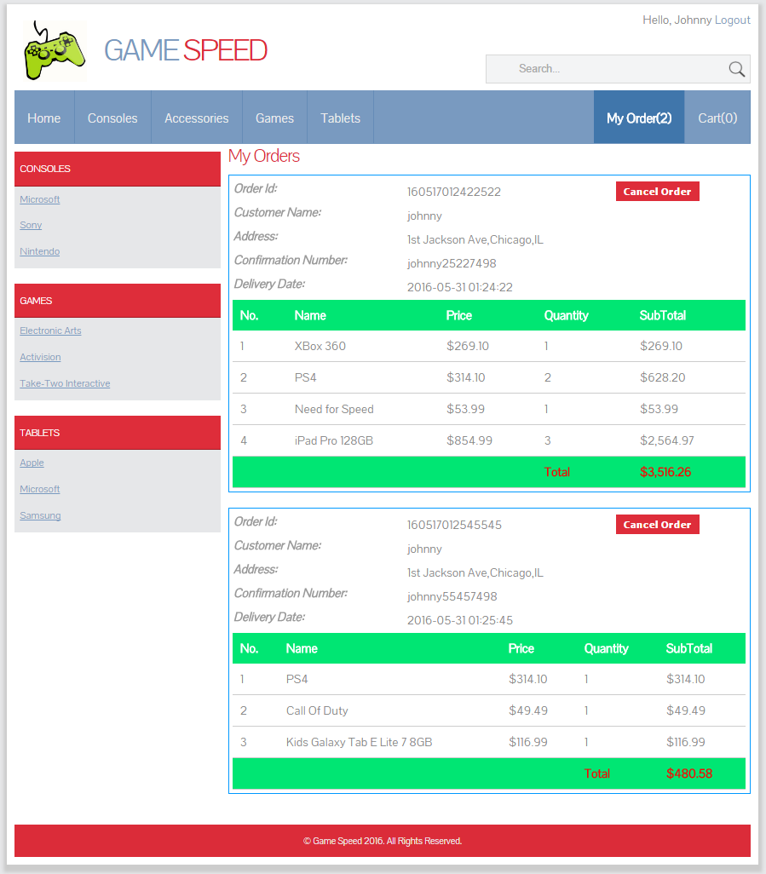

* 1. Store Manager

Login with the default user ‘storemanager’ and password ‘storemanager’. Select the user type of ‘Store Manager’.

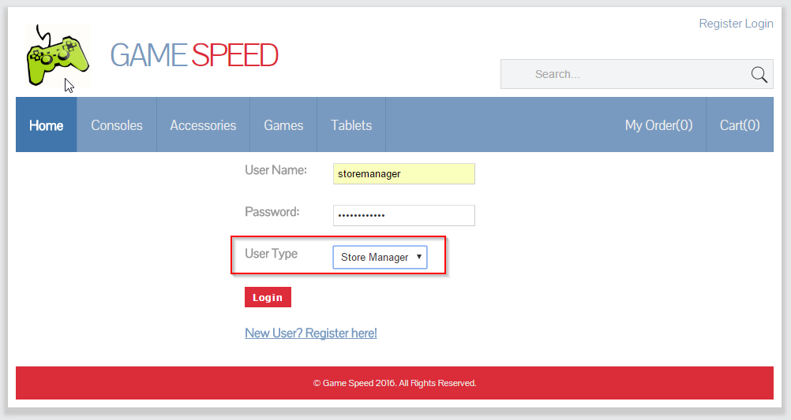

After login, you will see two more different menu items: Accessory and Game.

You can create, edit, and delete accessories.

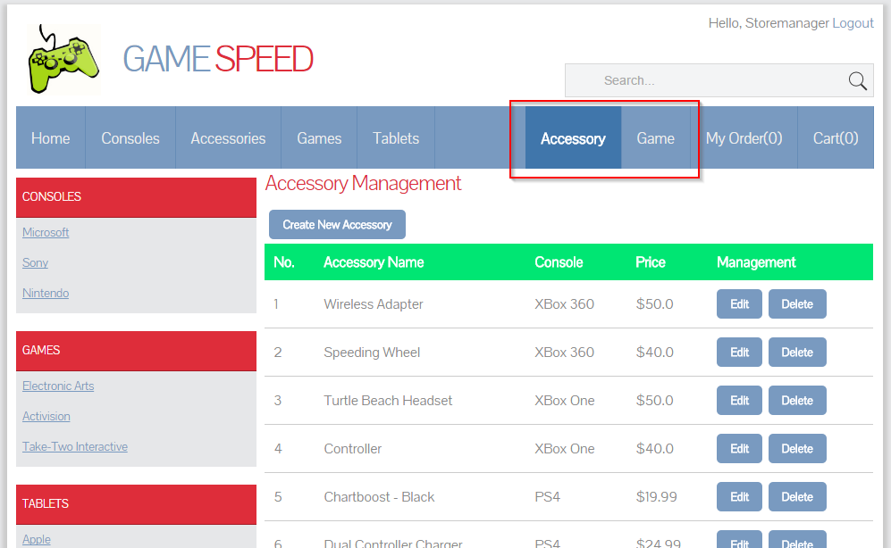

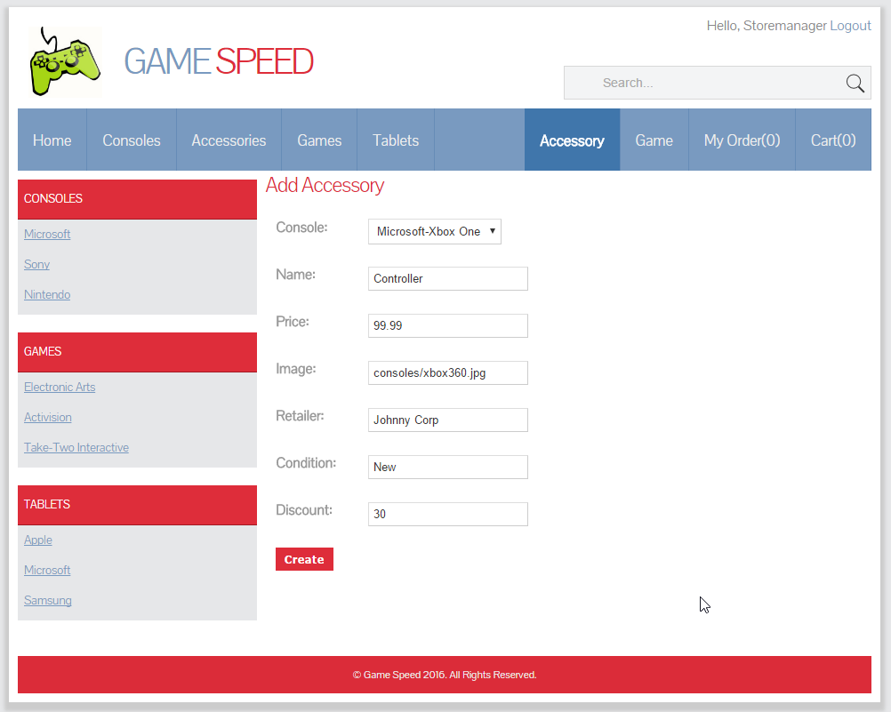

And, you can create, edit, and delete games.

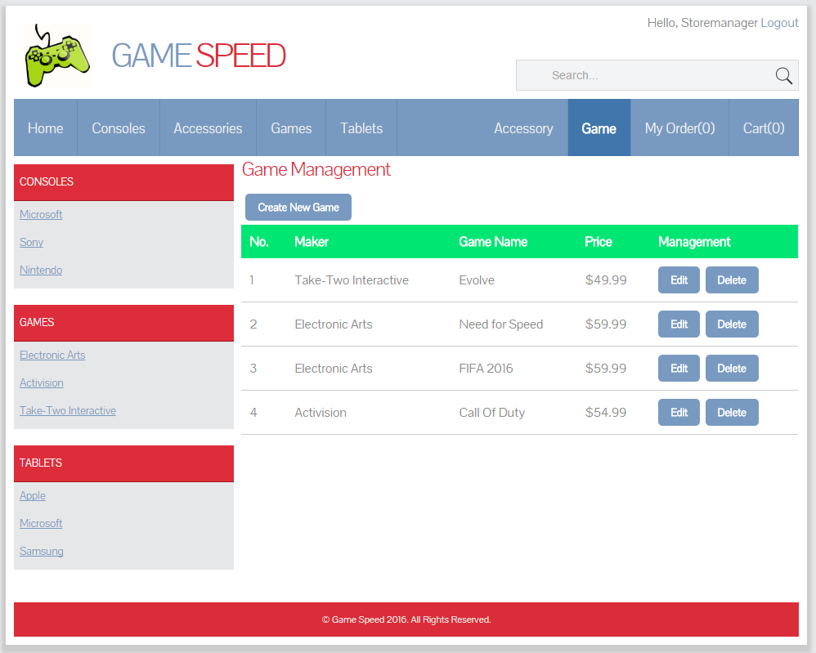

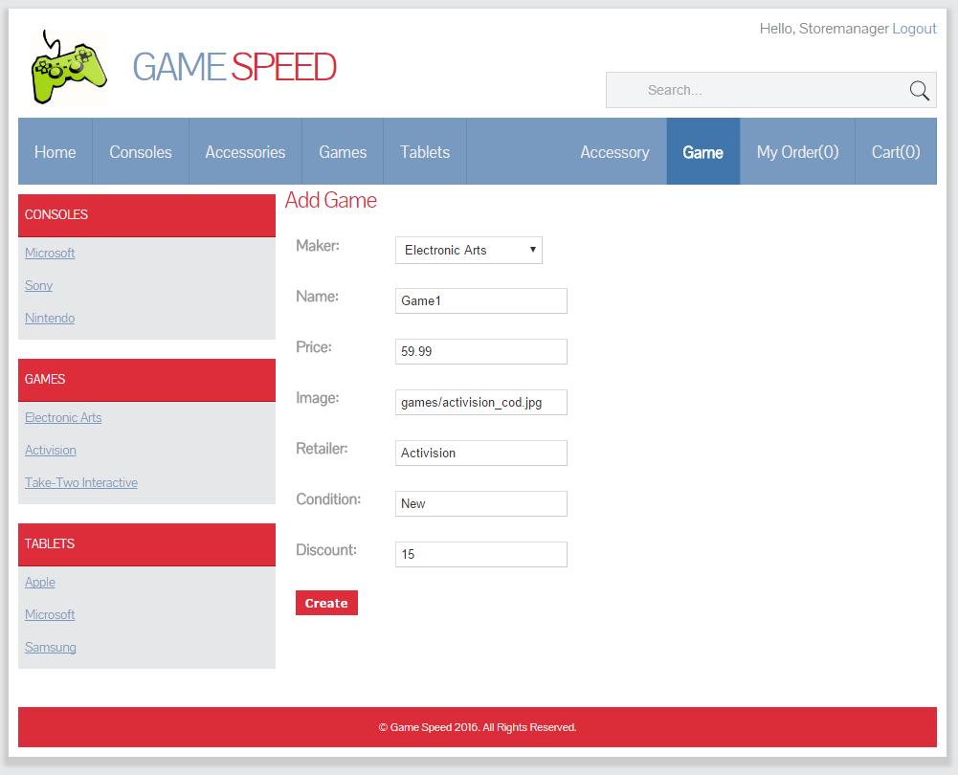

* 1. Salesman

Login with the default user ‘salesman’ and password ‘salesman’. Select the user type of ‘Salesman’.

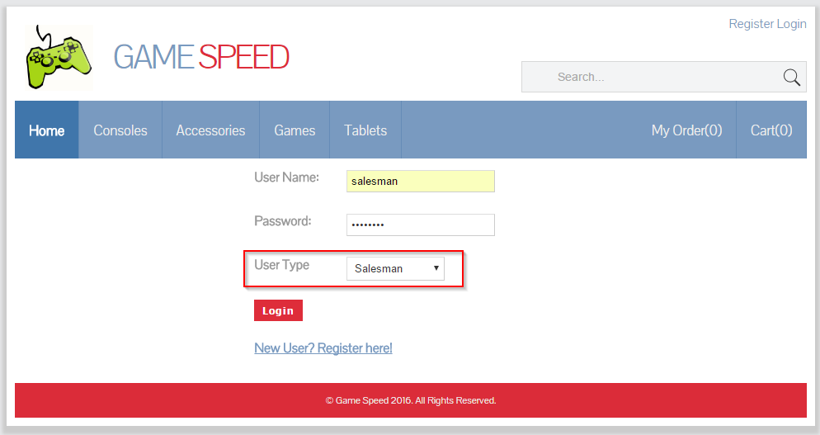

After login, you will see two more different menu options: All Orders and User.

You can create, edit, and delete customers’ orders.

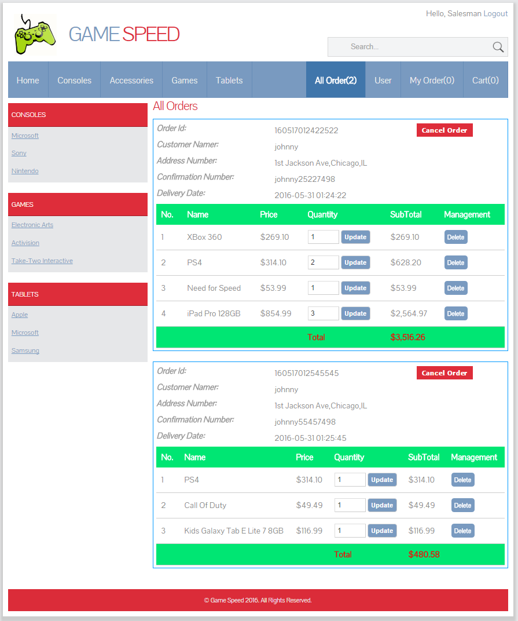

And you can create, edit, and delete users.

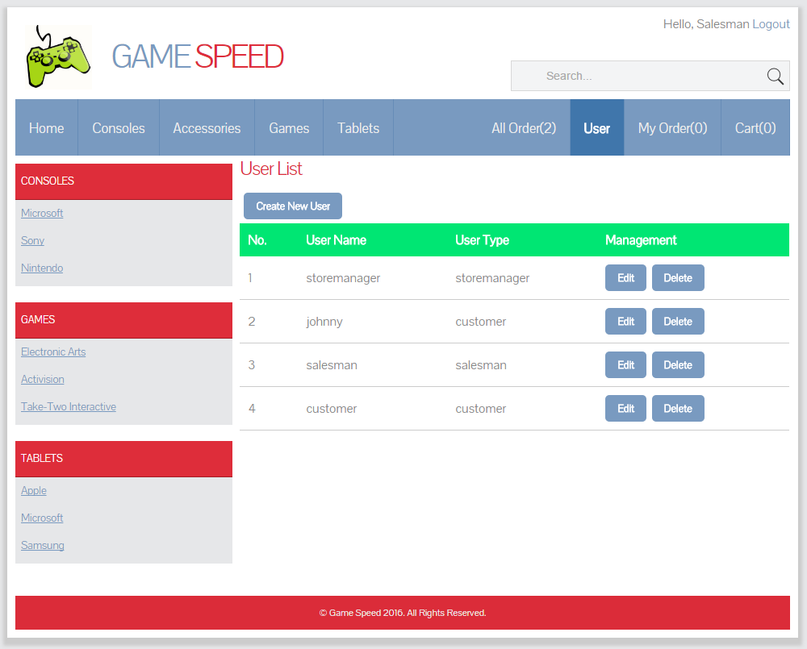

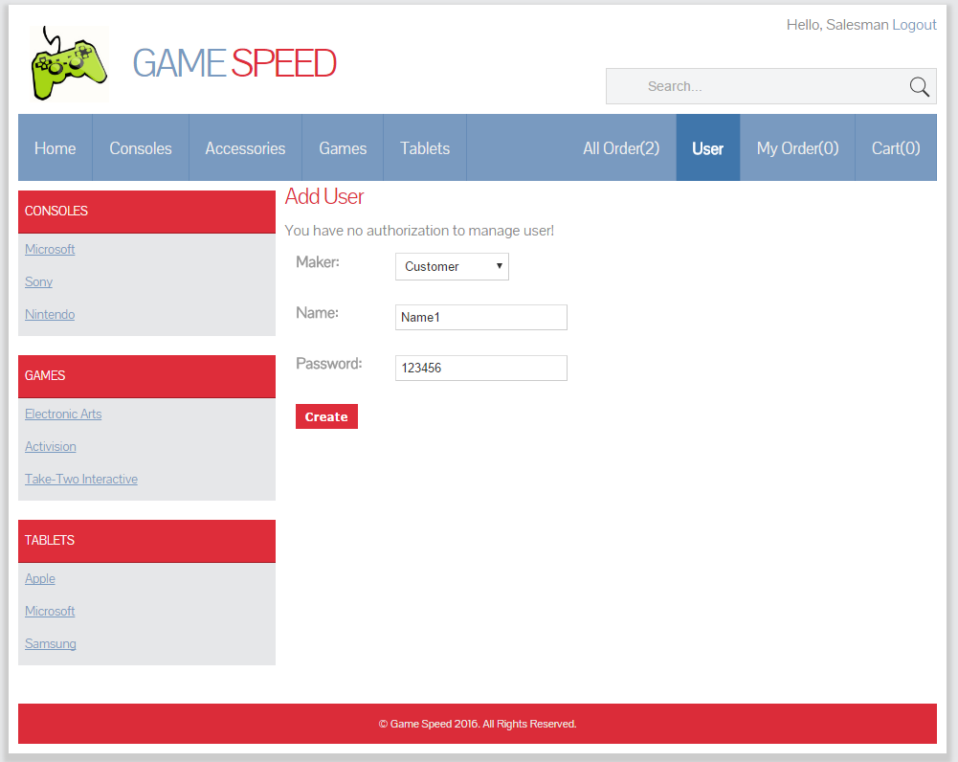

1. **Source Code**

I used NetBeans IDE 8.1 as development tool. And there two versions of this Game Store web application. The first one is developed by pure servlets. And the second developed with JSP + Beans without explicit servlets.

* 1. Servlet

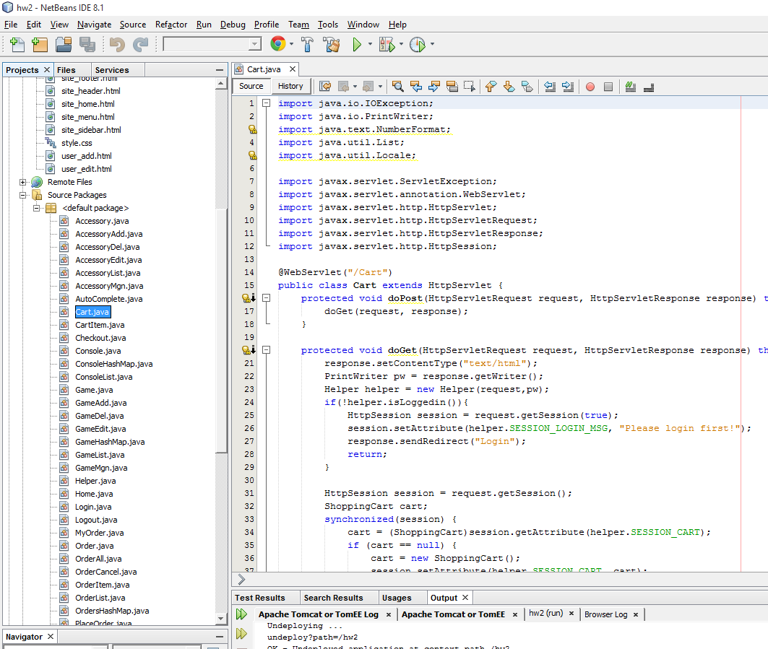

Data is stored in hashmap, in memory.

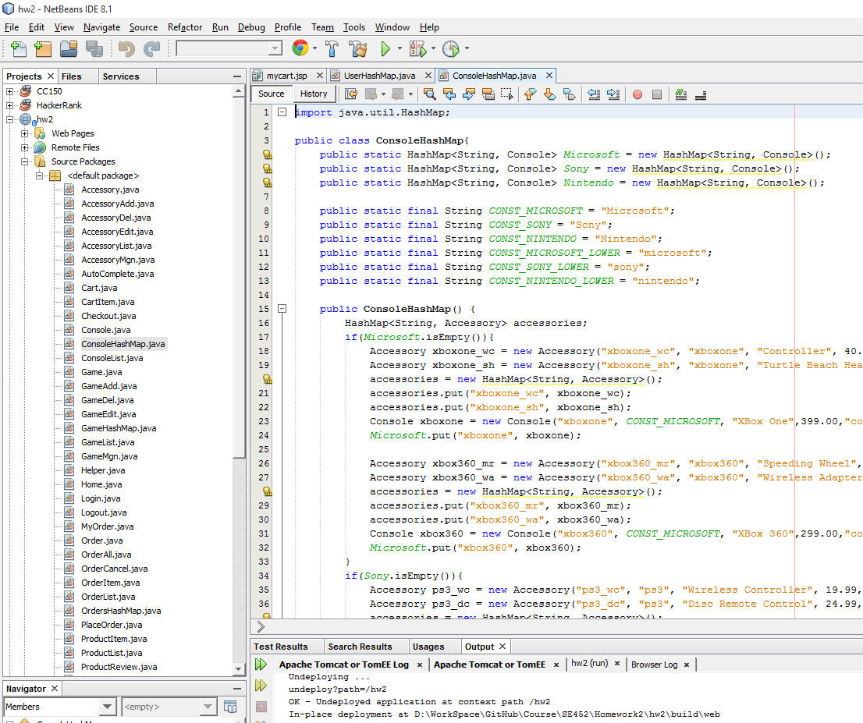

* 1. JSP + Beans

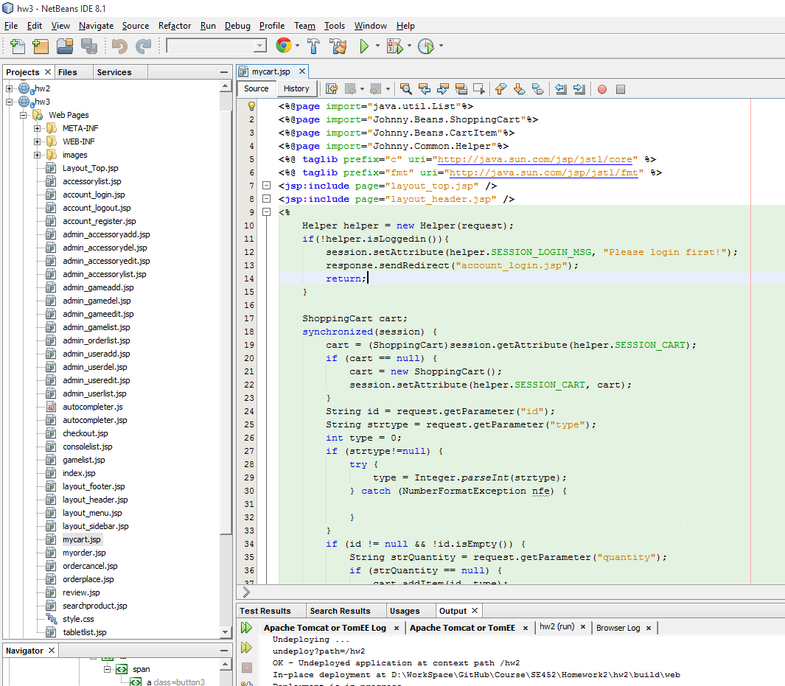

Data is stored in serialized files. They are placed in WEB-INF folder. Any change to the game store will be persisted to these files.

