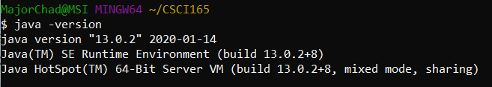

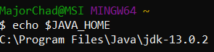 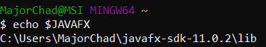

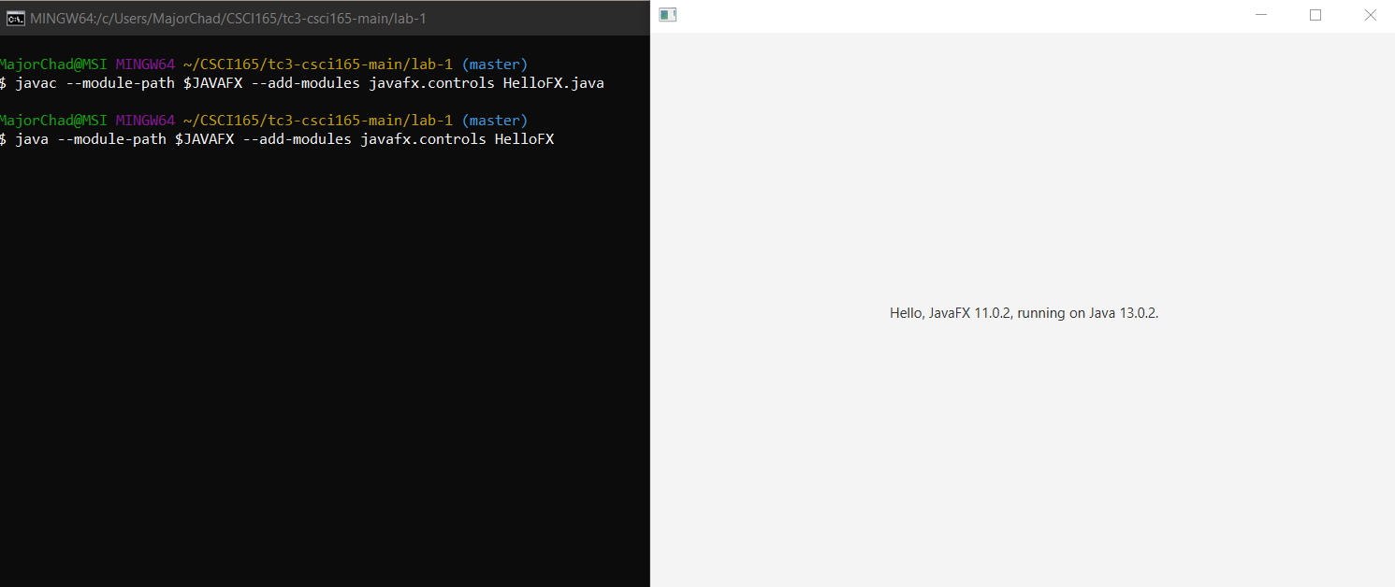

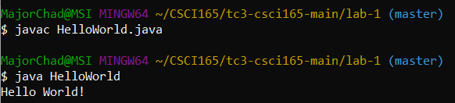

Puzzle Problems 1-6

1. Her first step would be to find number ***x***, she can find number ***x*** by using addition to add her ten homework grades together, this will produce number ***x***. She can then find the average of her homework grades by dividing ***x*** by however many homework grades she has, in this case that number is 10, so ***x***/10 = the average of her 10 homework grades.
2. To encode a message with Caesar’s cipher, you shift each letter in a message by ***N*** amount of letters to the right, (i.e “abc” when ***N***=1, would result in “bcd”). In the case of this problem, ***N***=5, so you would take each letter of the message, and shift the letters to the right in the alphabet by ***N*** amount of times, every letter shift will result in ***N*** being subtracted by 1, once ***N***=0, ***N*** will be reset to 5, and you will move on to the next letter in the message. If a shift has resulted in going past z in the alphabet, you would wrap around to the beginning of the alphabet and continue shifting by the remaining ***N*** amount of times.

1. The message received “sxccohv duh ixq” has been encrypted by a Caesar Cipher with a shift of three. The best way to decode a Caesar Cipher without knowing ***N*** amount of shifts, would be to employ the use of a counter starting at 1, where ***N***=counter and for every incorrect message, counter is added to by 1. Eventually the correct shift will be found, and you will uncover the secret message hidden by Caesar’s Cipher.
2. I would reserve the left most digit as a counter, adding one to it for every number he reads to me, and adding the numbers read to me in the other three digits. If it got to the point where he had over ten grades, the counter would have to be converted to hexadecimal to maintain the amount of space it takes on the chalkboard, while still being a functional counter. Same goes for the running total of the grades, as it soon as it hits anything above 999 it will have to be converted to hexadecimal to maintain the amount of space. If it gets to the point where even hexadecimal doesn’t fit on the chalkboard, it’s safe to assume this childs brain is large enough to do the calculations himself, and he’s just playing you. Once he has finished listing off his grades, you would take the right three digits (the total of grades) and divide it by the leftmost digit (the counter). This will give you the average of his homework grades.
3. When ***N***=15 the output would be as follows:

46

23

70

35

106

53

160

80

40

20

10

5

16

8

4

2

1

1. When ***N***=6 the output would be as follows:

3

10

5

16

8

4

2

1



