Semi-automatic Ultrasound tracking computation

1. Step 1: Angle Calculation
2. Linear regression of the points composing the boundary of the objects of interest.

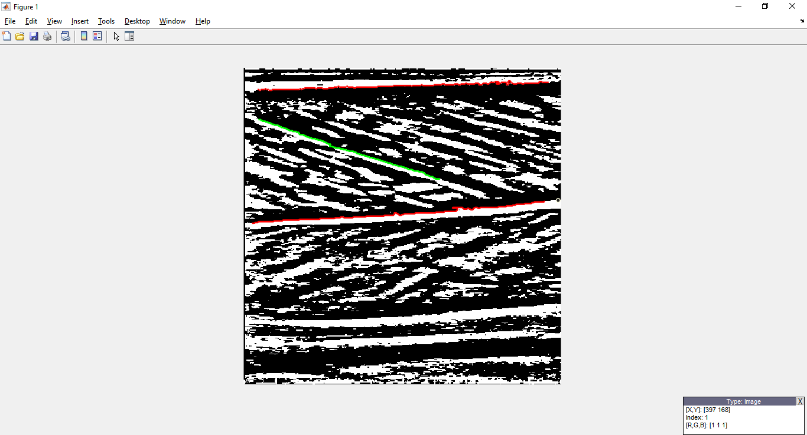

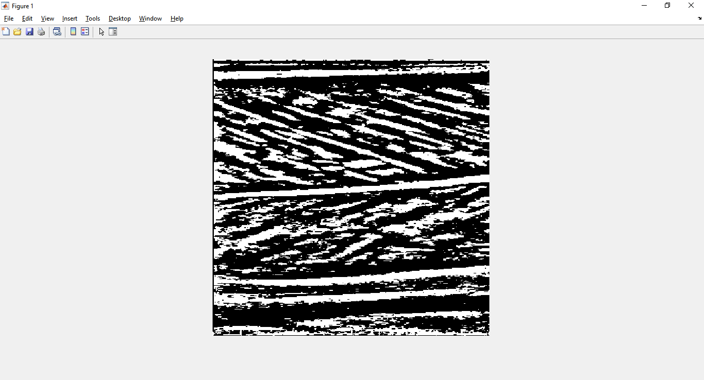

**Ap2 = AAp2 x + BAp2**

**Ap1 = AAp1 x + BAp1**

**Fl = AFl x + BFl**

Function used: *Polyfit*

1. Transform equation line to vector.

$$\vec{Fl}=\left(B_{x},B_{y}\right)=\left(1,A_{Fl}\right)=(1, 0.32)$$

$$\vec{Ap1}=\left(C_{x},C_{y}\right)=(1,A_{Ap1})=(1, -0.0274)$$

$$\vec{Ap2}=\left(D_{x},D_{y}\right)=(1,A_{Ap1})=(1, -0.0542)$$

With AFl | AAp1 | AAp2 the respective slope of Fl Ap1 and Ap2.

|  |  |  |  |  |  |  |  |  |  |  |  |  |
| --- | --- | --- | --- | --- | --- | --- | --- | --- | --- | --- | --- | --- |
|  |  |  |  |  |  |  |  |  |  |  |  |  |
|  |  |  |  |  |  |  |  |  |  |  |  |  |
|  |  |  |  |  |  |  |  |  |  |  |  |  |
|  |  |  |  |  |  |  |  |  |  |  |  |  |
|  |  |  |  |  |  |  |  |  |  |  |  |  |
|  |  |  |  |  |  |  |  |  |  |  |  | B |
|  |  |  |  |  |  |  |  | $$\vec{Fl}$$ |  |  |  |  |
|  |  |  |  |  |  |  |  |  |  |  |  |  |
|  |  |  |  | $$θ$$ |  |  |  | $$\vec{Ap1}$$ |  |  |  |  |
|  | A | **0** |  |  |  |  |  | $$\vec{Ap2}$$ |  |  | **1** | C D |
|  |  |  |  |  |  |  |  |  |  |  |  |  |

To find the angle θ between two vectors we use this formula:

$$\cos{θ}=\frac{\vec{Fl} • \vec{Ap1}}{\left\| \vec{Fl}\right\|×\left\| \vec{Ap1}\right\|}$$

$$\left\| \vec{Fl}\right\| is the norm of the vector, it means "the Euclidean lenght of vector \vec{Fl}"$$

$$\vec{Fl} • \vec{Ap1} is the dot product \left(scalar product\right) of the two vectors.$$

1. Calculate the norm of each vector.

In MATLAB we use the *norm()* function.

The calculation used by the function is as follows:

For $\vec{Fl}=\left(1,A_{Fl}\right)$ and $A_{Fl}=0.32$ the slope of the Fl equation line

$$\left\| \vec{Fl}\right\|=\sqrt{1^{2}+{A_{Fl}}^{2}}$$

$$\left\| \vec{Fl}\right\|=\sqrt{1^{2}+{0.32}^{2}}$$

$$\left\| \vec{Fl}\right\|=1.05$$

$$\left\| \vec{Fl}\right\|=1.05$$

$$\left\| \vec{Ap1}\right\|= 1.0004$$

1. Calculate the dot product of the two vector.

In MATLAB we use the *dot()* function

The calculation used by the function is as follows:

$$\vec{Fl} • \vec{Ap1}= B_{x}×C_{x}+B_{y}×C_{y}$$

$$\vec{Fl} • \vec{Ap1}= 1×1+A_{Fl}×A_{Ap1}$$

$$\vec{Fl} • \vec{Ap1}= 1×1+(0.32)×(-0.0274)$$

$$\vec{Fl} • \vec{Ap1}= 0.9912$$

1. Plug the results into the formula.
$$\cos{θ}=\frac{\vec{Fl} • \vec{Ap1}}{\left\| \vec{Fl}\right\|×\left\| \vec{Ap1}\right\|}$$

$$\cos{θ}=\frac{0.9912}{1.05×1.0004}$$

$$\cos{θ}=\frac{0.9912}{1.05×1.0004}$$

$$\cos{θ}=0.9444$$

2. Find The Angle based on the cosine.

In MATLAB we use the *acosd()* function.

The calculation used by the function is as follows:

$$θ=\cos^{-1}\left(0.9444\right)$$

$$θ=19.1959$$

1. Step 2: Fl Length Calculation
2. Solve the two linear equations || AFl x + BFl = AAp1 x + BAp1

Given:

$\left\{\begin{aligned}A_{Fl}x+B_{Fl}=y \\ A_{Ap1}x+B_{Ap1}=y\end{aligned}\right.$ $\left\{\begin{aligned}0.327x+60.73=y \\ -0.0274x+28.94=y\end{aligned}\right.$

Transform into Matrix Form:

Rearranged:

*Constant*

*Coefficient*

*Coefficient*

🡪

Translate into MATLAB language:

CoefMat = [0.327 -1; -0.0274 -1]

ConstMat = [-60.73; -28.94]

Decomposition:

*%% Backslash is used to solves the system of linear equations*  
IntersectionCoordinate( 1 , : ) = CoefMat\ ConstMat

Do the same computation for Fl and AP2, to get the second intersection point.

1. Fascicle Length