HW3

1. 安裝 R
2. 安裝 RStudio

變數類型與資料結構

* 變數類型：
  + 數值
    - numeric
    - integer
    - complex
  + 邏輯值
  + 文字
* 資料結構：
  + 一維
    - 向量
    - 因素向量
  + 二維
    - 矩陣
    - 資料框
  + 多維
    - 陣列
    - 清單

summary(cars)

## speed dist   
## Min. : 4.0 Min. : 2.00   
## 1st Qu.:12.0 1st Qu.: 26.00   
## Median :15.0 Median : 36.00   
## Mean :15.4 Mean : 42.98   
## 3rd Qu.:19.0 3rd Qu.: 56.00   
## Max. :25.0 Max. :120.00

## Including Plots

You can also embed plots, for example:

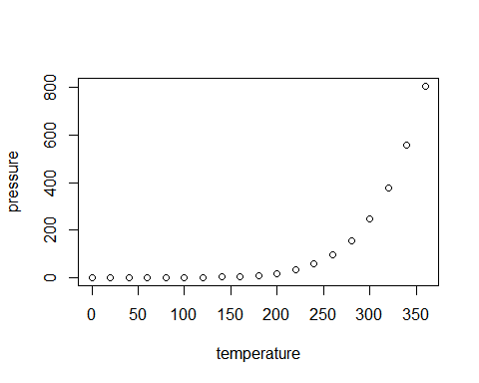

Note that the echo = FALSE parameter was added to the code chunk to prevent printing of the R code that generated the plot.