

2D-Polymeric-Insulator-Electric-Field-Analysis
Report date | Aug 23, 2026, 8:40:12 AM

Contents
1. Global Definitions
1.1. Parameters
1.2. Shared Properties
2. Component 1
2.1. Definitions
2.2. Geometry 1
2.3. Materials
2.4. Electrostatics
2.5. Mesh 1
3. Study 1
3.1. Parametric Sweep
3.2. Stationary
3.3. Solver Configurations
4. Results
4.1. Datasets
4.2. Tables
4.3. Plot Groups

Global Definitions
Date | Jun 29, 2026, 6:28:09 AM

Global settings
Name | 2D-Polymeric-Insulator-Electric-Field-Analysis.mph
Path | D:\COMSOL\2D-Polymeric-Insulator-Electric-Field-Analysis.mph
Version | COMSOL Multiphysics 6.3 (Build: 290)

Used products
COMSOL Multiphysics

Computer information
CPU | Intel64 Family 6 Model 186 Stepping 2, 6 cores, 15.66 GB RAM
Operating system | Windows 11

Parameters
Parameters 1
Name | Expression | Value | Description
L0 | 3350.7[mm] | 3.3507 m | total length of insulator
L | 3400[mm] | 3.4 m

Shared Properties

Default Model Inputs
Tag | cminpt

Component 1
Settings
Description | Value
Unit system | Same as global system (SI)

Definitions

Coordinate Systems

Boundary System 1
Coordinate system type | Boundary system
Tag | sys1

Coordinate names
First | Second | Third
t1 | n | to

Geometry 1
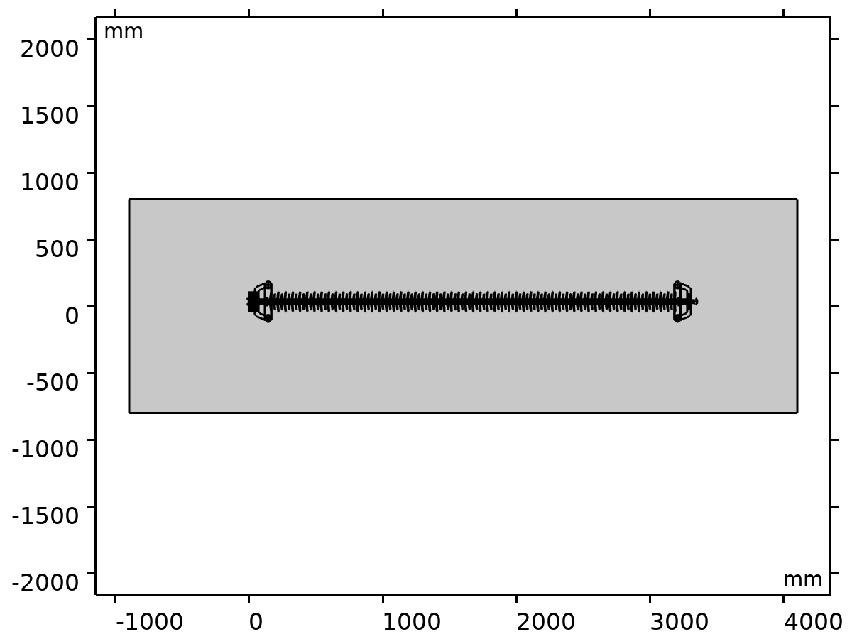
Geometry 1
Units
Length unit | mm
Angular unit | deg

Geometry statistics
Description | Value
Space dimension | 2
Number of domains | 208
Number of boundaries | 2650
Number of vertices | 2450

Import 1 (imp1)
Source
Description | Value
Source | DXF file
Filename | C:\Users\MULUK\Downloads\CLRI - C - 120 - BS - 0001.dxf

Information
Description | Value
Build message | Imported 1 curve object and 1 mixed object from C:\Users\MULUK\Downloads\CLRI - C - 120 - BS - 0001.dxf.

Move 1 (mov1)
Displacement
Description | Value
Specify | Displacement vector
x | 13900
y | -30500

Rectangle 1 (r1)
Size and shape
Description | Value
Width | 5000
Height | 1600

Position
Description | Value
Base | Center
Position | {1600, 0}

Form Union (fin)
Information
Description | Value
Build message | Formed union of 1 solid object, 1 curve object, and 1 mixed object.  Union has 208 domains, 2650 boundaries, and 2450 vertices.

Materials

Air
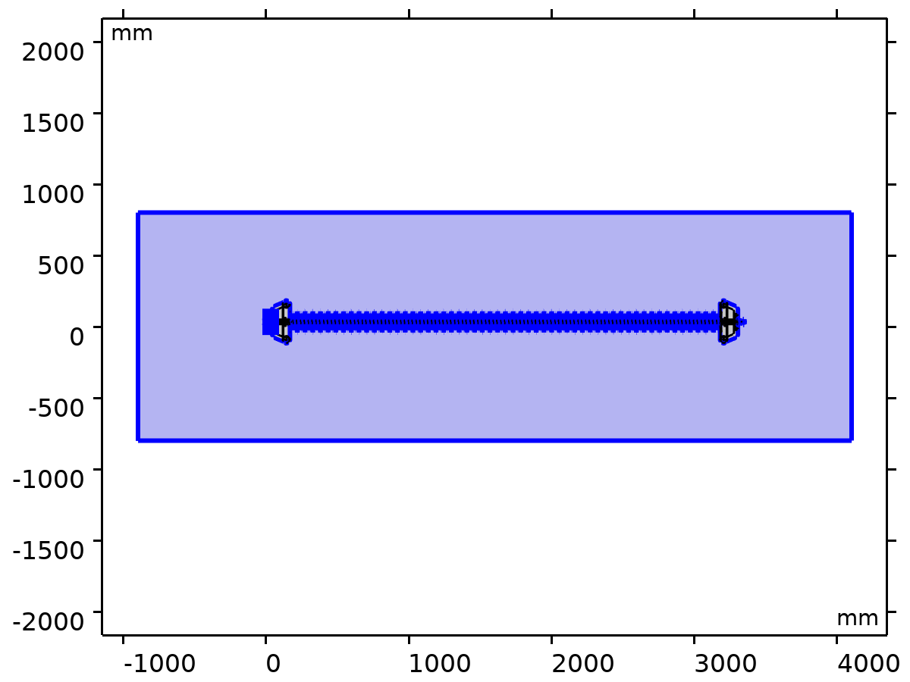
Air
Selection
Geometric entity level | Domain
Selection | Geometry geom1: Dimension 2: All domains

Basic
Description | Value | Unit
Coefficient of thermal expansion | alpha_p(pA, T) | 1/K
Mean molar mass | 0.02897 | kg/mol
Bulk viscosity | muB(T) | Pa·s
Relative permeability | 1 | 1
Relative permittivity | 1 | 1
Dynamic viscosity | eta(T) | Pa·s
Ratio of specific heats | 1.4 | 1
Electric conductivity | 0 | S/m
Heat capacity at constant pressure | Cp(T) | J/(kg·K)
Density | rho(pA, T) | kg/m³
Thermal conductivity | k(T) | W/(m·K)
Speed of sound | cs(T) | m/s

Refractive index
Description | Value
Refractive index, real part | 1
Refractive index, imaginary part | 0

Nonlinear model
Description | Value
Parameter of nonlinearity | def.gamma - 1

Ideal gas
Description | Value | Unit
Specific gas constant | R_const/Mn | J/(kg·K)
Heat capacity at constant pressure | Cp(T) | J/(kg·K)
Ratio of specific heats | 1.4 | 1
Mean molar mass | 0.02897 | kg/mol

FR4 (Circuit Board)
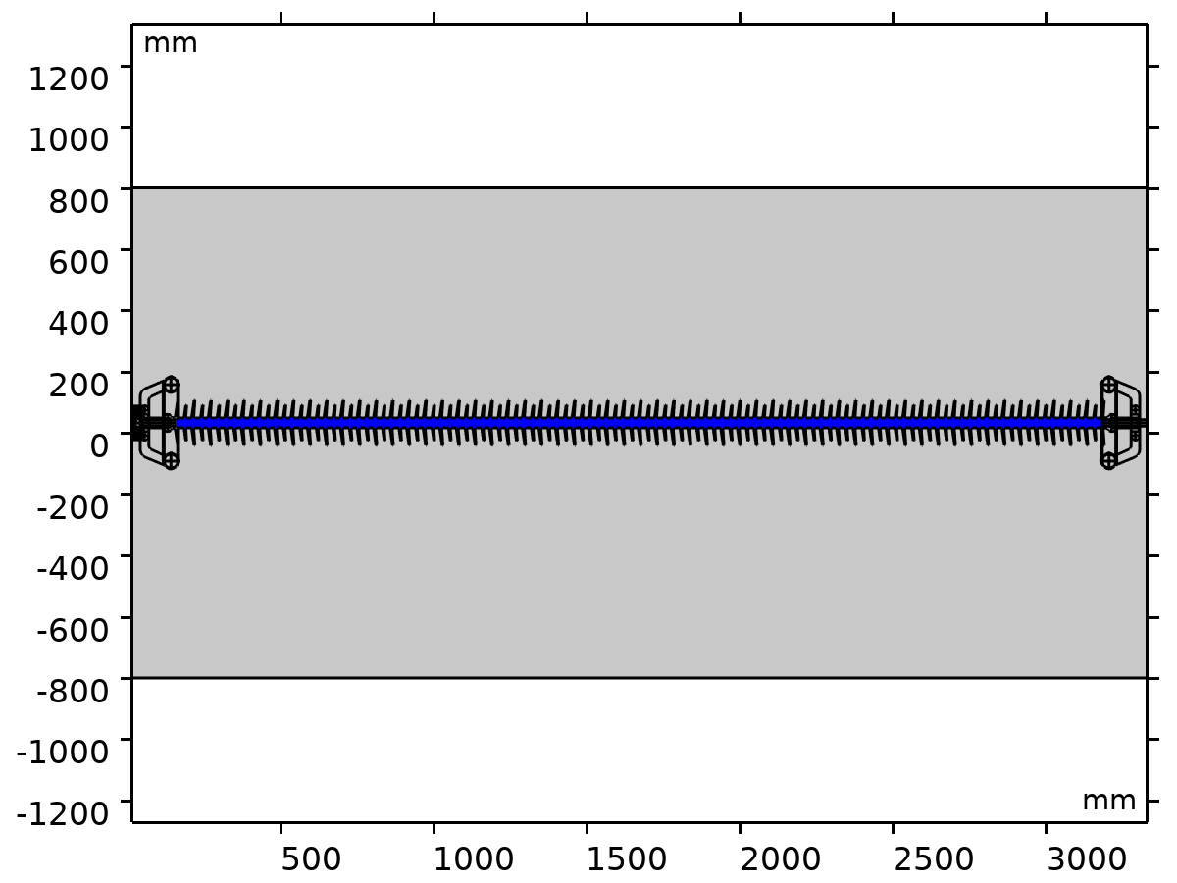
FR4 (Circuit Board)
Selection
Geometric entity level | Domain
Selection | Geometry geom1: Dimension 2: Domains 111–112

Basic
Description | Value | Unit
Relative permeability | 1 | 1
Electric conductivity | 0.004 | S/m
Relative permittivity | 4.5 | 1
Coefficient of thermal expansion | 1.8E-5 | 1/K
Heat capacity at constant pressure | 1369 | J/(kg·K)
Density | 1900 | kg/m³
Thermal conductivity | 0.3 | W/(m·K)

Young's modulus and Poisson's ratio
Description | Value | Unit
Young's modulus | 2.2E10 | Pa
Poisson's ratio | 0.15 | 1

Silicon
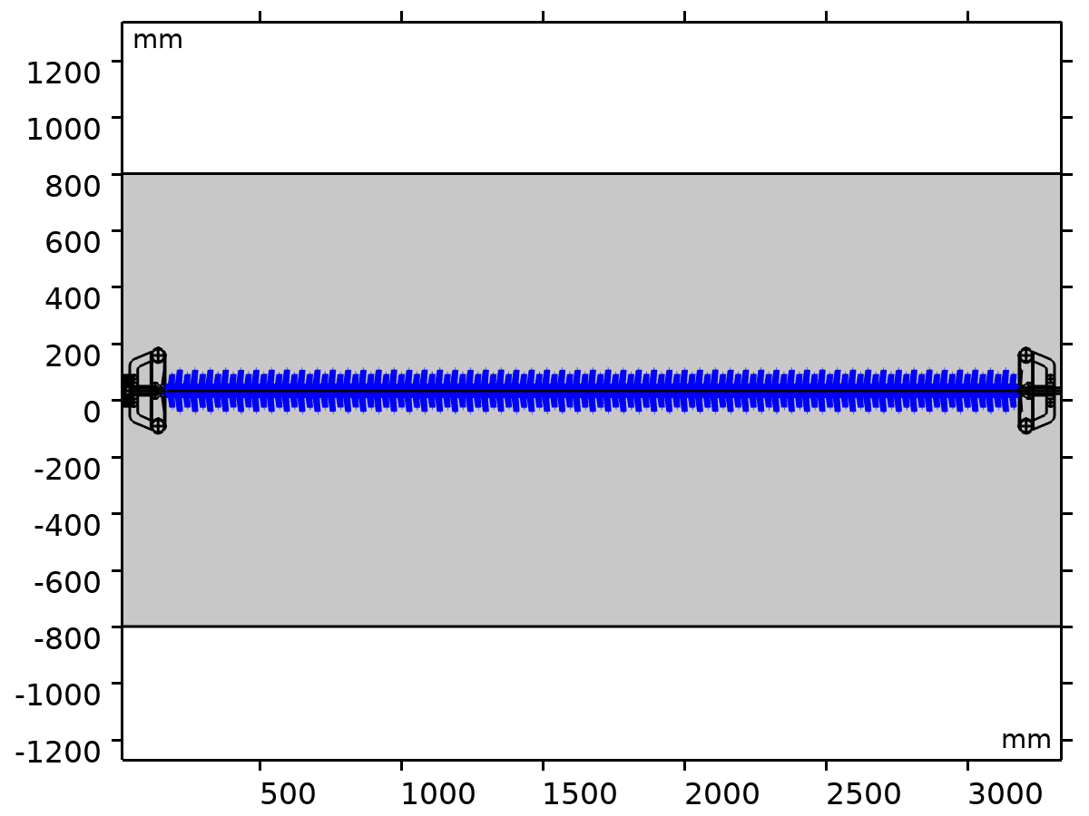
Silicon
Selection
Geometric entity level | Domain
Selection | Geometry geom1: Dimension 2: Domains 110, 113

Basic
Description | Value | Unit
Relative permeability | 1 | 1
Electric conductivity | 1E-12 | S/m
Coefficient of thermal expansion | 2.6E-6 | 1/K
Heat capacity at constant pressure | 700 | J/(kg·K)
Relative permittivity | 11.7 | 1
Density | 2329 | kg/m³
Thermal conductivity | 130 | W/(m·K)

Young's modulus and Poisson's ratio
Description | Value | Unit
Young's modulus | 1.7E11 | Pa
Poisson's ratio | 0.28 | 1

Refractive index
Description | Value
Refractive index, real part | 3.48
Refractive index, imaginary part | 0

Aluminum
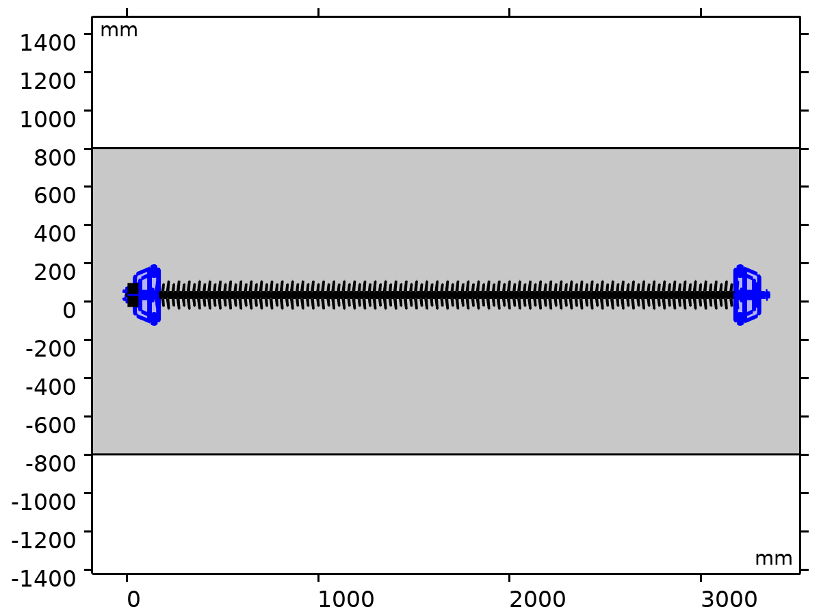
Aluminum
Selection
Geometric entity level | Domain
Selection | Geometry geom1: Dimension 2: Domains 2–109, 114–208

Basic
Description | Value | Unit
Relative permeability | 1 | 1
Heat capacity at constant pressure | 900 | J/(kg·K)
Thermal conductivity | 238 | W/(m·K)
Electric conductivity | 3.774E7 | S/m
Relative permittivity | 1 | 1
Coefficient of thermal expansion | 2.3E-5 | 1/K
Density | 2700 | kg/m³

Young's modulus and Poisson's ratio
Description | Value | Unit
Young's modulus | 7E10 | Pa
Poisson's ratio | 0.33 | 1

Murnaghan
Description | Value | Unit
Murnaghan third-order elastic moduli | -2.5E11 | N/m²
Murnaghan third-order elastic moduli | -3.3E11 | N/m²
Murnaghan third-order elastic moduli | -3.5E11 | N/m²

Electrostatics
Used products
COMSOL Multiphysics

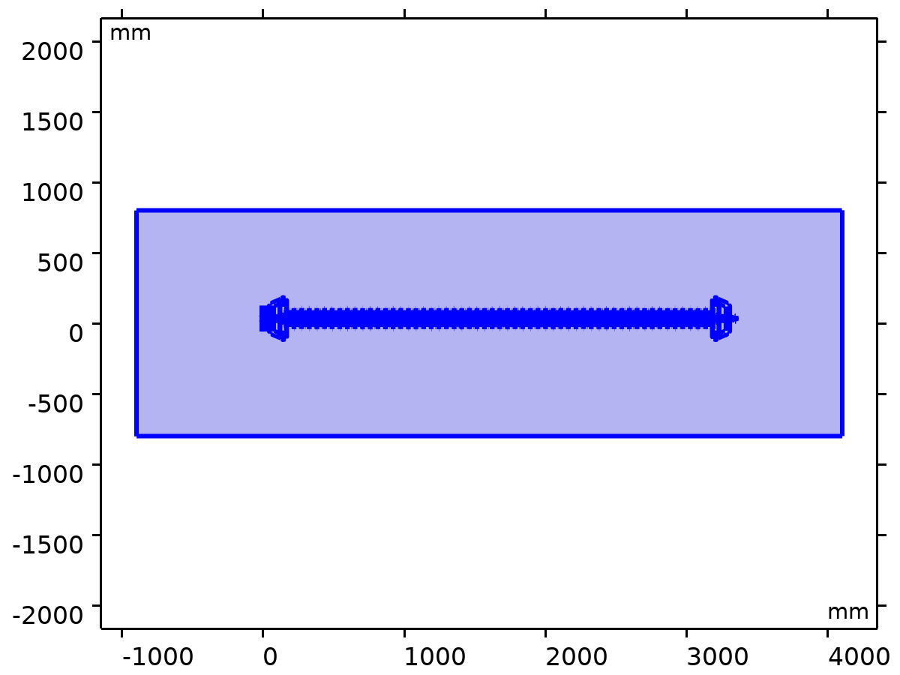
Electrostatics
Selection
Geometric entity level | Domain
Selection | Geometry geom1: Dimension 2: All domains

Equations
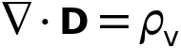
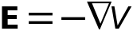

Interface Settings

Discretization
Settings
Description | Value
Formulation | Finite element (quadratic shape function)

Thickness
Settings
Description | Value | Unit
Out-of-plane thickness | 1 | m

Manual Terminal Sweep Settings
Settings
Description | Value | Unit
Use manual terminal sweep | Off
Reference impedance | 50 | Ω

Free Space 1

Free Space 1
Selection
Geometric entity level | Domain
Selection | Geometry geom1: Dimension 2: All domains

Equations

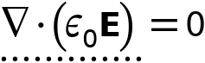

Zero Charge 1
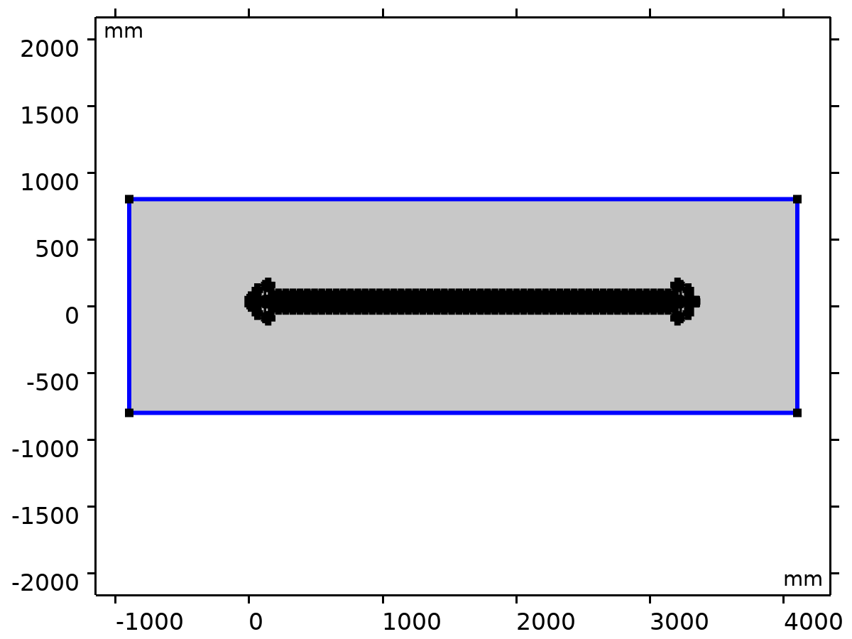
Zero Charge 1
Selection
Geometric entity level | Boundary
Selection | Geometry geom1: Dimension 1: All boundaries

Equations


Initial Values 1

Initial Values 1
Selection
Geometric entity level | Domain
Selection | Geometry geom1: Dimension 2: All domains

Settings
Description | Value | Unit
Electric potential | 0 | V

Coordinate System Selection
Settings
Description | Value
Coordinate system | Global coordinate system

Electric Potential 1
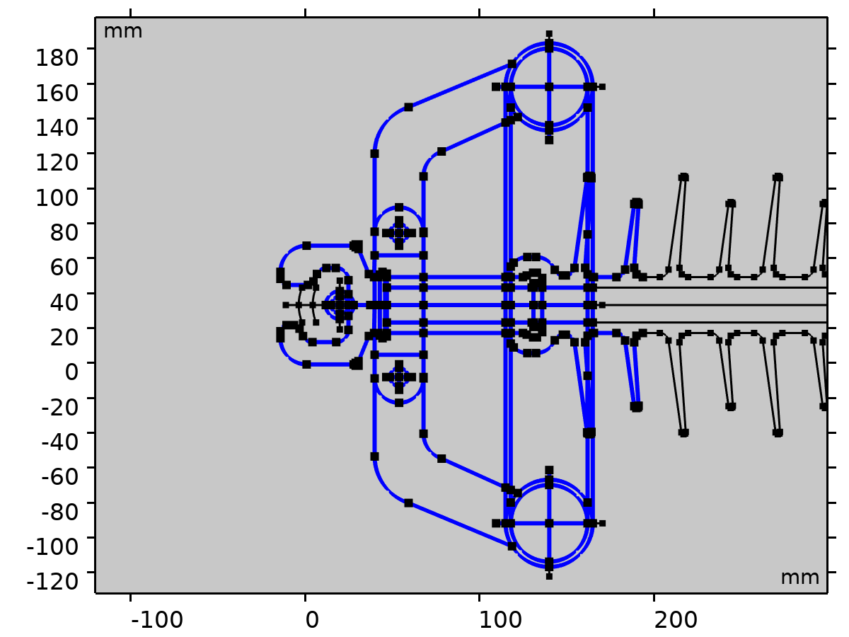
Electric Potential 1
Selection
Geometric entity level | Boundary
Selection | Geometry geom1: Dimension 1: Boundaries 4–5, 7–8, 10–13, 15–19, 21–25, 27–37, 39–40, 42–49, 51–52, 56–121, 123–133, 135–137, 140–187, 189–198, 200–227, 229–230, 232, 234, 236, 238–239, 241–244, 1111–1115, 1118–1119, 1122–1148, 1151–1233

Equations
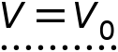

Electric Potential
Settings
Description | Value | Unit
Electric potential | 11000 | V

Ground 1
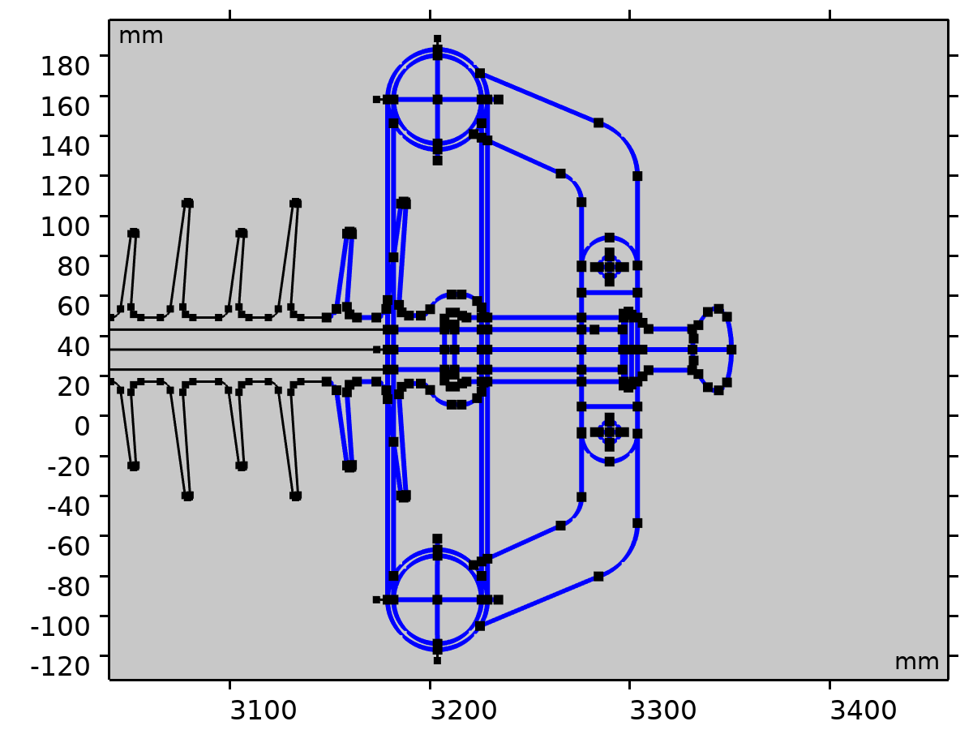
Ground 1
Selection
Geometric entity level | Boundary
Selection | Geometry geom1: Dimension 1: Boundaries 901–906, 910–943, 945–956, 958–1008, 1010–1014, 1016–1083, 1085, 1087–1089, 1092–1109, 2542–2626, 2629–2650

Equations
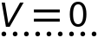

Mesh 1
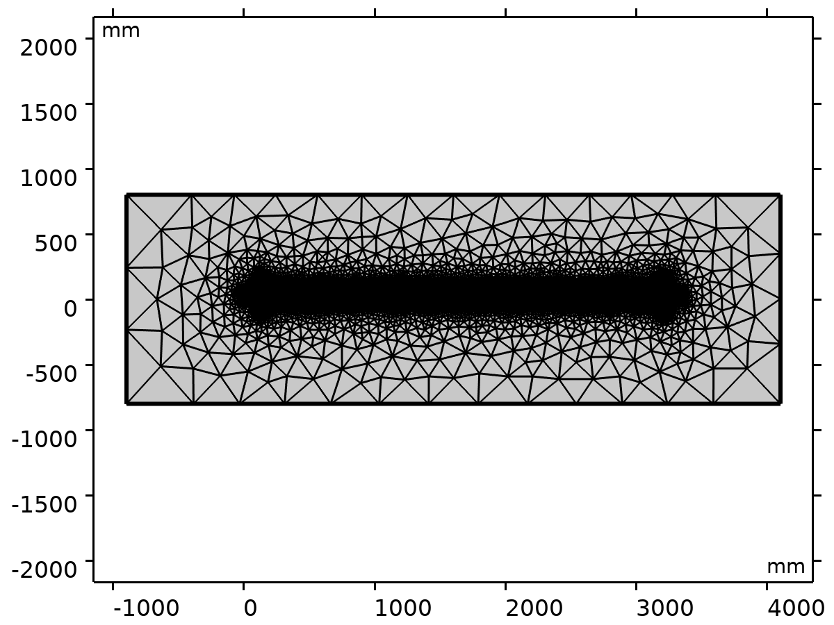
Mesh 1

Size (size)
Settings
Description | Value
Maximum element size | 650
Minimum element size | 30
Curvature factor | 0.6
Maximum element growth rate | 1.5
Predefined size | Coarser

Free Triangular 1 (ftri1)
Selection
Geometric entity level | Domain
Selection | Geometry geom1


Free Triangular 1
Settings
Description | Value
Number of iterations | 4
Maximum element depth to process | 4

Information
Description | Value
Last build time | 12 seconds
Built with | COMSOL 6.3.0.290 (win64), Jul 5, 2026, 2:04:17 AM

Study 1
Computation information
Computation time | 4 s

Parametric Sweep
Parameter name | Parameter value list | Parameter unit
L0 | 220[mm] 240[mm] 260[mm] 280[mm] 300[mm] | mm

Study settings
Description | Value
Sweep type | Specified combinations
Parameter name | L0
Unit | mm

Parameters
Parameter name | Parameter value list | Parameter unit
L0 (total length of insulator) | 220[mm] 240[mm] 260[mm] 280[mm] 300[mm] | mm

Stationary
Study settings
Description | Value
Include geometric nonlinearity | Off

Physics and variables selection
Key | Solve for
Electrostatics (es) | On

Store in output
Interface | Output | Selection
Electrostatics (es) | Physics controlled

Mesh selection
Component | Mesh
Component 1 | Mesh 1

Solver Configurations

Solution 1

Compile Equations: Stationary (st1)
Study and step
Description | Value
Use study
Use study step | Stationary

Dependent Variables 1 (v1)
General
Description | Value
Defined by study step

Initial value calculation constants
Constant name | Initial-value source
L0 | 220[mm] 240[mm] 260[mm] 280[mm] 300[mm]

Electric Potential (comp1.V) (comp1_V)
General
Description | Value
Field components | comp1.V

Stationary Solver 1 (s1)
General
Description | Value
Defined by study step

Results while solving
Description | Value
Probes | None

Parametric 1 (p1)
General
Description | Value
Defined by study step
Run continuation for | No parameter

Parameters
Parameter name | Parameter value list | Parameter unit
L0 | 220[mm] 240[mm] 260[mm] 280[mm] 300[mm] | mm

Fully Coupled 1 (fc1)
General
Description | Value
Linear solver

Results

Datasets

Study 1/Solution 1
Solution
Description | Value
Solution
Component | Component 1 (comp1)

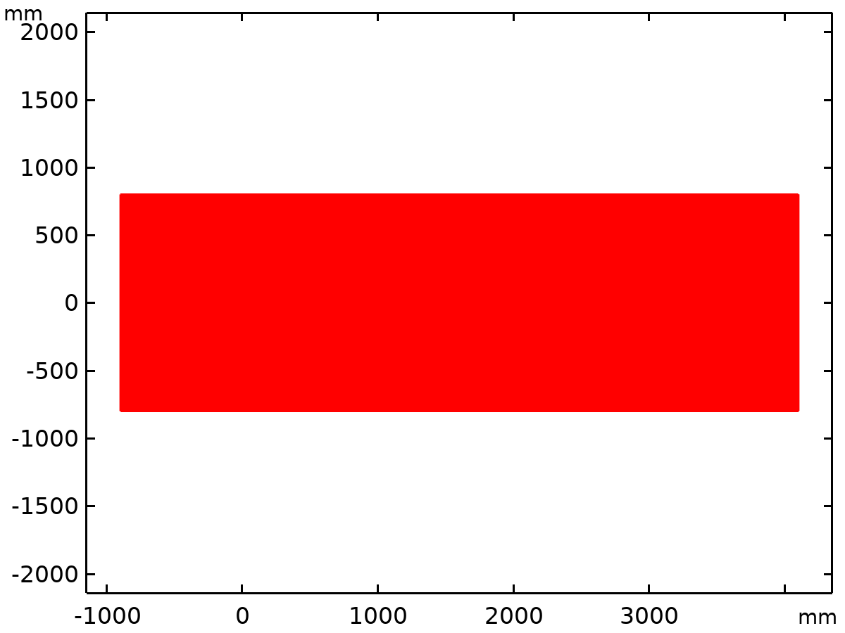
Dataset: Study 1/Solution 1

Cut Line 2D 1
Data
Description | Value
Dataset

Line data
Description | Value
Line entry method | Two points
Points | {{18, 0}, {80, 3350.7}}

Advanced
Description | Value
Space variable | cln1x
Normal variables | {cln1nx, cln1ny}
Tangent variables | {cln1tx, cln1ty}

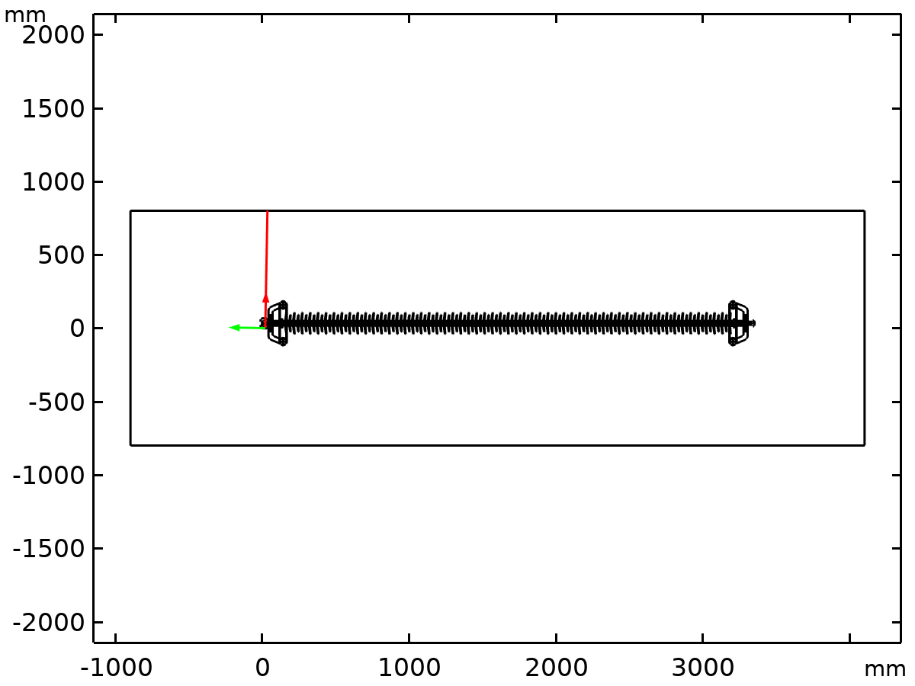
Dataset: Cut Line 2D 1

Edge 2D 1
Data
Description | Value
Dataset

Tables

Maximum and Minimum Values
Graph marker

Plot Groups

Electric Potential (es)
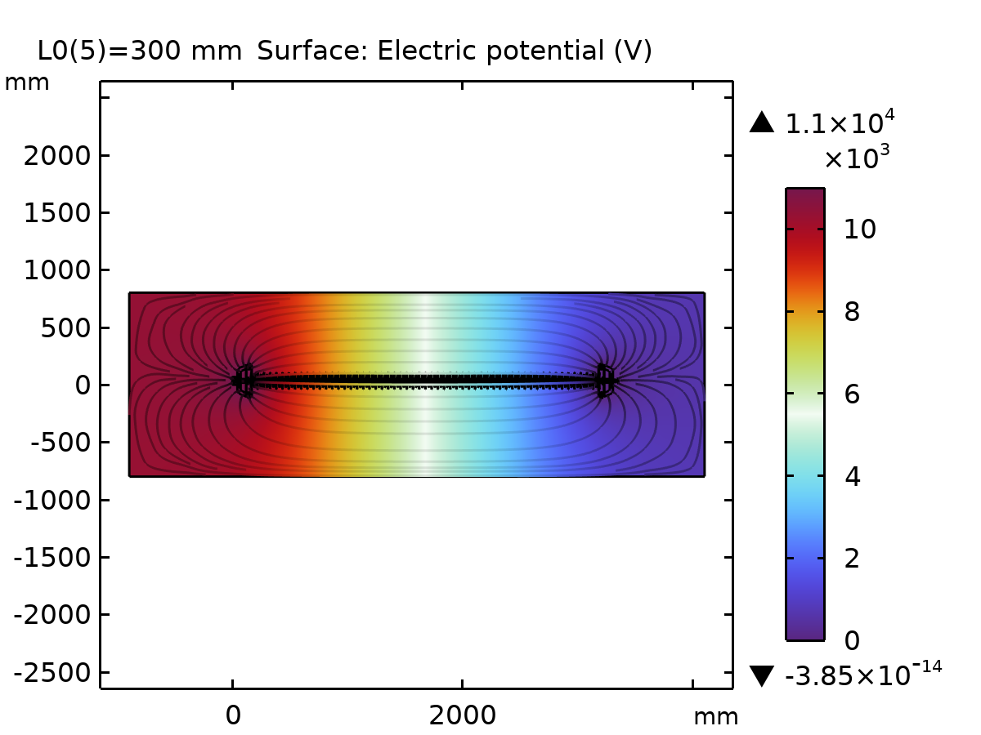
Surface: Electric potential (V)

Electric Field (es)
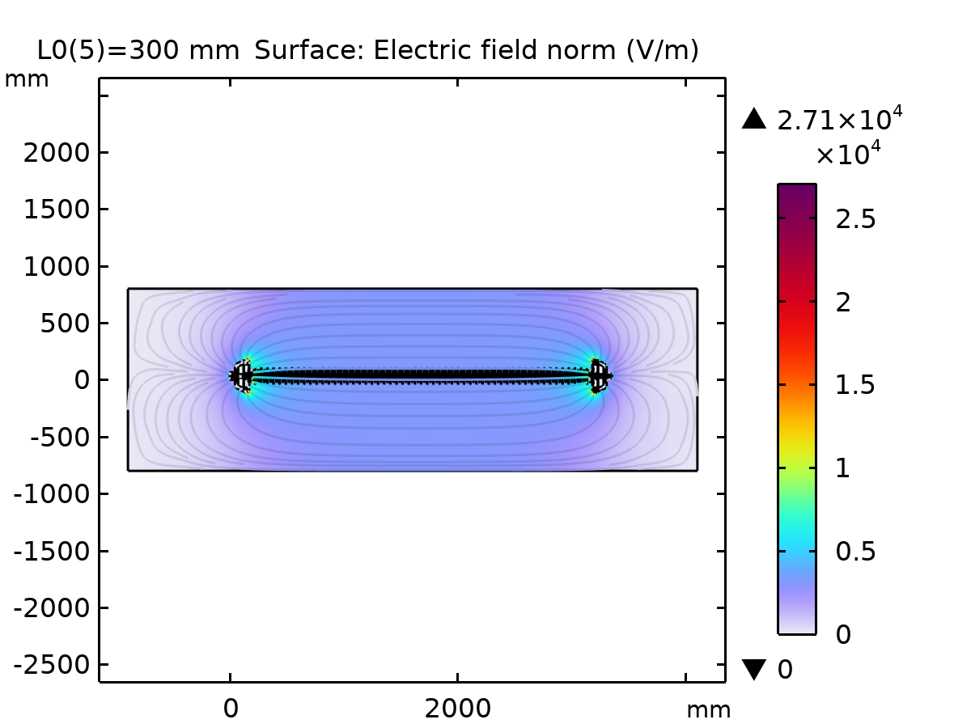
Surface: Electric field norm (V/m)

1D Plot Group 4
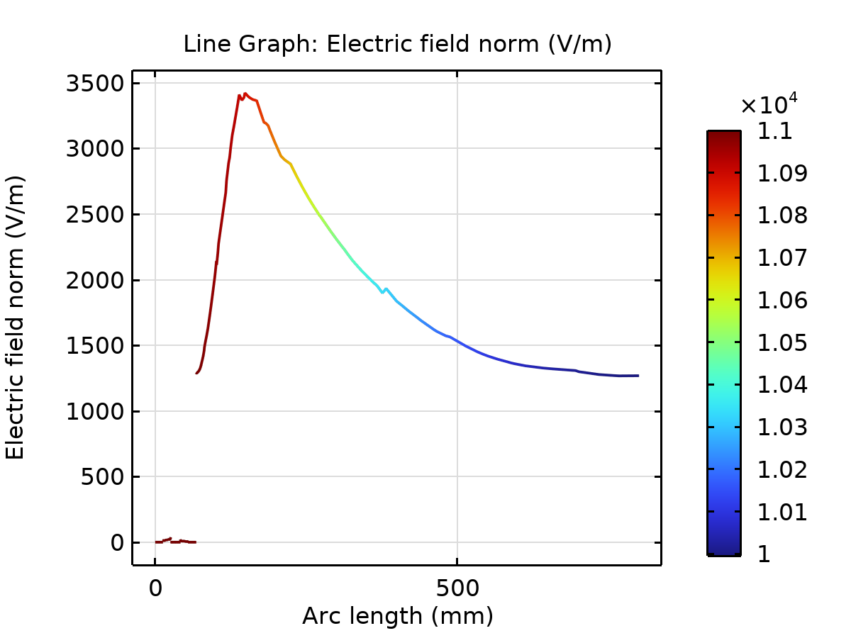
Line Graph: Electric field norm (V/m)

