**Hotel Room Pricing In The Indian Market**

*# Hotel Room Pricing In The Indian Market*  
*# NAME: SANJAY HANSDAK*

## 1. Reading the raw data into a data frame

##setting the directory and assigning a variabel to the data frame  
**setwd**("D:/Data Science and Analytics using R/Final Project")  
  
*#Reading the dataset and creating a data frame*  
hotel.df<-**read.csv**(**paste**("Cities42.csv",sep = ""))  
  
*#Viewing the data*  
**View**(hotel.df)

## 2. Changing the irregularity of dates in the data frame

Use of gsub() command to replace the wrong format of the date

*#Removing the repeated date by gsub command*  
  
hotel.df$Date<-**gsub**("18-Dec-16", "Dec 18 2016", hotel.df$Date)  
hotel.df$Date<-**gsub**("21-Dec-16", "Dec 21 2016", hotel.df$Date)  
hotel.df$Date<-**gsub**("24-Dec-16", "Dec 24 2016", hotel.df$Date)  
hotel.df$Date<-**gsub**("25-Dec-16", "Dec 25 2016", hotel.df$Date)  
hotel.df$Date<-**gsub**("28-Dec-16", "Dec 28 2016", hotel.df$Date)  
hotel.df$Date<-**gsub**("31-Dec-16", "Dec 31 2016", hotel.df$Date)  
hotel.df$Date<-**gsub**("4-Jan-17", "Jan 04 2017", hotel.df$Date)  
hotel.df$Date<-**gsub**("4-Jan-16", "Jan 04 2017", hotel.df$Date)  
hotel.df$Date<-**gsub**("8-Jan-16", "Jan 08 2017", hotel.df$Date)  
hotel.df$Date<-**gsub**("8-Jan-17", "Jan 08 2017", hotel.df$Date)  
hotel.df$Date<-**gsub**("Jan 4 2017", "Jan 04 2017", hotel.df$Date)  
hotel.df$Date<-**gsub**("Jan 8 2017", "Jan 08 2017", hotel.df$Date)

*#Checking the dates*  
  
**table**(hotel.df$Date)

##   
## Dec 18 2016 Dec 21 2016 Dec 24 2016 Dec 25 2016 Dec 28 2016 Dec 31 2016   
## 1652 1655 1655 1655 1655 1655   
## Jan 04 2017 Jan 08 2017   
## 1652 1653

*#Changing dates to factors for labelling*   
  
hotel.df$Date<-**factor**(hotel.df$Date)  
**is.factor**(hotel.df$Date)

## [1] TRUE

*#Checking the labelling*  
**levels**(hotel.df$Date)

## [1] "Dec 18 2016" "Dec 21 2016" "Dec 24 2016" "Dec 25 2016" "Dec 28 2016"  
## [6] "Dec 31 2016" "Jan 04 2017" "Jan 08 2017"

# DATA SUMMARY

### 3. Summary Statistics - mean, sd, median, min, max of variables

*#Analyzing the summary of the data and describing the variables*  
  
**library**(psych)  
**describe**(hotel.df)

## vars n mean sd median trimmed  
## X 1 13232 6616.50 3819.89 6616.5 6616.50  
## CityName* 2 13232 18.07 11.72 16.0 17.29  
## Population 3 13232 4416836.87 4258386.00 3046163.0 4040816.22  
## CityRank 4 13232 14.83 13.51 9.0 13.30  
## IsMetroCity 5 13232 0.28 0.45 0.0 0.23  
## IsTouristDestination 6 13232 0.70 0.46 1.0 0.75  
## IsWeekend 7 13232 0.62 0.48 1.0 0.65  
## IsNewYearEve 8 13232 0.12 0.33 0.0 0.03  
## Date* 9 13232 4.50 2.29 4.0 4.50  
## HotelName* 10 13232 841.19 488.16 827.0 841.18  
## RoomRent 11 13232 5473.99 7333.12 4000.0 4383.33  
## StarRating 12 13232 3.46 0.76 3.0 3.40  
## Airport 13 13232 21.16 22.76 15.0 16.39  
## HotelAddress* 14 13232 1202.53 582.17 1261.0 1233.25  
## HotelPincode 15 13232 397430.26 259837.50 395003.0 388540.47  
## HotelDescription* 16 13224 581.34 363.26 567.0 575.37  
## FreeWifi 17 13232 0.93 0.26 1.0 1.00  
## FreeBreakfast 18 13232 0.65 0.48 1.0 0.69  
## HotelCapacity 19 13232 62.51 76.66 34.0 46.03  
## HasSwimmingPool 20 13232 0.36 0.48 0.0 0.32  
## mad min max range skew  
## X 4904.44 1.0 13232 13231.0 0.00  
## CityName* 11.86 1.0 42 41.0 0.48  
## Population 3846498.95 8096.0 12442373 12434277.0 0.68  
## CityRank 11.86 0.0 44 44.0 0.69  
## IsMetroCity 0.00 0.0 1 1.0 0.96  
## IsTouristDestination 0.00 0.0 1 1.0 -0.86  
## IsWeekend 0.00 0.0 1 1.0 -0.51  
## IsNewYearEve 0.00 0.0 1 1.0 2.28  
## Date* 2.97 1.0 8 7.0 0.00  
## HotelName* 641.97 1.0 1670 1669.0 0.01  
## RoomRent 2653.85 299.0 322500 322201.0 16.75  
## StarRating 0.74 0.0 5 5.0 0.48  
## Airport 11.12 0.2 124 123.8 2.73  
## HotelAddress* 668.65 1.0 2108 2107.0 -0.37  
## HotelPincode 257975.37 100025.0 7000157 6900132.0 9.99  
## HotelDescription* 472.95 1.0 1226 1225.0 0.11  
## FreeWifi 0.00 0.0 1 1.0 -3.25  
## FreeBreakfast 0.00 0.0 1 1.0 -0.62  
## HotelCapacity 28.17 0.0 600 600.0 2.95  
## HasSwimmingPool 0.00 0.0 1 1.0 0.60  
## kurtosis se  
## X -1.20 33.21  
## CityName* -0.88 0.10  
## Population -1.08 37019.65  
## CityRank -0.76 0.12  
## IsMetroCity -1.08 0.00  
## IsTouristDestination -1.26 0.00  
## IsWeekend -1.74 0.00  
## IsNewYearEve 3.18 0.00  
## Date* -1.24 0.02  
## HotelName* -1.25 4.24  
## RoomRent 582.06 63.75  
## StarRating 0.25 0.01  
## Airport 7.89 0.20  
## HotelAddress* -0.88 5.06  
## HotelPincode 249.76 2258.86  
## HotelDescription* -1.25 3.16  
## FreeWifi 8.57 0.00  
## FreeBreakfast -1.61 0.00  
## HotelCapacity 11.39 0.67  
## HasSwimmingPool -1.64 0.00

**summary**(hotel.df)

## X CityName Population CityRank   
## Min. : 1 Delhi :2048 Min. : 8096 Min. : 0.00   
## 1st Qu.: 3309 Jaipur : 768 1st Qu.: 744983 1st Qu.: 2.00   
## Median : 6616 Mumbai : 712 Median : 3046163 Median : 9.00   
## Mean : 6616 Bangalore: 656 Mean : 4416837 Mean :14.83   
## 3rd Qu.: 9924 Goa : 624 3rd Qu.: 8443675 3rd Qu.:24.00   
## Max. :13232 Kochi : 608 Max. :12442373 Max. :44.00   
## (Other) :7816   
## IsMetroCity IsTouristDestination IsWeekend IsNewYearEve   
## Min. :0.0000 Min. :0.0000 Min. :0.0000 Min. :0.0000   
## 1st Qu.:0.0000 1st Qu.:0.0000 1st Qu.:0.0000 1st Qu.:0.0000   
## Median :0.0000 Median :1.0000 Median :1.0000 Median :0.0000   
## Mean :0.2842 Mean :0.6972 Mean :0.6228 Mean :0.1244   
## 3rd Qu.:1.0000 3rd Qu.:1.0000 3rd Qu.:1.0000 3rd Qu.:0.0000   
## Max. :1.0000 Max. :1.0000 Max. :1.0000 Max. :1.0000   
##   
## Date HotelName RoomRent   
## Dec 21 2016:1655 Vivanta by Taj : 32 Min. : 299   
## Dec 24 2016:1655 Goldfinch Hotel : 24 1st Qu.: 2436   
## Dec 25 2016:1655 OYO Rooms : 24 Median : 4000   
## Dec 28 2016:1655 The Gordon House Hotel: 24 Mean : 5474   
## Dec 31 2016:1655 Apnayt Villa : 16 3rd Qu.: 6299   
## Jan 08 2017:1653 Bentleys Hotel Colaba : 16 Max. :322500   
## (Other) :3304 (Other) :13096   
## StarRating Airport   
## Min. :0.000 Min. : 0.20   
## 1st Qu.:3.000 1st Qu.: 8.40   
## Median :3.000 Median : 15.00   
## Mean :3.459 Mean : 21.16   
## 3rd Qu.:4.000 3rd Qu.: 24.00   
## Max. :5.000 Max. :124.00   
##   
## HotelAddress   
## The Mall, Shimla : 32   
## #2-91/14/8, White Fields, Kondapur, Hitech City, Hyderabad, 500084 India: 16   
## 121, City Terrace, Walchand Hirachand Marg, Mumbai, Maharashtra : 16   
## 14-4507/9, Balmatta Road, Near Jyothi Circle, Hampankatta : 16   
## 144/7, Rajiv Gandi Salai (OMR), Kottivakkam, Chennai, Tamil Nadu : 16   
## 17, Oliver Road, Colaba, Mumbai, Maharashtra : 16   
## (Other) :13120   
## HotelPincode HotelDescription FreeWifi FreeBreakfast   
## Min. : 100025 3 : 120 Min. :0.0000 Min. :0.0000   
## 1st Qu.: 221001 Abc : 112 1st Qu.:1.0000 1st Qu.:0.0000   
## Median : 395003 3-star hotel: 104 Median :1.0000 Median :1.0000   
## Mean : 397430 3.5 : 88 Mean :0.9259 Mean :0.6491   
## 3rd Qu.: 570001 4 : 72 3rd Qu.:1.0000 3rd Qu.:1.0000   
## Max. :7000157 (Other) :12728 Max. :1.0000 Max. :1.0000   
## NA's : 8   
## HotelCapacity HasSwimmingPool   
## Min. : 0.00 Min. :0.0000   
## 1st Qu.: 16.00 1st Qu.:0.0000   
## Median : 34.00 Median :0.0000   
## Mean : 62.51 Mean :0.3558   
## 3rd Qu.: 75.00 3rd Qu.:1.0000   
## Max. :600.00 Max. :1.0000   
##

## 4. Identifying the idependent variable Y and independent variables X1,X2 and X3 from the dataframe.

*#Taking Y = RoomRent, identifying the most relevent predictor variables by correlation corrgram*  
  
  
*#Corrgram*  
  
**library**(corrgram)  
  
**corrgram**(hotel.df, order=TRUE, lower.panel=panel.shade,  
 upper.panel=panel.pie, text.panel=panel.txt,  
 main="Corrgram of Hotel data")

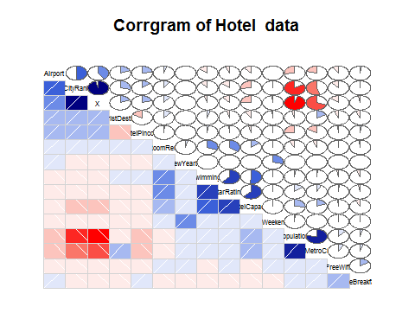

# ##through corrgram HasSwimming, StarRating, HotelCapital are very well correlated to RoomRent ##so we can take them as predictors ##Visualizing data for Y as Room rent and X1,X2,X3 as HasSwimmingPool, StarRating and HotelCapacity respectively

# VISUALIZATION

## 5. Visualizing the independent variables X1,X2 and X3 in the dataframe

*#Table for HasSwimmingPool*  
 **table**(hotel.df$HasSwimmingPool)

##   
## 0 1   
## 8524 4708

Swim<-**table**(hotel.df$HasSwimmingPool)  
 **barplot**(Swim,main="Barrplot of Hotel Swimming Pool")

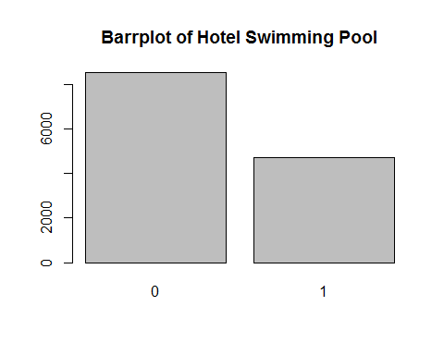

Result: The above visualization tells us that the number of hotel not having swimming pools is greater than the number of hotels having swimming pool.

*#Table for StarRating*  
 **table**(hotel.df$StarRating)

##   
## 0 1 2 2.5 3 3.2 3.3 3.4 3.5 3.6 3.7 3.8 3.9 4 4.1   
## 16 8 440 632 5953 8 16 8 1752 8 24 16 32 2463 24   
## 4.3 4.4 4.5 4.7 4.8 5   
## 16 8 376 8 16 1408

starRating<-**table**(hotel.df$StarRating)  
 **barplot**(starRating,main = "Barrplot for Star Rating")

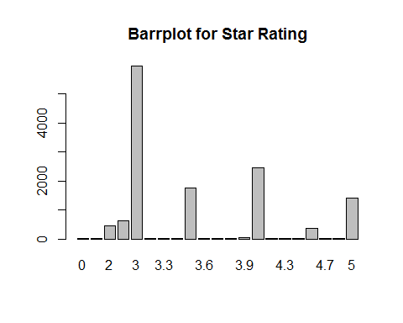

Result: The above data reveals the class of hotels in India , with 3 star hotels at it’s maximum i.e., the nmber of 3 star hotels is India I too large.

*#BoxPlot for HotelCapacity*  
 **boxplot**(hotel.df$HotelCapacity, main="Boxplot for Hotel Capacity",horizontal = TRUE)

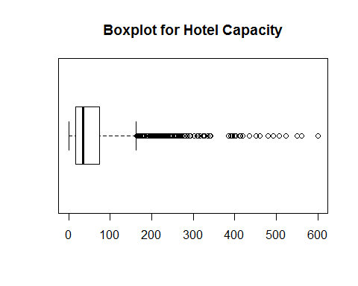

Result: There are a lot of outlier to the hotel capacity data which makes the data quite uncertain about the mean and median.

# ROLE OF DIFFERENT DEPENDENT VARIABLES ON THE PRICNG OF THE HOTEL ROOM.

### 5a. Scattreplot distribution between Star Rating and RoomRent

*#Scatterplot pair wise for predictor variable*  
   
 **library**(car)

##   
## Attaching package: 'car'

## The following object is masked from 'package:psych':  
##   
## logit

*#StarRating Vs RoomRent*  
   
 **scatterplot**(hotel.df$StarRating,hotel.df$RoomRent,main="RoomRent of Hotels with StarRating",ylab = "RoomRent in INR", xlab="Star rating out of 5",cex=1.1)

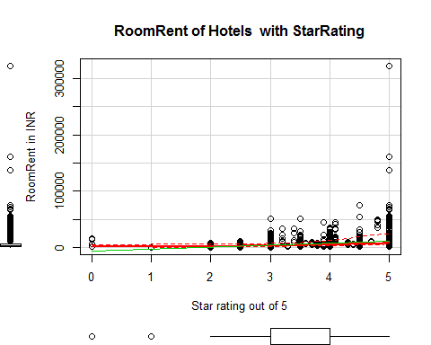

### 5b. Scattreplot distribution between Hotel Capacity and RoomRent

*#RoomRent Vs HotelCapacity*  
   
 **scatterplot**(hotel.df$RoomRent,hotel.df$HotelCapacity,main="RoomRent of Hotels with Hotel capacity",ylab = "Hotel Capacity in rooms", xlab="RoomRent in INR",cex=1.1)

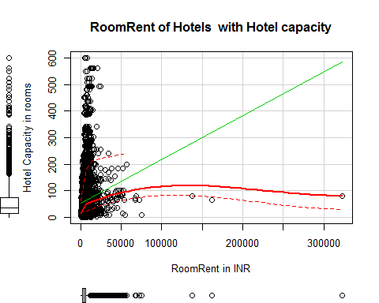

### 5c. Plot and bwplot distribution between HasSwimmingPool and RoomRent

*#RoomRent Vs HasSwimmingPool*  
   
 **plot**(**jitter**(hotel.df$RoomRent),**jitter**(hotel.df$HasSwimmingPool),main="RoomRent of Hotels with HasSwimmingPool",ylab = "Has Swimmng Pool ", xlab="RoomRent",cex=1.1)

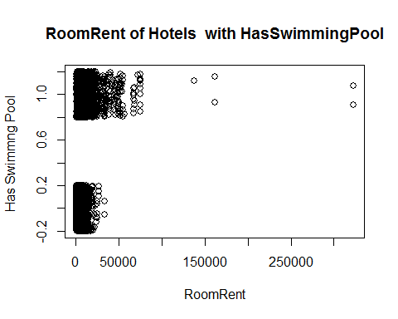

**library**(lattice)  
 **bwplot**(HasSwimmingPool~RoomRent, data = hotel.df,main="RoomRent of Hotels with HasSwimmingPool",ylab = "Has Swimmng Pool ", xlab="RoomRent" )

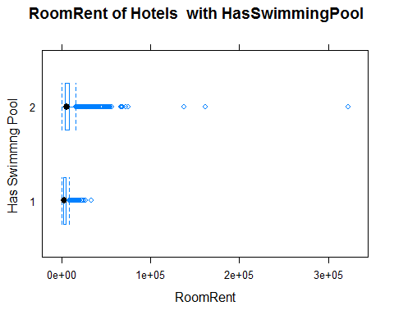

### 5d. Scattreplotmatrix distribution between Hotel Capacity, HasSwimmingPool, StarRating and RoomRent

*#Scatterplot matrix*  
   
 **scatterplotMatrix**(  
 hotel.df[  
 ,**c**("RoomRent","HasSwimmingPool","StarRating", "HotelCapacity")],   
 spread=FALSE, smoother.args=**list**(lty=2),  
 main="Scatter Plot Matrix", diagonal = "histogram")

## Warning in smoother(x, y, col = col[2], log.x = FALSE, log.y = FALSE,  
## spread = spread, : could not fit smooth

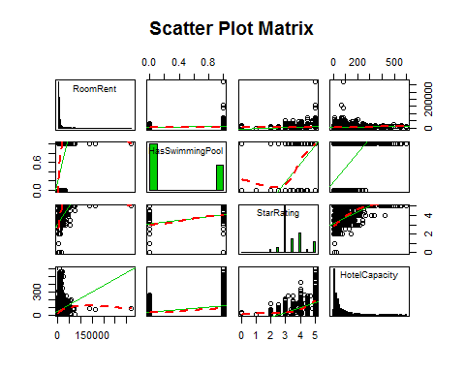

### 5e. Corrggram of Hotel Capacity, HasSwimmingPool, StarRating and RoomRent

*#Corrgram of Y, x1, x2, x3*  
   
 **library**(corrgram)  
   
 xyz<-**data.frame**(hotel.df$RoomRent, hotel.df$HasSwimmingPool, hotel.df$HotelCapacity, hotel.df$StarRating)  
 **corrgram**(xyz, order=TRUE, lower.panel=panel.shade,  
 upper.panel=panel.pie, text.panel=panel.txt,  
 main="Corrgram of Hotel Prices In India")

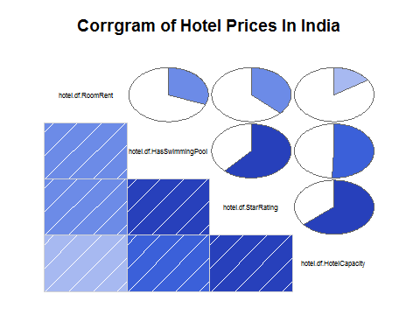

### 6. Covariance and Varaince matrix between Independent variables and RoomRent

*#Variance-Covariance Matrix for Y, x1, x2, x3*  
  
 x<-hotel.df[,**c**("HasSwimmingPool","StarRating", "HotelCapacity")]  
 y<-hotel.df[,**c**("RoomRent")]  
 **cor**(x,y)

## [,1]  
## HasSwimmingPool 0.3116577  
## StarRating 0.3693734  
## HotelCapacity 0.1578733

**cov**(x,y)

## [,1]  
## HasSwimmingPool 1094.202  
## StarRating 2048.375  
## HotelCapacity 88753.413

**var**(x,y)

## [,1]  
## HasSwimmingPool 1094.202  
## StarRating 2048.375  
## HotelCapacity 88753.413

*#Forming a variable which is having RoomRent less than 1 lakh because the outliers effect the average*  
 RoomRent1.df <-hotel.df[**which**(hotel.df$RoomRent<100000),]

This data frame containing the room rent of hotels less than 100k will help us to get a clear

View of how really is the mean of the data without getting affected by the extreme outliers.

### 7. Summary and Visualization of other factors which affect RoomRent

*#Comparing other factors and their pattern using other trends with roomrent*  
   
 *#Analyzing IsWeekeng effect on RoomRent*  
 **table**(hotel.df$IsWeekend)

##   
## 0 1   
## 4991 8241

table1<-**table**(hotel.df$IsWeekend)  
 **barplot**(table1, main="Distribution of Weekend", xlab="Not weekend(0) Weekend(1)", col="orange")

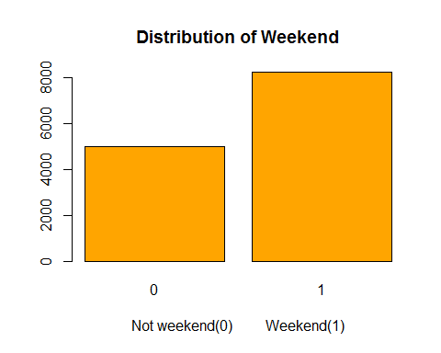

*#Effect of Isweekend on RoomRent*  
 iw= **aggregate**(RoomRent ~ IsWeekend, data=hotel.df,mean)  
 iw

## IsWeekend RoomRent  
## 1 0 5430.835  
## 2 1 5500.129

**boxplot**(RoomRent~IsWeekend,data=hotel.df, main="Room rent vs. IsWeekend", ylab="Not weekend(0) weekend(1)", xlab="Room Rent in rupees ", col=**c**("red","blue"),horizontal=TRUE)

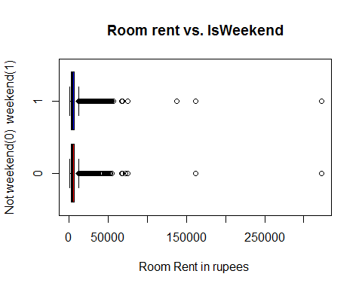

*#Without extreme outliers*   
 **boxplot**(RoomRent~IsWeekend,data=RoomRent1.df, main="Room rent vs. IsWeekend", ylab="Not weekend(0) weekend(1)", xlab="Room Rent in rupees ", col=**c**("red","blue"),horizontal=TRUE)

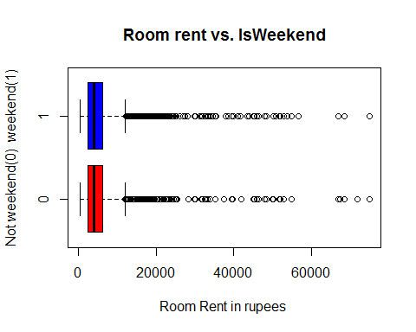

*#Comapring RoomRent on different dates*  
 **table**(hotel.df$Date)

##   
## Dec 18 2016 Dec 21 2016 Dec 24 2016 Dec 25 2016 Dec 28 2016 Dec 31 2016   
## 1652 1655 1655 1655 1655 1655   
## Jan 04 2017 Jan 08 2017   
## 1652 1653

**library**(lattice)  
 **histogram**(~Date, data = hotel.df, main="Distribution of Dates", xlab = "Differnt of Dates", col="Blue")

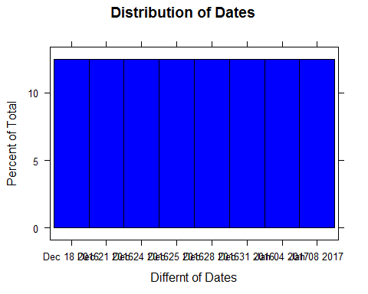

*#Effect of different dates on RoomRent*  
   
 d = **aggregate**(RoomRent ~ Date, data = hotel.df,mean)  
 d

## Date RoomRent  
## 1 Dec 18 2016 4896.402  
## 2 Dec 21 2016 5085.315  
## 3 Dec 24 2016 5543.236  
## 4 Dec 25 2016 5464.143  
## 5 Dec 28 2016 5593.924  
## 6 Dec 31 2016 6191.776  
## 7 Jan 04 2017 5674.062  
## 8 Jan 08 2017 5342.234

**scatterplot**(d$Date,d$RoomRent, main="Scatterplot between Date and RoomRent", xlab="Date", ylab = "Room Rent in Rupees")

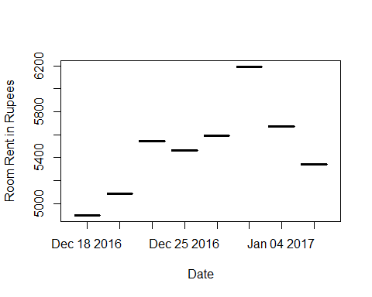

Result : The above Visualization of room rents according to the sold out dates tell us that the room rent on 31st December 2016 was the highest among all sold out dates. The average room rent on 31st December was around 6.1k.

**boxplot**(RoomRent~Date,data=hotel.df, main="Room rent vs. Date", xlab="Different Dates", ylab="Room Rent in rupees ", col=**c**("red","blue","green","yellow"))

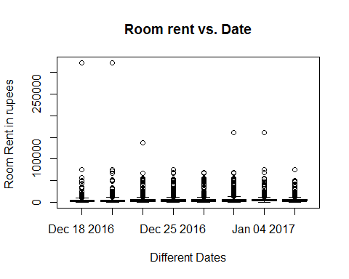

##Without extreme outliers  
 **boxplot**(RoomRent~Date,data=RoomRent1.df, main="Room rent vs. Date", xlab="Different Dates", ylab="Room Rent in rupees ", col=**c**("red","blue","green","yellow"))

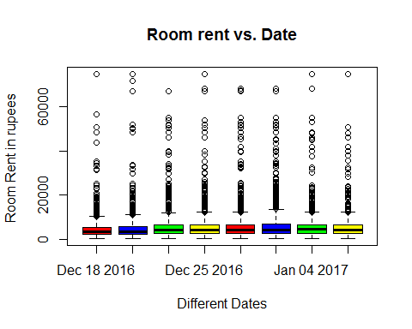

*#Analyzing IsMetroCity effect on RoomRent*  
 **table**(hotel.df$IsMetroCity)

##   
## 0 1   
## 9472 3760

table1<-**table**(hotel.df$IsMetroCity)  
 **barplot**(table1, main="Distribution of IsMetroCity", xlab="Not a Metro city(0) Is a Metro City(1)", col="blue")

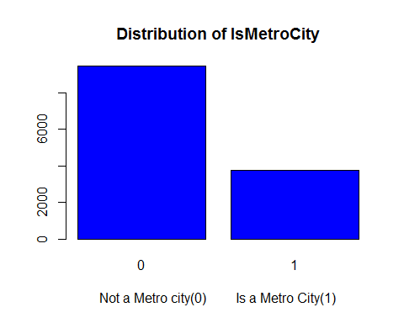

*#Effect of IsMetroCity on RoomRent*  
 imc = **aggregate**(RoomRent ~ IsMetroCity, data = hotel.df, mean)  
 imc

## IsMetroCity RoomRent  
## 1 0 5782.794  
## 2 1 4696.073

**boxplot**(RoomRent~IsMetroCity,data=hotel.df, main="Room rent vs. IsMetroCity", ylab="Metro city(1) or not(0)", xlab="Room Rent in rupees ", col=**c**("red","blue","green","yellow"),horizontal=TRUE)

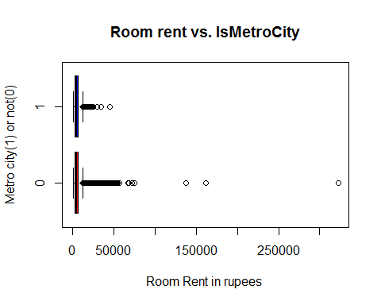

##Without extreme outliers  
 **boxplot**(RoomRent~IsMetroCity,data=RoomRent1.df, main="Room rent vs. IsMetroCity", ylab="Metro city(1) or not(0)", xlab="Room Rent in rupees ", col=**c**("red","blue","green","yellow"),horizontal=TRUE)

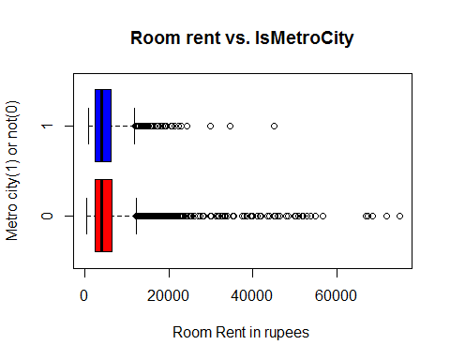

*#Analyzing IsTouristDestination effect on RoomRent*  
 **table**(hotel.df$IsTouristDestination)

##   
## 0 1   
## 4007 9225

table1<-**table**(hotel.df$IsTouristDestination)  
 **barplot**(table1, main="Distribution of IsToursitDestination", xlab="Not a Tourist Destination(0) Is a Tourist Destination(1)", col="yellow")

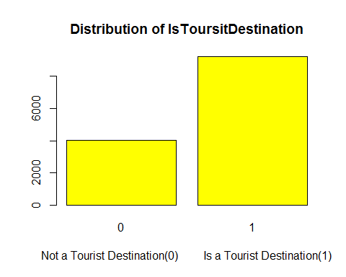

*#Effect of IsTouristDestination on RoomRent*  
 itd = **aggregate**(RoomRent ~ IsTouristDestination, data = hotel.df, mean)  
 itd

## IsTouristDestination RoomRent  
## 1 0 4111.003  
## 2 1 6066.024

**boxplot**(RoomRent~IsTouristDestination,data=hotel.df, main="Room rent vs. IsTouristDestination ", ylab=" IsTouristDestination (1) or not(0)", xlab="Room Rent in rupees ", col=**c**("red","blue","green","yellow"),horizontal=TRUE)

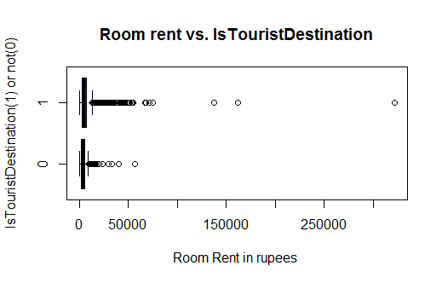

##Without extreme outliers  
 **boxplot**(RoomRent~ IsTouristDestination,data=RoomRent1.df, main="Room rent vs. IsTouristDestination ", ylab=" IsTouristDestination (1) or not(0)", xlab="Room Rent in rupees ", col=**c**("red","blue","green","yellow"),horizontal=TRUE)

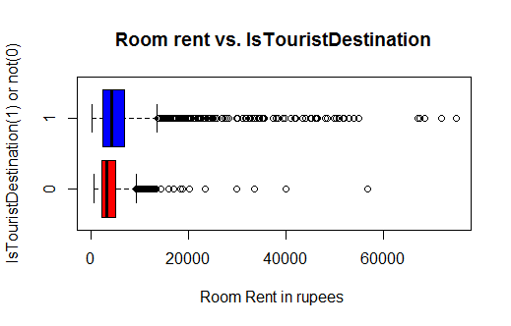

Result: The prices of Room of Hotels in Tourist Places is far more and have more outliers as that of normal city.

*#Analyzing FreeWifi Vs RoomRent*  
 **table**(hotel.df$FreeWifi)

##   
## 0 1   
## 981 12251

fw<-**table**(hotel.df$FreeWifi)  
 **barplot**(fw, main="Borplot of FreeWifi",xlab= "FreeWifi" ,col="red")

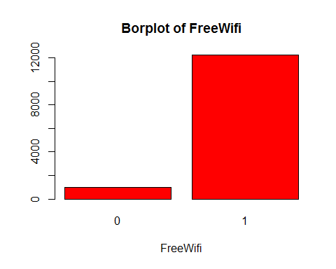

*#Effect of FreeWifi on RoomRent*  
 fw = **aggregate**(RoomRent ~ FreeWifi, data = hotel.df, mean)  
 fw

## FreeWifi RoomRent  
## 1 0 5380.004  
## 2 1 5481.518

##With extreme outliers of roomrent  
 **boxplot**(RoomRent~FreeWifi,data=hotel.df, main="Room rent vs. FreeWifi", ylab="Free Wifi available(1)", xlab="Room Rent in rupees ", col=**c**("red","blue","green","yellow"),horizontal=TRUE)

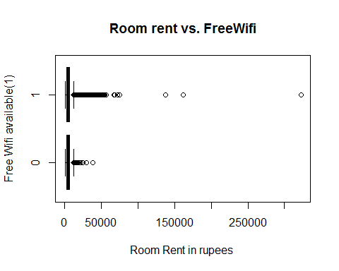

##Without extreme outliers of roomrent  
 **boxplot**(RoomRent~FreeWifi,data=RoomRent1.df, main="Room rent vs. FreeWifi", ylab="Free Wifi available(1)", xlab="Room Rent in rupees ", col=**c**("red","blue","green","yellow"),horizontal=TRUE)

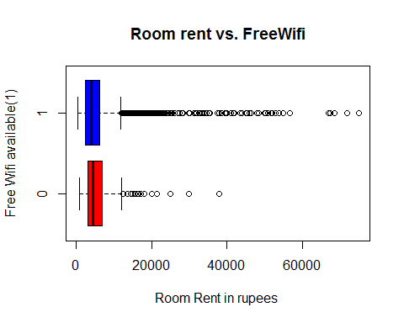

*#Analyzing FreeBreakfast Vs RoomRent*  
 **table**(hotel.df$FreeWifi)

##   
## 0 1   
## 981 12251

fw<-**table**(hotel.df$FreeBreakfast)  
 **barplot**(fw, main="Borplot of FreeBreakfast",xlab= "FreeWifi" ,col="red")

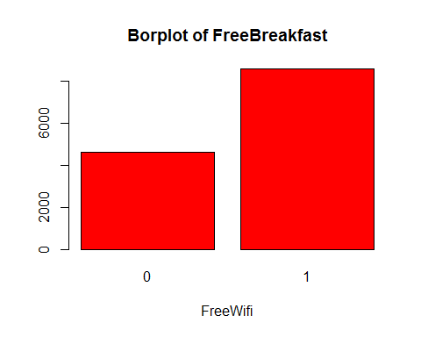

*#Effect of FreeBreakfast on RoomRent*  
 fb = **aggregate**(RoomRent ~ FreeBreakfast, data =hotel.df, mean)  
 fb1 = **aggregate**(RoomRent ~ FreeBreakfast, data =RoomRent1.df, mean)  
 ##Aggregate are affected by outliers a lot in the case of FreeBreakfast on RoomRent  
 fb

## FreeBreakfast RoomRent  
## 1 0 5573.790  
## 2 1 5420.044

fb1

## FreeBreakfast RoomRent  
## 1 0 5341.260  
## 2 1 5420.044

##With extreme outliers of roomrent  
 **boxplot**(RoomRent~FreeBreakfast,data=hotel.df, main="Room rent vs. FreeBreakfast", ylab="Free Breakfast available(1)", xlab="Room Rent in rupees ", col=**c**("green","yellow"),horizontal=TRUE)

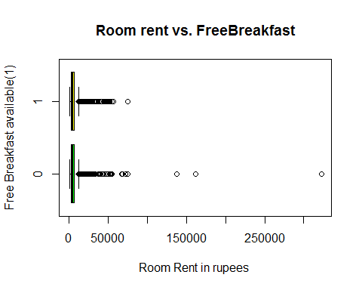

##Without extreme outliers of roomrent  
 **boxplot**(RoomRent~FreeBreakfast,data=RoomRent1.df, main="Room rent vs. FreeBreakfast", ylab="Free Breakfast available(1)", xlab="Room Rent in rupees ", col=**c**("green","yellow"),horizontal=TRUE)

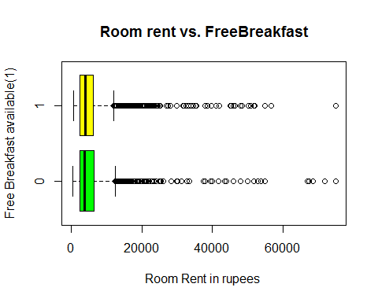

Result : The RoomRent for Hotel changes according with the outlier when it comes to FreeBreakfast

*#Analyzing Airport distance from hotel effects in what way on RoomRent*  
 **summary**(hotel.df$Airport)

## Min. 1st Qu. Median Mean 3rd Qu. Max.   
## 0.20 8.40 15.00 21.16 24.00 124.00

**boxplot**(hotel.df$Airport, main="Boxplot of Airport",xlab= "Distance of airport from hotel(Km)" ,col="green",horizontal = TRUE)

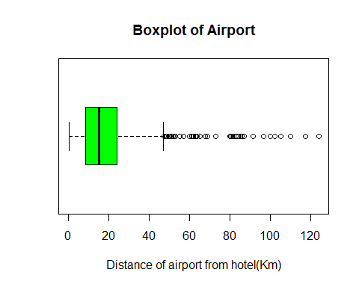

*#Effect of Airport distance on RoomRent*  
   
 **scatterplot**(hotel.df$Airport,hotel.df$RoomRent, main="Room rent vs. Airport distance", xlab="Airport distance(km)", ylab="Room Rent in rupees ",cex=1.1)

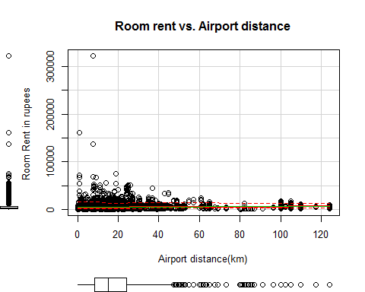

# Hypothesis

### 8. Articulating hypothesis and conducting t-test to determine their p value

##Hypothesis  
   
 *#1.Average RoomRent in hotels having swimming pool is more than that which don't have.*  
 **t.test**(RoomRent~HasSwimmingPool,data = hotel.df, alternative="less")

##   
## Welch Two Sample t-test  
##   
## data: RoomRent by HasSwimmingPool  
## t = -29.013, df = 5011.3, p-value < 2.2e-16  
## alternative hypothesis: true difference in means is less than 0  
## 95 percent confidence interval:  
## -Inf -4502.814  
## sample estimates:  
## mean in group 0 mean in group 1   
## 3775.566 8549.052

* Since the p-value is less than 0.05, we can reject the null hypothesis that the mean are equal

*#2.Average RoomRent in hotels with high star rating is high as compared to one which has less star rating.*  
 **t.test**(hotel.df$RoomRent,hotel.df$StarRating)

##   
## Welch Two Sample t-test  
##   
## data: hotel.df$RoomRent and hotel.df$StarRating  
## t = 85.813, df = 13231, p-value < 2.2e-16  
## alternative hypothesis: true difference in means is not equal to 0  
## 95 percent confidence interval:  
## 5345.575 5595.491  
## sample estimates:  
## mean of x mean of y   
## 5473.991838 3.458933

* Since the p-value is less than 0.05, we can reject the null hypothesis that they are equal

*#3.Average RoomRent in hotels providing Free Breakfast is more than that which don't provide.*  
 **t.test**(RoomRent~FreeBreakfast, data = hotel.df, alternative="less")

##   
## Welch Two Sample t-test  
##   
## data: RoomRent by FreeBreakfast  
## t = 0.98095, df = 6212.3, p-value = 0.8367  
## alternative hypothesis: true difference in means is less than 0  
## 95 percent confidence interval:  
## -Inf 411.5844  
## sample estimates:  
## mean in group 0 mean in group 1   
## 5573.790 5420.044

* Since the p-value is more than 0.05, we fail to reject the null hypothesis that they are equal

*#4.Average RoomRent in metro city hotels is more than that of non metro city hotel.*  
 **t.test**(RoomRent~IsMetroCity, data = hotel.df, alternative="less")

##   
## Welch Two Sample t-test  
##   
## data: RoomRent by IsMetroCity  
## t = 10.721, df = 13224, p-value = 1  
## alternative hypothesis: true difference in means is less than 0  
## 95 percent confidence interval:  
## -Inf 1253.463  
## sample estimates:  
## mean in group 0 mean in group 1   
## 5782.794 4696.073

* Since the p-value is more than 0.05, we fail to reject the null hypothesis that they are equal

*#5.Average RoomRent in hotels in metro cities is more than hotels in non metro cities.*  
 **t.test**(hotel.df$RoomRent,hotel.df$HotelCapacity)

##   
## Welch Two Sample t-test  
##   
## data: hotel.df$RoomRent and hotel.df$HotelCapacity  
## t = 84.882, df = 13234, p-value < 2.2e-16  
## alternative hypothesis: true difference in means is not equal to 0  
## 95 percent confidence interval:  
## 5286.515 5536.445  
## sample estimates:  
## mean of x mean of y   
## 5473.99184 62.51164

* Since the p-value is less than 0.05, we can reject the null hypothesis that the mean are equal

# Regression Model

### 9. Generating Regression models using lm() model and testing hypothesis

*#Generating a multiple linear regression model for RoomRent*  
 *#1.*  
 fit1<-**lm**(RoomRent~StarRating+HasSwimmingPool+HotelCapacity-1, data = hotel.df)  
 **summary**(fit1)

##   
## Call:  
## lm(formula = RoomRent ~ StarRating + HasSwimmingPool + HotelCapacity -   
## 1, data = hotel.df)  
##   
## Residuals:  
## Min 1Q Median 3Q Max   
## -8039 -2448 -1249 461 312401   
##   
## Coefficients:  
## Estimate Std. Error t value Pr(>|t|)   
## StarRating 1396.8746 26.1320 53.455 < 2e-16 ***  
## HasSwimmingPool 3719.6943 148.7835 25.001 < 2e-16 ***  
## HotelCapacity -7.6598 0.9415 -8.136 4.44e-16 ***  
## ---  
## Signif. codes: 0 '***' 0.001 '**' 0.01 '*' 0.05 '.' 0.1 ' ' 1  
##   
## Residual standard error: 6813 on 13229 degrees of freedom  
## Multiple R-squared: 0.4457, Adjusted R-squared: 0.4456   
## F-statistic: 3546 on 3 and 13229 DF, p-value: < 2.2e-16

*#Coefficents of the model*  
 fit1$coefficients

## StarRating HasSwimmingPool HotelCapacity   
## 1396.874562 3719.694300 -7.659814

*#Fitted residuals and values are checked and the deviation was around 1000 , because of*   
 *#large data points it's not suitable to show those in the output file.*  
   
###. Model1: salary = b0 + b1*StarRating + b2*HasSwimmingPool+ b3*HotelCapacity  
*# b0 = -1(assumption), b1 = 1396.874562, b2=3719.6943, b3= -7.659814*  
*# Model: salary = -1 + 1396.874562*StarRating + 3719.6943*HasSwimmingPool -7.659814*HotelCapacity*  
   
   
 *#2.*  
 fit2<-**lm**(RoomRent~StarRating+HasSwimmingPool+HotelCapacity+IsWeekend+IsTouristDestination-1, data = hotel.df)  
 **summary**(fit2)

##   
## Call:  
## lm(formula = RoomRent ~ StarRating + HasSwimmingPool + HotelCapacity +   
## IsWeekend + IsTouristDestination - 1, data = hotel.df)  
##   
## Residuals:  
## Min 1Q Median 3Q Max   
## -8326 -2517 -1212 463 312480   
##   
## Coefficients:  
## Estimate Std. Error t value Pr(>|t|)   
## StarRating 1258.9558 44.4985 28.292 < 2e-16 ***  
## HasSwimmingPool 3670.2511 148.8411 24.659 < 2e-16 ***  
## HotelCapacity -6.1769 0.9658 -6.396 1.65e-10 ***  
## IsWeekend -509.6479 119.1618 -4.277 1.91e-05 ***  
## IsTouristDestination 1053.0394 124.7325 8.442 < 2e-16 ***  
## ---  
## Signif. codes: 0 '***' 0.001 '**' 0.01 '*' 0.05 '.' 0.1 ' ' 1  
##   
## Residual standard error: 6792 on 13227 degrees of freedom  
## Multiple R-squared: 0.4493, Adjusted R-squared: 0.4491   
## F-statistic: 2159 on 5 and 13227 DF, p-value: < 2.2e-16

*#Coefficents of the model*  
 fit2$coefficients

## StarRating HasSwimmingPool HotelCapacity   
## 1258.955786 3670.251057 -6.176913   
## IsWeekend IsTouristDestination   
## -509.647863 1053.039364

*#Fitted residuals and values are checked and the deviation was around 1000 , because of*   
 *#large data points it's not suitable to show those in the output file.*  
   
   
 ###. Model1: salary = b0 + b1*StarRating + b2*HasSwimmingPool+ b3*HotelCapacity + b4*IsWeekend + b6*IsTouristDestination  
 *# b0 = -1(assumption), b1 =* 1258.955786*, b2=*3670.251057*, b3=* -6.176913*, b4=*-509.647863*, b5=*1053.039364  
 *# Model: salary = -1 +* 1258.955786*\*StarRating +* 3670.251057*\*HasSwimmingPool -*6.176913*\*HotelCapacity*  
 *#* -509.647863*\*IsWeekend +* 1053.039364*\*IsTouristDestination*   
   
   
 *#3.*  
 fit3<-**lm**(RoomRent~StarRating+HasSwimmingPool+HotelCapacity+Airport-1, data = hotel.df)  
 **summary**(fit3)

##   
## Call:  
## lm(formula = RoomRent ~ StarRating + HasSwimmingPool + HotelCapacity +   
## Airport - 1, data = hotel.df)  
##   
## Residuals:  
## Min 1Q Median 3Q Max   
## -8240 -2380 -1224 384 312742   
##   
## Coefficients:  
## Estimate Std. Error t value Pr(>|t|)   
## StarRating 1248.4270 33.2220 37.578 < 2e-16 ***  
## HasSwimmingPool 3903.7369 150.6728 25.909 < 2e-16 ***  
## HotelCapacity -6.7434 0.9482 -7.112 1.20e-12 ***  
## Airport 18.8697 2.6157 7.214 5.73e-13 ***  
## ---  
## Signif. codes: 0 '***' 0.001 '**' 0.01 '*' 0.05 '.' 0.1 ' ' 1  
##   
## Residual standard error: 6800 on 13228 degrees of freedom  
## Multiple R-squared: 0.4479, Adjusted R-squared: 0.4477   
## F-statistic: 2683 on 4 and 13228 DF, p-value: < 2.2e-16

*#Coefficents of the model*  
 fit3$coefficients

## StarRating HasSwimmingPool HotelCapacity Airport   
## 1248.426988 3903.736921 -6.743354 18.869726

*#Fitted residuals and values are checked and the deviation was around 1000 , because of*   
 *#large data points it's not suitable to show those in the output file.*  
   
 ###. Model1: salary = b0 + b1*StarRating + b2*HasSwimmingPool+ b3*HotelCapacity +b4*Airport + b5*Date  
 *# b0 = -1(assumption), b1 = 1248.426988 , b2=3903.736921, b3= -6.743354, b4= 18.869726*  
 *# Model: salary = -1 + 1248.426988*StarRating + 3903.736921*HasSwimmingPool -6.743354*HotelCapacity + 18.869726*Aiport*