**STUDY OF THE FACTORS THAT INVOLVE PRICING STRATEGY OF HOTELS IN INDIA**

SANJAY HANSDAK

**ABSTRACT**

The purpose of this project is to analyze the pricing strategy of hotels in the Indian hotel industry. Many factors drive hotel room prices which are primarily of two types: external and internal. The objective of this project is to identify the factors that matter the most.

**INTRODUCTION**

The dataset tracks hotel prices on 8 different dates at different hotels across different cities.

**DATA PREPROCESSING:-**

**DEPENDENT VARIABLE**

|  |  |  |
| --- | --- | --- |
| DECISION VARIABLE | UNITS | MEANING |
| RoomRent | Rupees | Rent for the cheapest room, double occupancy, in Indian Rupees.  Some hotels have more than one type of double occupancy room. For simplicity, we picked the cheapest room with double occupancy. |

**EXTERNAL FACTORS**

Many external factors can potentially influence the Room Rent. The dataset captures some of these external factors, as explained below.

|  |  |  |
| --- | --- | --- |
| VARIABLE | UNITS | MEANING |
| Date | Text | We have hotel room rent data for the following 8 dates for each hotel:  {Dec 31, Dec 25, Dec 24, Dec 18, Dec 21, Dec 28, Jan 4, Jan 8}  If a hotel is sold out on a given date, assume that the price of the hotel room on the date it is sold out is the maximum price from the sample of dates for which prices are available. |
| IsWeekend | Dummy | We use ‘0’ to indicate week days, ‘1’ to indicate weekend dates (Sat / Sun) |
| IsNewYearEve | Dummy | ‘1’ for Dec 31, ‘0’ otherwise |
|  |  |  |
| CityName | Text | Name of the City where the Hotel is located   e.g. Mumbai` |
| Population | Number | Population of the City in 2011 |
| CityRank | Dummy | Rank order of City by Population (e.g. Mumbai = 0, Delhi = 1, so on |
| IsMetroCity | Dummy | ‘1’ if CityName is {Mumbai, Delhi, Kolkatta, Chennai}, ‘0’ otherwise |
|  |  |  |
| IsTouristDestination | Dummy | We use ‘1’ if the city is primarily a tourist destination, ‘0’ otherwise. For example, Goa and Agra are primarily tourist destinations. We assume that most people who visit Goa and Agra and stay in their hotels are in these cities primarily for tourism. |

**INTERNAL FACTORS**

Many Hotel Features can influence the Room Rent. The dataset captures some of these internal factors, as explained below.

|  |  |  |
| --- | --- | --- |
| VARIABLE | UNITS | MEANING |
| HotelName | Text | e.g. Park Hyatt Goa Resort and Spa |
| StarRating | Number | e.g. 5 |
| Airport | km | Distance between Hotel and closest major Airport |
| HotelAddress | Text | e.g. Arrossim Beach, Cansaulim, Goa |
| HotelPincode | Number | 403712 |
| HotelDescription | Text | e.g. 5-star beachfront resort with spa, near Arossim Beach |
| FreeWifi | Dummy | ‘1’ if the hotel offers Free Wifi, ‘0’ otherwise |
| FreeBreakfast | Dummy | ‘1’ if the hotel offers Free Breakfast, ‘0’ otherwise |
| HotelCapacity | Number | e.g. 242.  (enter ‘0’ if not available) |
| HasSwimmingPool | Dummy | ‘1’ if they have a swimming pool, ‘0’ otherwise |

**METHOD**

The dataset was read into R. The data was summarized to understand the mean, median, standard deviation of each variable. The problem was formulated as Y = F(x1, x2, x3..)The Dependent Variable(s) (i.e. the Y in the Y = F(x)) in the Dataset was identified as RoomRent. The three most important Independent variables (i.e. x1, x2, x3) in the dataset

were taken as StarRating , HotelCapacity and IsATouristDestination. Some visualizations have been shown below to understand the correlation between these parameters.

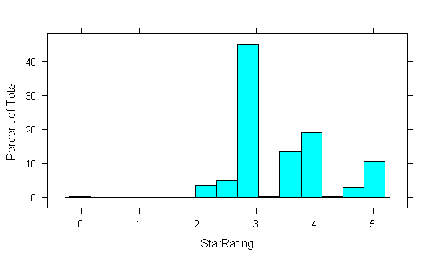

**Percentage of Hotels having 0-5 Star ratings**

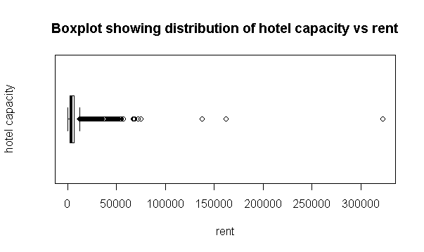

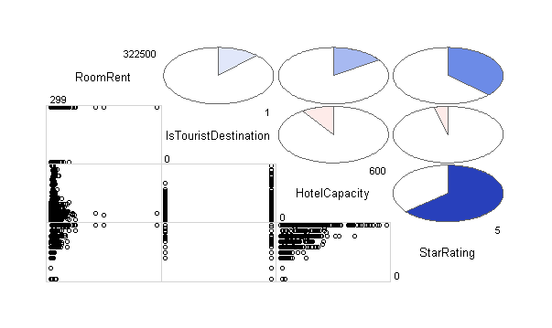

**Corrgram in R involving the Independent and Dependent Variables**

The dataset was then fitted by a linear regressor on a training set which consisted of 80% of the sample and predictions were made on the test set which contained 20% of the sample.

**OBSERVATIONS**

To get the optimal model the adjusted R-Squared was value was looked at. The model which gave the highest R-Squared value was chosen as final. First all the external factors were clubbed together and then the internal factors. Those features which showed a significantly less p value than 0.05 were taken as statistically significant and the final model result is shown below.

Call:

lm(formula = RoomRent ~ IsTouristDestination + HasSwimmingPool +

IsNewYearEve + IsMetroCity + StarRating + HotelCapacity,

data = training_set)

Residuals:

Min 1Q Median 3Q Max

-11995 -2373 -711 1049 308998

Coefficients:

Estimate Std. Error t value Pr(>|t|)

(Intercept) -8615.856 409.016 -21.065 < 2e-16 ***

IsTouristDestination 2269.917 150.651 15.067 < 2e-16 ***

HasSwimmingPool 2112.919 183.645 11.505 < 2e-16 ***

IsNewYearEve 702.754 203.505 3.453 0.000556 ***

IsMetroCity -1660.269 154.920 -10.717 < 2e-16 ***

StarRating 3730.666 128.298 29.078 < 2e-16 ***

HotelCapacity -11.630 1.175 -9.894 < 2e-16 ***

---

Signif. codes: 0 ‘***’ 0.001 ‘**’ 0.01 ‘*’ 0.05 ‘.’ 0.1 ‘ ’ 1

Residual standard error: 6955 on 10764 degrees of freedom

Multiple R-squared: 0.1795, Adjusted R-squared: 0.179

F-statistic: 392.4 on 6 and 10764 DF, p-value: < 2.2e-16

**CONCLUSION**

The most significant factors include the location of a hotel whether it is in a tourist area or in a metropolitan city, the date of booking falls on a special occasion like New Year Eve, the review it has in terms of rating and the total capacity of the hotel that determines the price of a room.

**REFERNECES**

[**www.RBloggers.com**](http://www.rbloggers.com)

**The final project report to be submitted under the internship of Prof. Sammer Mathur (IIM Lucknow, CMU) as a part of his data analytics internship in R.**