Summary
SignalLens is a layered forensic-analysis framework built around a responsive PyQt GUI, a threaded execution boundary, and a dependency-aware stage runner.
The GUI collects the image, analyst context, and workflow options, then delegates execution to an Analysis Worker, which launches the SignalLens Controller.
The controller runs a sequence of uniformly structured detector and support stages, each producing a structured payload and writing its result into shared analysis state.
Those heterogeneous payloads are normalized into Module Summary objects, transformed by the hypothesis engine into higher-level evidence abstractions and scorecards, and then arbitrated by decision logic that weighs suspicious signals against benign counter-evidence and contextual modifiers.
The final result is not a raw score but a balanced forensic conclusion — with polarity, confidence, dominant pattern, supporting and contradicting signals, rationale, and overlays — returned to the GUI for explainable presentation.

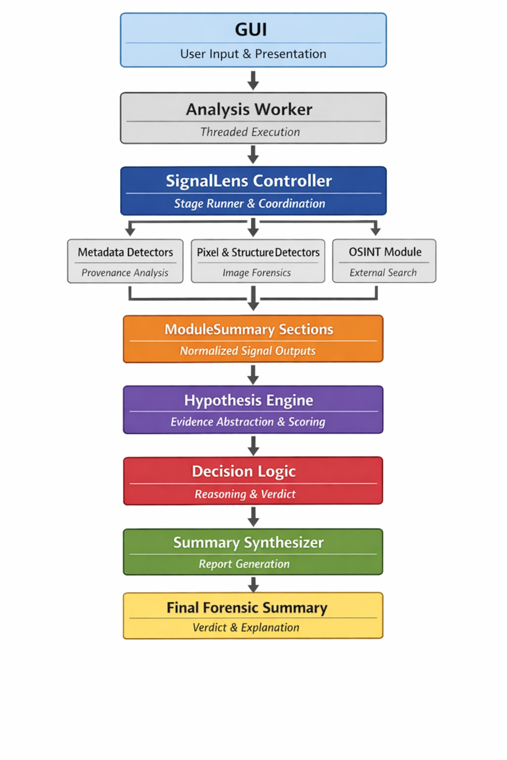
Contents
Summary 1
SignalLens 3
Five layers, conceptual architecture 5
Two major classes of modules 6
GUI Application modules 6
signallens_gui.py 6
signallens_settings.py 7
The role of each detector module 8
OSINT external provenance domain 8
osint_reverse_search.py 8
osint_dialogs.py 8
Metadata / provenance domain 9
exiftool_backend.py 9
exif_config.py 9
Pixel-forensic base detectors 9
vf_ela.py 9
vf_noise.py 10
vf_sensor_origin.py 10
vf_cfa_demosaic.py 10
vf_compression_history.py 10
Structural / segmentation detectors 10
vf_subject_boundary.py 10
vf_region_masks.py 10
vf_region_segmentation.py 10
vf_segmentation_alignment.py 11
Cross-domain fusion detectors 11
vf_cross_signal.py 11
vf_boundary_focus.py 11
vf_region_fft.py 11
Global structure / repetition detectors 11
vf_fft.py 11
vf_patch_similarity.py 11
vf_patch_spatial.py 12
vf_overlay.py 12
Subject-focused syntheticity detectors 12
vf_subject_texture_consistency.py 12
vf_subject_process_asymmetry.py 12
vf_subject_material_realism.py 12
The role of each framework module 13
signallens_controller.py 13
analysis_worker.py 13
gui_semantics.py 13
summary_types.py 13
summary_sections.py 13
summary_synthesizer.py 14
hypothesis_engine.py 14
decision_logic.py 14
signal_language.py 14
narrative_builder.py 14
A concise model of the whole system 16
Checklist for adding a new detector signal 17

Introduction
SignalLens is a layered forensic reasoning system wrapped in a responsive desktop shell.

At the outermost level, it behaves like a classic desktop analysis application: the GUI collects inputs and analyst context, hands execution to a worker thread, the worker instantiates a controller / stage runner, and that controller executes a sequence of detector stages in dependency order while accumulating results in shared analysis state.

The GUI imports and launches Analysis Worker, the worker constructs SignalLens Controller, and the controller runs the analysis pipeline stage by stage rather than collapsing everything into one monolithic function.

The important architectural point is that SignalLens is not just a collection of image checks. The current document captures this: detector modules observe different aspects of the image, framework modules normalize and combine those observations, and the system ultimately produces an explainable verdict rather than an opaque score.

The explicit model is: image → detectors → ModuleSummary sections → hypothesis engine → decision logic → rendered summary.

A compact way to express the architecture is this:

GUI
↓
Analysis Worker (thread boundary)
↓
SignalLens Controller / stage runner
↓
Detector and support stages
↓
Raw payloads in Analysis State
↓
summary_sections.py → ModuleSummary normalization
↓
hypothesis_engine.py → Evidence Snapshot / Derived Signals / Score Card
↓
decision_logic.py → dominant pattern / polarity / confidence / rationale
↓
summary_synthesizer.py + narrative_builder.py
↓
HTML/text summary + overlays
↓
GUI presentation

SignalLens is not just an image classifier; it is an evidence-balancing forensic argument engine with a modular detector front-end and an explainable reasoning back-end.

Extensible Setup
The extensibility comes from the fact that the system is built around uniform stage contracts and a shared semantic intermediate representation, not around tight coupling between detectors.

This document states this discipline very clearly: a new detector is only truly integrated once it is summarized, represented in the hypothesis layer, used in the scorecard, and reflected in the final narrative.
That is the architectural rule that keeps the system modular instead of ad hoc.

So, the extensibility is not merely “add a Python file.” It is a controlled pipeline:
- A detector runs as a stage and emits a structured payload.
- That payload is converted into a ModuleSummary with shared fields such as name, status, polarity, pattern, score, note, and details.
- The hypothesis layer abstracts many module summaries into higher-order evidence structures.
- Decision logic reasons over those abstractions.
- Narrative and rendering modules present the result coherently.

That means modules are replaceable and additive because they all enter the reasoning stack through the same normalization gate. One detector can be very low-level and numeric, another can be provenance-oriented, another can be relational or region-aware, but after summary_sections.py detectors are all expressed in one shared ontology.
Thit is probably the single most important design choice in the whole system.

Role of the Controller
The controller is best described as an execution spine or stage runner. The current document says it “runs all stages in dependency order, records outputs into Analysis State, logs progress, and tolerates stage failure without collapsing the whole pipeline.”

That gives you three strong architectural properties:
- Order with flexibility: stages can be inserted or reordered as long as dependencies are satisfied.
- Graceful degradation: one failed or missing stage does not necessarily invalidate the whole analysis.
- Uniform observability: each stage can log findings, write artifacts, and attach payloads in a consistent way.

Role of the GUI
The GUI is not just a launch button. It is the operator shell for the whole forensic workflow.
It loads settings, handles file selection and drag-and-drop, manages patch-profile selection and scene-context inputs, integrates OSINT actions, and triggers summary rebuilding for presentation.

It does not perform the heavy analysis itself. Instead, it delegates to Analysis Worker, which isolates the long-running pipeline in a worker thread and communicates back through finished, error, log, and status signals.
This is a clean PyQt architecture: responsive presentation layer outside, analysis pipeline inside.
To sum it all up: The GUI is the orchestration shell for human interaction; the worker is the concurrency boundary; the controller is the deterministic execution engine.

That architecture is explicit in the pipeline: image → detectors → ModuleSummary sections → hypothesis engine → decision logic → rendered summary.

Five layers, conceptual architecture
1. Detection layer
Independent modules inspect specific evidence domains: metadata, local forensic anomalies, camera-pipeline consistency, structure/repetition, region geometry, subject realism.

2. Structural coordination layer
Modules like region masks, cross-signal fusion, segmentation alignment, and boundary focus turn isolated observations into spatially meaningful relationships. This is where the system stops being feature extraction and starts reasoning about where and how anomalies occur.

3. Semantic normalization layer
summary_sections.py converts heterogeneous detector payloads into homogeneous ModuleSummary objects. That gives the rest of the framework a stable language.

4. Hypothesis abstraction layer
hypothesis_engine.py takes the normalized sections and builds:
Evidence Snapshot, Derived Signals, Score Card.

This is the decisive step where raw detector output becomes reasoning state. The document captures this: the system stops being a list of signals and becomes a model.

5. Decision and narrative layer
decision_logic.py performs final arbitration: dominant pattern, confidence tier, polarity, supporting signals, contradicting signals, and rationale. Then signal_language.py and narrative_builder.py convert that into human-readable explanation, while summary_synthesizer.py assembles the final result object and overlays.

A balanced conclusion
What makes the final output balanced is that the system is explicitly designed to reason over both suspicious and benign evidence, and not merely accumulate anomaly counts.

That shows up in multiple places:
- the hypothesis layer tracks support, caution, and counter-support via Score Card rather than only suspicious scores
- decision logic explicitly considers contradicting patterns and confidence rationale, rather than just strongest suspicious signal wins
- provenance can support a synthetic-context reading, but camera-like sensor/CFA/metadata evidence can also moderate or counterbalance that reading.

This document repeatedly emphasizes contextual moderation and false-positive control, especially for globally structured or repetitive scenes.

So, the system is not fundamentally a binary classifier. It is closer to an evidence-balancing forensic argument engine.

SignalLens reasoning flow

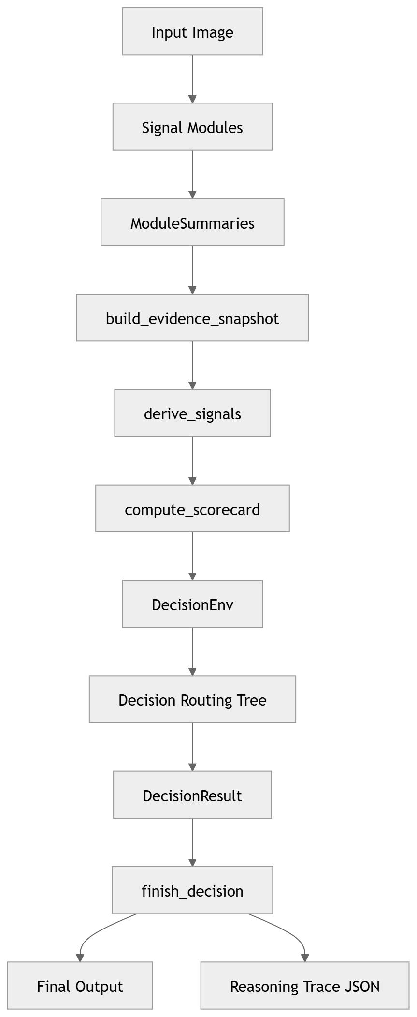
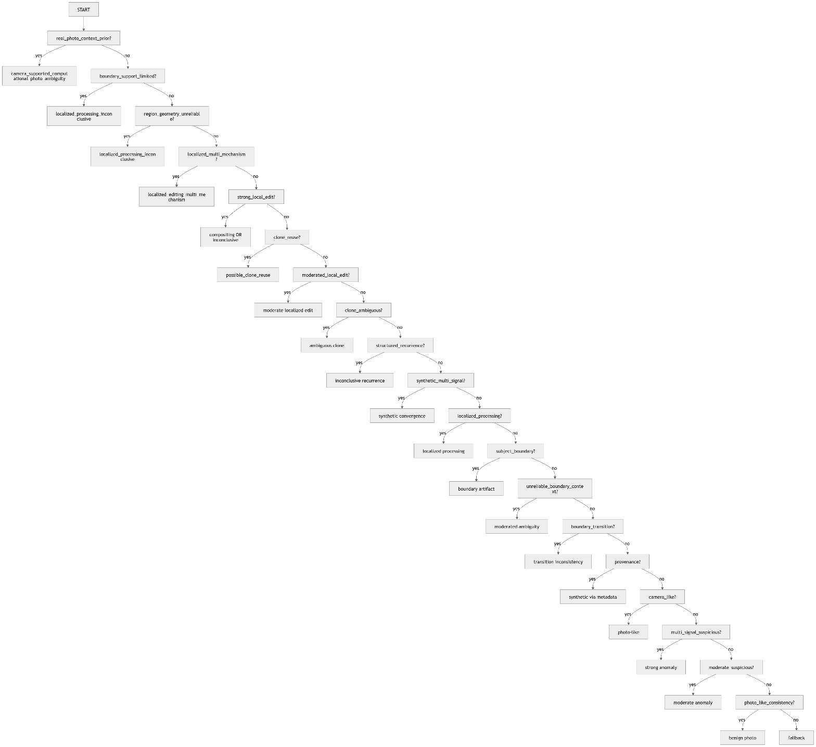
Rule-based hypothesis selection over structured signals
Route | Meaning
real_photo_context_prior | strong prior overrides anomalies
localized_multi_mechanism | multiple edit types detected
clone_reuse | duplication
boundary_transition | cutout artifacts
synthetic_multi_signal | diffusion-like patterns
fallback | best-effort synthesis
Internal signal flow
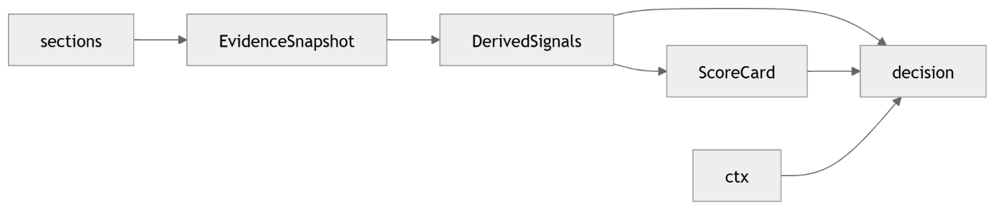

Two major classes of modules
Elementary detector modules. These are the modules whose primary job is to observe something specific in the image or its metadata.
Framework / orchestration modules. These do not “detect” syntheticity directly.
They: run stages in the right order, normalize outputs, align naming and semantics, combine evidence, generate explanation.
That distinction is important because otherwise the system can look more ad hoc than it really is.

GUI Application modules

signallens_gui.py
This is the main desktop application shell for SignalLens.

It provides the operator-facing interface for:
- drag-and-drop or file-picker image selection
- optional scene-context toggles
- patch-profile selection
- launching analysis in a worker thread
- displaying logs and status updates
- showing the synthesized HTML forensic summary
- managing OSINT review actions
- opening the output folder for the produced analysis artifacts

It also bridges analyst-supplied scene context into the summary synthesis layer, and refreshes the rendered summary whenever analysis state or OSINT state changes.

Role: User-facing orchestration shell. It does not perform forensic reasoning itself, but it is the operational control surface that binds together image selection, contextual analyst input, threaded execution, OSINT review, and summary presentation. In architectural terms, this is the application container around the core pipeline

signallens_settings.py
This is the settings access layer. It loads signallens_settings.json, caches the parsed settings, and exposes small helper accessors for commonly needed configuration such as:
- patch-similarity profiles
- output root
- supported image extensions

Role: Central configuration provider. It keeps runtime configuration out of the core modules and gives both GUI and pipeline code a single place to obtain stable environment settings.

Detector modules

OSINT external provenance domain

osint_reverse_search.py
This is the reverse-image OSINT state and persistence module. It defines the structured data model for reverse-search review:
- ReverseSearchMatch
- ReverseSearchQueryLinks
- ReverseSearchResult

It also provides the workflow for initializing a per-image OSINT record, opening reverse-search engines such as Google Lens, Yandex, TinEye, and Bing, saving and loading osint_results.json, and maintaining analyst-entered findings.

The module classifies discovered pages into source contexts such as:
- ai_gallery
- stock
- social
- news
- marketplace
- unknown

It then summarizes the findings into higher-level fields such as:
- matches_found
- possible_original_found
- derivative_detected
- ai_source_context_detected
- stock_source_context_detected
- news_source_context_detected
- dominant_source_type
- review_status
- summary

Role: An external-provenance context module. It does not itself ‘prove’ syntheticity from pixels. Instead, it records and structures analyst-reviewed online context so that provenance evidence can enter the same reasoning framework as the visual detectors.
This is especially important because the final reasoning layer explicitly allows metadata and/or OSINT to drive a provenance-supported synthetic-context conclusion.

osint_dialogs.py
This is the OSINT finding entry/edit dialog for the GUI.
It provides the modal data-entry interface used to add or edit a manual reverse-search finding. The dialog captures:
- provider
- result page URL
- title
- source image URL
- first-seen estimate
- source type
- similarity score
- analyst notes

It also performs basic validation, most importantly requiring a result page URL before accepting the entry.

Role: Analyst-input infrastructure for the OSINT subsystem. It is not a detector and not a reasoning module; its job is to ensure that reverse-image findings are captured in a consistent structure that can then be stored by osint_reverse_search.py and surfaced in the forensic summary.

Metadata / provenance domain

exiftool_backend.py
This is the metadata and provenance detector. It does not try to prove synthetic origin from absence. Instead, it looks for explicit workflow evidence:
- AI-generation or enhancement tool traces
- declarative generation / enhancement wording
- provenance-related metadata such as C2PA/JUMBF
- generic editing software
- camera-acquisition richness as a benign counter-signal

It ultimately produces a metadata classification such as:
- declared_synthetic_candidate,
- declared_enhancement_candidate,
- camera_metadata_present,
- sparse_or_stripped,
- inconclusive.

Role in the system: A provenance/context detector and counter-signal source, not the main visual driver.

exif_config.py
This is a helper file providing exiftool_backend.py with the configuration information stored inside exif_rules.json. These concern the metadata tags to watch for AI tooling data and generation and enhancement specific terms.
Role: provide configuration information the be used by exiftool_backend.py

Pixel-forensic base detectors

vf_ela.py
Detects JPEG-style error level irregularities and localized recompression anomalies.

Role: A low-level localization detector. Good at surfacing suspicious regions, but not sufficient alone.

vf_noise.py
Looks for residual/noise inconsistencies.

Role: Another low-level localization detector. Particularly valuable when it converges with ELA.

vf_sensor_origin.py
Looks for camera-pipeline microstructure. In your newer interpretation it also supports weak camera-consistent findings, not just suspicious inconsistency.

Role: A workflow-origin detector: synthetic vs camera-like acquisition tendencies.

vf_cfa_demosaic.py
Looks for CFA / demosaicing behaviour, again both suspicious inconsistency and benign camera compatibility.
Role: A second camera-workflow detector, complementary to sensor origin.

vf_compression_history.py
Looks for double-JPEG history, localized compression inconsistency, block-history anomalies, or consistency with a simple camera-save path.

Role: A save-history / postprocessing detector and contextual moderator.

Structural / segmentation detectors

vf_subject_boundary.py
Analyses subject/background transition plausibility and cutout-like artifacts.

Role: A segmentation-artifact detector focused on the subject boundary itself.

vf_region_masks.py
Builds subject, boundary, and background masks.

Role: This is foundational infrastructure rather than a primary detector. It creates the coordinate system for region-aware analysis. Still, it is useful enough to surface in the summary because later detectors depend on it. The controller stage order makes this explicit.

vf_region_segmentation.py
Interprets the region-mask geometry itself: fragmentation, overly clean segmentation, dominant subject ratio anomalies, or natural segmentation variability.

Role: A structural plausibility detector built on top of the masks.

vf_segmentation_alignment.py
Measures whether suspicious cross-signal hotspots align with the subject boundary.

Role: A relational structural detector: not “is there an anomaly?” but “is the anomaly where compositing or subject-specific editing would occur?”

Cross-domain fusion detectors

vf_cross_signal.py
Combines ELA and noise hotspots into a shared spatial-overlap representation and classifies both:
- cross-signal convergence
- boundary convergence
- With the newer refactor, it also provides a hotspot mask or hotspot footprint suitable for downstream alignment.

Role: This is one of the most important modules in the stack. It turns two weak local detectors into one stronger relational detector.

vf_boundary_focus.py
Looks specifically at the contour band around the subject and compares it to neighbouring regions.

Role: A boundary-localized editing detector; stronger and more semantically focused than plain ELA/noise.

vf_region_fft.py
Performs region-aware frequency comparison, especially subject vs background and boundary vs background.

Role: A structured periodicity detector with regional semantics.

Global structure / repetition detectors

vf_fft.py
Global frequency-domain detector for periodicity, decoder-grid structure, and axis-aligned synthetic signatures.

Role: A global structuredness detector. Strong for synthetic or decoder-mediated artifacts, but requires contextual moderation.

vf_patch_similarity.py
Detects repeated local motifs and near-duplicate local structure.

Role: A clone / repeated-texture detector. Strong but prone to false positives if used without context.

vf_patch_spatial.py
Adds region-aware spatial interpretation to patch similarity.

Role: A second-order patch reasoning detector. It is weaker for diffusion-style cases than the newer texture/asymmetry modules, but still useful as a supporting signal.

vf_overlay.py
This is the overlay rendering module. It creates visual analysis artifacts, especially shared-boundary overlays derived from the cross-signal/boundary pipeline.

In particular, it takes boundary-cluster blocks from the cross-signal payload and renders overlay images on top of the original image, including filled and outlined cluster visualizations.

Role: Visual explanation infrastructure. It is not itself a detector, but it converts detector output into interpretable forensic graphics. That matters because SignalLens is designed not only to score or narrate anomalies, but also to expose where they occur spatially.

Subject-focused syntheticity detectors

vf_subject_texture_consistency.py
Looks for stochastic regularity inside the subject surface, especially clothing and skin.

Role: A modern diffusion-style texture detector. It was introduced because classic duplicate matching was not enough for virtual fashion / Instagram-like images. The handover document describes this as a major turning point.

vf_subject_process_asymmetry.py
Compares subject, boundary, and background process statistics to detect different rendering / enhancement behaviour across regions. It includes:
- comparative asymmetry
- reverse asymmetry
- subject-only fallback when the background baseline is weak or the subject dominates

Role: A subject-vs-scene rendering divergence detector. This is one of the most important modern modules because it can catch virtual fashion model imagery even when the image is not globally synthetic. The source file makes that design explicit.

vf_subject_material_realism.py
Evaluates whether the subject material looks statistically plausible as photographed matter rather than generated / regularized matter.
Role: A subject-surface realism detector. Especially useful in combination with process asymmetry.

Framework modules

signallens_controller.py
Runs all stages in dependency order, records outputs into AnalysisState, logs progress, and tolerates stage failure without collapsing the whole pipeline. The current stage list makes clear that this is the orchestration spine of the system.

Role: Execution framework and dependency manager.

analysis_worker.py
Multi-threaded worker to keep GUI responsive while processing. Runs the controller in a separate thread and facilitates communications between processing and the PyQt graphical user interface. Presents logging information from the detector modules to the user at run time.
Role: Facilitates multithreaded processing.

gui_semantics.py
Defines ModuleSummary, polarities, strengths, and rendering semantics such as colours.

Role: Shared ontology for signal presentation.

summary_types.py
This file defines SummaryResult, the summary-level container object used after per-module normalization and overall synthesis.
It stores:
- overall confidence
- overall pattern
- overall text
- overall polarity
- per-section ModuleSummary objects
- overlay paths
- module scores
- context info
- full rendered text
- full rendered HTML

Role: Summary transport object. This is a small but important architectural file because it provides the canonical container in which the fully synthesized forensic reading is moved between summary assembly and presentation.

summary_sections.py
Builds a ModuleSummary for each payload.

Role: Normalization layer: each detector can be different internally, but all become a common object with:
- name
- status
- polarity
- pattern
- score
- note
- details
This is one of the most important architectural choices in the system.

summary_synthesizer.py
Builds the full SummaryResult, attaches all sections, extracts overlays, and calls decision logic for the overall forensic reading. The section list in the code makes the active detector inventory explicit.

Role: Summary orchestration and assembly.

hypothesis_engine.py
This is the main reasoning abstraction layer. It defines:
- EvidenceSnapshot: stable view of section evidence
- DerivedSignals: normalized booleans / scalars representing higher-level facts
- ScoreCard: accumulated support, caution, and confidence structures
It also provides:
- context building
- signal derivation
- base scoring
- scorecard computation

Role: Transforms many detector outputs into a compact, reason-able hypothesis state. This is where the system stops being “a list of signals” and becomes a model.

decision_logic.py
Consumes the scorecard and section state to decide:
- dominant pattern
- confidence tier
- overall polarity
- supporting signals
- contradicting signals
- confidence rationale
It explicitly separates “hypothesis engine” from “narrative synthesis.”

Role: Final arbitration and explanation layer.

signal_language.py
Humanizes internal pattern names into readable phrases.

Role: Translation layer between system ontology and user narrative.

narrative_builder.py
Renders the plain-text and HTML summary in the right section order.

Role: Presentation layer.

Checklist for adding new detector signals

Concept and scope
Define the signal precisely. Decide whether it is:
- elementary detector
- relational detector
- framework helper

State what it detects:
- syntheticity
- camera-origin consistency
- editing/compositing
- context moderation

Define failure modes and likely false positives.

Module implementation
Create the detector module vf_<name>.py.
Keep the module responsible only for:
- measurement
- scoring
- returning a structured payload:
  - pattern
  - note
  - scores
  - details
  - artifacts if relevant

Controller integration
Add the stage to SignalLensController. Place it in the correct dependency order.
Add require=[...] if it depends on prior payloads. Store the output in AnalysisState.

Summary integration
Add build_<name>_section() in summary_sections.py. Convert the raw payload into a ModuleSummary. Make sure score is populated if the signal should influence reasoning. Add the section into build_summary_result().
Add the key into ORDERED_SECTION_KEYS if it should render.

Hypothesis-engine integration
Add the section to EvidenceSnapshot if it participates in reasoning. Add new fields to DerivedSignals only for abstractions the rest of the system will actually use. Populate those fields in derive_signals().
Integrate them into compute_scorecard() in exactly one conceptual place:
- local editing
- clone
- synthetic structure
- subject realism
- provenance
- sensor/compression
- benign/counter-support
Decision integration
Decide whether the new signal should affect:
- dominant pattern
- confidence
- supporting signals
- contradicting signals

Update determine_dominant_pattern() if the new detector can realistically define the main reading.
Update confidence logic only if it materially changes certainty.

Narrative integration
Add a human-readable mapping in signal_language.py. Check that the note wording matches the tone of other modules. Make sure the rendered summary reads coherently when the new signal is present.

Validation
Test on:
- strong positives
- strong negatives
- edge cases
- false-positive-prone natural images

Check both: raw module behaviour, final verdict influence. Inspect whether the signal is actually used downstream, not merely computed. Confirm that adding the signal does not create hidden duplication with an existing one.

Performance
Measure runtime on:
- small social-media image
- large smartphone image

Identify whether the module scales with:
- pixels
- patch count
- pair count
- repeated passes
Add:
- sampling cap
- adaptive stride
- gating
- downscaling
if needed.

Maintenance
Ensure naming consistency:
- payload key
- section key
- EvidenceSnapshot field
- DerivedSignals field
Add debug output if the signal is complex or easy to mis-wire.
Update the architecture document.

The most important architectural discipline, when adding a new signal, the main thing to remember is: A detector is not “integrated” when it runs. It is only integrated when it is:
- summarized,
- represented in the hypothesis layer,
- used in the scorecard,
- and reflected in the final narrative.

That is the core discipline that keeps SignalLens coherent.

Scaling & Resolution Gating

Resolution gating is a first-class mechanism alongside patch budgeting.
Patch budgeting, as practiced inside vf_subject_process_asymmetry.py using the analysis mode switch, fixes one scaling axis: how many local samples or comparisons a detector is allowed to perform.

But heavy modules scale on different axes:
- FFT-family modules scale primarily with pixel count;
- patch-similarity / spatial-recurrence modules scale with patch count, pair count, and repeated passes;
- subject-process-asymmetry–style modules scale with region sample count and comparative feature extraction.

The checklist above points in exactly this direction: when a detector scales badly, you should identify whether the cost driver is pixels, patch count, pair count, or repeated passes, and then add sampling caps, adaptive stride, gating, and downscaling if needed.

SignalLens has detectors whose value depends on different spatial regimes:
- vf_fft.py is a global structuredness detector and already exposes a DEFAULT_MAX_DIM = 1024, which is effectively a built-in form of resolution gating. That is a strong sign that the architecture already accepts controlled downscaling for global periodicity analysis.
- vf_patch_similarity.py and vf_patch_spatial.py are global/repetition-style detectors that are strong but prone to false positives and expensive when patch populations explode.
- vf_subject_process_asymmetry.py, vf_subject_texture_consistency.py, and vf_subject_material_realism.py are subject-focused detectors, where preserving the subject and boundary regions matters more than preserving the full native image resolution everywhere.

Best policy by detector family
FFT and region-FFT
These are the easiest candidates for resolution gating. What matters is preserving:
- periodic structure
- grid regularity
- symmetry relationships
- radial / anisotropy characteristics
Those survive sensible downsampling far better than pixel-local artifacts do. The FFT module already uses a maximum dimension cap.
Use:
- a detector-specific max dimension, e.g. 1024–1536 for global FF ;
- higher caps for region-FFT only if the subject/boundary crop is small;
- anti-aliased downsampling, not naive shrink.

Patch similarity / patch spatial
These are the most dangerous for runtime blowups, because cost grows with the number of candidate patches and their comparisons. Patch budgeting helps, but if you allow huge native images through, the patch candidate space can still explode.

Use two-stage control:
- first, a resolution gate to cap raw image dimensions;
- second, patch budgeting / adaptive stride / sampling caps inside the detector.

Subject-focused detectors
These are more nuanced. For subject-process asymmetry and subject-texture consistency, the right approach is not full-frame downsampling alone. You want region-aware gating:
- keep the image or tasks at a working resolution where the subject still retains enough detail;
- possibly use a higher cap when the subject occupies a small fraction of the frame;
- possibly use a lower cap when the subject dominates the frame.

That aligns with the idea of turning patch_profile into analysis_mode, a more general analysis-context mechanism: the gating policy should depend on subject dominance, background reliability, and detector purpose.

Preserving structural high-frequency data is the key technical caution.You cannot preserve all high-frequency content after downsampling. What you can do is preserve the high-frequency patterns that are relevant to a given detector.

This means:
- for global FFT, preserve structured periodicity, not every finest native detail;
- for patch/repetition detectors, preserve repeatable local motifs at the target patch scale;
- for subject-surface detectors, preserve the texture scale those descriptors actually use.

resolution_policy = {
"fft": {"max_dim": 1024, "method": "lanczos"},
"region_fft": {"max_dim": 1280, "method": "lanczos"},
"patch_similarity": {"max_dim": 1400, "method": "area"},
"subject_texture_consistency": {"max_dim": 768, "method": "area"},
"subject_process_asymmetry": {"max_dim": 1024, "method": "area"},
}

A 'gate keeper' at image loading can enforce the resolution policy, as a policy-aware loader, not as a destructive global resize step.

GUI
↓
Worker
↓
Controller
↓
Image preparation / gatekeeper stage
↓
Detector stages consume prepared representations

Image_gatekeeper.py

Prepares standardized images so that image, RGB view, grayscale view, subject mask, and background mask must all share one explicit analysis geometry for:
- vf_fft.py
- vf_patch_similarity.py
- vf_subject_texture_consistency.py
- vf_subject_process_asymmetry.py
- vf_subject_material_realism.py

Threading
The architecture is doing the right first thing: the GUI creates a QThread, moves Analysis Worker into it, and the worker runs SignalLens Controller. That means the main Qt event loop is not blocked by the analysis call itself, so the window can remain responsive and keep receiving signals such as log, status, finished, and error.

Also, the controller is already very stage-oriented: it runs named stages sequentially, logs them, times them, and tolerates stage failure without crashing the whole analysis. That is a good foundation for performance tuning because it gives you a natural place to measure and selectively optimize the expensive stages instead of redesigning everything at once.

A worker thread solves UI blocking, but it does not magically solve CPU saturation.
- Event-loop blocking is largely solved this by moving analysis off the GUI thread.
- CPU starvation / overall sluggishness can still happen if one or more detectors consume a lot of CPU, memory bandwidth, or allocate very heavily. The whole application can still feel sluggish because the machine is saturated.

FFT / region-FFT as global and structured frequency analysis, patch similarity / patch spatial as repetition detectors, subject texture consistency using patch descriptors and nearest-neighbour search, subject process asymmetry and material realism using dense patch sampling and per-patch feature extraction loops are exactly the kinds of modules that can consume large amounts of CPU on large images.

Emergency Planning
- instrument runtimes (timers in stage runner)
- finish gatekeeper + resolution policy
- ensure heavy detectors consume prepared images
- cap patch counts and pair counts aggressively
- optimize algorithms inside the heavy modules:
  - subject modules still do patch iteration in Python: offload 1- 3 to OpenCV/Numpy
- ProcessPoolExecutor but only for the right subset:
  - FFT
  - patch similarity
  - possibly subject texture consistency
  - maybe ELA or noise if they become large-image bottlenecks

Treat multiprocessing as the last accelerator, not the first rescue. In SignalLens, the biggest wins are likely to come from:
- not analysing unnecessary pixels
- not generating unnecessary patches
- not repeating geometry work
- keeping heavy math inside native libraries
- only isolating the true hotspots in separate processes afterward

Output Architecture
SignalLens requires an explicit output architecture. This introduces a run-manifest layer that binds together input metadata, execution policy, stage outcome, detector payloads, normalized module summaries, final decision output, rendered reports, and artifact paths. The current output folder will become a durable, auditable forensic case record.

