requirements specification for new sOFTWARE
Additional information

1. INTRODUCTION 4
1.1. Company information 4
1.2. Project introduction 4
1.3. Glossary 4
2. PROJECT GOALS 5
2.1. Aims of the project 5
2.2. Project context 5
2.3. Previous activities 5
2.4. Timeline 5
2.5. Budget 5
3. users 6
3.1. User groups / System’s Actors 6
3.2. Permissions 6
4. functional requirements 7
4.1. Business process 7
4.2. Use cases – user functionalities 7
4.3. Back office 8
4.4. Reports 8
4.5. Integrations 8
4.6. Notifications (mail, in app, text) 8
4.7. Priorities 9
4.8. Out of scope 9
5. non-functional requirements 9
5.1. Limitations 9
5.2. Security 9
5.3. Usability and accessibility 9
5.4. Performance 9
5.5. Localisation 9
5.6. Training 9
5.7. Design 10
6. technical requirements 10
6.1. Technologies 10
6.1. Technological requirements 10
6.2. Language versions 10
6.3. Data migration 10
6.4. Integration with external systems 10
7. Implementation requirements 10
7.1. Project management 10
7.2. Development process 10
7.3. Maintenance requirements 10
8. ADDITIONAL INFORMATION 11

- INTRODUCTION
- Company information
PT. POMI is operator of 2,035 MW (contracted) power plant at Paiton – East Java, Indonesia. Unit 3, the first highly efficient 815 MW coal-fired super critical power plant in Indonesia, started commercial operation on 27 March 2012
- Project introduction
Please provide a brief description of the project and the software you would like to create.
- Glossary
Please provide an explanation of industry jargon used in the document, any words, expressions or acronyms which might be difficult to understand to people from the outside of your industry or company.
- PROJECT GOALS
This section provides generic information about the project.
- Aims of the project
Please describe project goals, what you want to accomplish and what are the expected outcomes. Please provide any KPIs for the project, if available.
- Project context
What is the story behind the idea for your software? What purpose does it serve? How is it placed among other initiatives in your organisation? Is it connected to any other initiatives or projects and, if so, to what extent?
- Previous activities
Please list and describe any project activities undertaken so far. What is their status?
- Timeline
What are your requirements in terms of delivery date? Should the software be delivered complete in one go or in iterations? Do you have an existing plan? Are the deadlines provided approximate or non-extendable?
- Budget
Please roughly outline the budget that your potential supplier could expect to work with to complete this project.
- users
How would you describe the users of the new software? What is important for them, what are their needs and problems?
- User groups / System’s Actors
Please list and describe groups of users who will utilise your software.
- Permissions
What model of permissions (including permissions for the user, user groups and others) should be used when designing the software? Will the permissions be granted automatically by the software or by the administrator each time?

- functional requirements
This section provides information on all known software functions and outcomes of its use.
- Business process
Please describe or present graphically steps to take to achieve the required business goal. For example:
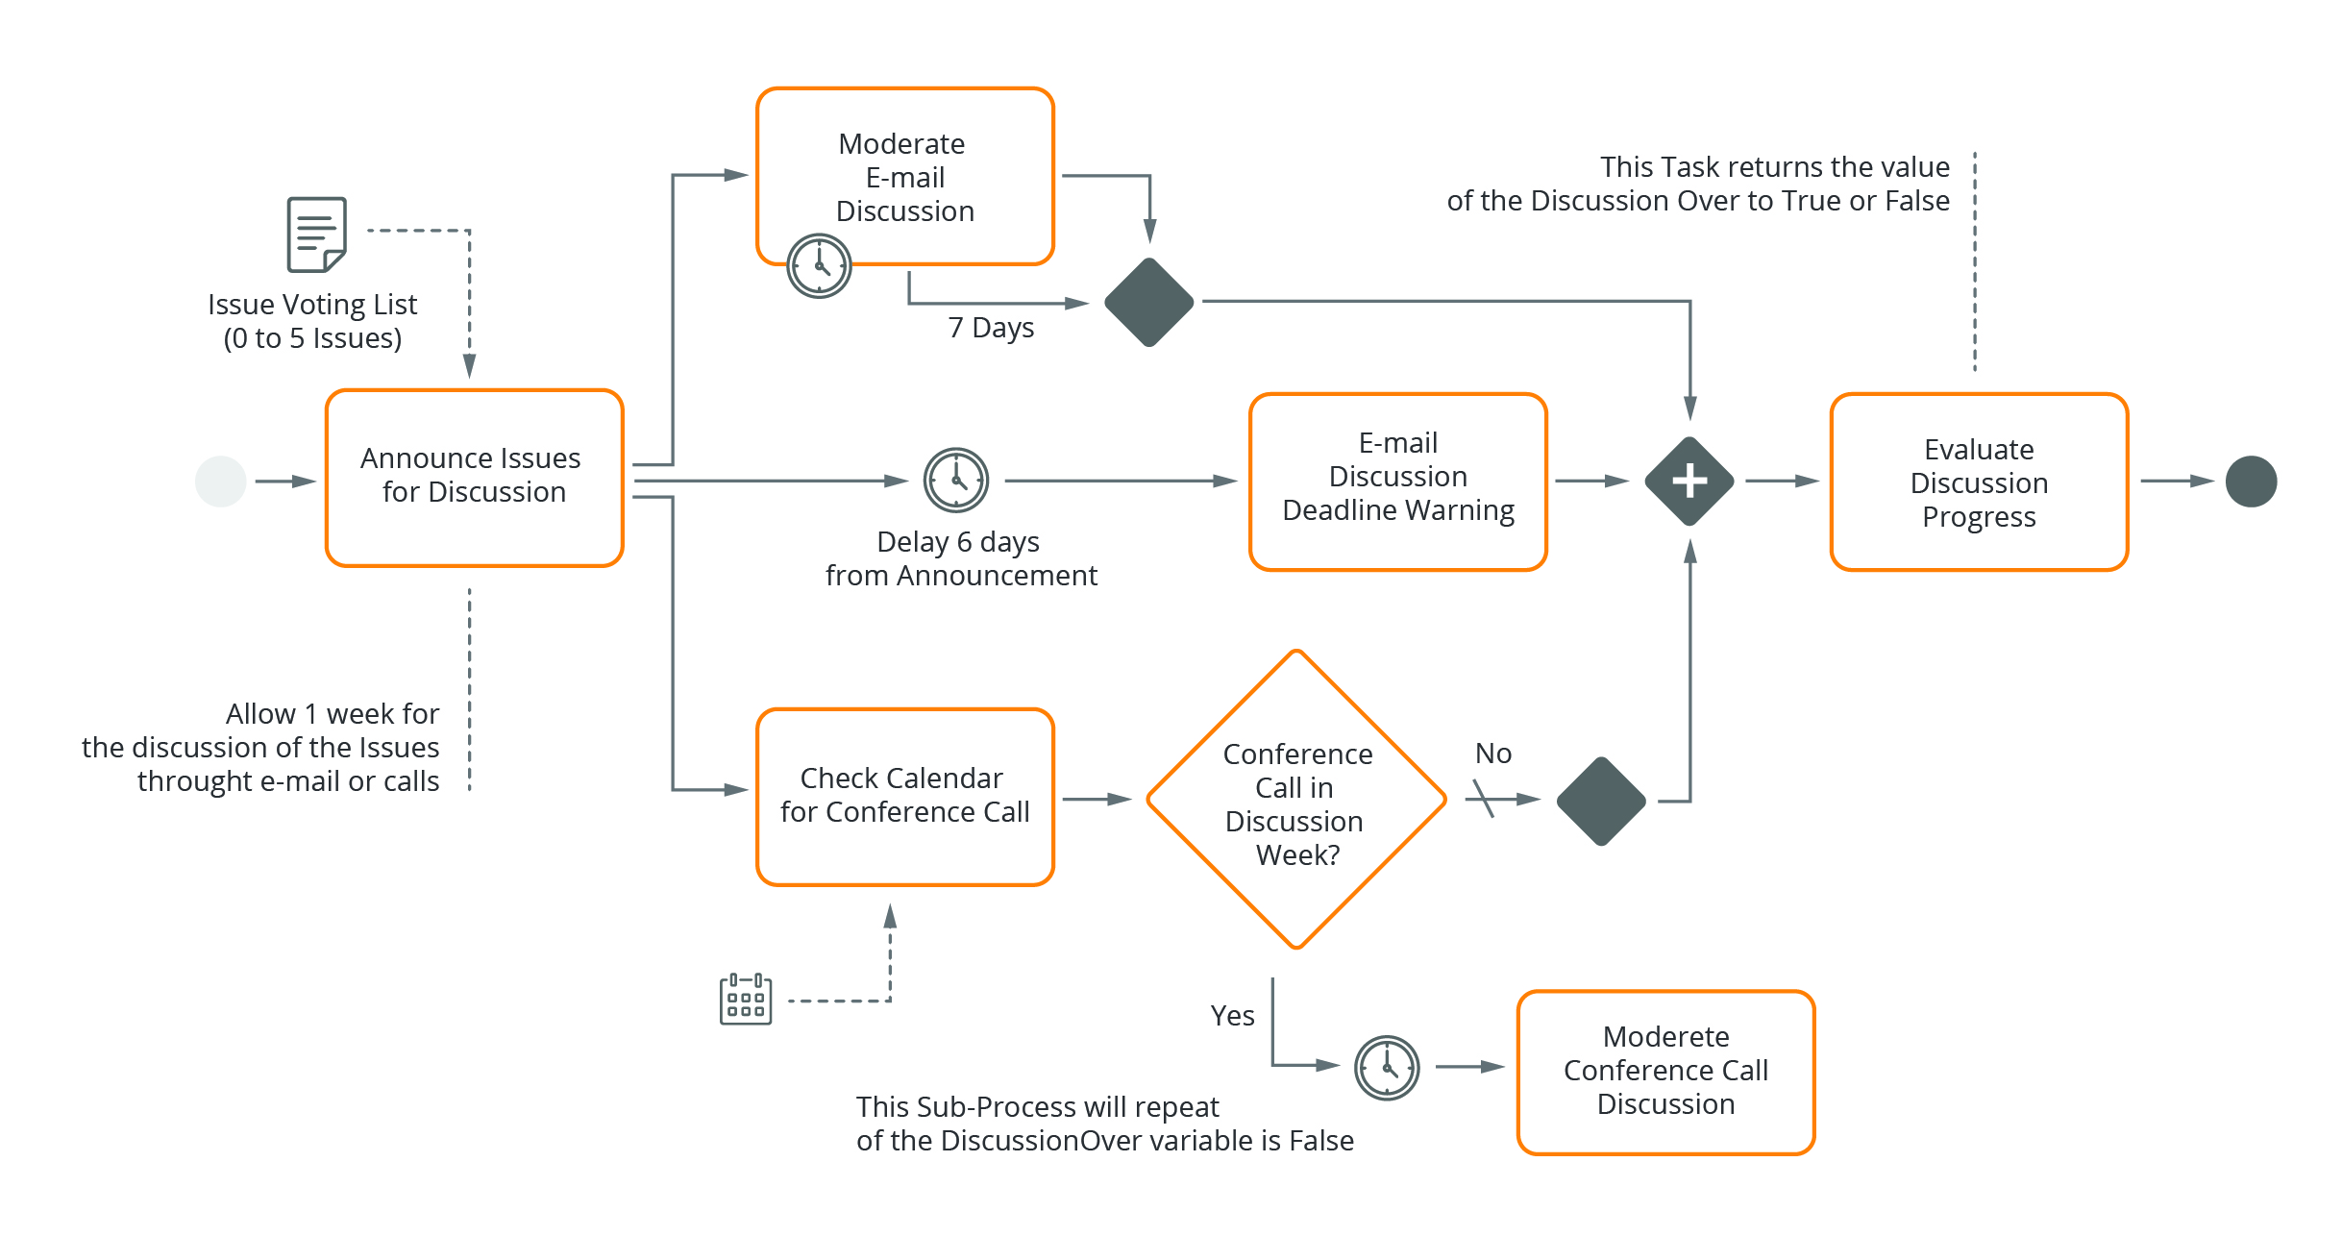
- Use cases – user functionalities
For every user group, please define or present graphically the actions they will perform in the software. For example:
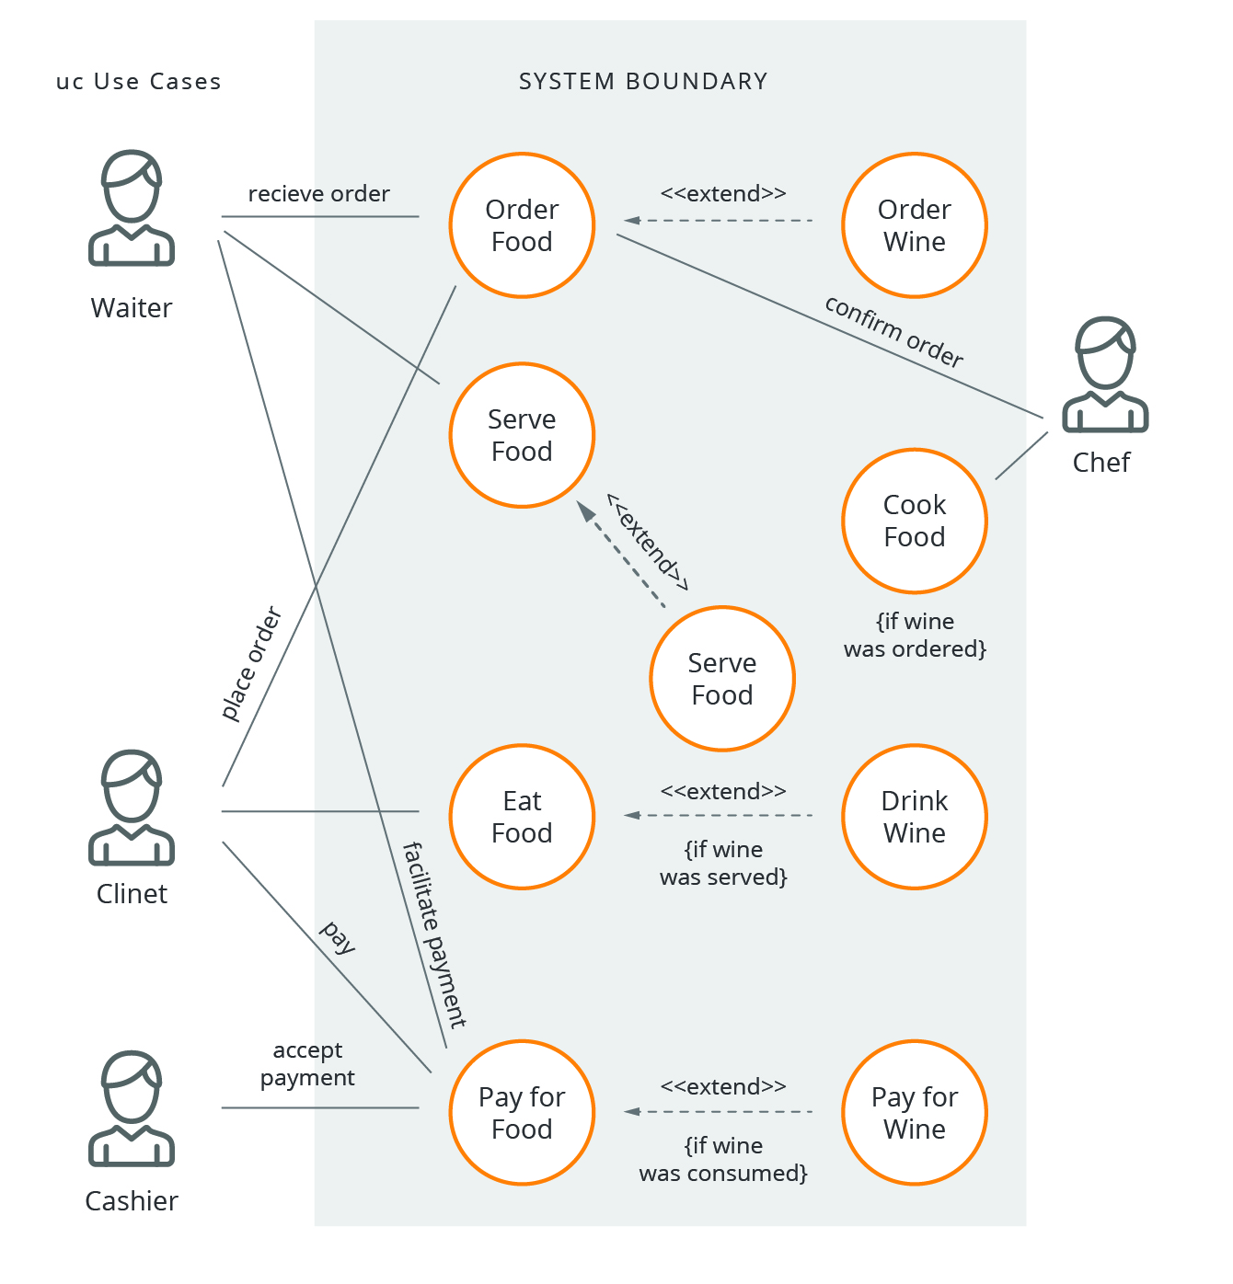
- Back office
Please describe additional functionalities which should be available for the administrator.
- Reports
This point covers information about required data in the form of reports, statistics or other forms of data aggregation and presentation.
Please describe reports which are required from your software. In particular please consider what data should be included in each of them and whether data grouping or summing is required. Please also define the expected form of reports – only shown in the program or exportable and non-editable/ editable (e.g. as a pdf/ Excel file). If possible, please provide an example of each report.
- Integrations
Please provide a list of programs with which you anticipate the need for integration. How is communication with these programs possible? Do you have documentation for these programs? If possible, please provide it with this document.
- Notifications (mail, in app, text)
If you want users to receive notifications from your new software, please describe how and when.
- Priorities
Please describe which of the above requirements are necessary to complete and which are optional or can be done at a later stage of the project.
- Out of scope
If there are any elements of the software that do not fall within the scope of the project, please describe them here.
- non-functional requirements
- Limitations
Please describe any limitations that apply to your new software. Please list any legal standards and company's policies the software must be compliant with.
- Security
Besides standards resulting from good software development practices, do you need to implement any specific security procedures?
Do you require your potential supplier to undergo an additional security audit?
- Usability and accessibility
Do you have any specific guidelines or requirements when it comes to usability (e.g. resulting from legal norms)? Does the software have to meet the requirements of any of the Web Content Accessibility Guidelines (WCAG) levels?
- Performance
Please describe what system load you anticipate - how many documents, users, transactions will be performed simultaneously and in a month. Please also define what maximum system response times are satisfactory for you, e.g. the home page loads in 2 seconds.
- Localisation
What languages should your software be available in? Do you plan to extend this list in the future? Should the software take into account time differences and different formats for storing dates and numbers depending on the region in which it is to be used?
- Training
Do you expect to run training in the operation of the new software? If so, for how many people and where would it take place? What form would the training be in (group/one-to-one/online training, or a written user's manual only)?
- Design
Should the quote also include graphic design? If so, please attach your company’s brand guidelines. If you already have a design – please attach it to the document. It is worth considering usability testing with a control group?
- technical requirements
- Technologies
What are your requirements in terms of technologies to use? Do you need your potential supplier to suggest or recommend the most appropriate technologies?
  - Technological requirements
What equipment should the software support? Which operating system and what screen resolution? Is the software supposed to be running in an existing environment? Do you already have the infrastructure in place to implement the software? If not, should the potential supplier also provide a quote for the infrastructure? Please also describe infrastructure requirements.
- Language versions
In what language versions will the software be running? Are there any changes planned in the future?
- Data migration
Does the software require data migration? When and how will this data be made available?
- Integration with external systems
Please provide a list of systems with which you anticipate the need for integration. How is communication with these systems possible?
- Implementation requirements
- Project management
Please describe your requirements and preferences for project management, methodology used, the means and frequency of contact.
- Development process
Please describe your requirements for the development process. Should the software be available to you instantly and any time? How long does testing take on your side? Do you have your own procedures for the ‘go live’?
- Maintenance requirements
What support do you expect from your potential supplier when your new software is up and running? How long should it last for? Should the cost be included as part of this project or priced independently?
- ADDITIONAL INFORMATION
Please add any other requests and information which you think might be relevant, useful or interesting for your potential supplier to know at this stage.

