# EXPERIMENT NO. 6

**Structured data flow analysis of CSS**

# Aim ;

Develop diagrams for **data flow analysis** Course Scheduling System

# Description :

Data Flow Diagrams

A Data Flow Diagram (DFD) is a traditional visual representation of the information flows within a system. A neat and clear DFD can depict the right amount of the system requirement graphically. It can be manual, automated, or a combination of both.

It shows how data enters and leaves the system, what changes the information, and where data is stored.

The objective of a DFD is to show the scope and boundaries of a system as a whole. It may be used as a communication tool between a system analyst and any person who plays a part in the order that acts as a starting point for redesigning a system. The DFD is also called as a data flow graph or bubble chart.

**The following observations about DFDs are essential:**

1. All names should be unique. This makes it easier to refer to elements in the DFD.
2. Remember that DFD is not a flow chart. Arrows is a flow chart that represents the order of events; arrows in DFD represents flowing data. A DFD does not involve any order of events.
3. Suppress logical decisions. If we ever have the urge to draw a diamond-shaped box in a DFD, suppress that urge! A diamond-shaped box is used in flow charts to represents decision points with multiple exists paths of which the only one is taken. This implies an ordering of events, which makes no sense in a DFD.
4. Do not become bogged down with details. Defer error conditions and error handling until the end of the analysis.

Standard symbols for DFDs are derived from the electric circuit diagram analysis and are shown in fig:

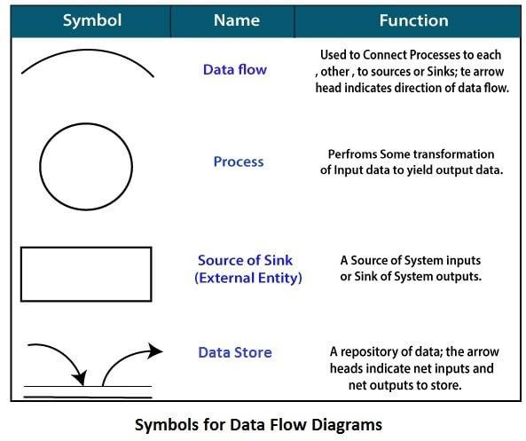

# 0-level DFDM

It is also known as fundamental system model, or **context diagram** represents the entire software requirement as a single bubble with input and output data denoted by incoming and outgoing arrows. Then the system is decomposed and described as a DFD with multiple bubbles. Parts of the system represented by each of these bubbles are then decomposed and documented as more and more detailed DFDs. This process may be repeated at as many levels as necessary until the program at hand is well understood. It is essential to preserve the number of inputs and outputs between levels, this concept is called leveling by DeMacro. Thus, if bubble "A" has two inputs x1 and x2 and one output y, then the expanded DFD, that represents "A" should have exactly two external inputs and one external output as shown in fig

The Level-0 DFD, also called context diagram of the result management system is shown in fig.

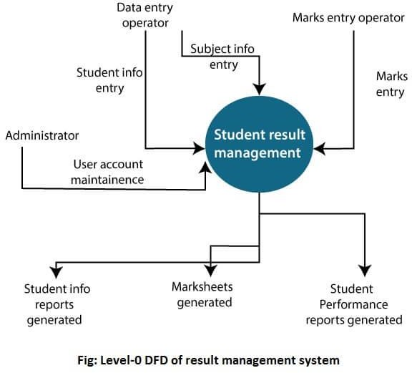

# 2-Level DFD

2-level DFD goes one process deeper into parts of 1-level DFD. It can be used to project or record the specific/necessary detail about the system's functioning.

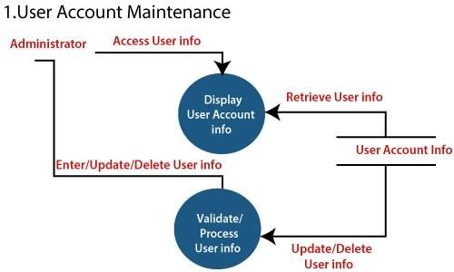

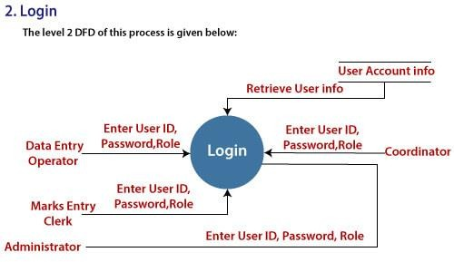

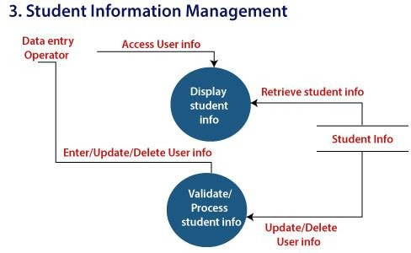

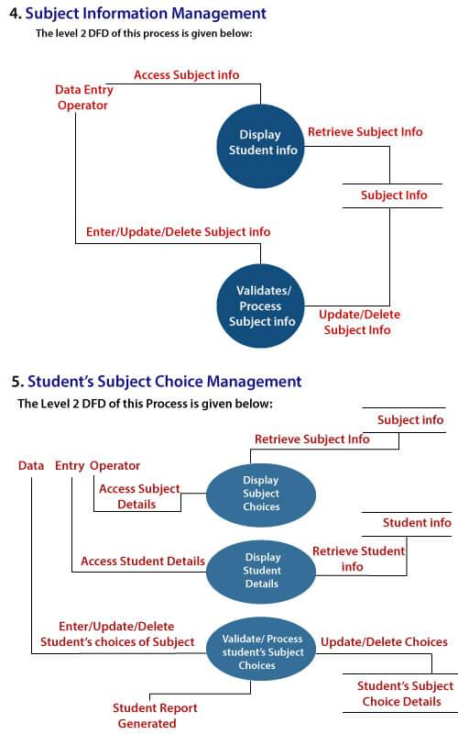

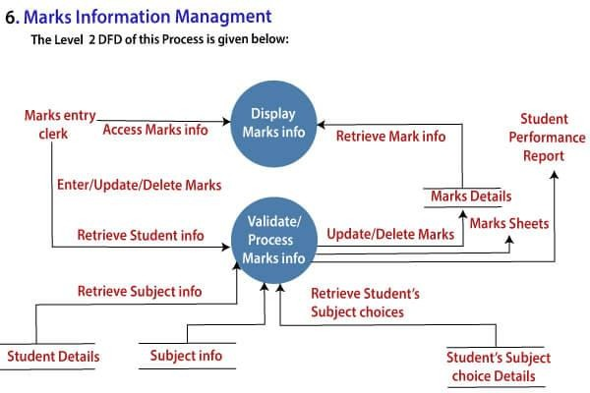

# Level 0:

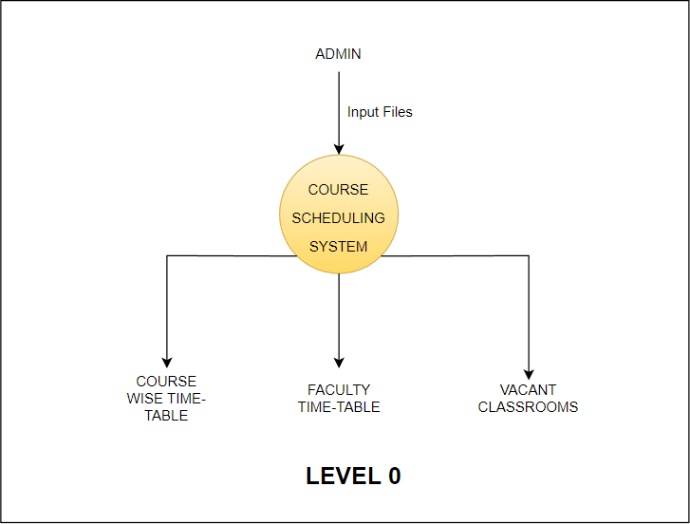

**Level 1:**

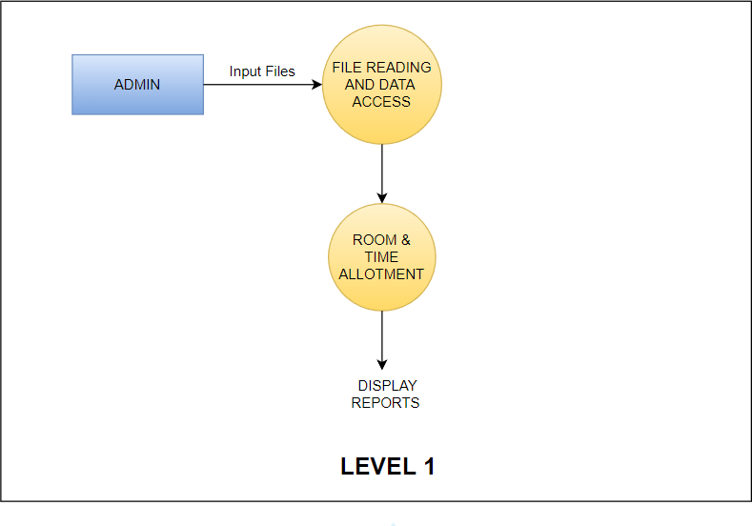

# Level 2:

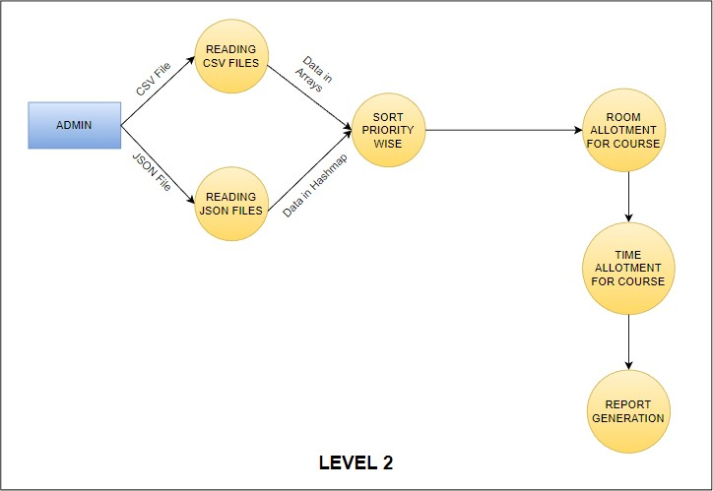

**Conclusion :** A diagramatic representation of the Course Scheduling System which defines the scope and objectives clearly has been developed using Data Flow Diagrams.