

Supplementary Information for: Insertion-sequence expansion and acquired defence systems distinguish hadal strains in the pangenome of the piezophilic bacterium Shewanella benthica

[First Author], [Second Author], [Senior Author]

Contents
Supplementary Tables S1–S10 are provided as a separate Excel workbook (Supplementary_Tables_S1-S10.xlsx). This document contains Supplementary Figures S1–S3 and Supplementary Note 1 (classification rules and analysis code).
Supplementary Table S1. Family-level master table: compartment, strain, eggNOG annotation, COG, KEGG, Pfam and curated functional class for all 5,794 families.
Supplementary Table S2. Annotation coverage by compartment.
Supplementary Table S3. Pangenome compartments, frequency spectrum and exclusive intersections.
Supplementary Table S4. Pangenome and core-genome sizes for all 15 strain subsets, Heaps' law fit and pairwise Jaccard similarity.
Supplementary Table S5. COG category composition and enrichment tests.
Supplementary Table S6. Functional classes by compartment and strain, and Fisher's exact tests for mobilome and defence enrichment.
Supplementary Table S7. Strain-specific mobilome and defence families with IS-family assignment.
Supplementary Table S8. Deep-sea trait inventory (26 modules) and member families.
Supplementary Table S9. Strain-specific gene families of each strain.
Supplementary Table S10. Software, databases and parameters.
Supplementary Figure S1. anvi'o representation of the S. benthica pangenome.
Supplementary Figure S2. anvi'o rarefaction curves with Heaps' law fit.
Supplementary Figure S3. Comparative organisation of surface-polysaccharide-associated loci.
Supplementary Note 1. Classification rules and analysis code.

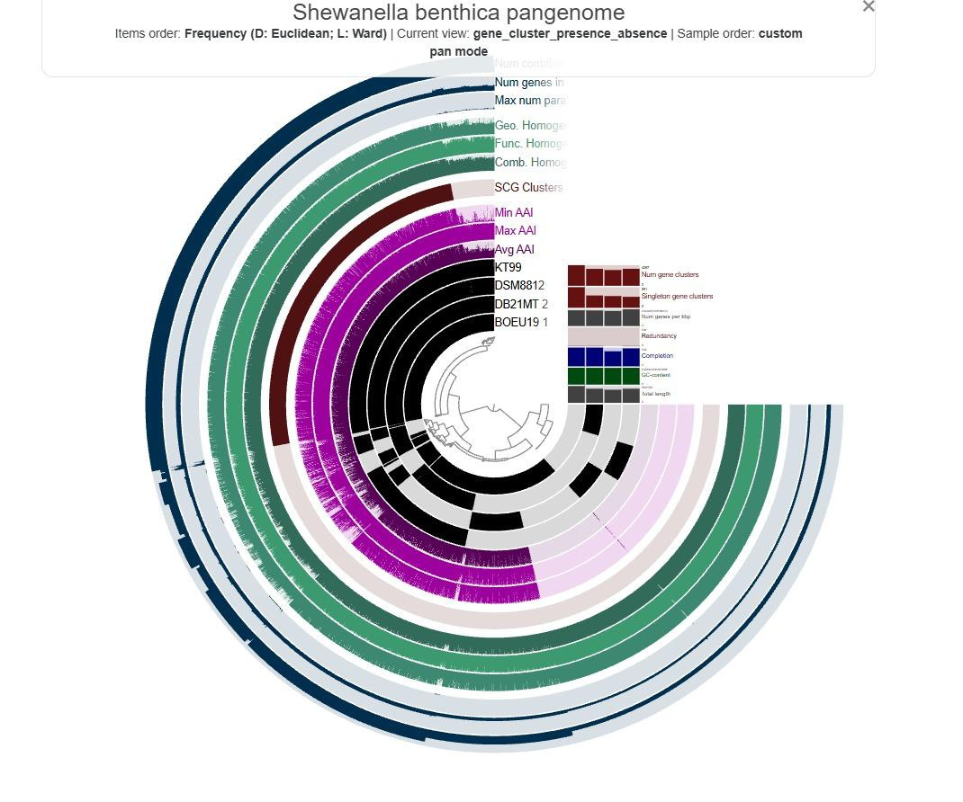
Supplementary Figure S1: anvi'o representation of the S. benthica pangenome. Gene clusters (radial items) are ordered by presence/absence frequency (Euclidean distance, Ward linkage). Inner black layers show the presence of each gene cluster in KT99, DSM8812, DB21MT-2 and BOEU19-1; outer layers show the number of contributing genomes, geometric and functional homogeneity indices, single-copy core gene clusters (SCG) and minimum, maximum and average amino-acid identity. The panel at the right summarises per-genome statistics (gene clusters, singletons, completion, GC content and total length). [Authors: export a higher-resolution SVG from anvi'o and enlarge the layer labels before submission.]

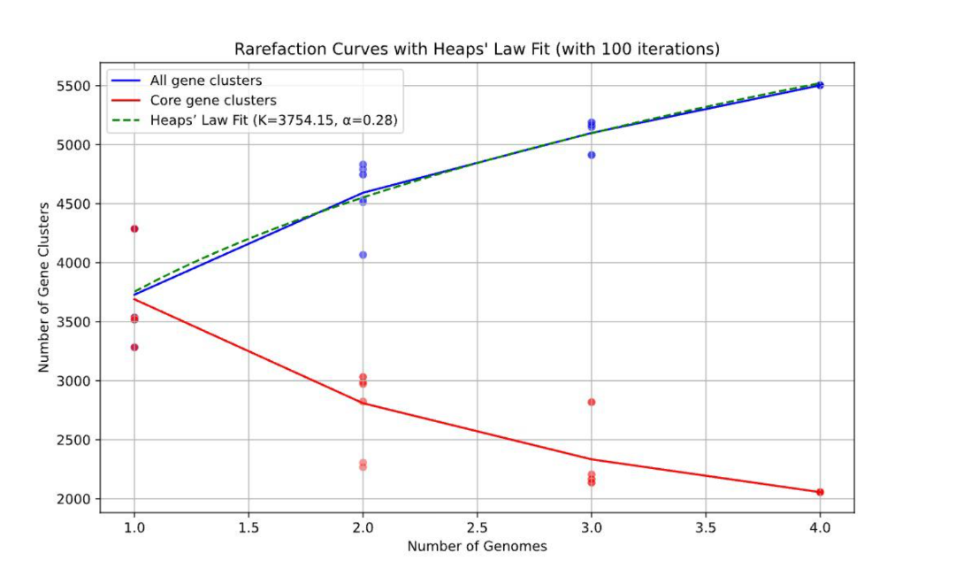
Supplementary Figure S2: Rarefaction of the anvi'o pangenome. Number of gene clusters in the pangenome (blue) and core genome (red) as a function of the number of genomes, with 100 random permutations; the dashed line is the Heaps' law fit (K = 3,754.15, γ = 0.28). Absolute values differ slightly from the Panaroo analysis (Fig. 2e) because anvi'o uses a different clustering algorithm (MCL on amino-acid similarity) and no gene-graph correction.

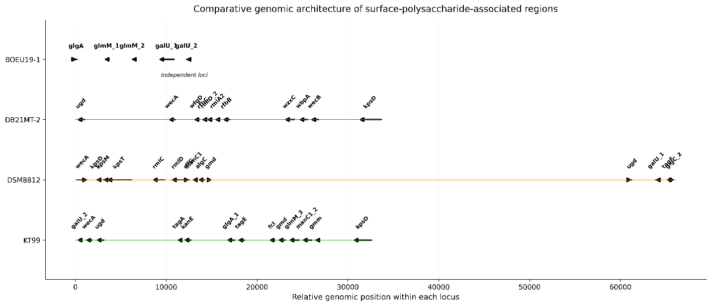
Supplementary Figure S3: Comparative organisation of surface-polysaccharide-associated loci. Arrows indicate genes and their orientation along each locus (relative coordinates, bp). BOEU19-1 encodes the relevant genes in independent loci, whereas DB21MT-2, DSM8812 and KT99 carry clustered regions of differing length and gene content (e.g., wec, rml, kps, gmd, man and gal genes). [Authors: label overlap should be resolved, e.g., with clinker or pyGenomeViz, before submission.]

Supplementary Note 1: Classification rules and analysis code
The functional classes, IS-family assignments, trait inventory, enrichment statistics and pangenome accumulation analyses reported in the main text were produced with the Python script below (analysis.py), run as python3 analysis.py Q1_pangenome_results.xlsx results/. Figures 2–5 were drawn with figures.py, available from the authors and the code repository. Regular expressions are applied to the concatenation of the Panaroo family name, eggNOG preferred name, description and Pfam domains (lower case). Rules are applied in the order: transposases/IS elements → prophages, integrases and plasmid functions → defence systems → primary COG letter.
"""Re-analysis of the Shewanella benthica Panaroo/eggNOG pangenome tables.
Usage: python3 -I analysis.py <input.xlsx> <outdir>
"""
import sys, re, json, itertools
import numpy as np, pandas as pd
from scipy.stats import fisher_exact, chi2_contingency
from scipy.optimize import curve_fit
def multipletests(p, method="fdr_bh"):
p = np.asarray(p, float); n = len(p); o = np.argsort(p)
q = p[o] * n / np.arange(1, n + 1)
q = np.minimum.accumulate(q[::-1])[::-1]; out = np.empty(n); out[o] = np.minimum(q, 1)
return None, out

xlsx, out = sys.argv[1], sys.argv[2]
X = pd.read_excel(xlsx, sheet_name=None)
STRAINS = ["BOEU19-1", "DB21MT-2", "DSM8812", "KT99"]
HADAL = {"DB21MT-2", "KT99"}
CATS = ["Core", "Accessory", "Strain-specific"]
R = {}

m = X["Master_functional"].copy()
for c in ["Strain", "Preferred_name", "Description", "COG_category", "KEGG_ko", "KEGG_Pathway", "KEGG_Module", "PFAMs"]:
m[c] = m[c].fillna("-").astype(str).str.strip()
m["txt"] = (m.Panaroo_family + " " + m.Preferred_name + " " + m.Description + " " + m.PFAMs).str.lower()

# ---------------- annotation coverage (corrected) ----------------
m["has_eggnog"] = ~((m.Description == "-") & (m.COG_category == "-") & (m.PFAMs == "-") & (m.Preferred_name == "-"))
m["has_desc"] = m.Description != "-"
m["has_cog"] = m.COG_category.str.fullmatch(r"[A-Z]+")
m["has_cog_informative"] = m.has_cog & ~m.COG_category.isin(["S", "R"])
m["has_kegg"] = m.KEGG_ko.str.startswith("ko:")
cov = []
for c in CATS:
s = m[m.Genome_category == c]
n = len(s)
cov.append(dict(Genome_category=c, Families=n,
eggNOG_hit=int(s.has_eggnog.sum()), Description=int(s.has_desc.sum()),
COG_assigned=int(s.has_cog.sum()), COG_informative=int(s.has_cog_informative.sum()),
KEGG_KO=int(s.has_kegg.sum())))
cov = pd.DataFrame(cov)
tot = cov.sum(numeric_only=True); tot["Genome_category"] = "Total"
cov = pd.concat([cov, pd.DataFrame([tot])], ignore_index=True)
for k in ["eggNOG_hit", "Description", "COG_assigned", "COG_informative", "KEGG_KO"]:
cov[k + "_pct"] = (100 * cov[k] / cov.Families).round(1)
R["coverage"] = cov.to_dict("records")

# ---------------- curated functional classes ----------------
TNP_P = r"dde_tnp|transposase|hth_tnp|\btnp|y1_tnp|y2_tnp|zf-is66|dedd_tnp|dimer_tnp|orfb_is605|orfb_zn_ribbon|isxo2|insertion element|cog1943|cog2801|cog3328|cog3436|cog3464|cog4584|cog2963|cog3039|cog3316|cog3547|cog5421|cog5433|cog4644|\bis[0-9]{1,4}\b|\bisl3\b|\btnpa|\btnpb|\binsa|\binsb|\bistb|mule"
PHAGE_P = r"\bphage\b(?! shock)|prophage|capsid|phage terminase|terminase (large|small)|gpp-like|portal protein|baseplate|tail fiber|tail tube|tail sheath|\bholin\b|integrase|site-specific recombinase|resolvase(?!, rnase h)|excisionase|phage_int|\bxis\b"
PLASMID_P = r"conjugal|conjugative|relaxase|f plasmid|plasmid transfer|traf_2|t4ss|type iv secretion system|mobilization protein|plasmid partition"
CRISPR_P = r"crispr-associated|clustered regularly interspaced|\bcas_|\bcas[0-9]+[a-z]?\b|\bcsy[0-9]\b|\bcse[0-9]\b"
RM_P = r"restriction|\bhsd[rms]|methylase_s|hsdm_n|hsdr|mrr_cat|mvai|n6_mtase|dna methylase|dna adenine methylase|cytosine-specific methyltransferase|dcm\b"
TA_P = r"toxin-antitoxin|antitoxin|(?<!tcdb)_toxin\b|-like toxin|abiei|abieii|abortive infection|\brele\b|\bhig[ab]\b|\bhic[ab]\b|\bmaz[ef]\b|\bvap[bc]\b|\byafq\b|\byafo\b|\bdinj\b|\byoeb\b|\bphd\b|mqsa"

EXCL = {"xerc", "xerd", "rnc", "vgrg", "pare", "cmr", "dnaj"}
def excluded(r):
return r.Preferred_name.lower() in EXCL
def classify(r):
t = r.txt
if excluded(r): t = ""
if re.search(TNP_P, t):
return "Mobilome: IS elements/transposases"
if re.search(PHAGE_P, t) or re.search(PLASMID_P, t):
return "Mobilome: prophages, integrases and plasmids"
if re.search(CRISPR_P, t) or re.search(RM_P, t) or re.search(TA_P, t):
return "Defence systems (CRISPR-Cas, R-M, TA)"
cog = r.COG_category
if not re.fullmatch(r"[A-Z]+", cog) or cog[0] in "SR":
return "Unknown / poorly characterized"
c = cog[0]
if c == "M":
return "Cell envelope biogenesis (M)"
if c in "TK":
return "Signal transduction and transcription (T, K)"
if c in "PU":
return "Inorganic ion transport and secretion (P, U)"
if c in "CEFGHIQ":
return "Metabolism (C, E, F, G, H, I, Q)"
return "Other characterized functions"

def subclass(r):
t = r.txt
if excluded(r): return ""
if re.search(CRISPR_P, t): return "CRISPR-Cas"
if re.search(RM_P, t): return "Restriction-modification"
if re.search(TA_P, t): return "Toxin-antitoxin / abortive infection"
if re.search(TNP_P, t): return "Transposase / IS element"
if re.search(r"integrase|recombinase|resolvase|excisionase|phage_int|\bxis\b", t): return "Integrase / recombinase"
if re.search(PHAGE_P, t): return "Phage structural / lysis"
if re.search(PLASMID_P, t): return "Plasmid / conjugation"
return ""

m["Functional_class"] = m.apply(classify, axis=1)
m["Mobilome_defence_subclass"] = m.apply(subclass, axis=1)
CLASS_ORDER = ["Mobilome: IS elements/transposases", "Mobilome: prophages, integrases and plasmids",
"Defence systems (CRISPR-Cas, R-M, TA)", "Cell envelope biogenesis (M)",
"Signal transduction and transcription (T, K)", "Inorganic ion transport and secretion (P, U)",
"Metabolism (C, E, F, G, H, I, Q)", "Other characterized functions", "Unknown / poorly characterized"]

# IS family assignment from Pfam domain / description
IS_RULES = [("IS66", r"is66|zf-is66|dde_tnp_is66"), ("IS4/IS5 (DDE_Tnp_1)", r"dde_tnp_1\b|dde_tnp_1,|dde_tnp_1$|dimer_tnp_tn5|is4|is5\b|tnp_dna_bind"),
("IS3/IS911", r"is3|is911|hth_tnp_1|rve_3|hth_21|cog2801|cog2963"), ("IS21", r"is21|istb|cog4584"),
("IS110", r"is110|dedd_tnp_is110|transposase_20"), ("IS200/IS605", r"is200|is605|y1_tnp|orfb|cog1943"),
("IS91", r"is91|y2_tnp"), ("IS1595/ISXO2", r"is1595|isxo2"), ("IS256/MULE", r"is256|transposase_mut|mule"),
("IS30/IS630", r"is30|is630|hth_tnp_tc|dde_3")]
def isfam(t):
for k, p in IS_RULES:
if re.search(p, t): return k
return "Unassigned transposase"
m["IS_family"] = np.where(m.Mobilome_defence_subclass == "Transposase / IS element", m.txt.map(isfam), "")

# ---------------- class composition ----------------
comp = pd.crosstab(m.Functional_class, m.Genome_category).reindex(CLASS_ORDER).reindex(columns=CATS).fillna(0).astype(int)
ss = m[m.Genome_category == "Strain-specific"]
comp_strain = pd.crosstab(ss.Functional_class, ss.Strain).reindex(CLASS_ORDER).reindex(columns=STRAINS).fillna(0).astype(int)
R["class_by_compartment"] = comp.to_dict()
R["class_by_strain"] = comp_strain.to_dict()

sub_strain = pd.crosstab(ss.Mobilome_defence_subclass, ss.Strain).drop(index="", errors="ignore").reindex(columns=STRAINS).fillna(0).astype(int)
sub_comp = pd.crosstab(m.Mobilome_defence_subclass, m.Genome_category).drop(index="", errors="ignore").reindex(columns=CATS).fillna(0).astype(int)
is_strain = pd.crosstab(ss[ss.IS_family != ""].IS_family, ss[ss.IS_family != ""].Strain).reindex(columns=STRAINS).fillna(0).astype(int)
R["subclass_by_strain"] = sub_strain.to_dict(); R["subclass_by_compartment"] = sub_comp.to_dict(); R["IS_by_strain"] = is_strain.to_dict()

# mobilome tests
mob = m.Functional_class.str.startswith("Mobilome")
ism = m.Functional_class == "Mobilome: IS elements/transposases"
tests = []
def fisher_row(name, a, b, c, d, desc):
o, p = fisher_exact([[a, b], [c, d]])
tests.append(dict(Test=name, Description=desc, a=a, b=b, c=c, d=d, odds_ratio=o, p_value=p))
for lab, mask in [("Mobilome (all)", mob), ("IS elements/transposases", ism)]:
sS = (m.Genome_category == "Strain-specific"); sC = (m.Genome_category == "Core"); sA = (m.Genome_category == "Accessory")
fisher_row(f"{lab}: strain-specific vs core", int((mask & sS).sum()), int((~mask & sS).sum()), int((mask & sC).sum()), int((~mask & sC).sum()), "[[SS with, SS without],[Core with, Core without]]")
fisher_row(f"{lab}: accessory vs core", int((mask & sA).sum()), int((~mask & sA).sum()), int((mask & sC).sum()), int((~mask & sC).sum()), "[[Acc with, Acc without],[Core with, Core without]]")
h = sS & m.Strain.isin(HADAL); nh = sS & ~m.Strain.isin(HADAL)
fisher_row(f"{lab}: hadal vs non-hadal strain-specific", int((mask & h).sum()), int((~mask & h).sum()), int((mask & nh).sum()), int((~mask & nh).sum()), "[[hadal SS with, without],[non-hadal SS with, without]]")
defm = m.Functional_class.str.startswith("Defence")
sS = (m.Genome_category == "Strain-specific"); h = sS & m.Strain.isin(HADAL); nh = sS & ~m.Strain.isin(HADAL)
fisher_row("Defence: hadal vs non-hadal strain-specific", int((defm & h).sum()), int((~defm & h).sum()), int((defm & nh).sum()), int((~defm & nh).sum()), "[[hadal SS with, without],[non-hadal SS with, without]]")
unk = m.Functional_class.str.startswith("Unknown")
fisher_row("Unknown: strain-specific vs core", int((unk & sS).sum()), int((~unk & sS).sum()), int((unk & (m.Genome_category == 'Core')).sum()), int((~unk & (m.Genome_category == 'Core')).sum()), "[[SS with, without],[Core with, without]]")
tests = pd.DataFrame(tests)
tests["p_BH"] = multipletests(tests.p_value, method="fdr_bh")[1]
R["fisher_tests"] = tests.to_dict("records")
chi = chi2_contingency(comp.values)
R["chi2_class_x_compartment"] = dict(chi2=chi[0], p=chi[1], dof=chi[2])
chi_s = chi2_contingency(comp_strain.values)
R["chi2_class_x_strain"] = dict(chi2=chi_s[0], p=chi_s[1], dof=chi_s[2])

# ---------------- COG enrichment (families counted once per letter) ----------------
LET = list("ABCDEFGHIJKLMNOPQSTUVWZ")
cogm = m[m.has_cog]
rows = []
for L in LET:
rec = {"COG": L}
for c in CATS:
s = cogm[cogm.Genome_category == c]
rec[f"{c}_n"] = int(s.COG_category.str.contains(L).sum()); rec[f"{c}_N"] = len(s)
rec[f"{c}_pct"] = 100 * rec[f"{c}_n"] / len(s)
for c in ["Accessory", "Strain-specific"]:
a, b = rec[f"{c}_n"], rec[f"{c}_N"] - rec[f"{c}_n"]
cc, d = rec["Core_n"], rec["Core_N"] - rec["Core_n"]
o, p = fisher_exact([[a, b], [cc, d]])
rec[f"{c}_vs_Core_OR"] = o; rec[f"{c}_vs_Core_p"] = p
rec[f"{c}_vs_Core_log2FC"] = np.log2(((a + .5) / (rec[f'{c}_N'] + 1)) / ((cc + .5) / (rec['Core_N'] + 1)))
rows.append(rec)
cog = pd.DataFrame(rows)
cog = cog[(cog[[f"{c}_n" for c in CATS]].sum(axis=1)) > 0].reset_index(drop=True)
for c in ["Accessory", "Strain-specific"]:
cog[f"{c}_vs_Core_q"] = multipletests(cog[f"{c}_vs_Core_p"], method="fdr_bh")[1]
R["cog"] = cog.to_dict("records")

# ---------------- intersections -> exact subset rarefaction ----------------
inter = X["Intersections"].copy()
inter["set"] = inter.Combination.str.split(r" \+ ").map(frozenset)
fam_per = {s: int(inter[inter.set.map(lambda x: s in x)].Families.sum()) for s in STRAINS}
R["families_per_strain"] = fam_per
pair = {}
for a, b in itertools.combinations(STRAINS, 2):
sh = int(inter[inter.set.map(lambda x: a in x and b in x)].Families.sum())
un = int(inter[inter.set.map(lambda x: a in x or b in x)].Families.sum())
excl = int(inter[inter.set.map(lambda x: x == frozenset([a, b]))].Families.sum())
pair[f"{a}|{b}"] = dict(shared=sh, union=un, jaccard=sh / un, exclusive_pair=excl)
R["pairwise"] = pair
sub = []
for k in range(1, 5):
for S in itertools.combinations(STRAINS, k):
S = set(S)
pan = int(inter[inter.set.map(lambda x: len(x & S) > 0)].Families.sum())
core = int(inter[inter.set.map(lambda x: S <= x)].Families.sum())
sub.append(dict(n_genomes=k, strains=" + ".join(sorted(S)), pangenome=pan, core=core))
sub = pd.DataFrame(sub)
heaps = lambda N, K, g: K * N ** g
popt, pcov = curve_fit(heaps, sub.n_genomes, sub.pangenome, p0=[3600, .3])
perr = np.sqrt(np.diag(pcov))
pred = heaps(sub.n_genomes, *popt); ss_res = ((sub.pangenome - pred) ** 2).sum(); ss_tot = ((sub.pangenome - sub.pangenome.mean()) ** 2).sum()
R["heaps_panaroo"] = dict(K=popt[0], gamma=popt[1], K_se=perr[0], gamma_se=perr[1], R2=1 - ss_res / ss_tot)
means = sub.groupby("n_genomes")[["pangenome", "core"]].agg(["mean", "std", "min", "max"])
R["rarefaction_means"] = {int(k): {f"{a}_{b}": float(v) for (a, b), v in row.items()} for k, row in means.iterrows()}
# new genes added by the k-th genome (mean over all orderings)
newg = []
for perm in itertools.permutations(STRAINS):
seen = set()
for i in range(4):
before = int(inter[inter.set.map(lambda x: len(x & seen) > 0)].Families.sum()) if seen else 0
seen = seen | {perm[i]}
after = int(inter[inter.set.map(lambda x: len(x & seen) > 0)].Families.sum())
newg.append(dict(k=i + 1, new=after - before))
newg = pd.DataFrame(newg).groupby("k").new.mean()
R["new_genes_mean"] = newg.to_dict()
pw = lambda N, k, a: k * N ** (-a)
po, _ = curve_fit(pw, newg.index[1:].values.astype(float), newg.values[1:], p0=[1500, 1])
R["new_gene_powerlaw"] = dict(kappa=po[0], alpha=po[1])

# ---------------- adaptive trait inventory ----------------
# Trait inventory: gene symbols matched on names (Panaroo family + eggNOG preferred name, "_n" suffixes stripped),
# phrases matched on description + Pfam. Each tuple: (module, trait, symbol_regex, phrase_regex)
m["names"] = (m.Panaroo_family.str.replace(r"_[0-9]+", "", regex=True).str.replace("~~~", " ") + " " + m.Preferred_name).str.lower()
m["descp"] = (m.Description + " " + m.PFAMs).str.lower()
TRAITS = [
("Membrane homeoviscosity", "PUFA (EPA) synthase PfaA/B/C/D", r"\bpfa[a-e]\b", r"polyunsaturated fatty acid synth"),
("Membrane homeoviscosity", "Fatty acid desaturase, FabF, FabB", r"\bdes[a-c]\b|\bfab[fb]\b", r"fatty acid desaturase"),
("Respiration & bioenergetics", "Na+-NQR (NqrA-F, NqrM)", r"\bnqr[a-fm]\b", r"nqr complex|nqrm"),
("Respiration & bioenergetics", "Rnf complex", r"\brnf[a-g]\b", r"^$x"),
("Respiration & bioenergetics", "Cytochrome bd oxidase (CydAB)", r"\bcyd[ab]\b", r"cytochrome bd"),
("Respiration & bioenergetics", "TMAO reductase system (TorA/C/D/Y, TorRST)", r"\btor[acdrsty]\b", r"trimethylamine"),
("Respiration & bioenergetics", "Nitrate/nitrite reduction (Nap, Nrf, Nir)", r"\bnap[a-h]\b|\bnrf[a-h]\b|\bnir[bdk]\b", r"nitrate reductase|nitrite reductase"),
("Respiration & bioenergetics", "Multiheme c-type cytochromes (Mtr/Omc)", r"\bmtr[abc]\b|\bomc[a-z]\b", r"decaheme|multiheme"),
("Piezolytes & polyamines", "Polyamine biosynthesis (SpeA/B/D/E)", r"\bspe[abde]\b", r"spermidine synthase|spermine"),
("Piezolytes & polyamines", "Polyamine ABC transport (PotABCD/FGHI)", r"\bpot[a-i]\b", r"^$x"),
("Piezolytes & polyamines", "Glycine betaine / choline / ectoine", r"\bbet[abt]\b|\bect[abcd]\b|\bopu[a-d]\b|\bpro[vwx]\b|\bbcct\b", r"glycine betaine|ectoine|bcct transporter|bcct_"),
("Piezolytes & polyamines", "Mechanosensitive channels (MscS/MscL)", r"\bmsc[sl]\b", r"mechanosensitive"),
("Stress & genome maintenance", "Chaperones/proteases (DnaK/J, GroESL, Clp, HtpG, Lon)", r"\bdna[kj]\b|\bgro[els]+\b|\bclp[abpxs]\b|\bhtp[gx]\b|\bhsl[uv]\b|\blon\b", r"^$x"),
("Stress & genome maintenance", "Cold-shock proteins (Csp)", r"\bcsp[a-z]\b", r"cold.shock"),
("Stress & genome maintenance", "Recombination and SOS repair (Rec, Uvr, UmuDC, LexA)", r"\brec[abcdfnoqrjg]\b|\buvr[abcd]\b|\bumu[cd]\b|\blexa\b", r"^$x"),
("Surface & motility", "Flagellar apparatus", r"\bfl[gih][a-z]\b|\bmot[ab]\b", r"flagell"),
("Surface & motility", "Type IV pili", r"\bpil[a-z]\b", r"type iv pil|pilin"),
("Surface & motility", "Capsule/LPS/O-antigen biosynthesis", r"\bwz[a-z]\b|\bwec[a-g]\b|\brf[abce]\b|\brml[a-d]\b|\bkps[a-z]\b|\bwb[a-z]{2}\b|\bwf[a-z]{2}\b", r"lipopolysacch|exopolysacch|capsular polysacch|o-antigen"),
("Nutrient acquisition", "Chitinases and glycoside hydrolases", r"\bchi[abc]\b", r"chitin|glyco_hydro|glycosyl hydrolase|glycoside hydrolase"),
("Nutrient acquisition", "TonB-dependent iron/siderophore uptake", r"\btonb\b|\bfhu[a-e]\b|\bfep[a-g]\b|\bfec[a-e]\b", r"tonb|siderophore|ferric|hemin|heme receptor"),
("Nutrient acquisition", "Heavy-metal efflux/resistance (Czc, Cus, Cop, Mer, Ars)", r"\bczc[abcd]\b|\bcus[abcf]\b|\bcop[ab]\b|\bmer[aprt]\b|\bars[abcr]\b", r"cobalt-zinc-cadmium|copper resistance|mercur|arsenate|arsenical"),
("Mobilome & defence", "Transposases / IS elements", r"^$x", None),
("Mobilome & defence", "Prophages, integrases and plasmid functions", r"^$x", None),
("Mobilome & defence", "CRISPR-Cas (type I-F, Csy)", r"^$x", None),
("Mobilome & defence", "Restriction-modification", r"^$x", None),
("Mobilome & defence", "Toxin-antitoxin / abortive infection", r"^$x", None),
]
SUBMAP = {"Transposases / IS elements": ["Transposase / IS element"],
"Prophages, integrases and plasmid functions": ["Integrase / recombinase", "Phage structural / lysis", "Plasmid / conjugation"],
"CRISPR-Cas (type I-F, Csy)": ["CRISPR-Cas"], "Restriction-modification": ["Restriction-modification"],
"Toxin-antitoxin / abortive infection": ["Toxin-antitoxin / abortive infection"]}
tr = []
m["Trait"] = ""
for grp, name, sym, phr in TRAITS:
if phr is None:
mask = m.Mobilome_defence_subclass.isin(SUBMAP[name])
else:
mask = m.names.str.contains(sym, regex=True) | m.descp.str.contains(phr, regex=True)
s = m[mask]
m.loc[mask & (m.Trait == ""), "Trait"] = name
rec = dict(Module=grp, Trait=name, Total=len(s))
for c in CATS: rec[c] = int((s.Genome_category == c).sum())
for st in STRAINS: rec[f"SS_{st}"] = int(((s.Genome_category == "Strain-specific") & (s.Strain == st)).sum())
rec["Example_genes"] = ", ".join(sorted(set([x for x in s.Preferred_name if x != "-"]))[:16])
tr.append(rec)
traits = pd.DataFrame(tr)
R["traits"] = traits.to_dict("records")

# ---------------- save ----------------
import os; os.makedirs(out, exist_ok=True)
m.drop(columns=["txt","names","descp"]).to_pickle(f"{out}/master.pkl")
comp.to_csv(f"{out}/class_by_compartment.csv"); comp_strain.to_csv(f"{out}/class_by_strain.csv")
sub_strain.to_csv(f"{out}/subclass_by_strain.csv"); sub_comp.to_csv(f"{out}/subclass_by_compartment.csv"); is_strain.to_csv(f"{out}/IS_by_strain.csv")
tests.to_csv(f"{out}/fisher_tests.csv", index=False); cog.to_csv(f"{out}/cog_enrichment.csv", index=False)
sub.to_csv(f"{out}/subset_rarefaction.csv", index=False); traits.to_csv(f"{out}/traits.csv", index=False); cov.to_csv(f"{out}/coverage.csv", index=False)
json.dump(R, open(f"{out}/results.json", "w"), indent=1, default=float)
print(json.dumps({k: R[k] for k in ["families_per_strain", "heaps_panaroo", "new_genes_mean", "new_gene_powerlaw", "chi2_class_x_compartment", "chi2_class_x_strain"]}, indent=1, default=float))
print(cov.to_string()); print(comp); print(comp_strain); print(sub_strain); print(sub_comp); print(is_strain)
print(tests.to_string()); print(pd.DataFrame(pair).T)
print(cog[["COG", "Core_pct", "Accessory_pct", "Strain-specific_pct", "Strain-specific_vs_Core_log2FC", "Strain-specific_vs_Core_q", "Accessory_vs_Core_log2FC", "Accessory_vs_Core_q"]].round(4).to_string())
print(traits.drop(columns="Example_genes").to_string())
print(sub.to_string())

