COMP3311
sqlite3:
Instructions:

.open *.db
.mode column
.headers on
.schema
.tables
.read *.sql
.output *.sql
.dump
.quit

Query Processing: Mapping SQL to RA.
eg.
select a as x
from R join S on (b=c)
where d=100

Tmp=sel[d=100](R join[b=c] S)
Res = Rename[a→x](Proj[a] Tmp)
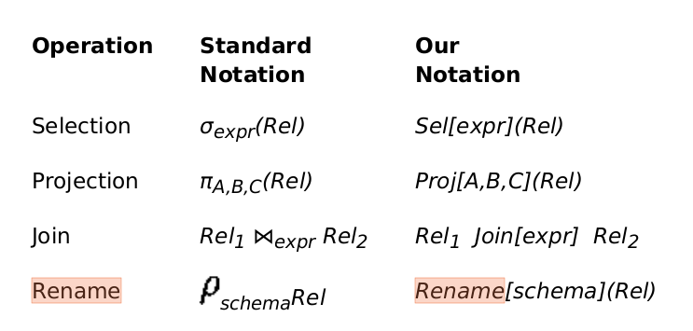
双反前,箭正后

1.Draw ER diagram

2.Build a CREATE TABLE.sql (ER type, OO type , Single Table type)

3.php, trigger(psql)

4.fds BCNF

5. sql statement to relational algebra

6. concurrency and serializablility

