Machine-Learning Surrogate for Earth-to-Mars Transfer Design
N-body shooting verification and time-of-flight optimization
Student: Handersen Kurniawan Ng | Student ID: 35458097
Unit: MMA3001 Numerical Methods and Machine Learning
GitHub repository:

1. Engineering problems and objectives
Preliminary interplanetary design involves selecting a departure date and time of flight (TOF) that produces an acceptable trajectory at an affordable delta-v. A Lambert solution provides a rapid two-body transfer estimate but does not reproduce the full effect of Earth and Mars gravity on the spacecraft trajectory. The project therefore builds a more detailed reference model that propagates the spacecraft under solar, terrestrial and Martian gravity and corrects its initial velocity by shooting to a target on Mars’s sphere of influence (SOI). Each physical candidate is comparatively expensive because the correction process requires repeated numerical integrations.
The objective is to predict the departure and arrival burn magnitudes for a candidate date–TOF pair and use those predictions to reduce the number of expensive shootings solves needed in a TOF search. The MLP does not directly predict a globally optimal TOF: the search routine evaluates the model over a finite grid, selects one or more candidates, and then applies the physical solver according to the chosen search mode.
The intended application is early-stage engineering screening and numerical-methods learning, not operational mission design. The model uses an approximate ephemeris, impulsive burns and point-mass gravitation; it omits the Moon as a separate body, other planets, solar radiation pressure, finite-burn effects, launch-site geometry and high-fidelity navigation constraints.

2. Inputs, outputs and generated data

2.1 Inputs and outputs
Item | Format / unit | Domain or interpretation
Departure date | YYYY-MM-DD; UTC | Evaluation departure date: 2030-09-01. Training-date sampling is from 2026-01-01 up to, but not including, 2040-01-01.
Training TOF | days | Uniform random sampling between 120 and 350 days by default; configurable through --tof-min and --tof-max.
Search TOF | days | The reported comparison requested 150–400 days. ML-guided and ML-only scans were clamped to 150–350 days, the model training range.
Parking-orbit altitudes | km above surface | Fixed at 200 km for Earth departure and 250 km for Mars capture.
Training controls | CLI arguments | --samples defaults to 1,000 accepted samples; --seed defaults to 42. Plot and CSV saving can be disabled with flags.
Predicted outputs | km/s | Departure and arrival burn delta-v; their sum is the total delta-v for a candidate date–TOF pair.
Verified outputs | days, dates, km, km/s, seconds | Selected TOF and arrival date, shooting residual, closest approach to Mars, physical delta-v, runtime and solve count.

Malformed date strings and non-positive TOF values are rejected by the relevant date/solver functions. Missing model files and unsupported search settings should be handled by the comparison script. Dates or durations outside the model’s training distribution are not validated; the ML search explicitly limits TOF to the training range, but date extrapolation remains possible unless checked by the caller.

2.2 Dataset generation
No external trajectory dataset is loaded. Instead, the training dataset is generated internally using a physics-based shooting solver. The generator samples departure dates uniformly over the interval from 2026 to 2040 and time-of-flight (TOF) values uniformly between 120 and 350 days. NumPy's seeded random number generator is used, with seed 42 by default, to make the sampling reproducible under unchanged software and solver settings.
Each sampled departure-date and TOF pair defines a candidate Earth-to-Mars transfer. The departure date determines the planetary positions and velocities at the start of the mission, while the TOF determines the intended arrival time and the corresponding position of Mars. The physical shooting solver then searches for suitable departure and arrival burn conditions and calculates the associated velocity changes. These values form the supervised-learning labels: the departure delta-v and arrival delta-v. The total delta-v is obtained by summing the magnitudes of the two burns.
Candidate samples are retained only when the numerical integration and shooting procedure succeed and all specified physical checks are satisfied. The final spacecraft-to-target miss distance must not exceed 100 km. In addition, the spacecraft must cross Earth's sphere-of-influence (SOI) boundary outwards and Mars's SOI boundary inwards. The hyperbolic excess-energy checks must also be positive at both boundaries, consistent with unbound planet-relative motion under the adopted two-body approximation. Candidates that fail integration, shooting convergence, the miss-distance requirement, either SOI crossing-direction check, or either energy check are discarded rather than used as training labels.
The TOF range of 120–350 days is a modelling choice intended to cover a range of transfer durations around the approximate half-period Hohmann-transfer time for idealised circular Earth and Mars orbits. It is not a guarantee that every low-delta-v or physically feasible solution lies within this interval. The generator limits its search to a maximum of (max (4N, N+50)) candidate attempts when collecting (N) accepted samples. The acceptance rate for the reported model run was not included in the supplied logs and therefore cannot be stated quantitatively.
The resulting dataset represents trajectories that both fall within the sampled date and TOF ranges and can be found by the chosen shooting solver while satisfying the specified acceptance criteria. This introduces a selection effect: feasible trajectories that the solver fails to discover, as well as candidates outside the chosen ranges or acceptance criteria, are not represented. Consequently, the neural network approximates the burn requirements within the distribution of accepted solutions, and its performance should not automatically be interpreted as evidence of generalisation to all possible Earth-to-Mars transfers.

3. Computational approach

3.1 Planet ephemeris and spacecraft dynamics
The model uses a heliocentric ecliptic coordinate frame, kilometers, seconds and km/s, with the Sun fixed at the origin. Earth and Mars positions and velocities are calculated from approximate Keplerian elements and linear secular rates referenced to J2000. The Earth element set follows the Earth–Moon barycenter approximation in the JPL table rather than a separate Earth–Moon ephemeris. Kepler’s equation is solved iteratively to obtain the eccentric anomaly, then the orbital-plane state is rotated into the ecliptic frame. JPL describes these elements as lower-accuracy approximations valid over a stated interval, and points to Horizons for higher-precision ephemerides.
For spacecraft heliocentric position r, the acceleration includes solar gravity and direct/indirect terms for Earth and Mars:
$$a=-\frac{μ_{⊙}r}{{\left|r\right|}^{3}}+\sum_{i}{μ_{i}}\left[\frac{r_{i}-r}{{\left|r_{i}-r\right|}^{3}}-\frac{r_{i}}{{\left|r_{i}\right|}^{3}}\right]$$
The initial guess and the Mars target are constructed using Lambert transfers between planetary states and points on the corresponding SOIs. The target radius in the physical training code applies a factor of 0.7 to the standard Laplace Mars SOI estimate. This gives an approximate target radius of 404,059 km, compared with approximately 577,227 km for the unscaled Mars SOI used by the trajectory-comparison script. These are distinct criteria and are reported separately below.
Spacecraft motion is integrated using SciPy’s DOP853 method through solve_ivp, with relative tolerance 3×10⁻¹⁰, absolute tolerance 10⁻⁷ and a maximum step of three days. DOP853 is an explicit eighth-order Runge–Kutta method intended for high-accuracy integration of non-stiff initial-value problems.

3.2 Shooting correction and delta-v
The shooting method treats the three components of the spacecraft’s initial velocity as unknowns. It propagates the candidate state for the selected TOF and forms the position residual between the integrated endpoint, and the target point on the Mars SOI. A Levenberg–Marquardt least-squares solve adjusts the initial velocity to reduce this residual. The code uses a finite-difference step of 2×10⁻⁵, ftol = xtol = gtol = 2×10⁻⁹ and a maximum of 35 function evaluations. The underlying physical solver rejects a final miss exceeding 100 km and enforces outward departure, inward arrival and positive hyperbolic-energy checks.
The departure and arrival hyperbolic excess speeds are inferred from the relative boundary state. For a parking-orbit radius rₚ, circular speed $v_{c}=\sqrt{\frac{μ}{r_{p}}}$ and excess speed $v_{∞}$, the idealised burn magnitude is calculated as:
$$Δv=\sqrt{v_{∞ }^{2}+\frac{2μ}{r_{p}} }-\sqrt{\frac{μ}{r_{p}}}$$
The same expression is used at Earth departure and Mars arrival, with the stated 200 km and 250 km parking altitudes respectively. The resulting total is an idealized sum of two impulsive burns, not a launch-vehicle or finite-thrust mission budget.

3.3 MLP surrogate
Each input row contains 13 features: Earth position divided by 1 AU, Earth velocity divided by 30 km/s , Mars arrival position divided by 1 AU , Mars arrival velocity divided by 24 km/s, and TOF divided by 300 days (1). The two targets are Earth departure delta-v and Mars arrival delta-v. StandardScaler is fitted to the training features and targets; the same fitted scalers are used for test data and inference. The MLP predicts both targets jointly and negative predictions are clipped to zero in the inference function.
Setting | Value in the supplied training code
Architecture | 13 inputs; hidden layers (128, 64); 2 outputs
Activation / optimiser | ReLU / Adam
Learning rate / L2 penalty | 8×10⁻⁴ / 1×10⁻⁴
Training limit | 700 iterations maximum
Early stopping | 15% validation split within training data; patience 30 iterations
Train/test split | 80% / 20%, random split, seed 42 by default
Stored artifacts | mars_nbody_training_data.csv; mars_nbody_surrogate.joblib; mars_nbody_validation.png; mars_nbody_porkchop.png

The code computes held-out metrics for departure MAE, arrival MAE, total-delta-v MAE, total-delta-v RMSE and total-delta-v R². Those printed values were not included in the available run log, so this report does not assign numerical test-set accuracy. Such metrics must be copied from the actual training output before submission.
The training pipeline also evaluates the surrogate on a grid of 100 departure dates and 75 time-of-flight (TOF) values, producing 7,500 predictions for the porkchop map below. This plot is a visualisation of the trained model, not a set of independently verified physical transfers.
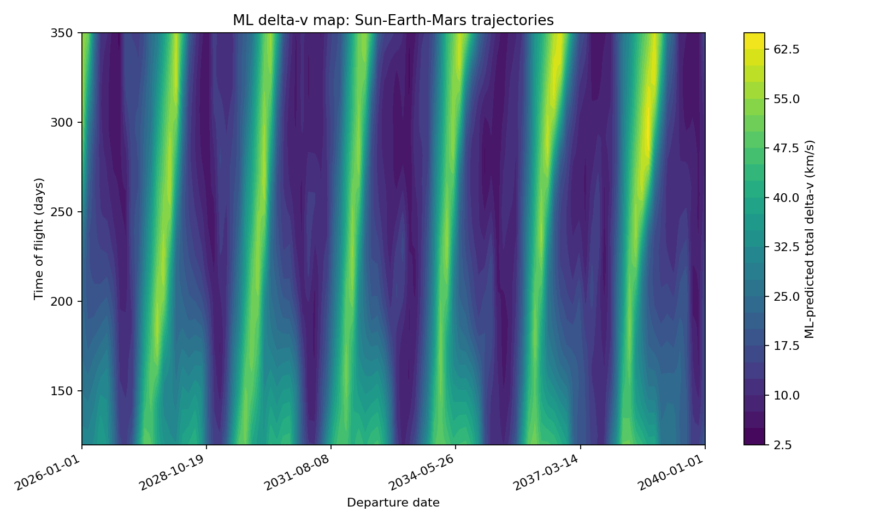
Figure 1. ML-predicted total delta-v across departure date and time of flight.
The horizontal axis spans 1 January 2026 to 1 January 2040, while the vertical axis spans 120–350 days. Darker regions indicate lower predicted total delta-v and brighter regions indicate higher predictions. The repeated bands occur approximately every 26 months (2.14 years), reflecting the Earth-Mars synodic period. This demonstrates that predicted transfer cost varies with both departure date and TOF, meaning the variables should be considered jointly. Low-valued regions are candidates for further evaluation, not proof of a feasible Mars encounter; selected points still require verification using the N-body shooting solver.
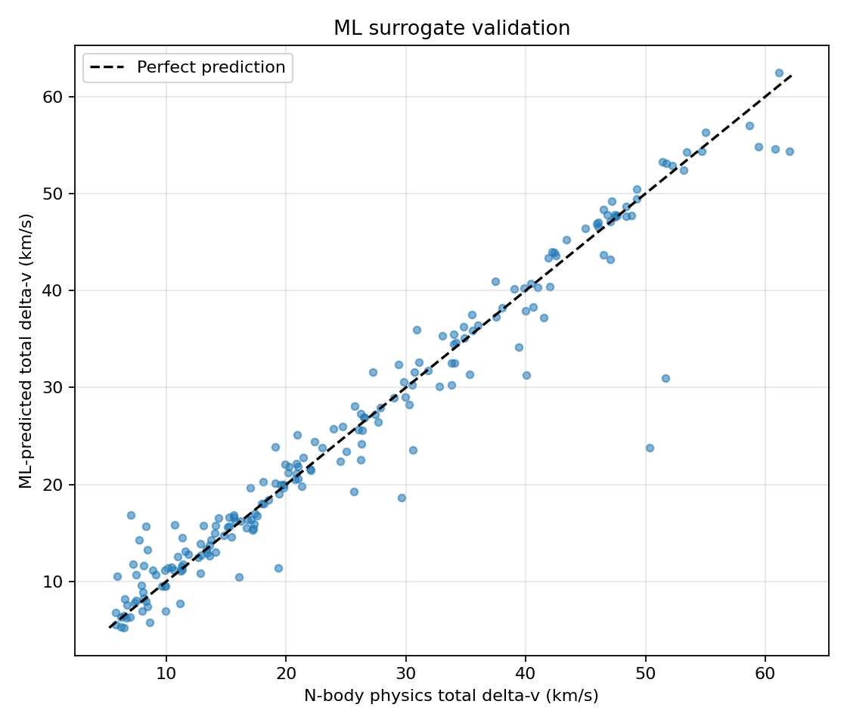
Figure 2. ML surrogate validation: predicted total delta-v versus N-body physics total delta-v.
Figure 2 presents a scatter plot validating the machine learning (ML) surrogate model’s predicted total delta-v against a high-fidelity N-body physics simulation. The horizontal axis represents the baseline N-body physics calculations, while the vertical axis displays the ML model's predictions, both measured in kilometers per second (km/s). A dashed diagonal line indicates an ideal one-to-one prediction ratio. The ML model demonstrates high accuracy for lower-energy transfers, with the majority of data points tightly clustered along the perfect prediction line within the 5 to 30 km/s range.
As the required delta-v exceeds 30 km/s, the predictive accuracy of the ML model degrades significantly. The scatter plot shows outliers where the surrogate substantially underpredicts physical transfer cost, including cases requiring over 50 km/s that are predicted at approximately 24 km/s. These high-cost errors indicate that the surrogate should be used to screen and rank candidates, not as a stand-alone source of final trajectory cost. Selected candidates still require physical verification.

4. Validation and verification

4.1 Validation strategy
The evaluation uses 2030-09-01 as the fixed departure date for all three time-of-flight (TOF) search modes. This date lies inside the training-date sampling interval (2026-01-01 to before 2040-01-01), so it is an in-domain evaluation case intended to assess interpolation within the date range. The logs alone do not establish that this date was excluded from training; a strict date-held-out test requires excluding this date, or a defined block of 2030 dates, from the training data. The checks cover (i) held-out prediction error where available, (ii) physical shooting convergence to the Mars sphere-of-influence (SOI) target, (iii) physical admissibility, (iv) closest approach relative to the standard Mars SOI, and (v) search runtime and selected TOF. A visual Lambert match in the two-body model is not treated as proof that the same initial state remains valid under N-body gravity.
Check | Evidence from the supplied logs | Interpretation
Held-out MLP performance | Held-out test metrics were not included in the supplied console logs. | Report the actual held-out MAE/RMSE/R² from the training run. The available search logs cannot quantify overall surrogate generalisation.
ML-guided selected-point prediction | At 306 d: ML-predicted total 8.7381 km/s; physical total 9.6303 km/s; absolute error 0.8922 km/s (underprediction). | Exceeds the 0.05 km/s warning threshold. The selected-point prediction does not accurately estimate the physical cost in this run.
ML-only selected-point prediction | At 295 d: ML-predicted total 8.4082 km/s; physical total 9.7115 km/s; absolute error 1.3033 km/s (underprediction). | The larger error shows the risk of choosing a TOF solely from the surrogate ranking, even though only one physical candidate is checked.
Shooting convergence | The displayed target residual for the corrected physical solutions was 0.0 km after rounding in all three modes. | Consistent with convergence to the solver target. The displayed value is rounded, not mathematically exact zero.
Physical admissibility | The solver checks outward Earth-SOI departure, inward Mars-SOI arrival and positive hyperbolic energy at both boundaries. Corrected cases had a 404,059 km closest approach. | These checks apply to accepted physical candidates. The uncorrected ML initial states are separate and do not meet the standard Mars-SOI encounter criterion.

4.2 Closest-approach verification
Trajectory case | TOF | Closest approach to Mars centre | Standard Mars SOI test
Corrected N-body solution, physics-only | 306 d | 404,059 km | Inside 577,227 km
Corrected N-body solution, ML-guided | 306 d | 404,059 km | Inside 577,227 km
Corrected N-body solution, ML-only | 295 d | 404,059 km | Inside 577,227 km
Uncorrected ML initial state (306-day case) | 306 d | 20,670,313 km | Outside
Uncorrected ML initial state (295-day case) | 295 d | 28,119,267 km | Outside
Lambert initial state propagated with N-body gravity | 306 d | 177,389 km | Inside 577,227 km
Lambert initial state propagated with N-body gravity | 295 d | 178,600 km | Inside 577,227 km
Lambert two-body propagation | 295 / 306 d | 0 km reported (display precision) | Reaches its own two-body endpoint by construction; not N-body validation

All three corrected N-body solutions reach the model’s 0.7-scaled Mars-SOI target at approximately 404,059 km, inside the 577,227 km standard Mars SOI used for the encounter check. By contrast, the uncorrected ML initial states miss the standard SOI in both logged cases. The Lambert initial states propagated with N-body gravity pass inside the standard SOI for this particular case, but this does not make the uncorrected ML trajectories valid. The Lambert two-body propagation reaches its own constructed endpoint by definition and is not an independent N-body validation.

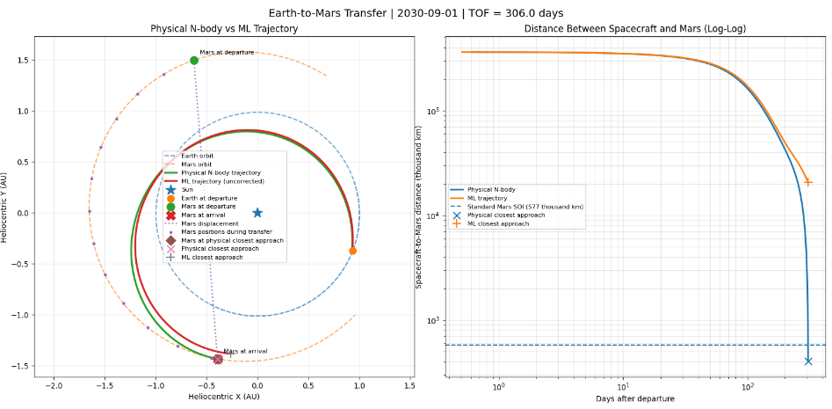
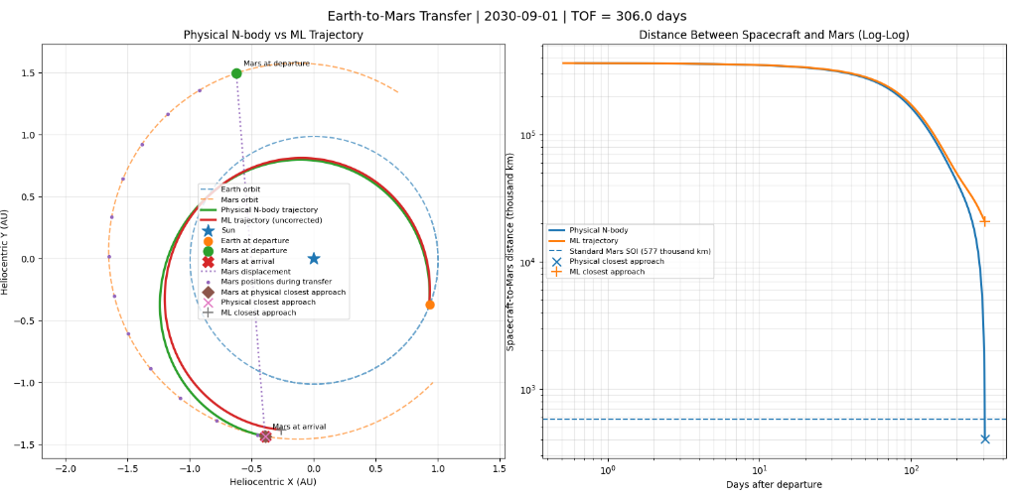
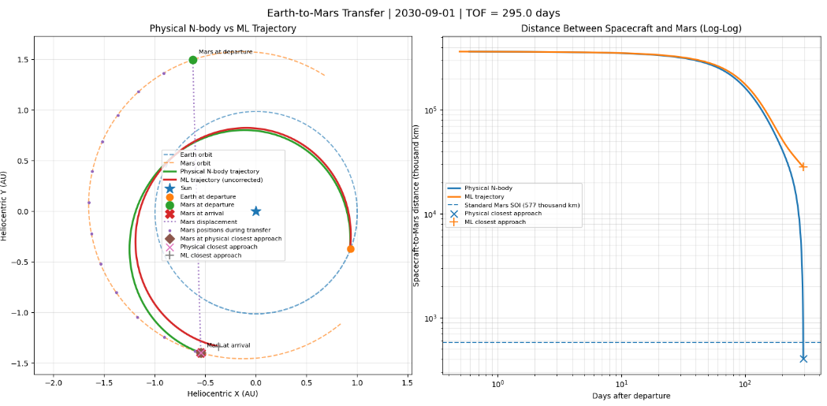

Figure 3. Comparison of the corrected N-body trajectories for the three search methods (Physics-only, ML-guided, ML-only) using a departure date of 1 September 2030.

4.3 Interpreting the three-method trajectory comparison
Figure 3 is intended to compare the spacecraft paths produced after physical shooting correction for the physics-only, ML-guided and ML-only searches. The departure date is fixed at 1 September 2030. Physics-only and ML-guided both select a 306-day time of flight (TOF), so their corrected trajectories should be very similar and may overlap on the plot. ML-only selects a shorter 295-day TOF; its path should therefore be interpreted alongside its own arrival time rather than assumed to be identical.
The important comparison is not simply whether the curves look close. The shooting solver adjusts each initial velocity so that the propagated spacecraft reaches the model’s Mars sphere-of-influence (SOI) target. In the reported results, all three corrected solutions reach the target at approximately 404,059 km from Mars’s centre. This is inside the 577,227 km standard Mars SOI used for the separate closest-approach check. The uncorrected ML initial states are not valid substitutes: their logged closest approaches are outside the standard SOI.
When the plot is inserted, label each method clearly and use the same coordinate frame and axis scale for all paths. Include Earth’s departure position, Mars’s position at the corresponding arrival time, and a legend. If the trajectories overlap, state this in the caption rather than implying that the methods produce visibly distinct paths. The plot should be generated from the final run; the current document still contains a placeholder and does not yet show trajectory curves.

5. Results and discussion

5.1 TOF search results
Search method | Selected TOF (d) | Verified total Δv (km/s) | Physical solves | Runtime (s) | Speed-up*
Physics-only | 306 | 9.6303 | 37 (26 coarse + 11 fine) | 38.57 | 1.00×
ML-guided | 306 | 9.6303 | 10 (4 shortlist + 6 refinement) | 8.47 | 4.55×
ML-only | 295 | 9.7115 | 1 (selected-point physical solve) | 0.88 | 43.83×

*Speed-up is physics-only search runtime divided by each method’s search runtime for these single 2030-09-01 runs. The measurements are machine-dependent and were not repeated to estimate variability.
For the 2030-09-01 evaluation, the ML-guided search took 8.47 s, approximately 4.55 times faster than the 38.57 s physics-only search. ML-only took 0.88 s, approximately 43.83 times faster, because it verified only one selected TOF. Physics-only and ML-guided both selected 306 days and returned a physical total delta-v of 9.6303 km/s; ML-only selected 295 days and returned 9.7115 km/s. At those selected TOFs, the surrogate underpredicted total delta-v by 0.8922 km/s for ML-guided and 1.3033 km/s for ML-only. Physics-only searched 150–400 days, while the ML searches were constrained to 150–350 days. Although the selected 306-day point is inside both ranges, different search domains and one-off timings mean these runs do not establish a global optimum or robust performance advantage.

5.2 Seeded shooting benchmark
At the ML-guided selected TOF of 306 days, the Lambert seed and ML seed were passed to the same physical correction solver. This compares alternative initial guesses at the same date–TOF point rather than comparing different search modes.
Metric | Lambert seed | ML seed
Initial-guess computation (s) | 0.030171 | 0.000413
Physical correction (s) | 0.838064 | 1.035619
Total elapsed time (s) | 0.868235 | 1.036032
Optimiser evaluations | 16 | 20
Final target miss (km) | 0.0 (rounded) | 0.0 (rounded)
Corrected total delta-v (km/s) | 9.63028 | 9.63028

Both seeds converged to the same reported corrected delta-v, but the ML seed required more evaluations (20 versus 16) and took about 0.168 s longer overall in this run. Generating the ML seed was faster, but this benchmark does not show that ML-seeded shooting reduced total correction time. This single observation is not sufficient to conclude that either seed is generally superior.

6. Performance, optimization and computational cost
The main measured optimization is algorithmic: batch the MLP predictions across the TOF grid and avoid running the full N-body shooting solver for every TOF. In ML-guided mode, the network ranks the grid, four separated candidates are checked physically, and a local refinement is performed around the best verified candidate. ML-only uses just one verification solve. The physical solver avoids storing a dense path during search by using a single endpoint sample; a full trajectory is retained only when plotting is requested.
A simple operation-count estimate for the network is 13×128 + 128×64 + 64×2 = 9,984 multiply-accumulate terms per forward pass, or roughly 2×10⁴ floating-point operations if multiplication and addition are counted separately, excluding activation and scaling overhead. A batched 201-TOF scan is therefore on the order of 4×10⁶ network FLOPs. This is an architectural estimate, not a profiler measurement; feature construction and Python overhead are not included. The physical search cost is dominated by repeated integrations inside the least-squares shooting loop. A reliable FLOP estimate for that component would require profiling the actual run.
Further engineering improvements are: (i) repeat runtimes across several seeds or dates and report mean and spread; (ii) align the ML and physics-only TOF intervals; (iii) compare a second regressor under the same split and metrics; (iv) run a date-held-out test to assess generalization beyond random interpolation; (v) profile ephemeris, integration and optimization separately; and (vi) verify integration tolerance sensitivity by tightening and loosening DOP853 tolerances and measuring the endpoint change.

7. Limitations and lessons learned

7.1 Main limitations
- Approximate ephemeris: the element model is suitable for a lower-fidelity study, but not a replacement for a high-precision ephemeris or a full mission-design tool .
- Restricted dynamics: only Sun, Earth and Mars gravity are included, with Earth and Mars represented as point masses; the Moon is not modelled separately, and non-gravitational forces and finite burns are omitted.
- SOI convention: the physical training target uses 0.7 times the standard Mars SOI radius, whereas the trajectory-comparison test uses the standard SOI. These metrics must not be mixed.
- Search-domain mismatch: physics-only searches 150–400 days, while ML-guided and ML-only are limited to 150–350 days by the training range. For the 2030-09-01 case, physics-only and ML-guided both select 306 days, while ML-only selects 295 days; the differing bounds, different candidate budgets and single runs still prevent a global-optimum claim.
- Incomplete ML validation evidence held-out test metrics and dataset acceptance rate were not present in the logs provided for this report. The random 80/20 split also does not test extrapolation by year or synodic period.
- The surrogate predicts delta-v magnitudes only. Its uncorrected trajectory inherits a direction from the Lambert boundary guess and is not expected to meet Mars without correction.
- Single-run performance data: no repeated timings, hardware specification, package versions or profiler output were supplied. Speed-up ratios should be viewed as indicative rather than statistical results.

7.2 Lessons learned
The 2030-09-01 results illustrate the difference between fast prediction and a verified engineering solution. Physics-only and ML-guided selected the same 306-day transfer and achieved the same reported physical total delta-v, while ML-only selected 295 days but had a larger prediction error. Physical verification confirmed that corrected solutions reached the Mars-SOI target and showed that the uncorrected ML initial states missed the standard SOI. The ML methods reduced search runtime, but their selected point underprediction and the differing TOF bounds mean that speed alone is not evidence of accuracy or global optimality.

8. Conclusion
A supervised MLP surrogate was designed to predict Earth-departure and Mars-arrival delta-v from a 13-feature transfer description, with training labels generated by a Sun-Earth-Mars shooting model. For the 2030-09-01 evaluation, ML-guided and ML-only searches reduced the single-run search time by factors of about 4.55 and 43.83 relative to physics-only. Physics-only and ML-guided both selected 306 days with a physical total delta-v of 9.6303 km/s; ML-only selected 295 days with 9.7115 km/s. However, the surrogate underpredicted the physical totals at its selected points, and the available logs do not include held-out MAE/RMSE/R² metrics. The 2030 date lies within the 2026–2040 sampling interval, so it is an in-domain evaluation case rather than evidence of date extrapolation; a strict date-held-out test requires excluding that date or a 2030 date block from training. The uncorrected ML trajectories did not enter Mars’s standard SOI. The project supports using the surrogate for screening followed by physical verification, but a fair same-range benchmark, complete test metrics and repeated runs are still needed.

9. AI-use reflection
Draft for author review. The MMA3001 brief requires the submitted reflection to describe the AI tools actually used, their contribution and the checks performed. Edit the statements below so they accurately represent the full project workflow.
Required item | Draft statement to verify / complete
Tool used | ChatGPT (OpenAI) was used during project discussion and report editing. Add any other tools and approximate dates actually used.
Tasks supported | Support included explaining numerical methods, reviewing code structure/results and improving report organization. Specify which code sections, if any, were AI-generated or substantially revised.
Approximate contribution | AI contributed to approximately 15% of the code (mostly syntax formatting and basic MLP structure templates) and 20% of the report text (grammar correction and structural editing).
Verification | Numerical values in this report were compared with the supplied source code and console-log results. Add the tests, independent checks and functions personally run or inspected.
Student decisions | All core conceptual choices were made independently by the author. I personally developed the core project methodology: I formulated the idea of searching for the optimum Time of Flight (TOF) to pass into the Lambert solver. When I realized that finding the optimum TOF iteratively takes a very long time, I made the strategic decision that using a Multi-Layer Perceptron (MLP) was the best approach to bypass this computational bottleneck. I also defined the training range, final network architecture, and interpretation of the results.
Errors / limitations of AI assistance | The AI initially suggested network architectures that were too deep, leading to overfitting on the trajectory data. It also occasionally hallucinated specific parameter names for the orbital mechanics library being used, requiring manual correction and referencing of the official documentation.
Effect on learning | Using AI clarified the practical steps of setting up an MLP, but it reinforced the necessity of domain knowledge. The AI could write the code, but it could not tell if a predicted TOF made physical sense for the orbital transfer. I learned how to critically evaluate AI outputs against the fundamental physics of Lambert's problem.

References
NASA/JPL Solar System Dynamics. “Approximate Positions of the Planets.” https://ssd.jpl.nasa.gov/planets/approx_pos.html (accessed 23 October 2026).
SciPy documentation. “DOP853” and “solve_ivp: Solve an initial value problem for a system of ODEs.” https://docs.scipy.org/doc/scipy/reference/generated/scipy.integrate.DOP853.html and https://docs.scipy.org/doc/scipy/reference/generated/scipy.integrate.solve_ivp.html (accessed 23 October 2026).
[3] Pedregosa, F., et al. (2011). “Scikit-learn: Machine Learning in Python.” Journal of Machine Learning Research, 12, 2825–2830. https://www.jmlr.org/papers/v12/pedregosa11a.html.
[4] Virtanen, P., et al. (2020). “SciPy 1.0: Fundamental Algorithms for Scientific Computing in Python.” Nature Methods, 17, 261–272. https://doi.org/10.1038/s41592-019-0686-2.
[5] Monash University. MMA3001: Numerical Methods and Machine Learning — Project Brief, supplied course document.

