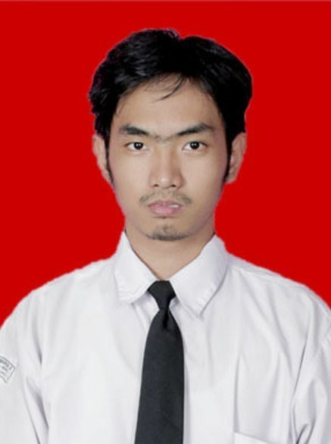
Alexander Hansen Paulus

Perumahan Kopo Permai II blok 27 A no.9,
(+62)87824130128, alexanderhansen124@gmail.com

EMPLOYMENT OBJECTIVE
A career in Information Technology, specifically in the areas of DevOps, that will optimally utilize in scalability, automation, system stability, strong analytical skills, problem solving and time management to support continuous integration/continuous deployment.

EDUCATION
INSTITUT TEKNOLOGI HARAPAN BANGSA, Bandung, Indonesia October 2025
Sarjana Informatika. Concentration: Database and Network
GPA 3.24

SMA Santa Maria 2, Bandung, Indonesia May 2019

EXPERIENCE
GKI Anugrah Library, Bandung, Indonesia November 2024 - March 2025
A church library which provides some books on Christian spiritual and faith matters.
Intern, Information System Migration Team
- Migrate custom system information to SLiMS-based information system
- Research app development process
- Migrate data from custom schema MySQL to SLiMS database schema
- Jointly developed the PHP app with two other college
- Produced project documentation
Mova Intelligence Technology, Bandung, Indonesia
A startup focused on integrating and developing agentic AI applications.
Contract, Fullstack Software Developer
- Develop and maintain AI chatbot for Telegram & Whatsapp services
- Develop and maintaining web ui for chatbot
- Implemented CI/CD pipelines using GitLab CI to automate build, test and deployment process.
- Produced project documentation on Spring AI, Spring boot, React and Thymeleaf project
Others
- Jointly developed the Unity-based game with two other programmers
- Jointly developed a Vue.js-based front-end application with four other programmers
- Jointly developed an android-based application with one other programmer
- Jointly developed Jest testing case with three other programmers
ADDITIONAL INFORMATION
- Highly proficient in the following technologies:
- Programming language : Java, Python, Golang, C#, C++.
- Web technologies: Node.js.
- Testing framework: Jest.
- Front-end framework: Vue.js, React.js, Thymeleaf.
- Back-end framework: Laravel, Spring Boot, Spring AI, LangChain4J.
- CI/CD tools : Jenkins, Gitlab Auto Deployment.
- Containerization : Docker.
- Databases : MySQL, SQL server, MongoDB, Redis, PostgreSQL, Firebase.
- Cloud: AWS, Google Cloud Platform.
- Fluent in English
- Member of ITHB Japanese Culture Community (2023-2024); JCC is a Japanese Culture Community in ITHB
- Member of OMK Katedral Santo Petrus (2024-present); OMK Katerdral Santo Petrus is Catholic Youth Group in Saint Peter Cathedral, Bandung, West Java
- Projects :
  - Unity : hansen9/Castle_Phantasia
  - Vue.js : Aristodd/DailyFresh-FrontEnd
  - Android app: hansen9/Groomer
  - Jest : Commits · WoufWouf35/TUBES_PBO

