**Log in/registration**
- OTP verification UI: Improve. Must be consistent with design.
**ADMIN Dashboard**
- Collection Schedule: Instead of mentioning each purok, just put “All Puroks”.
- 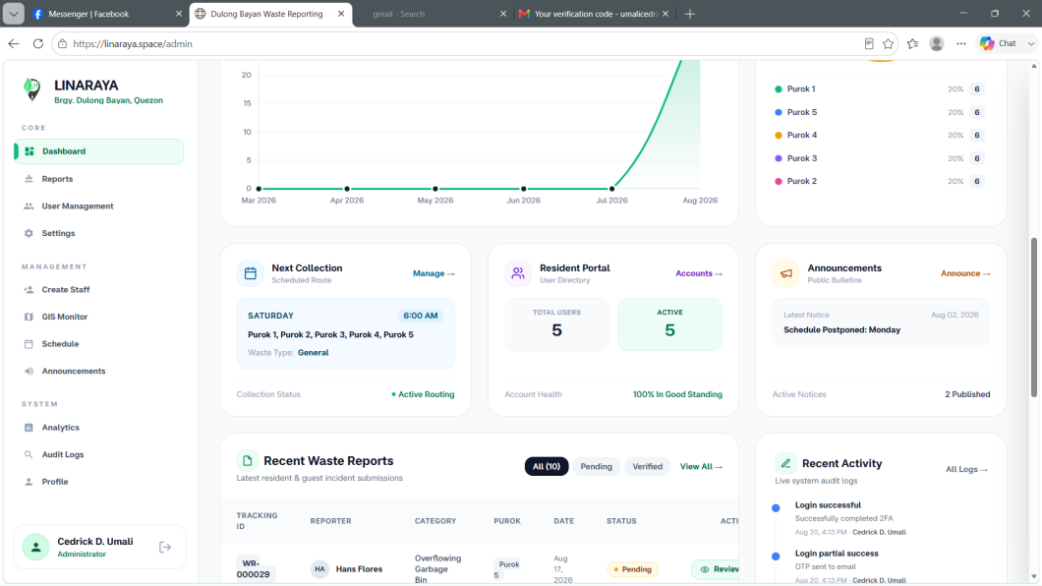

**Reports**
- Enhance / improve the table, remove the evidence pictures. The table should be formal, not the one at the UI itself.
- 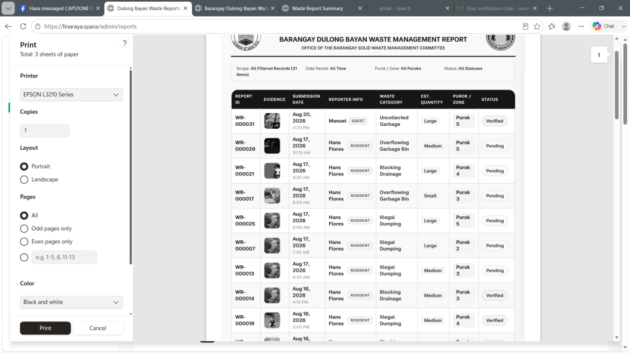

-Also, the guest and resident tags in the name are aligned
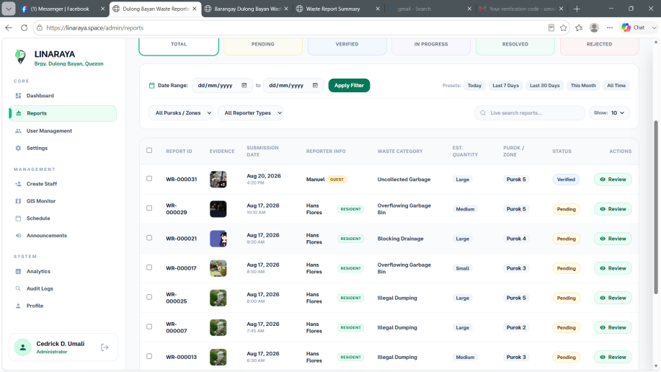

**User Management**
- Inconsistent color palette
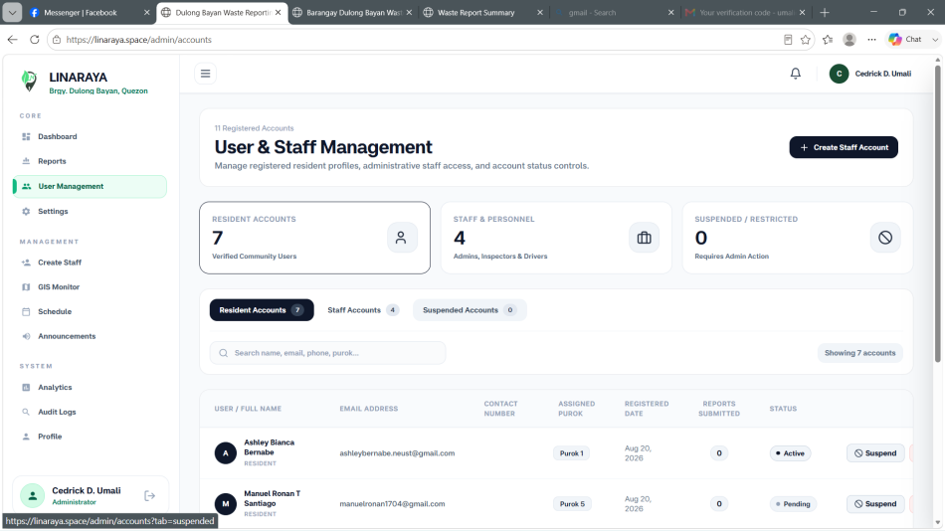

**admin Settings**
*Barangay Info*
- Make it full “barangay information” title.
- Inconsistent color palette.
- Sentence case should be automatically applied even if the input is in lower case. Apply to all forms
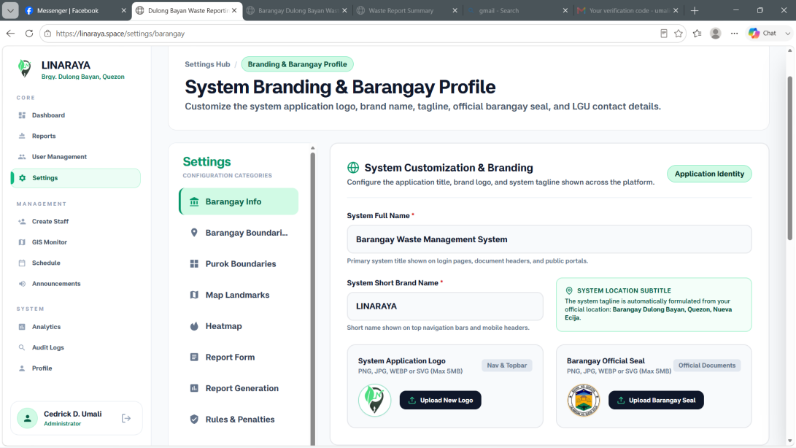

*Barangay Boundary*

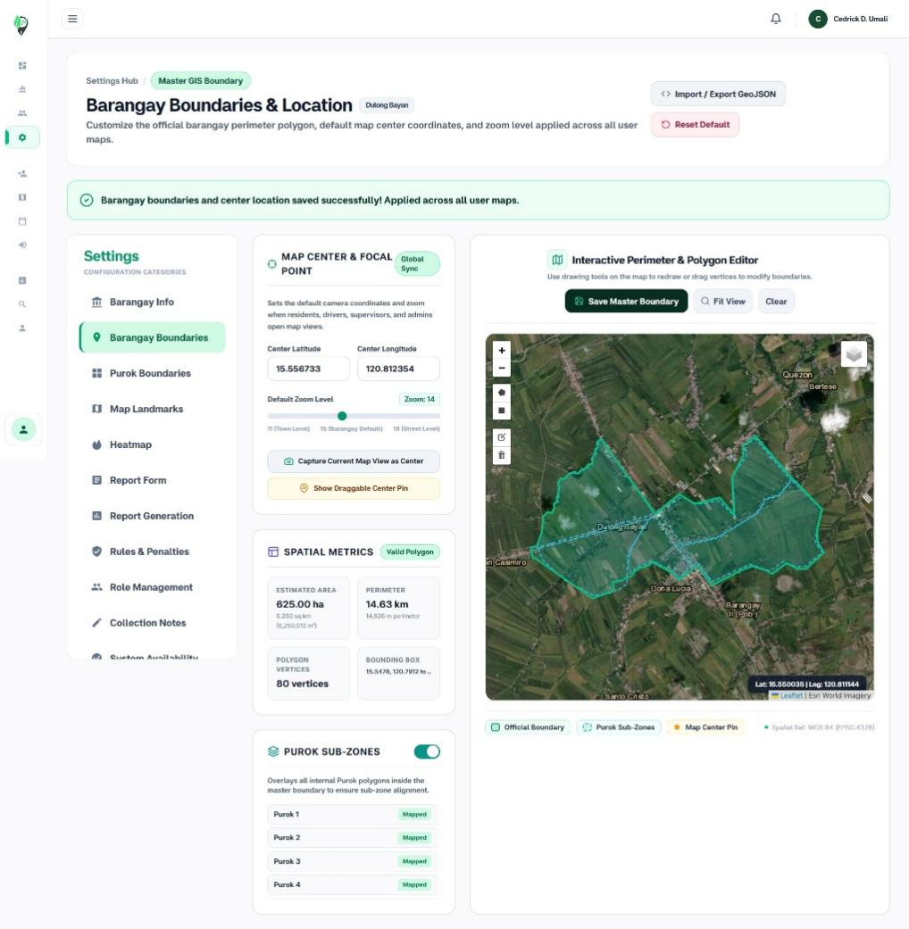
- The content is too clustered (close together), put the map at the bottom then the cards at the top (the width should fit.)

*Purok Boundaries*

- Add “Add Purok” and some features.
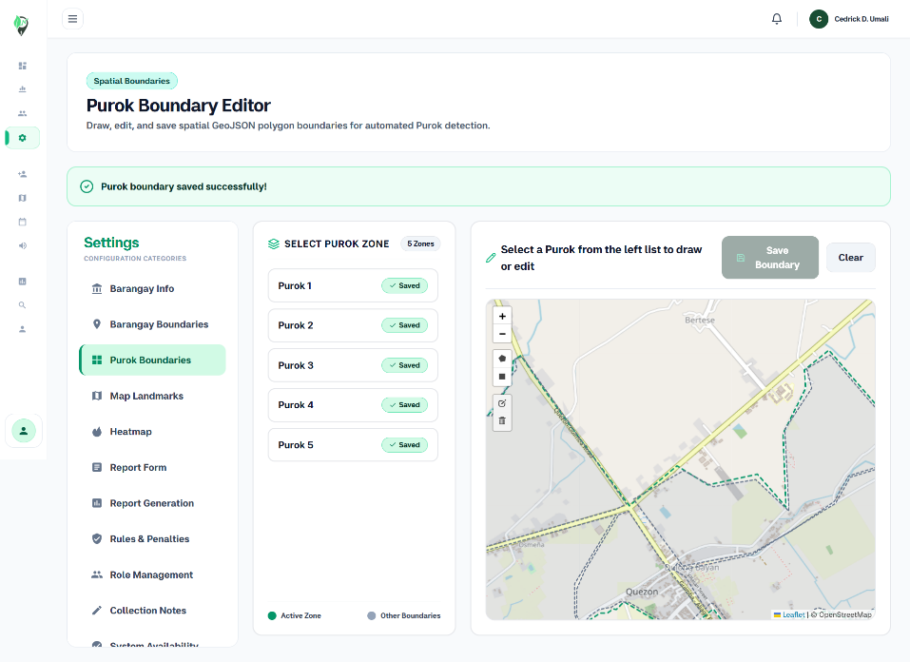

*Heatmap*

- It should be possible to change the number of reports for each intensity (e.g., Low Intensity (minimum report threshold (3)–5)). Since the threshold can be changed, I suppose it should have intervals. For instance: Moderate (6–10), Severe (11+), and Low Intensity (3–5 reports).

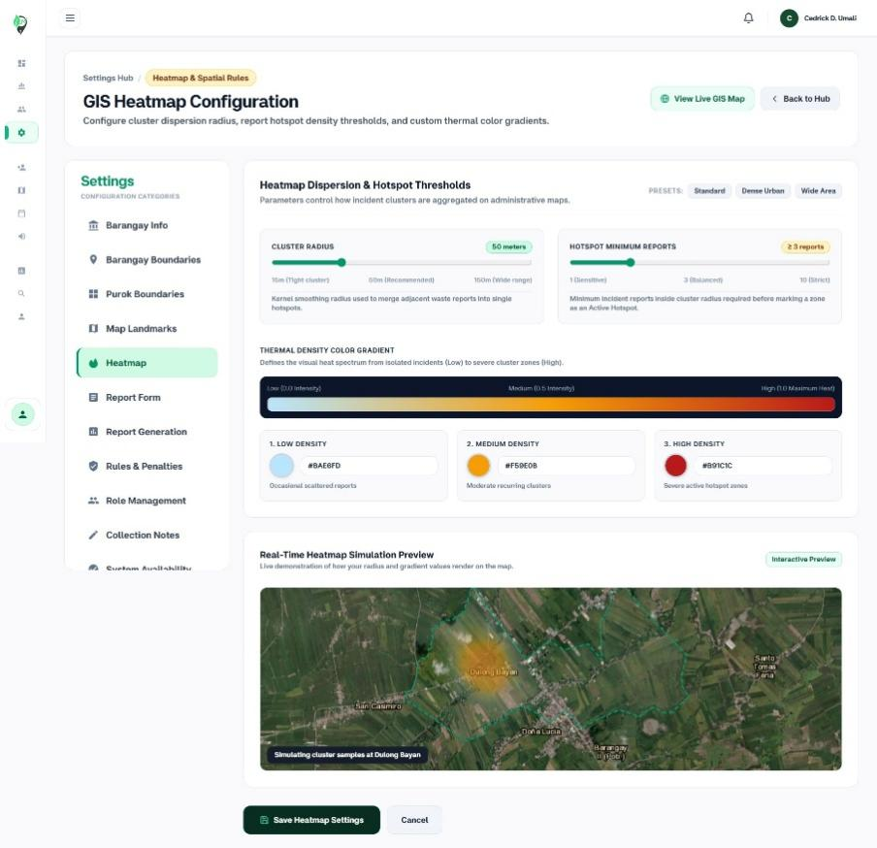

*Penalties and Probited Actions*
- Add Prohibited Actions and Penalties should be separate because they are based on the barangay ordinance. This should also be reflected in the UI on the landing page.

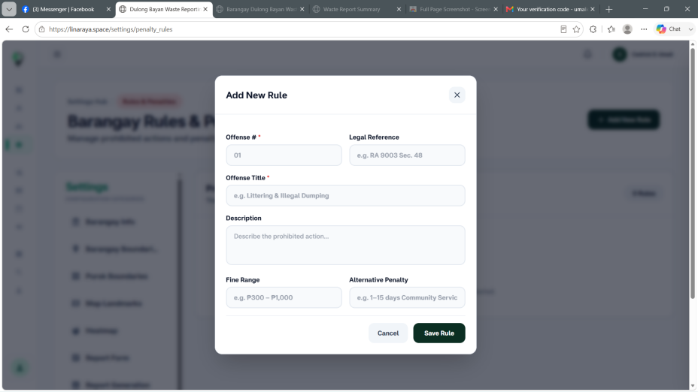

*Collection Notes.*
- Please include this on the collection schedule page.

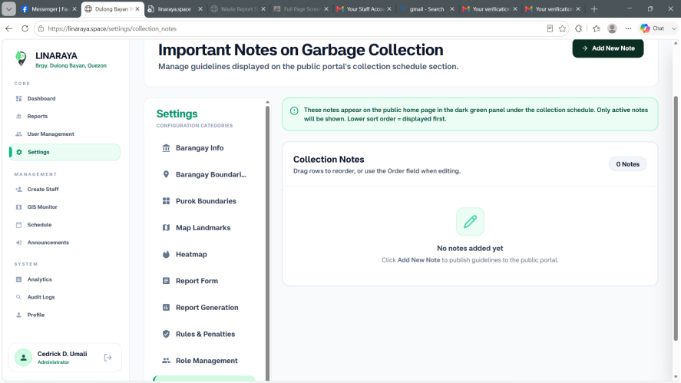

*System Availability*
- Issue: Under Maintenance is active by default please fix.
- Enhance/improve the UI of System Lockdownmake it understandable.
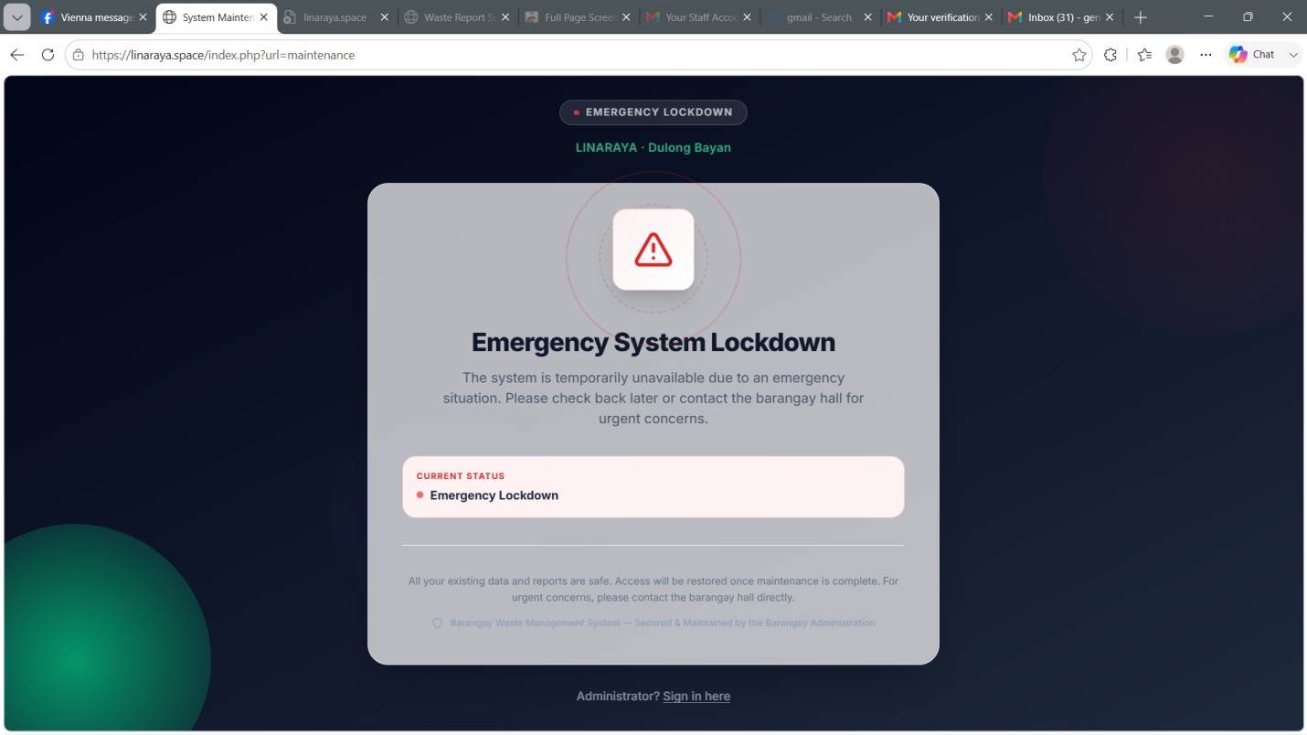
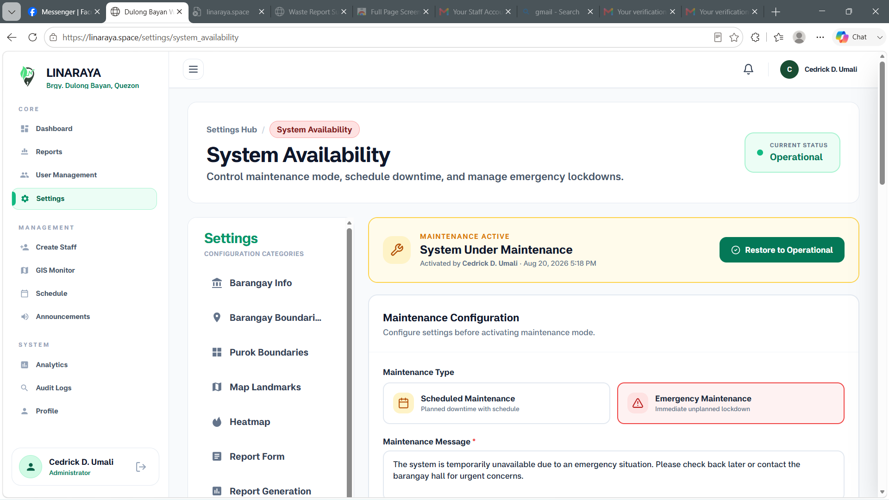

**GIS Monitor**
- The heatmap is inaccurate, it should not appear as a heatmap if there is only 1 report within the radius that is set. Then if there are reports that are adjacent within the radius that will enter the color intensity. Which should be set in the settings. (Heatmap Settings) each color should have an associated number of reports before it becomes a heatmap.
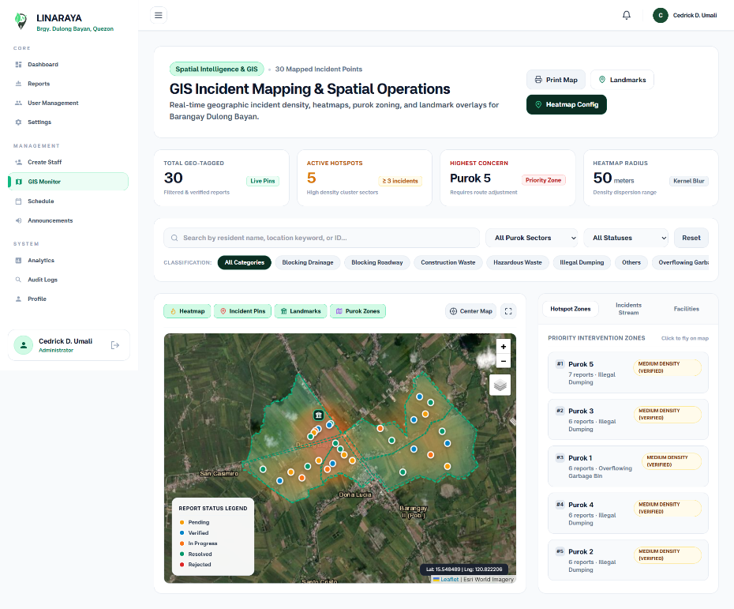
**Announcement**
- Editing doesn't work please fix.
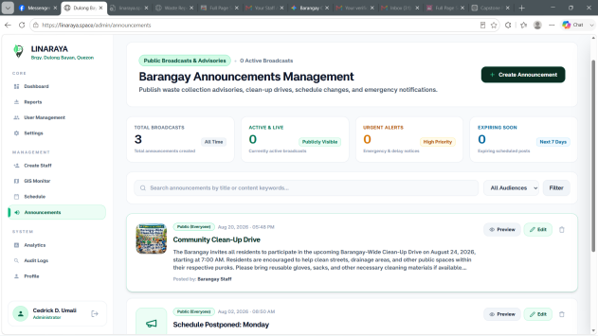

*edit Announcement page*
- The edit card is superimposed on the current page, and the edit page has an ugly user interface. I suppose it just appears.
- 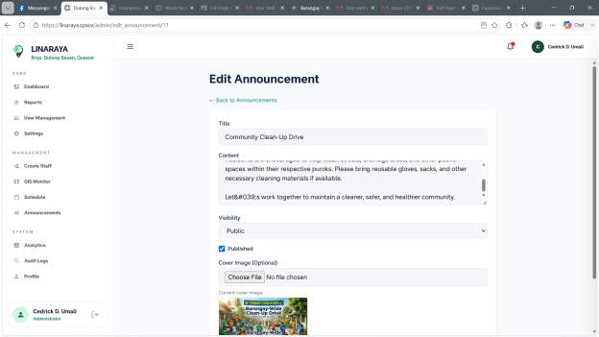
**Profile**
- Profile picture not working please fix and redesign the UI.
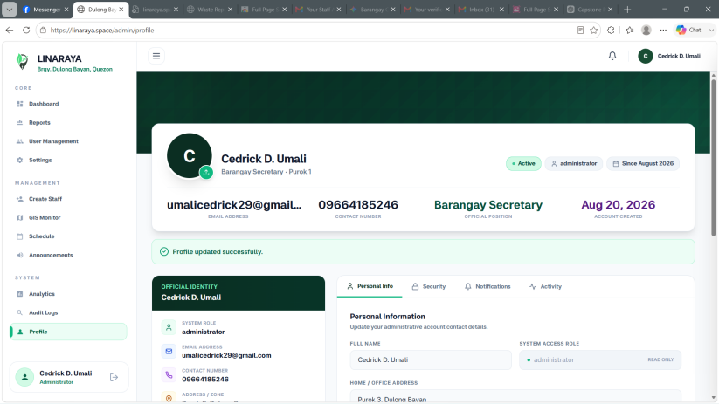
**Analytics**
- Add Resident vs. Guest participation
