Title Page

Table of Contents
Introduction 3
1961 - Letter 1 4

I
Table of Contents
I 3
ntroduction 3
1961 - Letter 1 4
ntroduction text
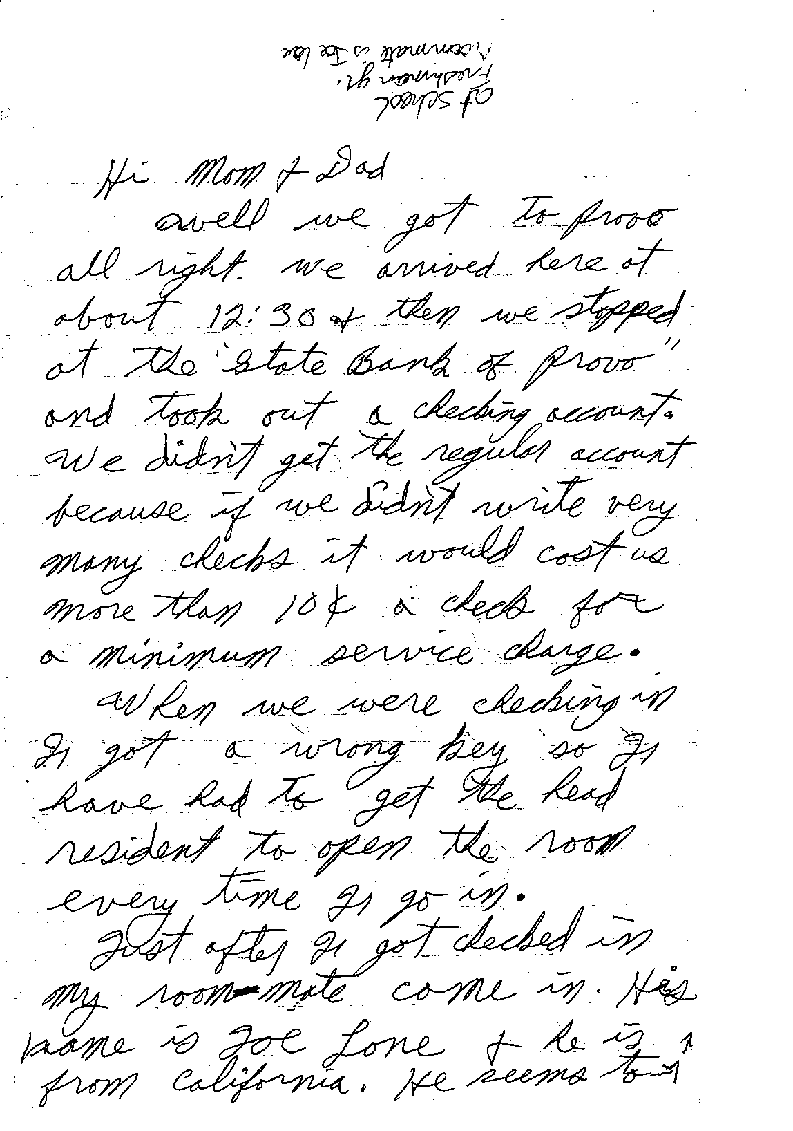 | Hi Mom & Dad  Well we to Provo all right. We arrived here at about 12:30 & then we stopped at the "State Bank of Provo" and took out a checking account. We didn't get the regular account because if we didn't write very many checks it would cost us more than 10 cents a check for a minimum service charge.  When we were checking in I got a wrong key so I have had to get the head resident to open the room every time I go in.  Just after I got checked in, my room-mate came in. His name is Joe Lone & he is from California. He seems to

