**The past 30 years of sea ice cover in Canada**

June 11, 2019

Hansen Johnson

Sea ice has been in decline for many years 1. Stroeve et al., 2 suggest it declined sharply in 2007. This has been confirmed by modeling efforts 3,4. Figure 1 shows the timeseries. Here’s another citation from 5

**Figures**

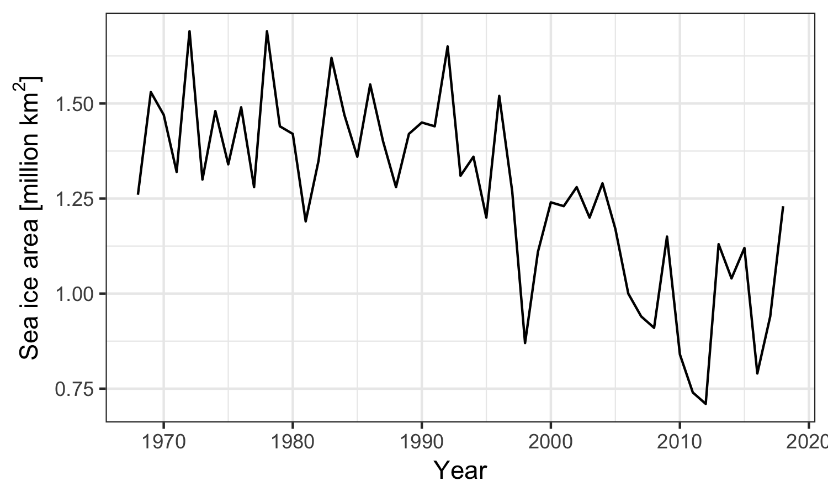

**References**

1. Rothrock, D. A., Yu, Y. & Maykut, G. A. Thinning of the Arctic sea-ice cover. *Geophys. Res. Lett.* **26**, 3469–3472 (1999).

2. Stroeve, J. *et al.* Arctic Sea Ice Extent Plummets in 2007. *Eos, Transactions American Geophysical Union* **89**, 13–14 (2008).

3. Saucier, F. J., Roy, F., Gilbert, D., Pellerin, P. & Ritchie, H. Modeling the formation and circulation processes of water masses and sea ice in the Gulf of St. Lawrence, Canada. *Journal of Geophysical Research: Oceans* **108**, (2003).

4. Saucier, F. J. *et al.* Modelling the sea ice-ocean seasonal cycle in Hudson Bay, Foxe Basin and Hudson Strait, Canada. *Climate Dynamics* **23**, 303–326 (2004).

5. George, J. C., Zeh, J. E., Suydam, R. S. & Clark, C. W. Abundance and Population Trend (1978-2001) of Western Arctic Bowhead Whales Surveyed Near Barrow, Alaska. *Marine Mammal Science* **20**, 755–773 (2003).