1. Launch two ec2-instances and connect it to a application load balancer, where the output traffic from the server must be an load balancer IP address

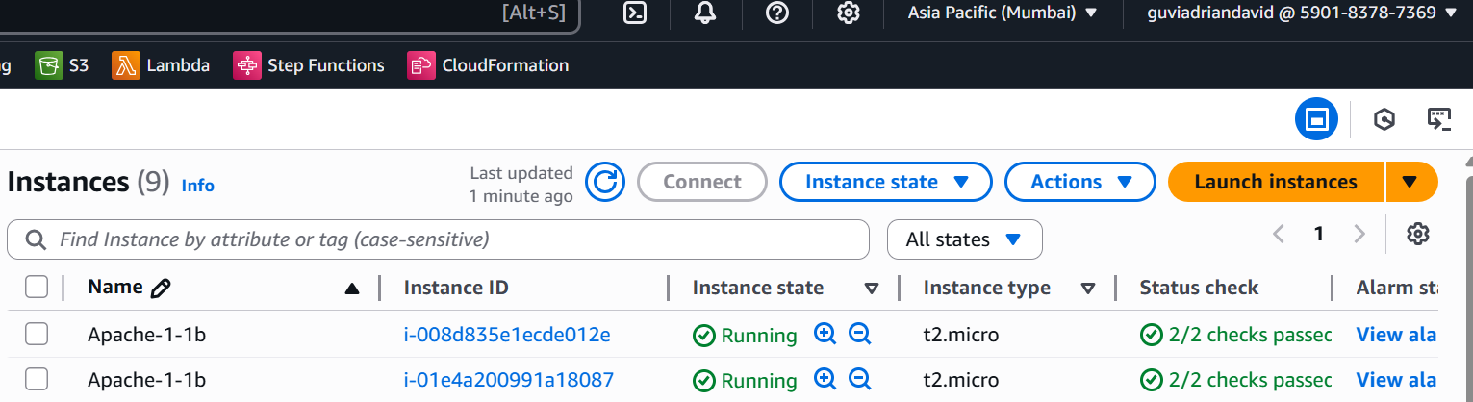

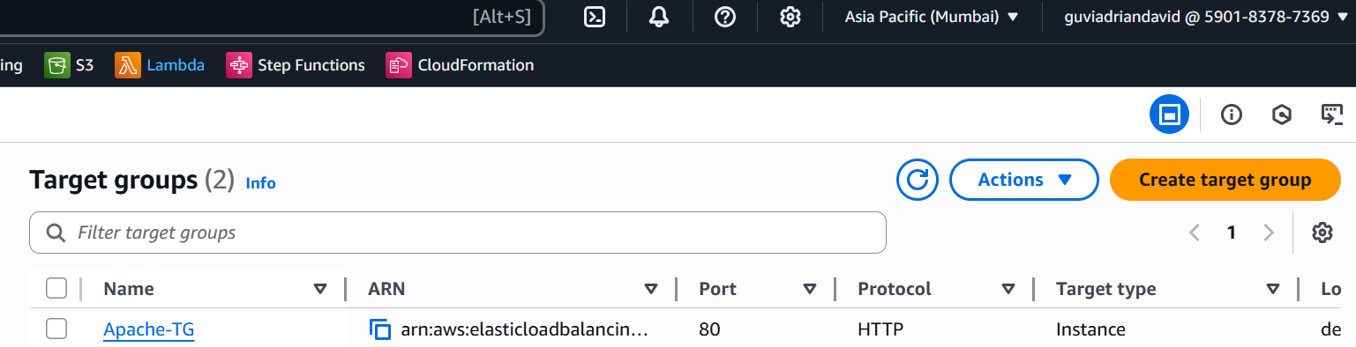

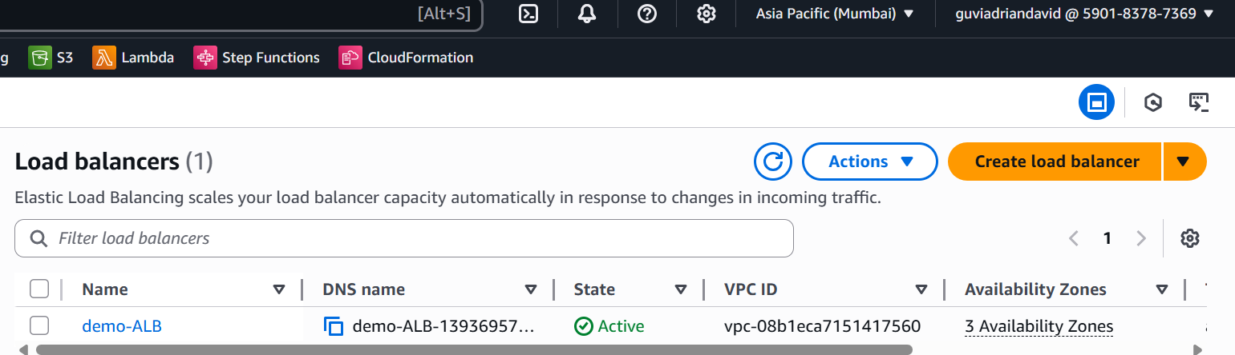

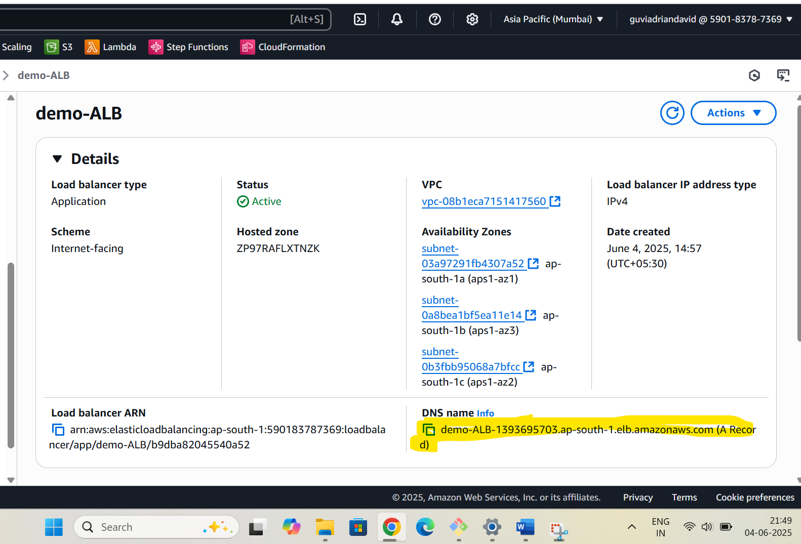

My customised page from load balancer DNS url:

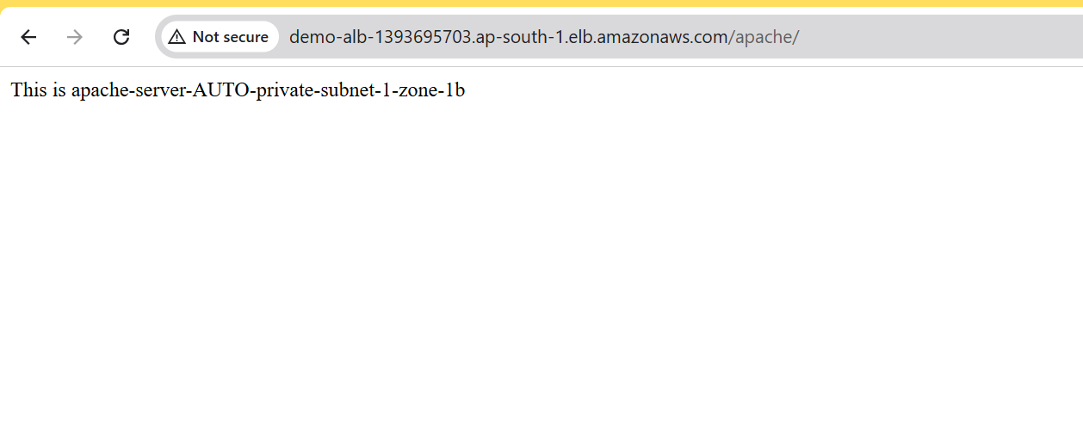

S3 -Task

Uploaded files in S3 bucket

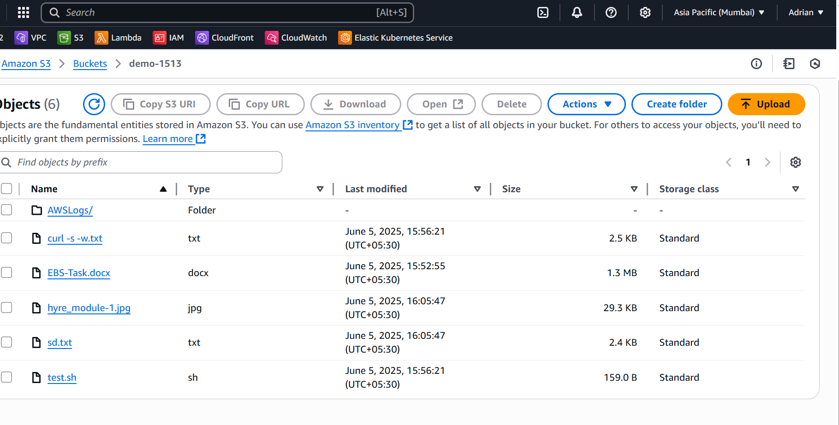

Cloud Trail configured and mapped with Cloud watch to monitor

