Creating the file with extention

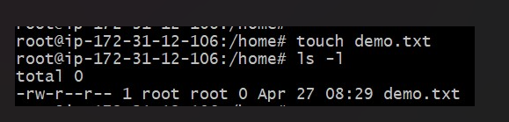

Gave the required permission

