Script to check the response code

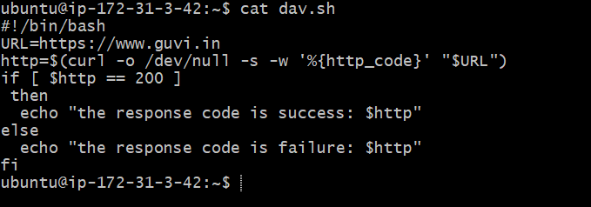

Success code when accessing https://www.guvi.in

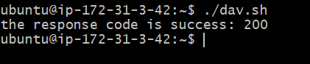

Modified as <https://guvi.in> and received as 301 (redirection), and we termed as failure as shown below

