Script to check the response code

Curl is used to retrieve the data response through https, http, ssl etc

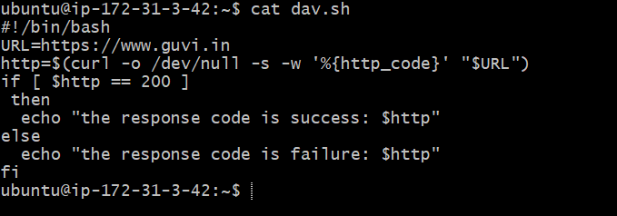

Success code when accessing https://www.guvi.in

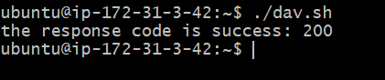

Modified as <https://guvi.in> and received as 301 (redirection), and we termed as failure as shown below

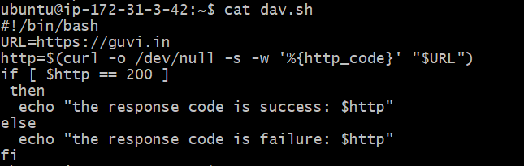

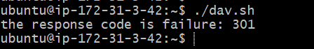

Given a file, replace all occurrence of the word "give" with "learning" from 5th line till the end in only those lines that contain the word "welcome"

Done text processing to replace the name I used “sed” cmd

