To get the IP for the guvi domain

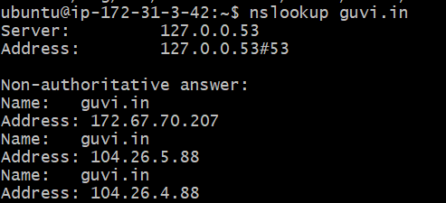

To check the connectivity

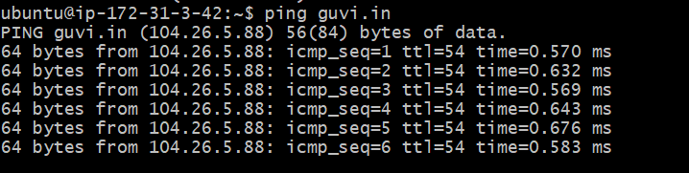

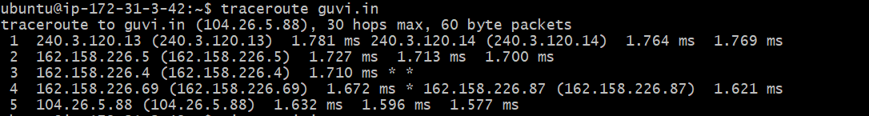

“Top” cmd to check CPU/memory usage of my server

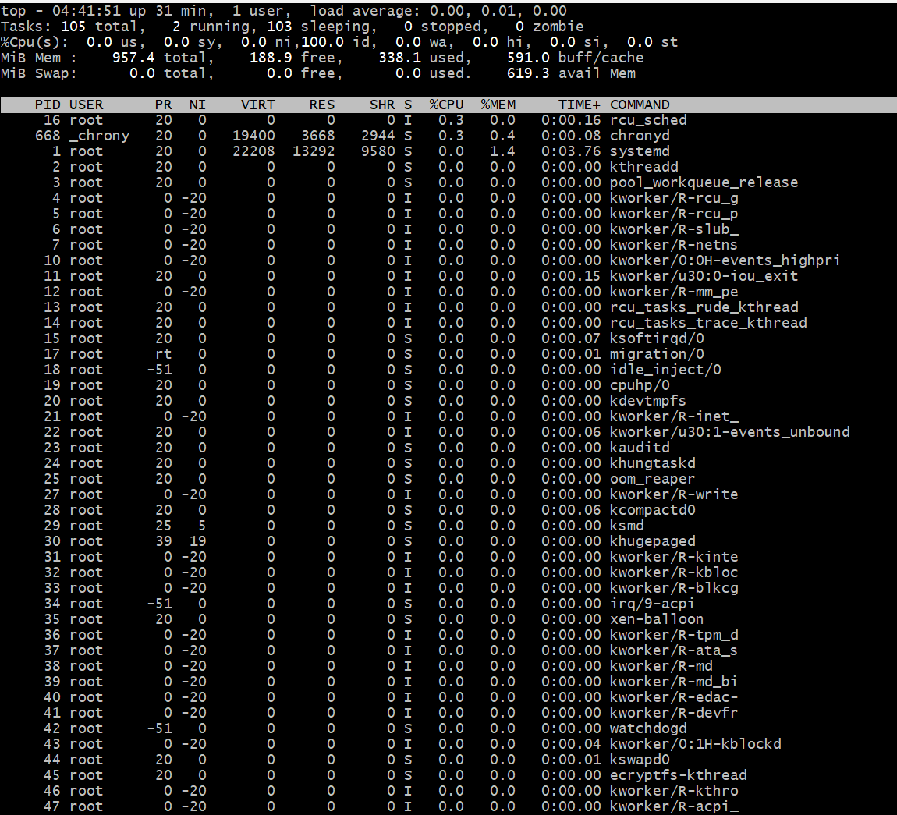

To check whether my port is open or not

Port not opened for 9000

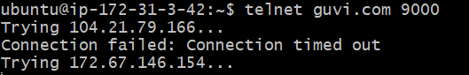

Port opened for 443

