Created VPC



Internet Gateway attached with VPC

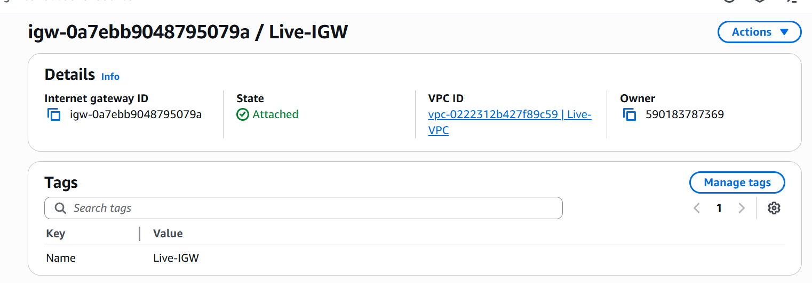

Created Public subnet(IGW attached with Dedicated routing table) with 256 IPs (172.16.1.0/24) from pool IP Range 172.16.0.0/16

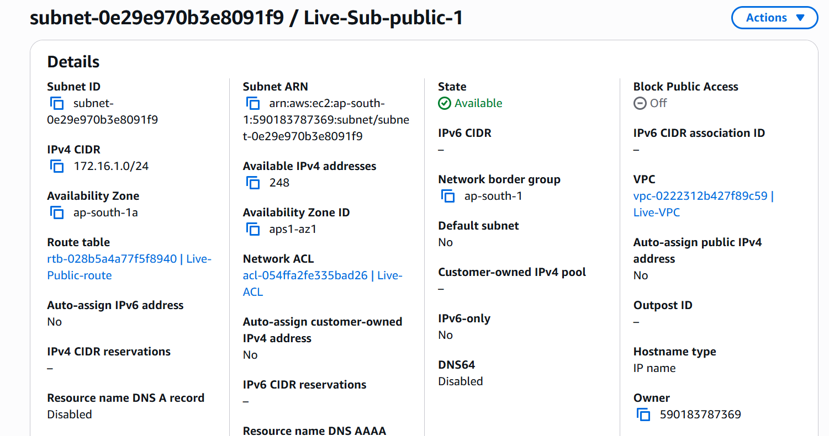

Created Private subnet (IGW not attached with Dedicated routing table)with 256 IPs (172.16.3.0/24) from pool IP Range 172.16.0.0/16

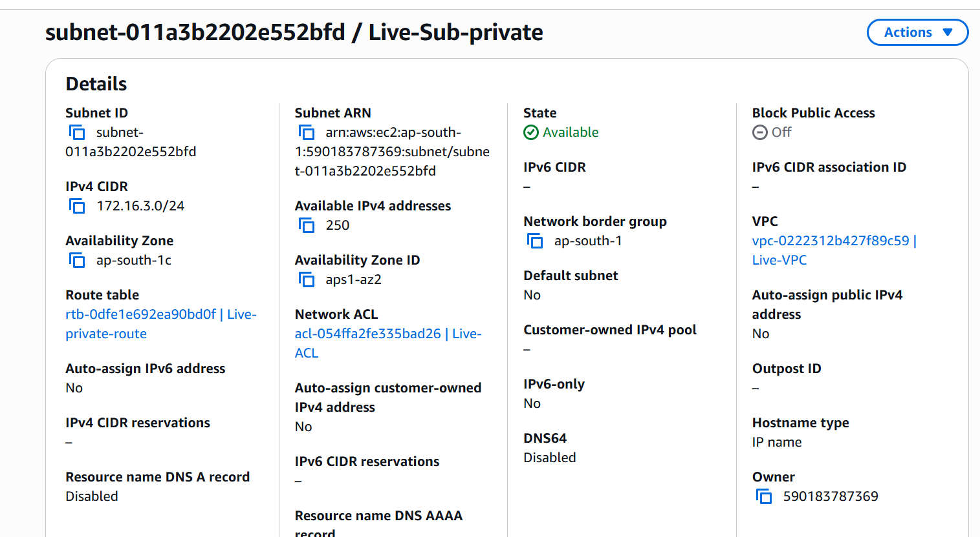

Route table connecting the Internet gateway and the subnets

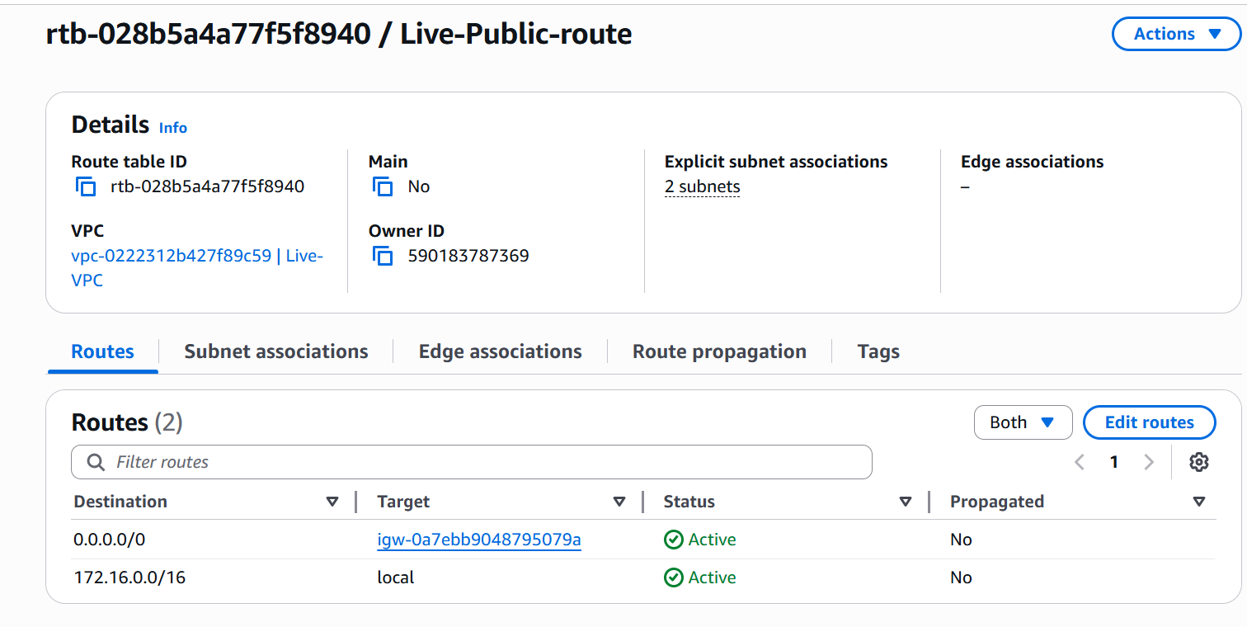

Route table connecting the Internet gateway and the subnets

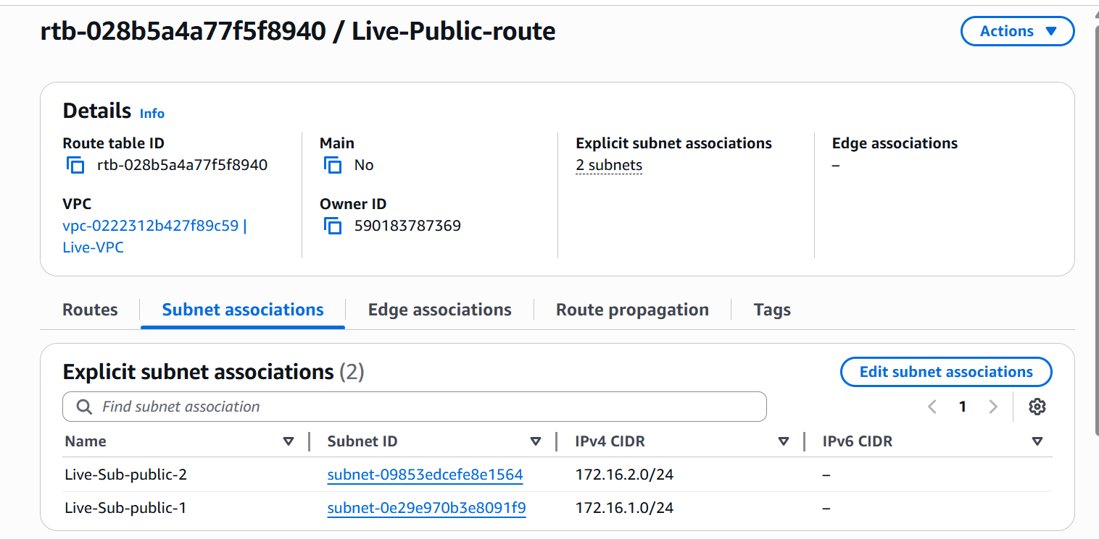

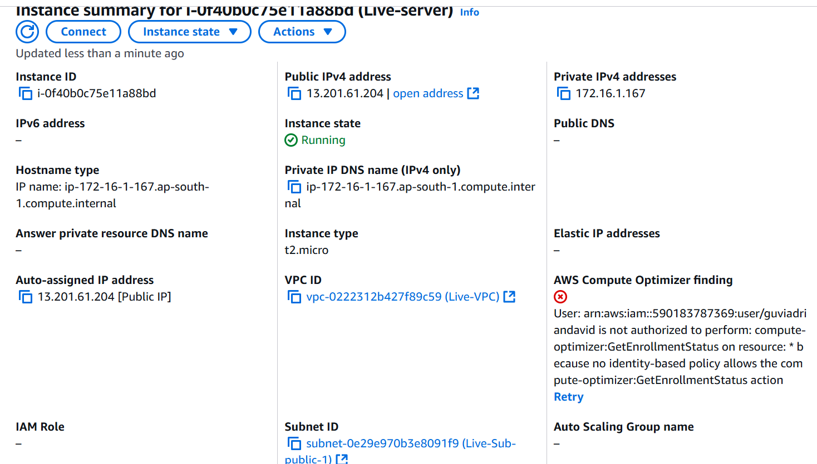

Accessing the server over Internet

