Hendrikus Hansen Witarsa

C0TB1713

**Finite Element Simulation**

1. **General Idea**

Before we start working, we have to know what method will be used. In this report, I will use the triangle method (triangulation). Next, how do we divide the circle into triangles? There are many ways to do that, but my idea is to do “spider web” triangulation. To show you what I mean by “spider web”, this picture will give the example.

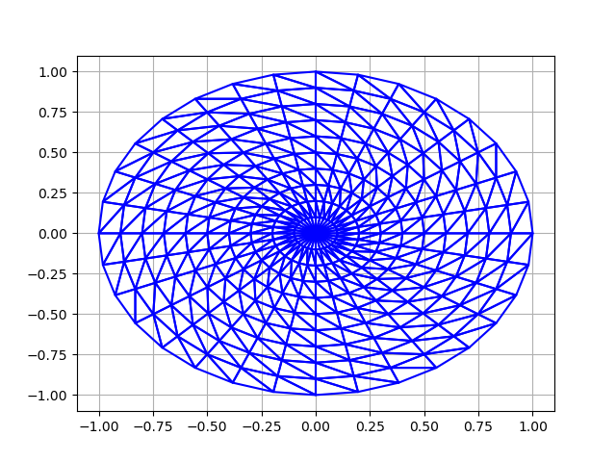

To get into this triangulation, first, there is always a node at the origin (0,0). And then, decide how many nodes we want at the outer surface. It is better that the number is multiplication of 4 so that we get the nodes at the top and bottom of the circle. Lastly, decide how many nodes we want in each radius connecting the origin to one of the node in the surface. After we got all the nodes, make the triangulation like the pictures. Also, in this experiment, we use load control, which means we decide how much force goes into the material, and then we find the displacement of all nodes. The force is given to the top node vertically (0, f). It means we only need the force in y-direction.

Therefore, the parameters in this experiment are:

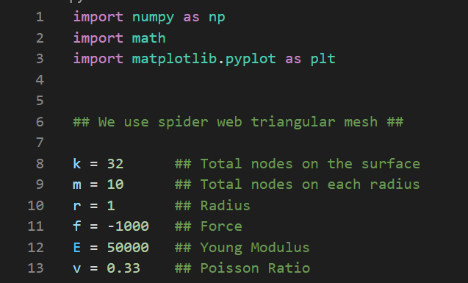

The total nodes on the surface (k), total nodes on each radius (m), radius of the circle (r), force in y-direction (f), Young’s modulus (E) and Poisson’s ratio (v) of the material.

1. **Nodes’ coordinate**

Some of the early things we need to define include the total stiffness matrix (KE) and the origin point (O).

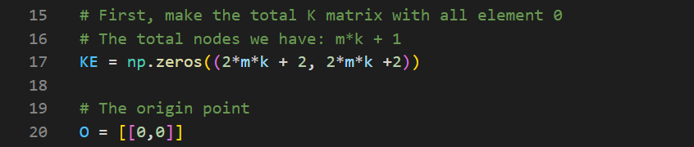

We also need to define the index of each node. This is how to define them. (k=8, m=2)

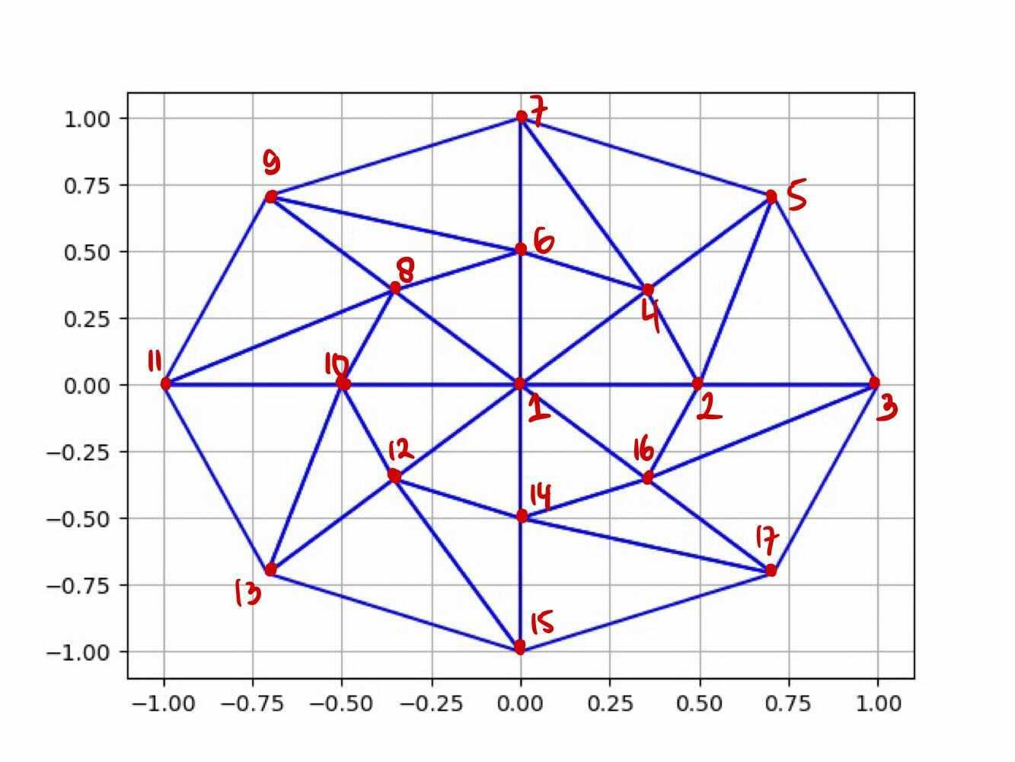

The origin has index 1. Move to the right and put the index in order to the nodes. And then, rotate around the circle counter clockwise and in each radius, start indexing the node from the one near the origin until the surface node.

Next, we want to find the coordinate of each node and store them into O in order of the index. First, create an empty list P. Insert the coordinate of the nodes in the surface using the that depends on the angle theta.

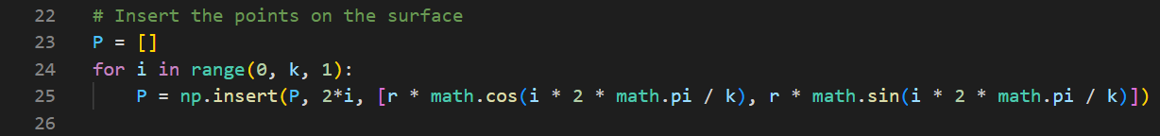

Next, insert the coordinate of the nodes in each radius and store them in respective position in the list P. To do that, we find the node coordinate from the biggest index to the smallest index.

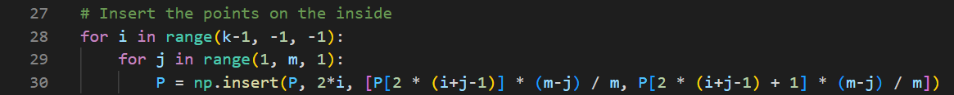

Put the coordinates that we got into the list O we have with the origin coordinate. This results in all the node coordinates in order.

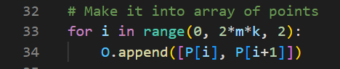

1. **Indexing the triangle**

We want to find the 3 indexes of each triangle and store it into a list. Take a look at triangulation below (k=8, m=3). We will divide the triangles into 3 groups.

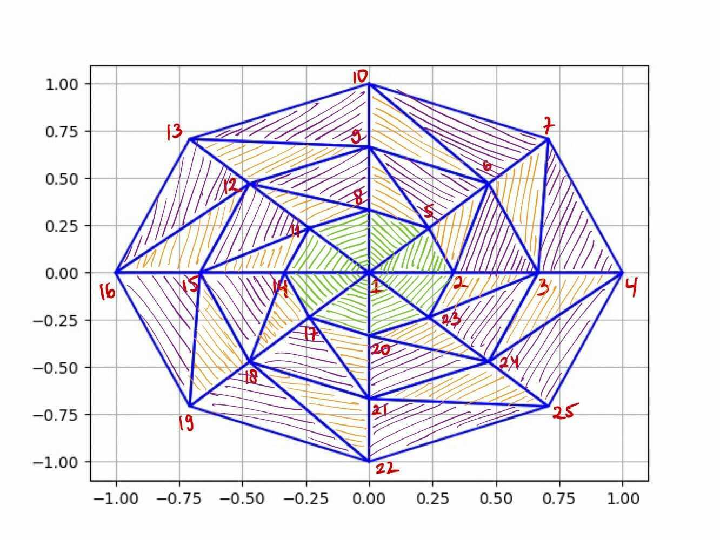

* Group 1 (green triangles):

The triangles which include the origin.

Example of list of indexes: [1,2,5], [1,5,8], [1,8,11], etc.

* Group 2 (purple triangles):

The triangles which don’t include the origin and has the same pattern of the 3 indexes.

Example: [2,3,6], [3,4,7], [5,6,9], [6,7,10], etc.

The difference between the first and second index is 1, and the difference between the second and third index is 3. So, the triangles with this kind of indexes are put into one group.

* Group 3 (orange triangles):

Similar with group 2 but with different pattern.

Example: [2,6,5], [3,7,6], [5,9,8], [6,10,9], etc.

The difference between the first and second index is 4, and the difference between the second and third index is -1.

For each group, we need to find the list of indexes.

Group 1: Store them into a list A.

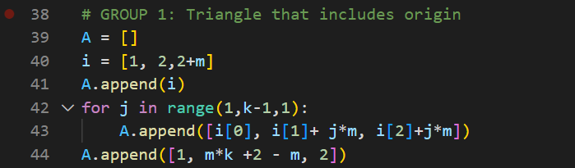

Group 2: Store them into a list B.

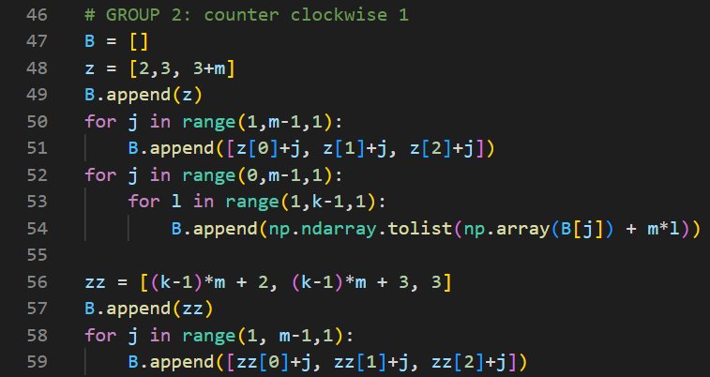

Group 3: Store them into a list C.

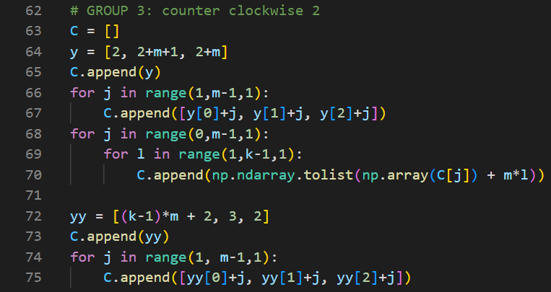

Lastly, combine A, B, and C into a list called I where all the triangle nodes will be stored.



In this list, the order does not matter as long as we have all the indexes.

1. **Stiffness Matrix**

If we are given 3 nodes with their coordinates, we have to know the stiffness matrix between them. In this section, we will build the function to get it given 3 nodes.

1. D Matrix

First off, get the D matrix consist of Young’s modulus and Poisson’s ratio. There are 2 kinds of matrix, depends on the condition:

* Plane strain problem, in which we assume that the depth of the material is infinity. The D matrix is given by D_strain.

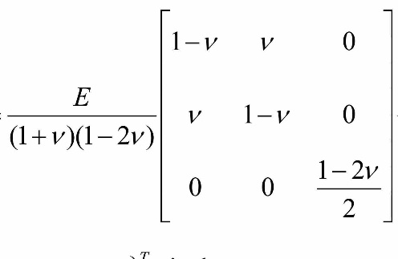

* Plane stress problem, in which we assume that the depth of the material is 1. The D matrix is given by D_stress.

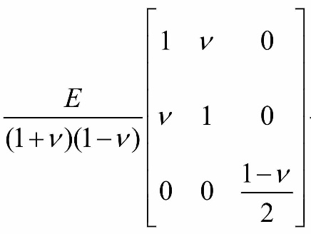

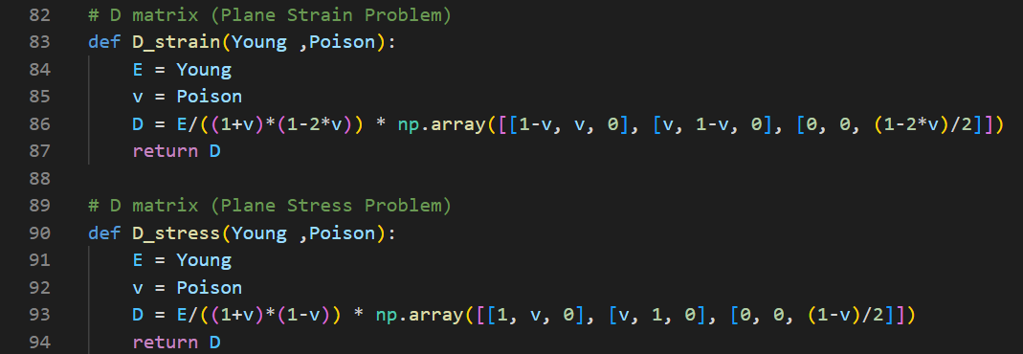

1. a (Area of triangle)

If we are given 3 nodes, let say x (x1, y1), y (x2, y2), and z (x3, y3) we have to find the area of the triangle. The area is given by this equation:

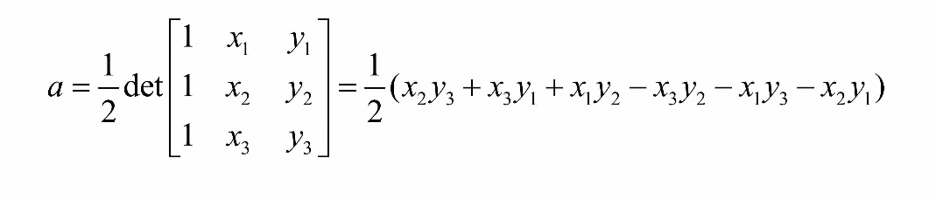

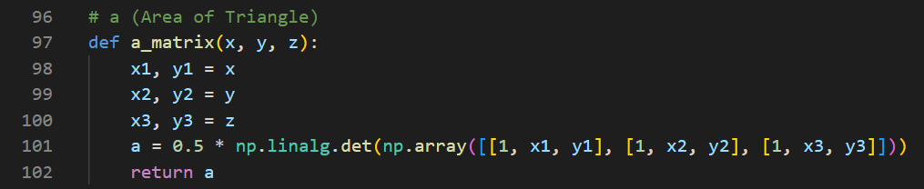

1. B Matrix

Next, calculate the B matrix according to the following equation:

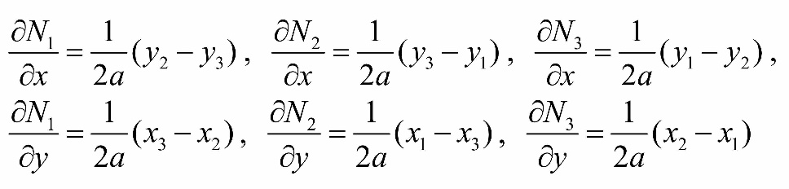

The B Matrix is given by:

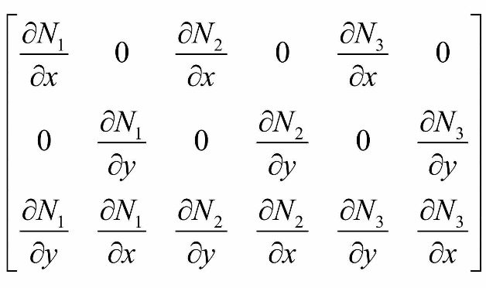

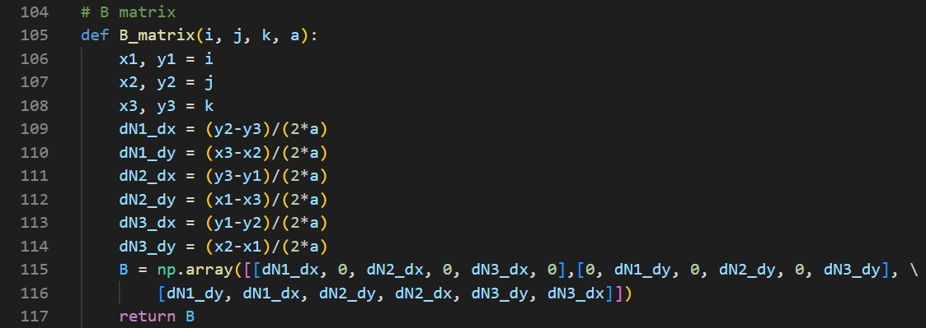

1. Stiffness matrix (K)

We can find the stiffness matrix by this equation:

Implement it to the code and we got

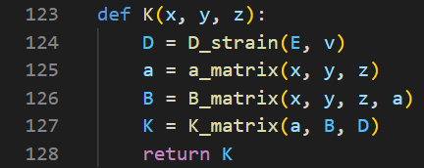

1. **Total Stiffness Matrix**

Until now, we have gotten the list of all the nodes’ coordinates which is stored in O, the list of all the triangle’s indexes which is stored in I, the stiffness matrix K(x, y, z) originated from 3 nodes. Now, we want to use them to build the total stiffness matrix.

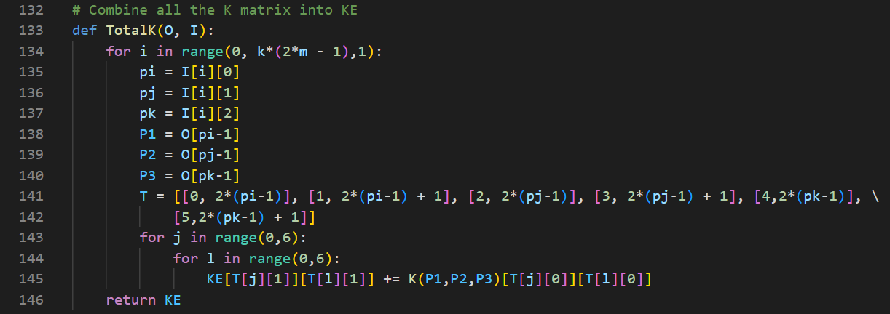

The input are O and I. For each triangle in I, pi is the first index of the triangle, pj is the second index of the triangle, pk is the third index of the triangle. P1 is the coordinate of node pi, P2 is the coordinate of node pj, P3 is the coordinate of node pk. We know that each stiffness matrix is a 6x6 matrix.

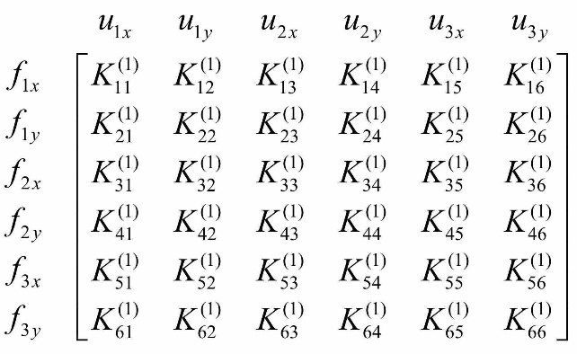

Let us imagine a stiffness matrix where the 3 indexes are pi, pj, and pk. Then the element inside the matrix in the first row or column belongs to the 2(pi-1)th row or column in the total stiffness matrix. The element inside the matrix in the second row or column belongs to the (2(pi-1) + 1)th row or column in the total stiffness matrix. We can define this way for all the 6 rows or columns. That is why we make a list T containing 0,1,2,3,4,5 and their respective row or column in the total stiffness matrix. Lastly, we can just add each element in each stiffness matrix into the total stiffness matrix.



The total stiffness matrix KE is given by TotalK(O, I).

1. **Displacement matrix**

In this section, we want to build a force matrix. Reduce the total stiffness matrix and force matrix, multiply the inverse of the reduced total stiffness matrix with the reduced force matrix to get the displacement matrix.



Take a look at this example. We need to pay attention to the nodes in a line connecting the top and bottom nodes. The other nodes can be freely displaced, that means their displacement is not 0 and the force is 0 for them. Now, for node 1,8,9,10,20,and 21, their displacement will look like this (0, u), because they can only move vertically, they can not move horizontally. While for node 22, the displacement is (0, 0) because this node can not move anywhere. So, we need to know which indexes has a 0 displacement and remove those row or column in the total stiffness matrix according to the indexes.

In this picture below, in line 152-153, we are removing the rows and columns caused by the most bottom node. In line 154-155, we are removing the rows and columns caused by the node in the bottom radius (excluding the origin). In line 156-157, we are removing the rows and columns caused by the node in the top radius (excluding the origin). In line 158, we are removing the rows and columns caused by the origin.

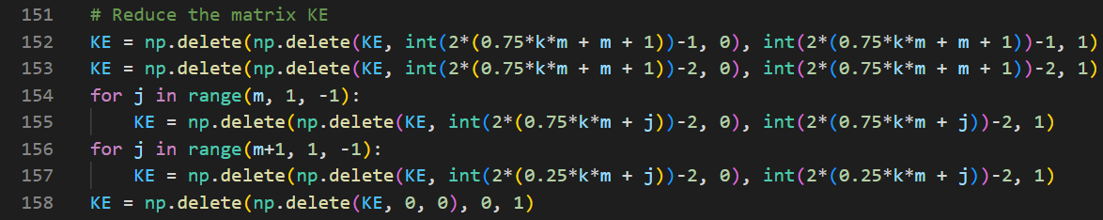

Next, make the reduce forced matrix. And replace the force in y-direction of the top node with f.

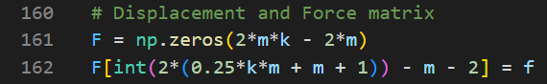

Then, the reduced displacement matrix is given by the multiplication of inverse of reduced KE and reduced F.



Then, to make it easier, we add 0 again to denote that the x-direction displacement of the nodes in the middle line is 0. In line 168, we insert 0 to the x displacement of the origin. In line 169-170, we insert 0 to the x displacement of the nodes on the top radius (excluding origin). In 171-172, we insert 0 to the x displacement of the nodes on the bottom radius (excluding origin). In line 173-174, we insert 0 to the x and y displacements of the most bottom node.

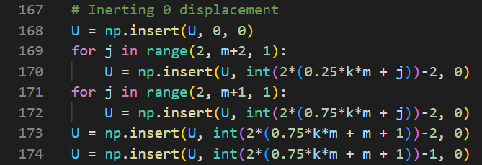

Lastly, reshape U so that each element contains each node displacement in order.



1. **Boundary Condition**

Add the displacement list to the coordinates list to get the coordinate of all nodes after displacement and named the list OO.



Do not forget that we have a boundary condition, in which the y-coordinate of all nodes cannot exceed -r. We don’t want the material to exceed the surface below. So, we extract all the y-coordinate from the list OO. If any of them is below -r. Then, changed them into -r.

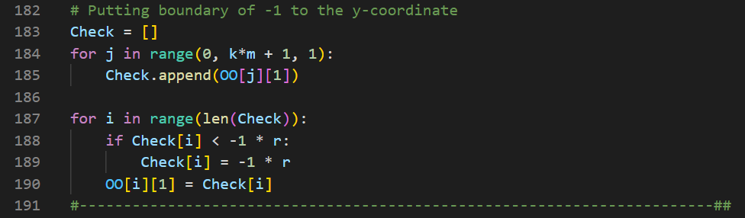

1. **Plotting**

In the final step, plot the circle, the triangulation, and the surface below.

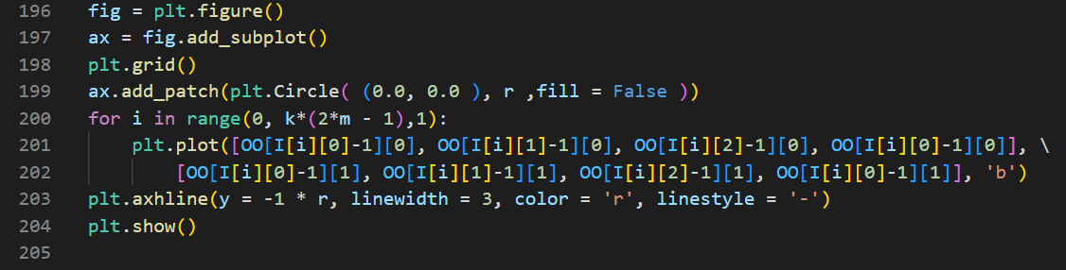

And this is the result.

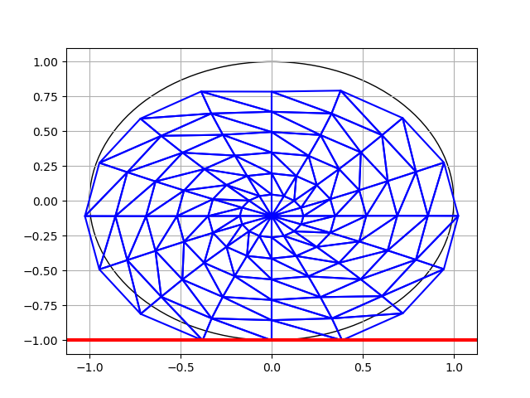

The result can change depending on how we change the parameter in the beginning.

1. **Stress**

Now, we need to estimate where the stress is highest. First, we need to obtain the tau matrix for each triangle. We can obtain that by this following equation:

Where is the displacement matrix of each triangle. First, we need the index of the 3 nodes in the triangle. Then, obtain their corresponding coordinate, the area of the triangle, the B matrix, and the D matrix. Multiply them all to get the tau matrix and stored in a list called tau.

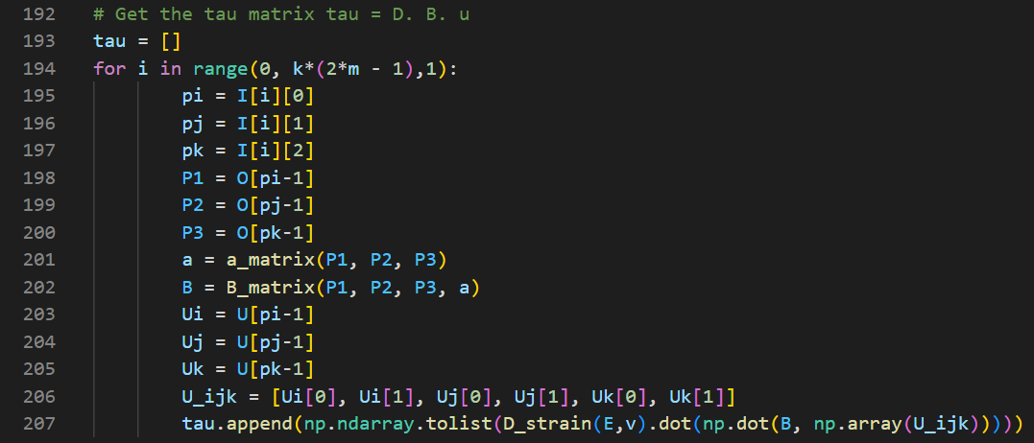

Then, we divide the tau list into 3: tau_xx, tau_yy, tau_xy because there are 3 different kinds of stress and we want to know for each kind of stress, where is the maximum value of it.

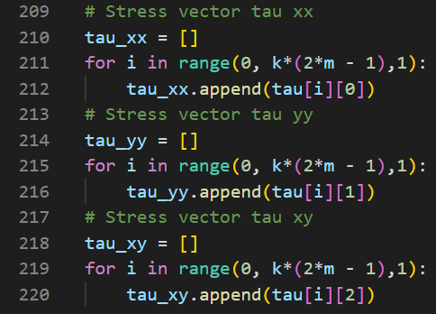

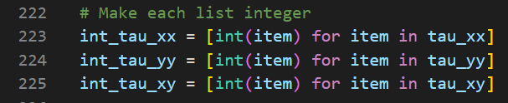

Turn the float list into integer list so as to make it easier to locate the maximum value and obtaining the index.

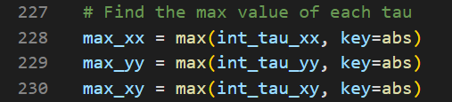

Define max_xx as the maximum value among all the tau_xx of all triangles. Define the same way for max_yy and max_xy.

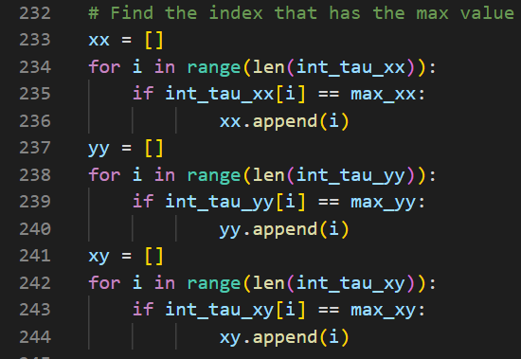

Next, we want to find in which indexes that contain the maximum value. Note that there can be more than 1 index that has the same maximum stress value. Store them into 3 lists called xx, yy, and xy.

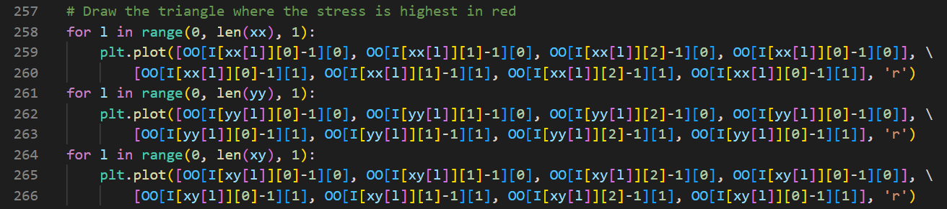

Lastly, for each triangle that has the maximum value stress, we draw them in the plot and put the red color so we can differentiate which triangle has the maximum stress value from all the triangles we have.

1. **Discussions**

**10.1 Effect of the number of triangles**

Assume the parameter below is the same. We want to change the value of k (number of nodes on the surface) and m (number of nodes on each radius).

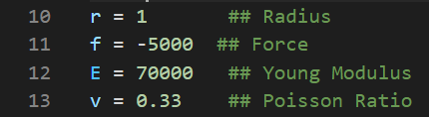

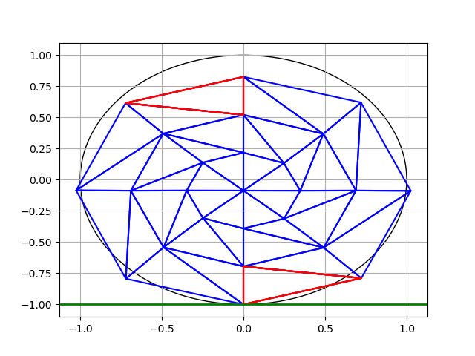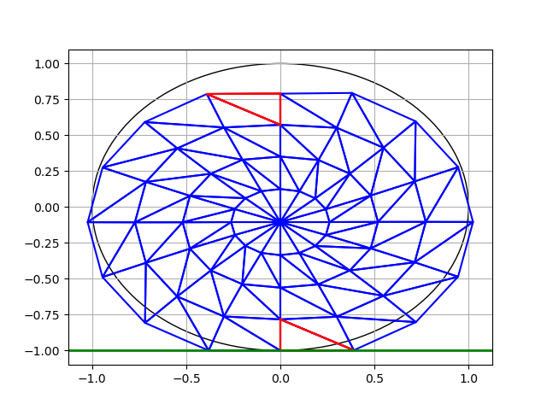

(k, m) = (8, 3) (k, m) = (16, 4)

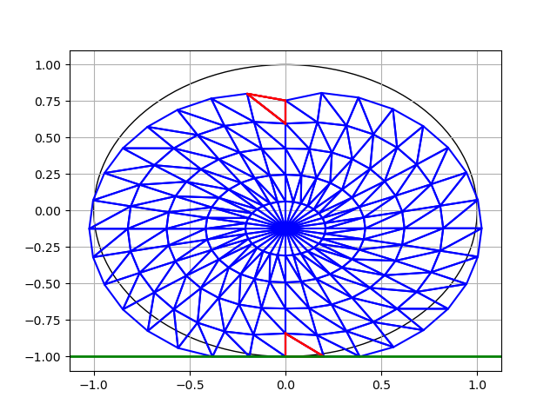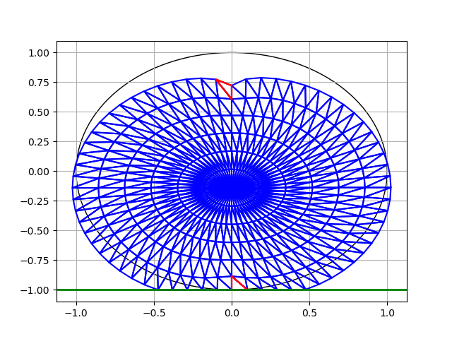

(k, m) = (32, 5) (k, m) = (64, 6)

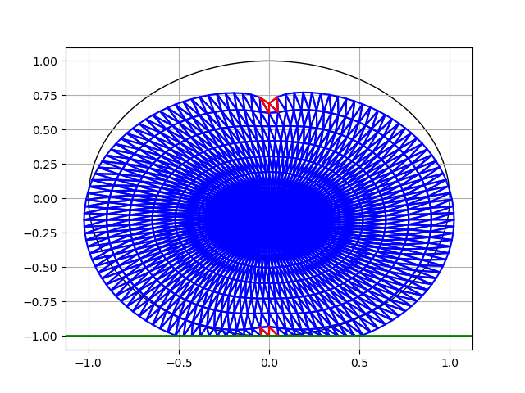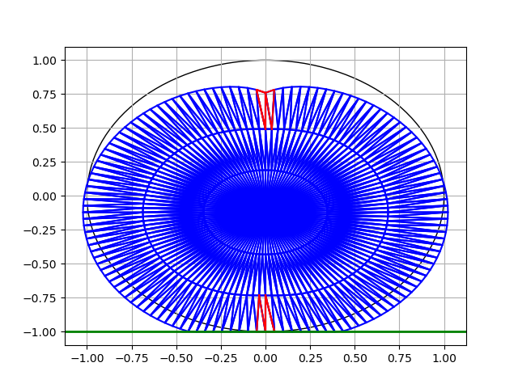

(k, m) = (128, 8) (k, m) = (128, 3)

From these 5 results of different pair of (k, m), we can clearly see the difference. If k is too small, we cannot see the displacement very clear. As k increases, we can see that the top node/point, really has a lot of displacement. We cannot see this if k is too small. And also, the shape of the object become much clearer, nearing a circle. Actually, in this case of triangulation, the value of k matters significantly compare to the value of m. For example, for k=8 and k=128, they are very different where 128 is better than 8. But in the case of (128,8) and (128,3), we can see that there is not much different. We can see the shape of the object clearly in both cases, and also the displacement of the top point. Of course (128,8) is still better but there is not much difference between them.

One more observation that we can see is the triangles in which the stress is highest. In the first 4 pictures, there is one red triangle at the top and one red triangle at the bottom. That means at those triangles, the stress is highest. But this problem is a symmetry, so the results should be symmetry along the y-axis. When we increase the value of the k (for (128,3) and (128,8)), we see that there are 2 red triangles in each top and bottom. This means that the place where the stress is highest is at the top and bottom at the object.

**10.2 Effect of the size of the object**

Now, we change the radius of the object and see what changes. The value of k and m are 128 and 6 respectively.

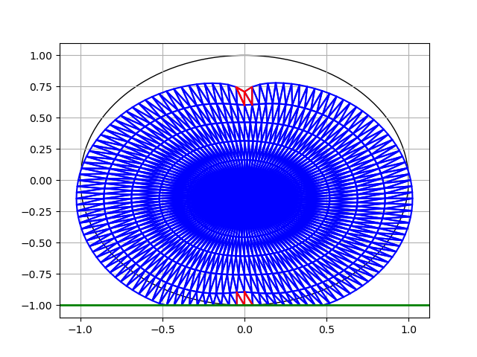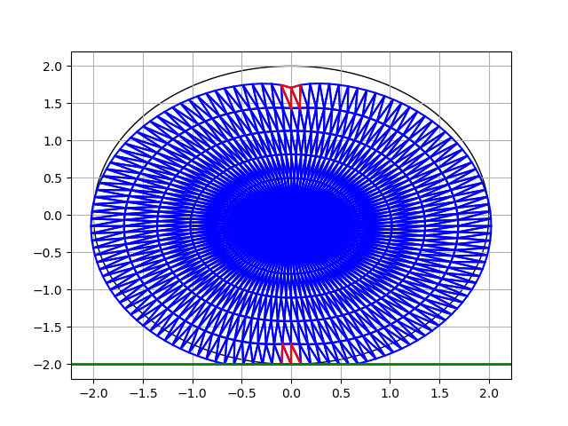

r = 1 r = 2

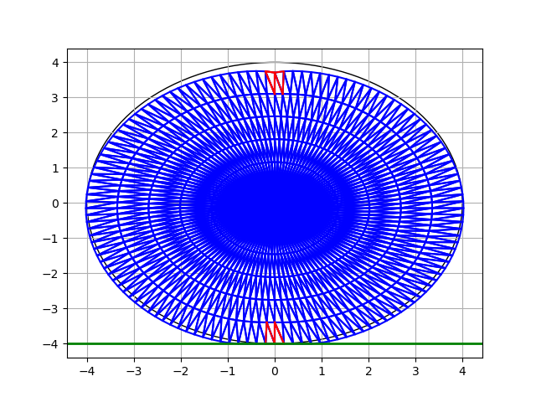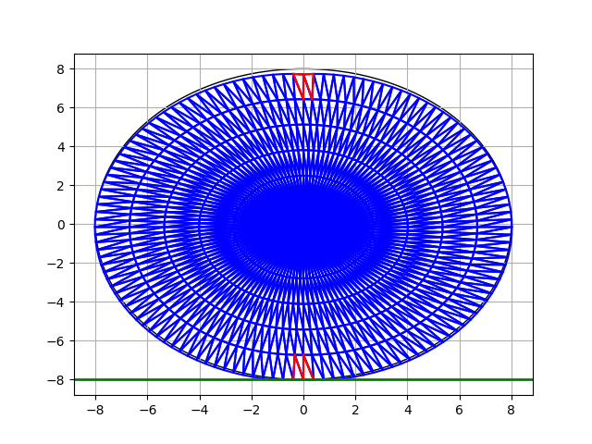

r = 4 r = 8

We have 4 different results from 4 different values of radius. The larger the radius is, the less displacement we have. In r=1, we can see the top surface really curve because of the force given. But in r=8, there is barely any displacement. It requires more force for the larger object.

**10.3 Plane strain and plane stress problem**

(k, m) = (64, 6), r = 1

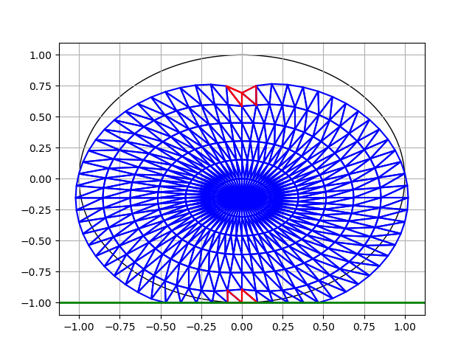

Plane strain Plane stress

(k, m) = (128, 6), r = 4

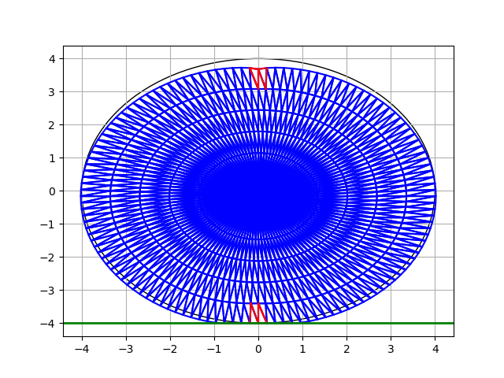

Plane strain Plane stress

(k, m) = (8, 4), r = 3

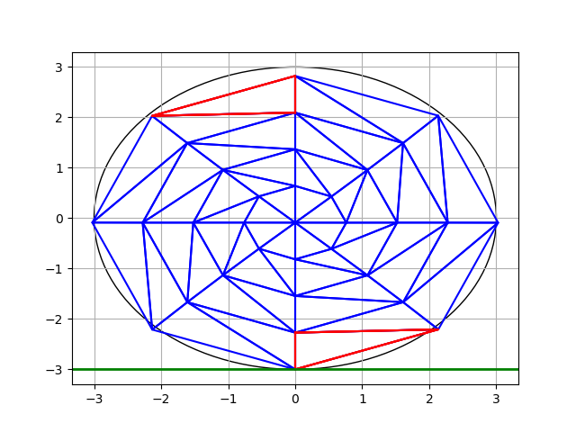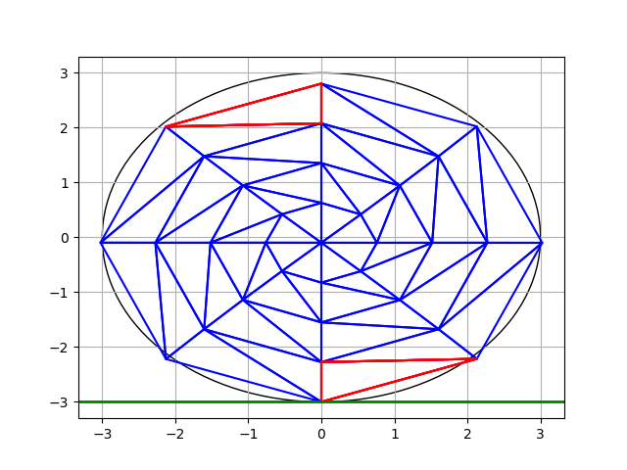

Plane strain Plane stress

From the 3 results of 3 different parameters, we can see that there is not much different between plane strain and plane stress condition. Plane strain and plain stress condition affect the D matrix. In case 2 and 3, we see that regardless of the condition we are using, the place in which the stress is highest is the same. But in case 1, the place in which the stress is highest is different. There are 2 red triangles in plane strain, but there are 3 red triangles in plane stress. The displacement between the 2 conditions is not the same, there is a slight difference between them. The absolute value of the highest stress is definitely not the same. But overall, there is not much different between plane strain and plane stress condition.

**10.4 Effect of element type**

In this section, we will be using some different materials for the object. Different materials have different Young’s modulus and Poisson’s ratio.

1. Stainless Steel – Grade 304 [1]: E = 199000 MPa, v = 0.29
2. Aluminum Alloy 1100 [2] : E = 69000 MPa, v = 0.33
3. Cooper Alloy C26000 [3] : E = 110000 MPa, v = 0.35
4. Magnesium Alloy AZ31 [4] : E = 45000 MPa, v = 0.35
5. Glass [5] : E = 98000 MPa, v= 0.24

The parameters that we use are as follow:

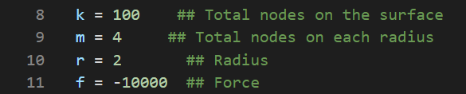

And the results are as follow:

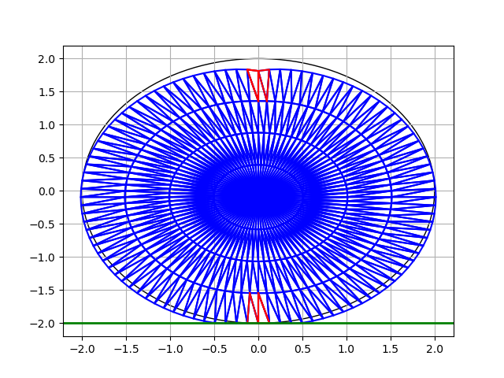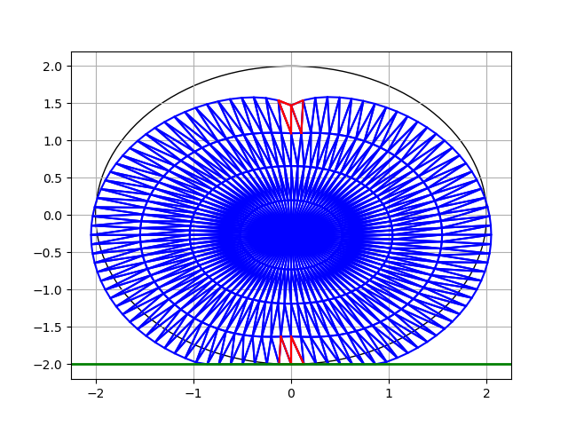

Stainless Steel Aluminum Alloy

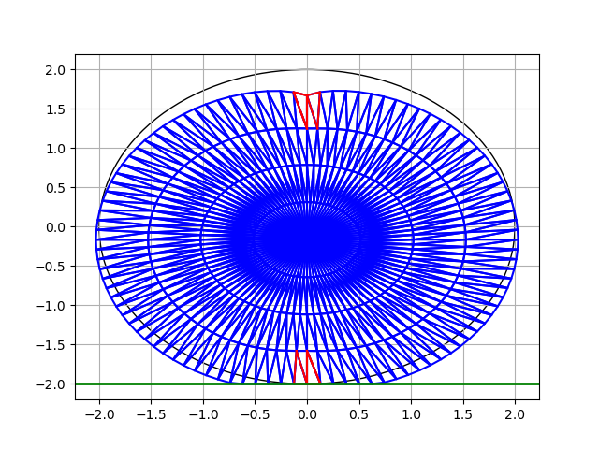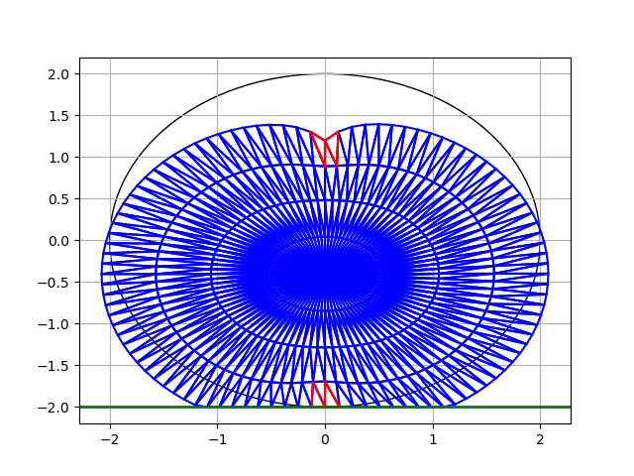

Cooper Alloy Magnesium Alloy

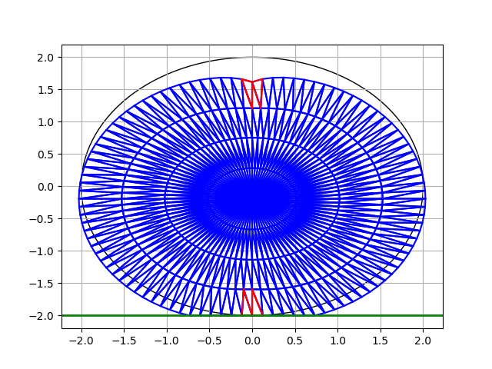

Glass

Here, different materials are being triangulated the same way and dare given the same force on the same node. We can see the different results in the pictures. Stainless steel is the materials with the least deformation while magnesium alloy is the materials with the most deformation. It seems that the value of Young modulus affect the strength of the materials. As we can see, stainless steel has 199000 MPa, while magnesium alloy only has 45 MPa. Cooper alloy and glass have similar deformation since the value of their Young’s modulus don’t have much different. The 5 materials’ Poisson ratio are all similar to each other.

**References**

[1][4][5] https://www.kobelco.co.jp/english/titan/characteristic/

[2][3] https://www.sonelastic.com/en/fundamentals/tables-of-materials-properties/non-ferrous-metals.html