**Epidemiology week 1**

**Lecture 1: Introduction to epidemiological research**

Epidemiology = occurrence research

= concerned with the **frequency** and **pattern** of health events in a population

Present: shift in focus from **single** determinants & disease occurrence to **combined** causes (determinants)

Future: measurements capacity is growing -> more complex topics

1. **Research question**

* Outcome outcome = f(Determinants)
* Determinants e.g bleeding =f(Aspirin)
* Domain = situation for which the relation and its occurrence is studied
  + Goal: generalize the empirical relation to a larger group
  + E.g. findings in study about study including elderly generalized to the findings being true for older (healthy) adults

Example:

* + Outcome: myocardial infarction
  + Determinant: variation in intake of SFAs
  + Domain: humans

MI = f(SFA variation | confounders)

1. **Design of the occurrence relation**

Fractures = f(antidepressants | confounding)

**DEPTH model**

* Diagnostic knowledge – what’s wrong
* Etiologic knowledge – why ill
* Prognostic knowledge – what if I don’t intervene
* Therapeutic (prognostic) knowledge – what if I intervene

1. **Collection of data (Lecture 2)**
2. **Data Analysis and scientific interpretation**

**Measures:**

* Frequency (measures: Prevalence & Incidence)
* Association
* Impact

|  |  |  |
| --- | --- | --- |
| **Frequency measures** | **Association measures** | **Impact measures** |
| Prevalence |  | Attributable risk |
| Cumulative incidence | Relative risk | Population attributable risk |
| Incidence density | Relative rate |  |
| Odds | Odds ratio |  |

**Prevalence** = estimate of probability/risk that one will be ill at some point in time (%) -> severity

Example: Fractures =f(antidepressants)

P= number of people using antidepressants / population at risk

**Incidence** = How often does XXX occur?

Example: **Crude (naïve) estimation**

10 year risk of fracture when 20 people at risk and 2 get a fracture within 10 years

* 2/20 = 10% = cumulative risk
* Underestimation of real risk
* Need to take complete follow-up in consideration!
  + Instead of 20*10= 200 years
  + Due to missing values only 176 years observed -> **2/176 > 2/200**

**Cumulative Incidence**

* Proportion %
* Probability of XXX (0-1)
* Definition of
  + Time frame
  + Population ‘at risk’

**Incidence density (ID):**

# cases / person years of population at risk

**ID= 2/176**

**Cumulative incidence Incidence Density**

|  |  |
| --- | --- |
| * Proportion * Easy to use * Not ideal with long time periods (not equal follow-up for all) * Use for small time units | * Density * Harder to use * Better for large time units |

|  |  |  |  |
| --- | --- | --- | --- |
| **Item** | **Prevalence** | **Cumulative incidence** | **Incidence density** |
| Numerator | All cases counted on a single occasion | New cases occurring during a specified follow-up period | New cases occurring during a specified follow-up period |
| Denominator | All individuals examined - cases and non-cases | All susceptible individuals present at the start of the study | Sum of time periods during which all individuals could have developed disease |
| Time | Single point or period | Defined period | Measured for each individual from beginning of study until disease event |
| Interpretation | Probability of having disease at a point in time | Probability of developing disease over a specified period | How quickly new cases develop over a specified period |

**Measure of association & Measures of impact**

**Odds**

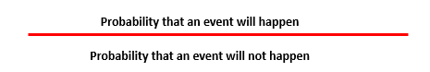

10 year outcome odds = (2/20) / (18/20) = **0.11**

* Used for logistic regression if real risk cannot be estimated
* **Real risk** preferred whenever possible

**Risk Ratio (RR):**

* Short follow up -> easy interpretation
* Long follow up -> limited because of CI estimation
* Rate Ratio often preferred

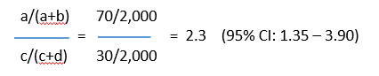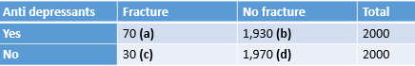

* **1 =** no association between exposure and disease
* **>1 =** positive association (exposure increases risk)
* **<1 =** negative association = protective effect (exposure decreases risk)

**Rate Ratio**

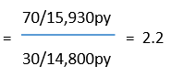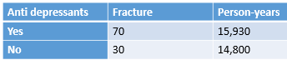

**Interpretation:**

2.2 times higher risk of fractures when use of anti depressants

**Etiologic Research**

* Inference is either correct of incorrect = biased

**Bias** = result of any process that confounds the relation

* Selection bias
* Observation bias
* …
* **Confounding** (mixing together)

= a distortion (inaccuracy) in the estimated measure of association that occurs when the primary exposure of interest is mixed up with some other factor that is associated with the outcome

**Confounder** = a variable that influences both the dependent and independent variable, causing a spurious association

* + Intrinsic – can be handled during:
    - Analysis (when measured correctly) – after getting data
    - Type of data collection (design phase) – beforehand
  + Predicts occurrence of outcome & is associated with determinant
  + Has NO direct effect in the occurrence relation -> extraneous
  + Conditions for confounding factor:
    - Associated with exposure (but not consequence)
    - Associated with outcome (independently of exposure)

Example:

* + Physical activity as confounding factor for research in effect of antidepressants on fractures
  + Risk Ratio needs to be adjusted according to the confounder

**Validity and Precision**



**Precision**

* Reproducibility, Reliability, Consistency
* More precise => the greater the statistical power (at the same sample size)
* Effected by random error

**Accuracy**

* The degree it actually represents what it is intended to represent.
* Important influence on the internal & external validity of the study
* Accuracy =><= Systematic error (bias)

**Question underlying any occurrence relation**:

*What would have happened to the same people if they had not been exposed?*

* Compare exposed to non-exposed
* Non experimental cohorts/case-controls: hard to compare design & analysis
* Experimental cohort: hard to compare design (randomization of the groups)

**Lecture 2: Introduction to epidemiological research**

**Descriptors of data collection**

* + Time
  + Population closed/open (= e.g. district in Utrecht where people can move in/out of)
  + Analysis on all participants (census) or sample
  + Experimental/non experimental

**Types of data collection**

* + **Cohorts**
  + **Cross-sections**
  + **Randomized trials**
  + **Case control studies**

**Cohorts**

* + - Non-experimental (= researcher does not decide who gets treatment) /observational
    - Group of individuals followed up for specific period of time
    - Census
    - Population closed/open

Purpose:

* + - * Find out if exposure is associated with outcome
      * compare to non-exposure
      * estimate risk of outcome – measure incidence among exposed & unexposed

Source of Bias:

* + - * selection bias
        + when subject specifically included based on known relation to exposure/risk
        + when loss of follow-up has to do with occurrence relation
      * observation/information bias
        + e.g. prior knowledge effects interpretation of X-ray (expecting a fracture)
      * (confounding)

Cannot be rectified (=adjusted/calculated) in analysis

**Recipe:**

1. Identify groups – unexposed & exposed
2. Measure incidence
3. Compare incidence (exposed & unexposed)
4. Assure comparability

|  |  |
| --- | --- |
| * Latency period * Loss of follow-up * Large sample size * Exposure can change * (un-)ethical? * Cost & time | * Incidence in both exposed & unexposed groups * Works with rare exposure * Time frame is clear (t>0) * Less subjected to bias as we don’t know outcome (don’t know what the future holds) – scientific advantage |

**Cross-sections**

* + - Time=0
    - Population closed
    - Census
    - Non-experimental exposure

|  |  |
| --- | --- |
| * Quick * cheap | * Explain selection * Consequence of time   e.g. when studying certain gene with old people where a lot of people with this gene have already died |

**Trials** (experimental cohort)

* + - Time>0 (because cohort -> waiting for occurrence)
    - Population closed
    - Census
    - Experimental exposure
      * Subjects intervened to find effects of intervention
      * Q: How effective is intervention?
      * E.g. drug vs. placebo

**Randomization** (Trials)

= random allocation to exposures

* Groups with comparable means levels of known/unknown determinants of outcome
* That way differences have to be due to intervention
  + Best way for good evidence/results
* 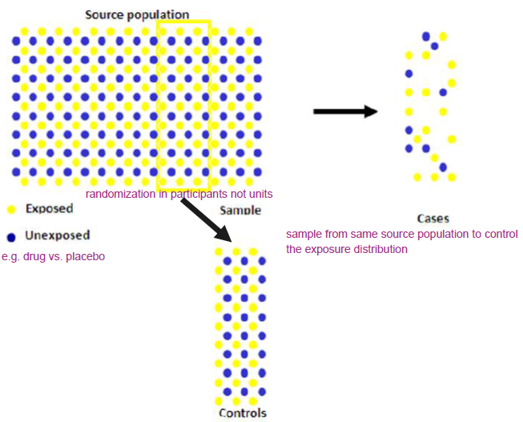Threats: selection bias

**Case Control**

= case-referent, patient-control

* + Time >0
  + Population usually open (can be closed/nested)
  + Sample of participants
  + Non-experimental exposure

Purpose:

* Provide estimate of exposure in the source population

**Distribution of exposure in cases & controls**

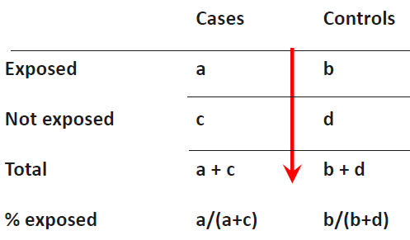**Odds of exposure** =

Prob. to be exposed/ prob. to be unexposed

**Odds ratio=**

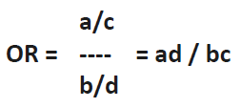

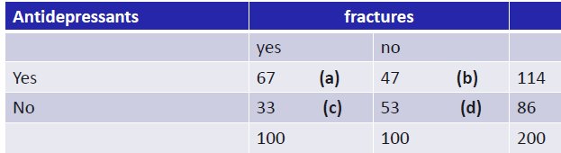**Previous example:**

**Exposure odds ratio (OR)=**

67*53/33*47=3351/1551=2.3

Odds ratio (**OR**) **=** incidence rate ratio (**IRR**) **IF** case control study is executed correctly

Source of Bias:

* + - Selection bias
      * When exposed cases are selected specifically
      * E.g. when suspected cases are send to specialized hospital based on knowledge of exposure
    - Information bias
      * Exposure measurement performed different for cases

|  |  |
| --- | --- |
| * No absolute rates/risk * Not good for rare exposures * Prone to bias * Often performed too quick/sloppy | * Research rare diseases * Long latency (=time between exposure & symptoms) * Low cost * Small sample size * ethical |

**Diagnostic Research**

**Diagnostics in practice**

Start: Patient with complaint/symptom

Differential Diagnosis (DD)

* + what is the most important/dangerous possibility?

**Prevalence** = prior risk = baseline likelihood of having disease with no other knowledge

**e.g.** child with neck stiffness – 20% prior risk of it being bacterial meningitis

prior risk too low to start treatment for BM but too high to send home -> reduce uncertainty

**Gold standard**

* + Real disease status; ‘ truth
  + Reference / standard test
    - Would bring certainty but oftentimes too invasive/espensive/ineffeicient
* Simpler diagnostics (medical history, simple lab…) *from less to more invasive*
  + Decisive test in case of doubt

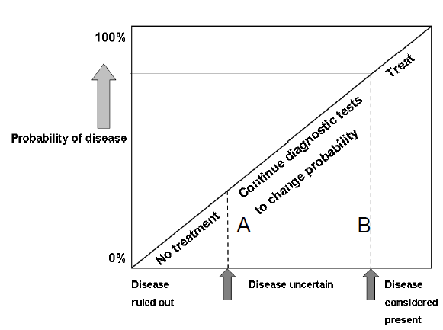

**prior risk -> testing -> posterior-risk**

* The bigger difference between prior & posterior risk = the higher value of test
* testing until posterior-risk is acceptable – acceptable uncertainty dependent on disease

**Diagnostics in practice** is an **estimation of risk/change of the presence** of a disease based on patients test results

**Study Design**

* + Research question
  + Domain
  + Determinant(s)
  + Outcome
  + Study design
  + Data analysis, interpretation + reporting

**Research question/ occurrence relation**

* Which test to estimate presence/absence of disease
* What determinants (predictors)
* Determinant- outcome relation
* Occurrence relation = Prediction not explanation
  + %BM = ƒ( age , sex , indicators, etc.)

**Domain**

* Who? = generalization
* Study population = domain sample
* all participants suspected of disease based on symptom in setting
* Study population

**Determinants**

* Diagnostic determinants = all possible/relevant tests
* No prior knowledge of outcome
* Same measurement for all cases

**Size 1 to 10 rule**:

* Size of study population should be a minimum of 10 for 1 determinant (2 det. = 20 cases)

Measure of **Outcome**

= diagnostic outcome/ result of reference test (= gold standard)

* Predict/try to be as close as possible to the truth
* Gold standard test (e.g. very invasive but confirming test would have to be done with all patients for real proof of whether disease present or not)

**Study design**

**Descriptors**

* Non- experimental -> **observational** (because end product will be likelihood/risk ratio)
* Confounding not an issue as we are not trying to explain whether test result is causally related – we just want to know what action to take as a doctor

**Ideal study**

* **Cross-section** = determinants & outcome measurements at the same time (t=0)
* **T=0** because at point of testing the patient already has/ does not have the disease
  + **Testing** outcome & determinants for ideal study to see what determinants predict the outcome accurately

**Data-analysis**

* All outcomes and diagnostic measures

1. **Estimate prior risk**
2. **Compare each test with reference test – univariable (for each case)**
   * Often with odd ratio
3. **Compare combinations index test results with reference test – multivariable**
   * Model building
   * Find added value of certain test or set of tests if it predicts a result better

* Predictive values matter not the certainty of disease being present or absent

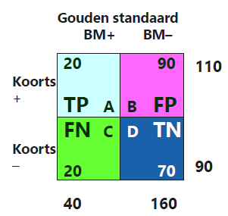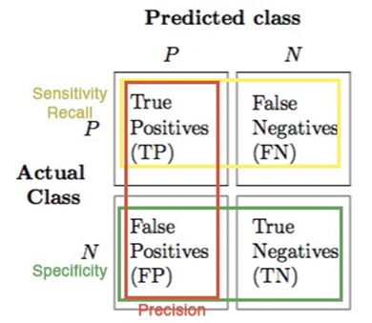

**Horizontal**:

chance of disease + symptom/test result = predicted value

A/A+B = 20/20+90 = 18%

* + 18% chance that disease when symptom

**Predicted value is more important than certainty**

**Vertical**:

calculating the change of a symptom (fever) when certainty of disease

**Diagnostic Process**

* Hierarchical (often starting with medical history = test 1)

**Data Analysis**

* ROC (Receiver Operating Characteristic) – Area under the curve (AUC)

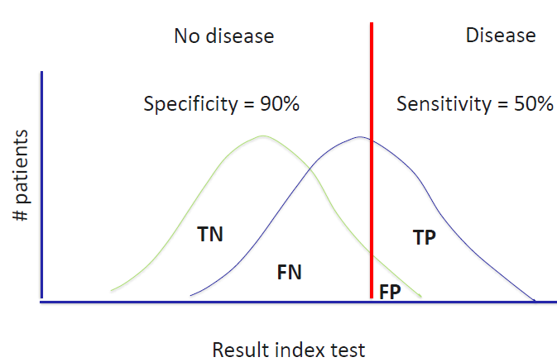

**Red line = cut off value**

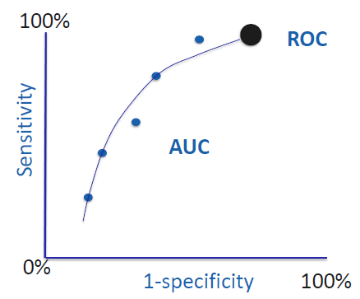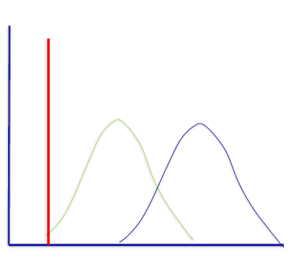

**Tossing coin AUC 0.5**

**The more tests the bigger AUC and the better prediction**

**Diagnostic score**

* Calculating by weighting information through testing
* Absolute risk score for each patient
* Build ROC curve
* Probability sorted by groups and check with observed values for risk of disease

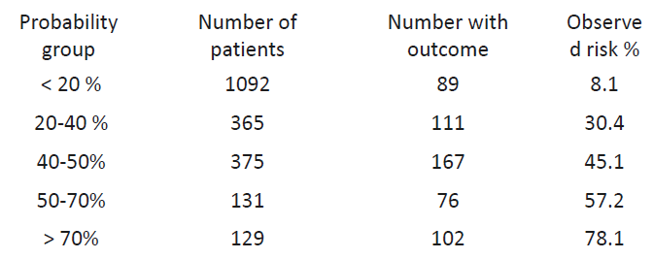

After internal validation of the model -> external validation

**Reporting**

* Purpose of diagnostic research is ONLY to improve medical practice

**Prognostics**

* Purely clinical
* “Will I die?”

**Similar in steps to diagnostic research but:**

* What determinants predict future for patient
* not “guess what’s wrong with me” but “what will happen to me in the future?”
* Cohort with characteristics (determinants) to find relevant outcomes