# DEPTH model

* **Diagnostic** knowledge – what’s wrong
* **Etiologic** knowledge – why ill
* **Prognostic** knowledge – what if I don’t intervene
* **Therapeutic** (prognostic) knowledge – what if I intervene

|  |  |  |
| --- | --- | --- |
| **Frequency measures** | **Association measures** | **Impact measures** |
| Prevalence |  | Attributable risk |
| Cumulative incidence | Relative risk | Population attributable risk |
| Incidence density | Relative rate |  |
| Odds | Odds ratio |  |

|  |  |  |  |
| --- | --- | --- | --- |
| **Item** | **Prevalence** | **Cumulative incidence** | **Incidence density** |
| Numerator | All cases counted on a single occasion | New cases occurring during a specified follow-up period | New cases occurring during a specified follow-up period |
| Denominator | All individuals examined - cases and non-cases | All susceptible individuals present at the start of the study | Sum of time periods during which all individuals could have developed disease |
| Time | Single point or period | Defined period | Measured for each individual from beginning of study until disease event |
| Interpretation | Probability of having disease at a point in time | Probability of developing disease over a specified period | How quickly new cases develop over a specified period |

## The definition of epidemiology

is “the study of disease in populations and of factors that determine its occurrence over time.” The purpose is to describe and identify opportunities for intervention. **Epidemiology** is concerned with the distribution and determinants of health and disease, morbidity, injury, disability, and mortality in populations.

**Incidence** is a measure of the new occurrence of a disease event (eg, illness or death) within a defined time period in a specified population. Two essential components are the number of new cases and the period of time in which those new cases appear. In an example regarding the class of veterinary students, if 13 of them developed influenza over the course of 3 mo (one quarter), the incidence would be 13 cases per quarter.

An **incidence rate** takes the population at risk into account. In the previous example, the incidence rate would be 13 cases per quarter/102 students, or 0.127 cases per quarter per student. Incidence rates are usually expressed by a multiplier that makes the number easier to conceptualize and compare. In this example, the multiplier would be 100, and the incidence rate would be 12.7 cases per quarter per 100 students (or 12.7%). An **attack rate** is an incidence rate; however, the period of susceptibility is very short (usually confined to a single outbreak).

A similar concept to incidence is **prevalence**. Prevalence (synonymous with “point prevalence”) is the total number of cases that exist at a particular point in time in a particular population at risk. Again using the influenza example from above, if 7 students had influenza at the same time during the academic quarter, the prevalence would be 7/102 or 0.069 cases per class (or 6.9%).

## Descriptive Epidemiology

In summary, descriptive epidemiology serves to describe the occurrence of disease in a population. Descriptive methods are commonly applied to little-known diseases; they use preexisting data, address the questions of who/where/when, and identify potential associations for more in-depth analytical studies.

**Cross-sectional studies** are one-time assessments of the incidence or prevalence of a disease in a defined population, which is usually selected at random from a larger population at risk (eg, a serosurvey of veterinarians for the presence of antibodies to *Bartonella henselae* organisms to determine risk factors and for cat scratch disease). Cross-sectional studies are especially useful in forming hypotheses to be addressed by follow-on analytic studies.

Two main types of bias in descriptive epidemiology are **selection bias** and **observation bias**. Selection bias results from the identification of subjects/cases from a subset that is not representative of the entire population at risk. A nonmedical example of selection bias would occur in a voter survey, intended to predict the outcome of a political election, but drawn from a sample of voters from either high- or low-income status, neither of which would be representative of the overall voting population. Observation bias arises from systematic differences in the method of obtaining information from subjects/cases. Consider a study comparing library usage between students at two universities. Significant differences might result if students from one university were queried over the phone regarding library visits, whereas students at the other university were directly observed for actual usage. In general, bias in descriptive studies is not as prevalent or significant as bias in analytical studies.

## Analytical Epidemiology

Analytical studies are applied to study the etiology of disease, to identify a causal relationship between exposures and health outcomes. They are typically used when insights of a particular health issue are available, commonly from previous descriptive studies. In evaluating the causality of disease associations, analytical studies address the question of “why” as opposed to the “person/place/time” of descriptive studies.

Analytical epidemiology is accomplished through either **observational studies** or **interventional studies**. In the former, the investigator does not control the exposure between the groups under study and typically cannot randomly assign subjects to study groups.

## Observational Studies:

### Ecologic Studies

The unit under study is a group of people or animals versus an individual. The group has no size limitation but must be able to be defined. For instance, the group could be a kennel of dogs, a class of veterinary students, or the citizens of an entire country. Once defined, the group is analyzed against some exposure to see what outcome(s) ensue. Examples of ecologic studies include Dr. John Snow’s analysis of the association between the incidence of cholera in London and where people obtained their drinking water, an analysis of how tobacco taxes affect tobacco usage, and an analysis of certain occupations for resultant hearing loss.

**Advantages**

* quick,easy, and inexpensive
* Individual data are not necessary, only aggregate data for the group(s) under study.
* Finally, they are useful in generating information about the overall context of health, especially how it is affected by variables such as demographics, geography, and the social environment.

**Disadvantages**.

* First, the measurement of many exposures is imprecise, especially of large groups in which the influence(s) of those exposures is difficult to define or not equally exerted. This phenomenon of unequal variable exertion results in another potential drawback to ecologic studies. Known as **ecologic fallacy**, it is described by “associations observed at the group level do not necessarily hold true at the individual level.” As an example, one could determine that the average IQ of a class of veterinary students is above average (which, by definition, would be 100). If a particular student was randomly selected from that class, could it be inferred that that student’s IQ was above 100? The answer is no, because of the difference between average and median. If the class had only a few people above average, but these students were significantly above average, and the rest of the students were only slightly below average, the distribution would be skewed toward a higher IQ when, in actuality, many members of the class would be below average.

# Cohort Studies

In this type of study, a group of individuals (termed a cohort) is observed over time for changes in health outcomes.

When the period of the study is from the present into the future, the study is a **prospective cohort study**. In this case, the cohort is assumed to share a particular exposure and is followed over time to document the occurrence of new instances of a particular disease or outcome. Obviously, each member of the cohort must not have the disease or outcome at the beginning of the study.

The major **advantage** of the prospective cohort study is that many different exposures can be considered and analyzed for influencing the outcome under study. **Disadvantages** include the high cost in terms of money and time during the period of the study and the inability to study very rare diseases or health outcomes unless the cohort is extremely large.

When the period of the study is from the past to the present, the study is a **retrospective cohort study**. The methodology is very similar to that of the prospective cohort study, except that all the events (exposures and outcomes) have already occurred; the investigator is merely looking back rather than forward. Retrospective studies are conceived after some individuals have already developed the outcomes of interest. The investigators jump back in time to identify a cohort of individuals at a point in time before they developed the outcomes of interest, and try to establish their exposure status at that point in time. They then determine whether the subject subsequently developed the outcomes of interest. If so, they can analyze the exposure(s) that may have contributed to those outcomes.

Retrospective cohort studies have several advantages over prospective cohort studies. They typically take less time and are less expensive. Additionally, they can address rare outcomes, because the cases are selected after having already developed the disease or outcome. Disadvantages include a potentially high possibility of selection bias, the fact that individuals may have difficulty recalling certain exposures (termed **recall bias**), and the requirement for the existence of medical and/or exposure records.

#### **Advantages**

* Subjects in cohorts can be matched, which limits the influence of confounding variables
* Standardization of criteria/outcome is possible
* Easier and cheaper than a randomized controlled trial (RCT)

#### **Disadvantages**

* Cohorts can be difficult to identify due to confounding variables
* No randomization, which means that imbalances in patient characteristics could exist
* Blinding/masking is difficult
* Outcome of interest could take time to occur

Regardless of being retrospective or prospective, the measure of association of all cohort studies is the **relative risk** (RR). Relative risk is calculated by dividing the incidence rate of the disease or outcome in the exposed individuals by the incidence rate in the unexposed individuals. An RR of 1 means there is no difference in risk between the two groups. An RR <1 means that the outcome is less likely to occur in the exposed group than in the unexposed group. Conversely, an RR >1 means the outcome is more likely to occur in the exposed group than in the unexposed group. Consider an example in which the incidence of prostate cancer among neutered male dogs was found to be 1.37%, and the incidence in intact male dogs was 0.36%. In this case, the relative risk would be 1.37/0.36 or 3.8. This could be stated as “Neutered male dogs would be nearly four times as likely as intact male dogs to develop prostate cancer.”

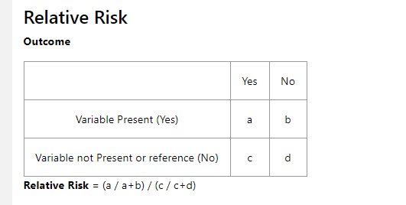

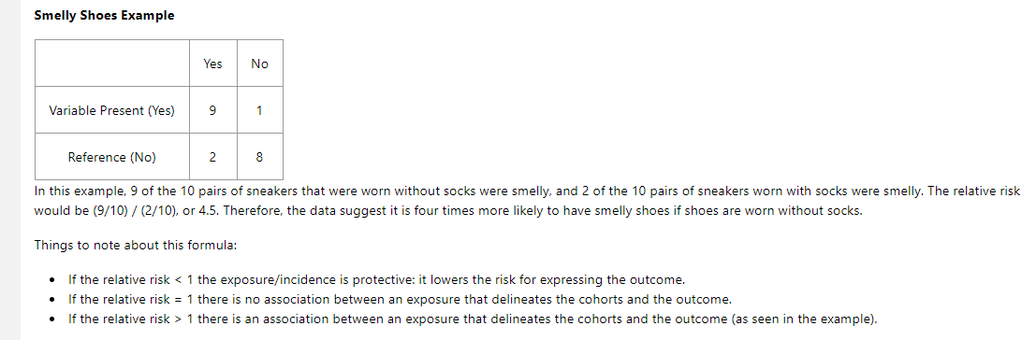

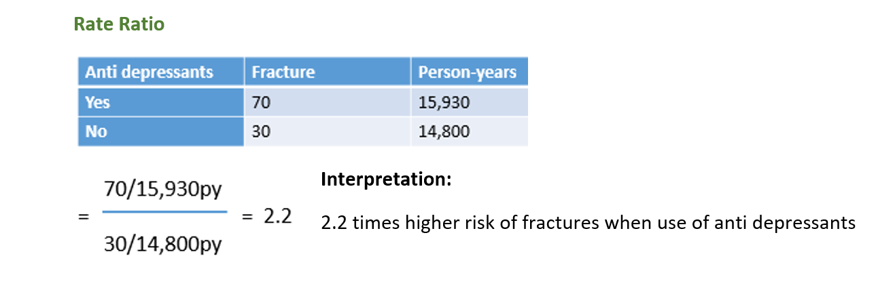

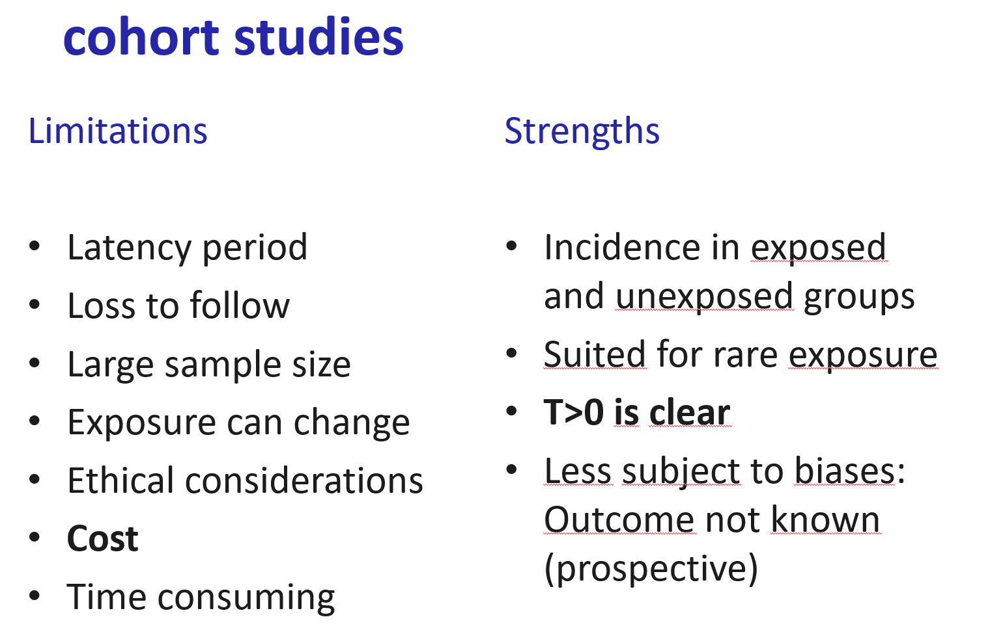

# Case-Control Studies

In this type of study, subjects are selected as either having a particular outcome (cases) or not having the outcome (controls). They are then compared in a retrospective way to identify differences in their exposures that might explain the differences in outcomes. Ideally, cases and controls should be as similar as possible in all characteristics except the outcome in order to make the comparisons simpler and more meaningful. That is why some investigators “match” cases and controls. In one notable example, a very large case-control study in 1950 studied people with lung cancer and demonstrated a very positive association between smoking and lung cancer. Although it did not prove causality alone, it was instrumental in the U.S. Surgeon General’s now-standard warnings.

Case-control studies have several **advantages**. They are inherently retrospective, so they are relatively quick and inexpensive. Because the cases have already been identified, they are appropriate for studying rare diseases and examining multiple exposures. **Disadvantages** include the fact that, like cohort studies, they are prone to selection, recall, and observer bias. Additionally, their application is limited to the study of one outcome.

#### **Advantages**

* Good for studying rare conditions or diseases
* Less time needed to conduct the study because the condition or disease has already occurred
* Lets you simultaneously look at multiple risk factors
* Useful as initial studies to establish an association
* Can answer questions that could not be answered through other study designs

#### **Disadvantages**

* Retrospective studies have more problems with data quality because they rely on memory and people with a condition will be more motivated to recall risk factors (also called recall bias).
* Not good for evaluating diagnostic tests because its already clear that the cases have the condition and the controls do not
* It can be difficult to find a suitable control group

The most common measurement of association in case-control studies is the odds ratio. The **odds ratio** (OR) represents the odds that an outcome will occur from a particular exposure, compared with the odds of the outcome occurring in the absence of that exposure. ORs are calculated using a 2 × 2 frequency table

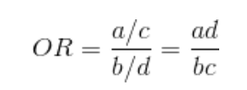

An OR of 1 means the exposure did not affect the odds of the outcome. An OR >1 means the exposure is associated with a higher odds of the outcome, and an OR <1 means the exposure is associated with a lower odds of the outcome. Although a higher OR indicates a stronger association between exposure and outcome, it does not necessarily imply statistical significance and, by itself, is not enough to prove causality.

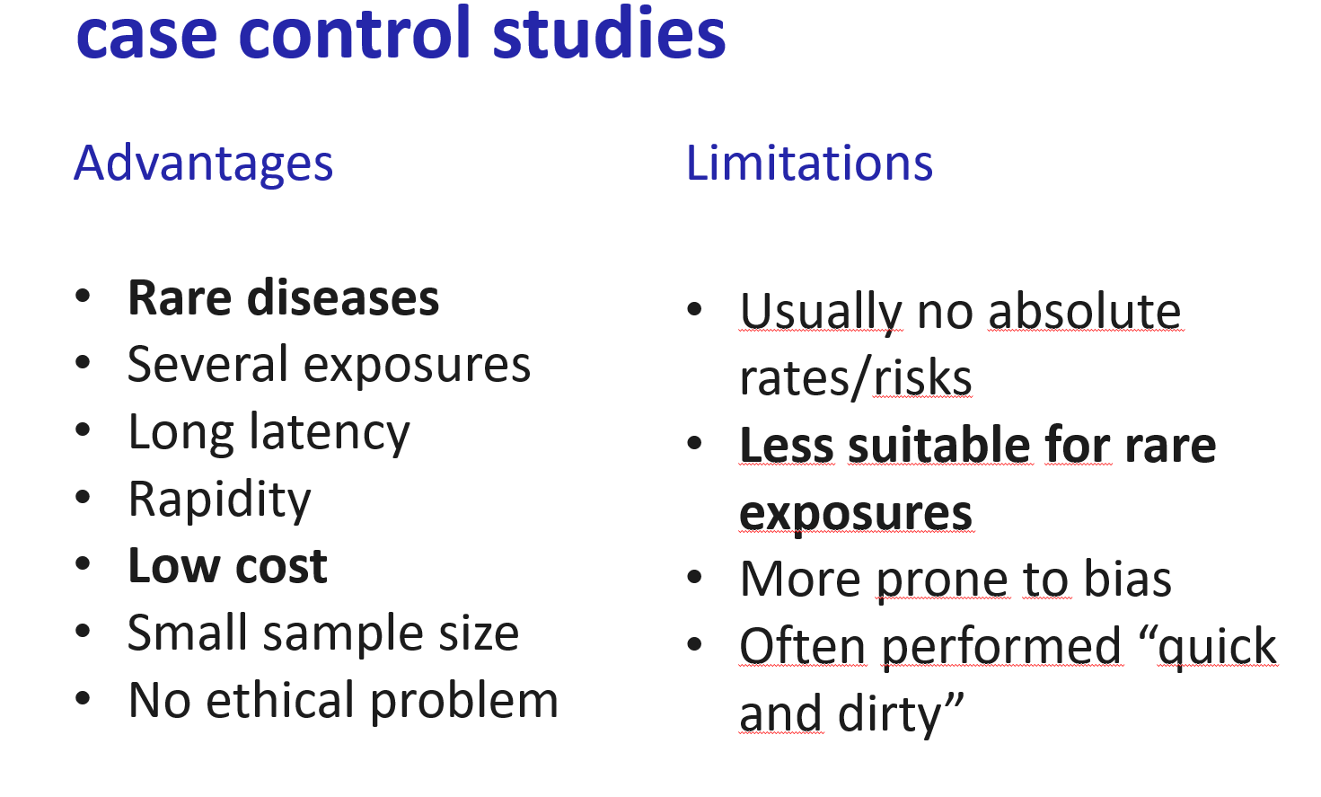

## Interventional Studies:

The other category of studies that comprise analytical epidemiology are interventional studies. In contrast to observational studies, the investigator using an interventional approach can intentionally change some form of exposure between several groups to determine differences in outcome(s). In medical research, these exposures typically include interventions such as vaccines, therapeutic drugs, surgical techniques, or medical devices. The results of interventional studies can be very powerful in proving causality or identifying efficacy of various interventions. Interventional studies typically take one of two forms, either **a randomized controlled (clinical) trial** or **a nonrandomized (community) trial.**

# Randomized Controlled (Clinical) Trials:

participants are selected from a population and randomly assigned to one of two groups, one being the study group and the other being the control group. Study groups receive the intervention, and the controls do not.

**Bias** can be introduced in such a trial when either the participants or the investigator know which participants are in which group. This bias can be alleviated in one of two ways. First, in a single-blinded design, the participants are unaware whether they are in the study group or the control group. Additionally, in a double-blinded design, neither the investigator nor the participants are aware of the group assignments.

A **major advantage** of randomized controlled clinical trials is an inherently high validity for identifying differences in therapeutic efficacy of various interventions. Perhaps the major **disadvantage** is the high potential for **ethical implications**. Additionally, this type of study is not usually applicable for **discovering disease etiologies**; observational studies are much better suited for this purpose.

#### **Advantages**

* Good randomization will "wash out" any population bias
* Easier to blind/mask than observational studies
* Results can be analyzed with well known statistical tools
* Populations of participating individuals are clearly identified

#### **Disadvantages**

* Expensive in terms of time and money
* Volunteer biases: the population that participates may not be representative of the whole
* Loss to follow-up attributed to treatment

# Nonrandomized (Community) Trials

In this type of study, the units are groups (or communities) of participants assigned to treatment or control conditions. Although the communities may be selected at random, the individuals within them obviously are not. These studies are commonly undertaken to assess the quality and effectiveness of educational programs, behavioral changes, or mass interventions such as water fluoridation.

## Bias

Bias is defined as the systematic deviation of results or inferences from truth.

**The Hawthorne Effect:** Participants in a study may act or behave differently because they know they are being studied

**Recall bias:** Cases and controls may remember an exposure differently (and non-randomly). Usually, cases remember exposures more clearly than controls.

**Selection bias:** This occurs when selected controls are not representative of the population from which the cases were selected. Or lost in follow-up.

**Observer bias:** The investigator, having knowledge of the outcome(s), might record exposures differently between cases and controls.

**Confounding:** In epidemiologic studies, a confounder is a variable that is not considered in the study design but is associated with the exposure and exerts an effect on the outcome. Confounders can either produce a false association between variables or mask a true association between variables. An example of the former was a spurious conclusion drawn from a study of the relationship between alcohol consumption and heart disease. In the study, it was concluded that alcohol consumption was significantly associated with heart disease. Smoking was later identified as a confounder, because smoking was correlated both with alcohol consumption and also with heart disease. When corrected for the effects of this confounder, no association was found between alcohol consumption and heart disease.

## Error

When analyzing results of an epidemiologic study, there are two categorical types of error when either accepting or rejecting the null hypothesis.

**Type I error**, also known as a **false positive**, is when the null hypothesis is rejected when it actually should have been accepted. In other words, this is the error of accepting an alternative hypothesis (the real hypothesis of interest) when the results can actually be attributed to chance. Type I error (which can never be zero) is generally reported as the ***P* value**.

**Type II error**, also known as a **false negative**, is when the null hypothesis is accepted when it actually should have been rejected. In other words, the study did not have adequate power to detect an association between a variable and an outcome when the association actually existed.

## Variable Associations and Causality

Several sets of systematic criteria for determining causality have been proposed:

1) Strength—Although a small association does not mean that there is not a causal effect, the larger the association, the more likely that it is causal.

2) Consistency—Repeatedly similar findings observed by different persons in different places with different samples strengthen the likelihood of a causal effect.

3) Specificity—Causation is more likely in a very specific population at a specific site and disease with no other likely explanation. The more specific the association between an exposure and an outcome, the higher the probability of causation.

4) Temporality—The outcome must occur after the exposure.

5) Biological gradient—Greater exposure generally results in greater incidence of the outcome. However, in some cases, the mere presence of the exposure, without regard to its magnitude, can trigger the effect. In yet other cases, an inverse relationship is observed when greater exposure of a protective factor leads to lower incidence of outcomes.

6) Plausibility—A rational, explainable mechanism between cause and effect is helpful (but may be limited by current knowledge).

7) Coherence—Agreement between epidemiologic and laboratory findings increases the likelihood of a causal effect.

8) Analogy—The effect of similar associations between other variables of exposure and outcome may be considered.

## Sensitivity and Specificity

**Sensitivity** is the probability of a positive test result when the disease is actually present. A sensitive test is “positive in disease” and minimizes false-negative results, thus minimizing type II error. **Specificity**, in contrast, is the probability of a negative test result in the absence of disease, thereby correctly classifying an individual as disease-free (regarding that particular condition). A specific test is “negative in health” and minimizes false-positive results, thus minimizing type I error.

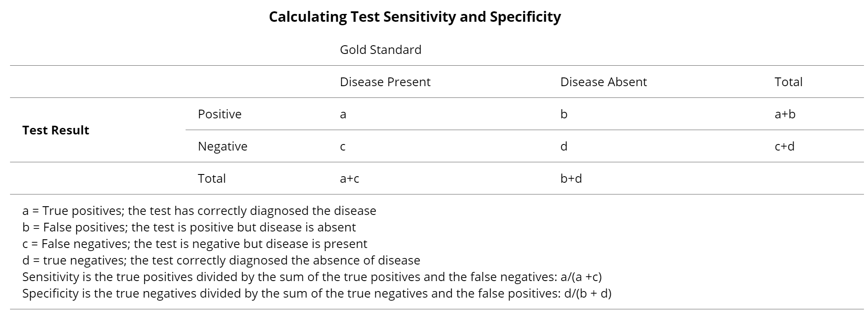

Sensitivity and specificity are inversely proportional, ie, when one increases, the other decreases. Therefore, the accuracy of a test is a trade-off between each of these parameters.

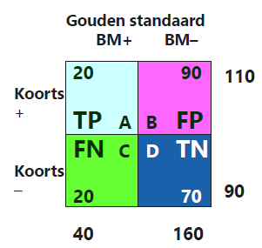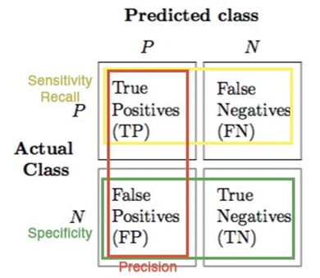

## Validity and Precision

|  |  |
| --- | --- |
|  | **Precision**   * Reproducibility, Reliability, Consistency * More precise => the greater the statistical power (at the same sample size) * Effected by random error   **Accuracy**   * The degree it actually represents what it is intended to represent. * Important influence on the internal & external validity of the study * Accuracy =><= Systematic error (bias) |

## Diagnostics in practice

* So what is diagnostics in practice?
  + Estimation of risk/chance of presence of disease based on patient’s test results
* Why not all possible tests?
  + Too burdening
  + Unnecessary: different tests often provide same info
  + Note: in practice very often more testing than strictly needed!
* What diagnostics is really necessary? 🡪 Scientific diagnostic research

# Data analysis: 3 steps

1. Estimate prior risk (without test results)
2. Compare each index test result with reference test result = univariable
3. Compare combinations of index test results with reference test result = multivariable (via model, usually logistic regression)
   1. Adhere model building to diagnostic order in medical practice
   2. Determine added value of index test results as compared to already collected, previously collected index test results