**Q1:**

Take a look at the following output:

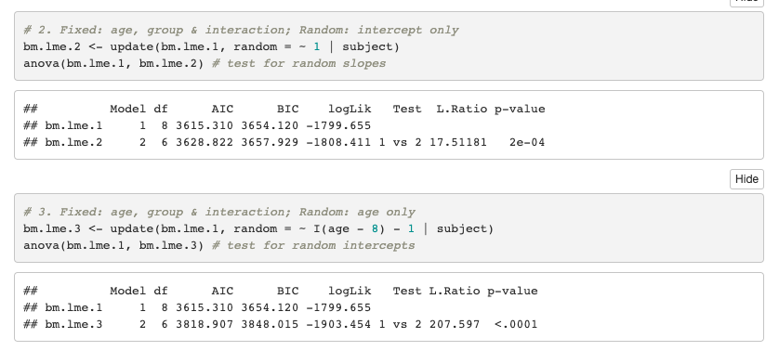

Which model would you prefer based on the AIC?

1. Bm.lme.1
2. Bm.lme.2
3. Bm.lme.3

**Q2:** Look at the following table with different estimates of the same model using centering or no centering. Two values are erased and marked as A and B.

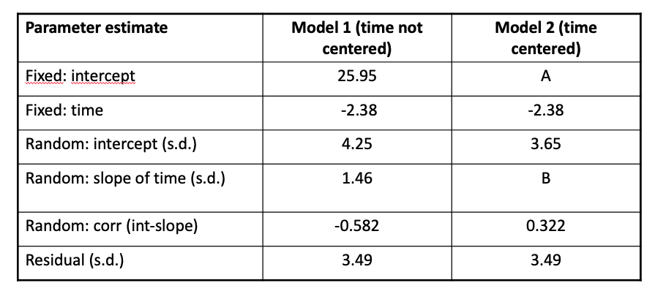

Will the estimates for A and B compared to the model which is uncentered?

1. Both stay the same
2. A will be the same, B can change
3. A can change, B will be the same
4. Both can change

**Q3:** Which of the following statements with respect to *single imputation* are true?

1. Single imputation will deflate correlations in our data.
2. Estimated standard errors will be too low
3. Both are False
4. 1 is True, 2 is False
5. 1 is False, 2 is True
6. Both are True

**Q4:** Consider the following statement:

Multiple imputation, as most advanced imputation technique, can deal with data that are missing not at random.

1. True
2. False

**Q5:** Cumulative incidence and Incidence density are terms that belong to

1. Frequency measures
2. Association measures
3. Impact measures

**Q6:** Take a look at the table below. What should be filled in at the X marker?

|  |  |
| --- | --- |
| Item | Cumulative incidence |
| Numerator | New cases occurring during a specified follow-up period |
| Denominator | X |
| Time | Defined period |
| Interpretation | Probability of developing disease over a specified period |

1. All individuals examined - cases and non-cases
2. All susceptible individuals present at the start of the study
3. Sum of time periods during which all individuals could have developed disease
4. How quickly new cases develop over a specified period

**A1:** Take the lowest AIC value, thus bm.lme1. **(**For practice you can also try doing L.Ratio test!)

**A2:** The random slope will stay the same. The intercept can change because of centering.

**A3:** C is correct. Correlations will be inflated, not deflated using single imputation.

**A4:** Data missing not at random is also one of the common pitfalls of using multiple imputation. It cannot solve this problem.

**A5:** Frequency measures, see slide 26 Wednesday of introduction to epidemiology.

**A6:** Answer B is correct.