**Assessment of the wake effect on the energy production of onshore wind farms using GIS**

Stefano Grassi, Sven Junghans, Martin Raubal

Method to estimate the mean annual energy produces by wind farms with GIS

* Wind resource layers (16 wind directions)
* Roughness of terrain important (variation of land cover over the year)
* Mean annual energy = technical characteristics & wind resource & wake effect between wind turbines
* **Reduced efficiency coefficient** = impact of layout of wind farms on annual energy production
  + Shows that there’s energy losses because regular wind farm layouts are designed to use **prevailing wind speed** (= wind that blows predominantly from a particular directionin that area) but are neglecting additional information and therefore losing energy
  + When the wind comes from a different direction (e.g. 90 degrees of prevailing wind) the turbines waste up to 60% of the available energy

**Goal:** reduce the uncertainty of investments in wind (obviously you cannot depend on wind 100%)

Method for predicting the **AEP (=Annual Energy Production)** of wind farms using a GIS platform by using a physical approach.

**Methodology:**

**Workflow**

1. **data selection and creation of a geodatabase**

selection of GIS:

* **data land** cover, boundaries, linear infrastructure, water: Kansas Data Access and Support Center4 (DASC)
* **wind data** using Mesomap system made out of atmospheric simulation models, databases, storage systems
  + MASS (Mesoscale Atmospheric Simulation System) = numeric weather model simulating physics of atmosphere using long-term wind measures
  + Vector data (shapefile with points), containing the necessary wind data, are used in this study
* **Data** about **location of wind turbines**: DASC webpage and verified using Google Earth

1. **modelling of the terrain roughness**

**subphases:**

* pre-processing phase
* estimate of the roughness and ruggedness (main process)
* generation of the attribute data
* Considered when ground is covered with snow and consider areas used for crop farming = different land cover. The intermediate steps of the vegetation growth are also taken into account.
* modelled and twelve different raster data sets corresponding to each month are created to describe the land cover change over the year
* previous studies have shown that wind exponent depends on roughness and changes with the wind direction
* ruggedness index (RIX) explains complexity of topography in region (>30% = terrain is complex) – in this study RIX has no impact on estimated AEP
* heterogeneity of terrain is analyzed with GIS software tool

1. **modelling of the wake effect due to the interaction of WTs**

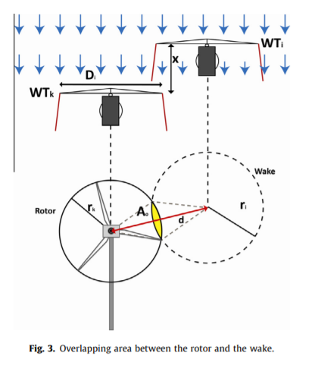- interaction of wind turbines depends on the first wind turbine of the wind farm that gets hit by wind

- there’s overlapping areas were the turbines take away wind and therefore energy from each other

- the wake generated by a WT in upstream can influence another WT in downstream depending on the position and affects the production -> creating **wind shadows**

**(4) estimation of the AEP and the quantification of its uncertainties &**

**(5) assessment of the reduced energy production due to the wind farm layout and the variation of the wind direction**

**-** the AEP of every WT is affected by

* wind direction
* wind speed distribution
* layout of other WT

In order to identify the impact of the layout, and the generated wakes, on the AEP of a wind farm, a coefficient called ‘‘reduced efficiency coefficient’’ (REC) for each wind direction has been defined.

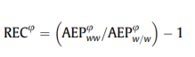shows how the AEP of a wind farm layout is reduced because of the wake effect when the wind blows from direction $φ$.

**Results/Conclusion:**

* The work demonstrates that the wake effect due to the interaction of multiple WTs and the analysis of the roughness factor depending on the wind direction can be modelled and embedded into a GIS-based process. This enables a more realistic modelling of the actual conditions and thus a more reliable assessment of the long-term AEP of a wind farm.
* The model was tested comparing the predicted AEP with the actual AEP of four wind energy projects. Results showed an overall underprediction of the AEP of 3.56% and an underprediction of the long-term CF of 1.11%