# Hans Alberto Franke

## Date: 13/11/2020

## Assignment Spatial Data: Lab_1_2

## Questions without answers in tutorial:

Filtered => Levenstein < 80 and leven < 10

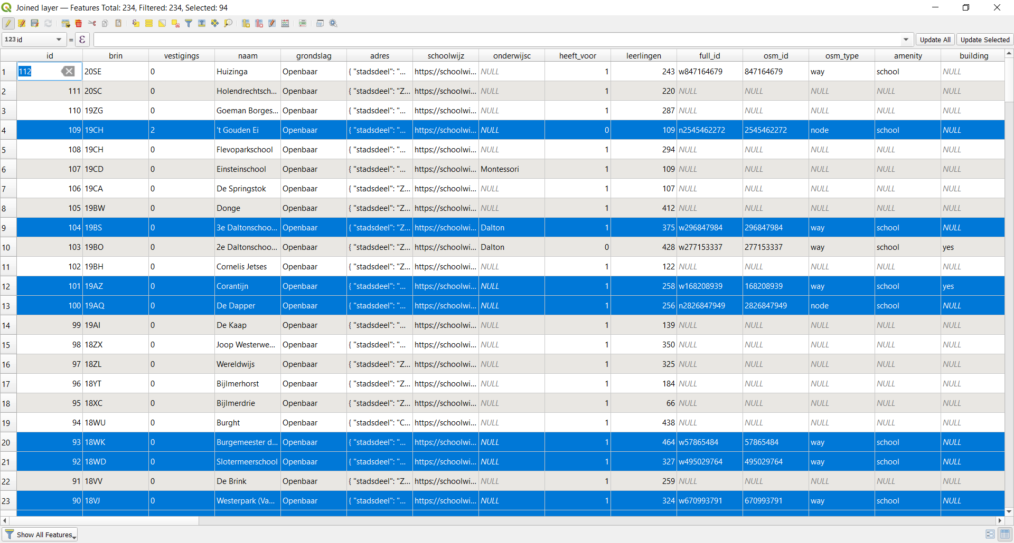

## Completeness and Accuracy (Metrics from tutorial)

### Completeness (percentage):

Result => 94 / 234 = 40.17%

### Spatial accuracy : Compute the average distance between matches

## 

# Assignment:

## Assess quality of one other geodata source, and document everything

## 

Do a similar kind of analysis for at least one other geodata source. This can be a polygon dataset, so that you can reuse your script (otherwise you would need to adapt your script), or it could be a point or line data source. You might also use a different OSM key/value pair to obtain OSM vector data, or reuse a geodata source you have collected in lab 1.1.

If you don’t find any good reference dataset as above (and in order to save time), you can do a qualitative assessment of spatial accuracy and completeness, by just visually comparing it with some background map.

Finally document all your quality assessments for all datasets in a pdf document, including references to the data sources, some screenshots of maps and some short text describing each data quality dimension for each source. Submit this document on blackboard.

# Dataset:

### Description:

Beaches of my home town (Florianopolis – Brazil). Comparison from municipality maps to osm datasearch

Website: [http://www.pmf.sc.gov.br/entidades/geo/index.php?cms=mapas+para+download&menu=0](http://www.pmf.sc.gov.br/entidades/geo/index.php?cms=mapas+para+download&menu=0%20) (Portuguese only ☹ )

Link: <http://www.pmf.sc.gov.br/arquivos/arquivos/zip/10_05_2018_11.17.24.3ce25d647fc4fe7ee200936f0cf75c52.zip>

Description in .pdf inside .rar file

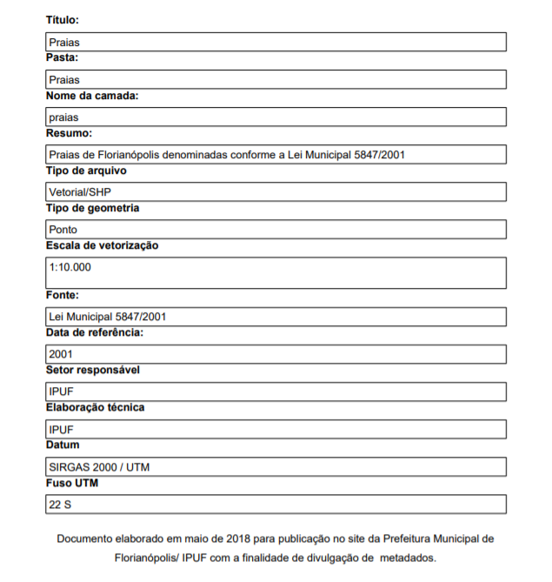

### Screenshot:

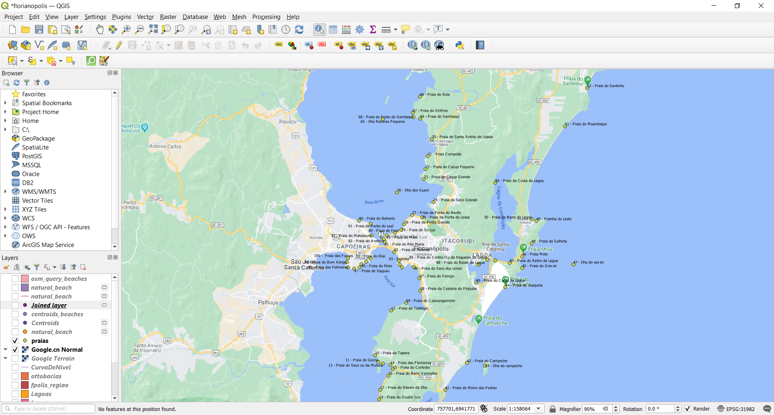

### OSM_Query:

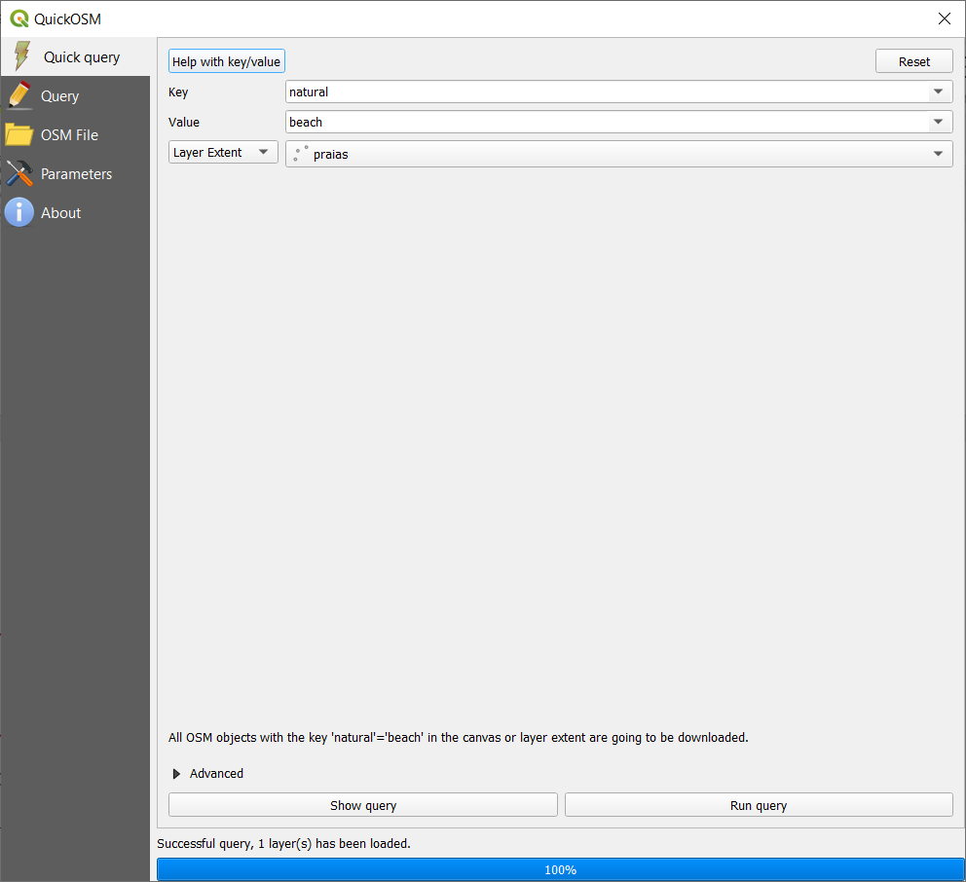

### OSM_Screenshot:

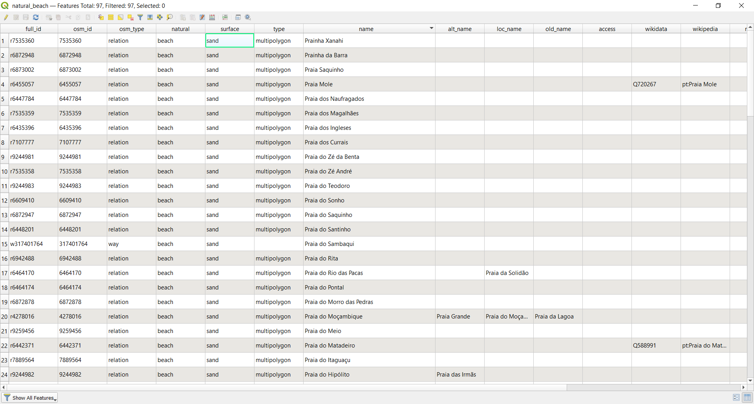

### Accuracy:

Visually one can see that the maps from municipality are represented by points, whereas the OSM as a multipolygon. So I tried to calculate centroids of this polygons to visualize compare them to OSM_Query:

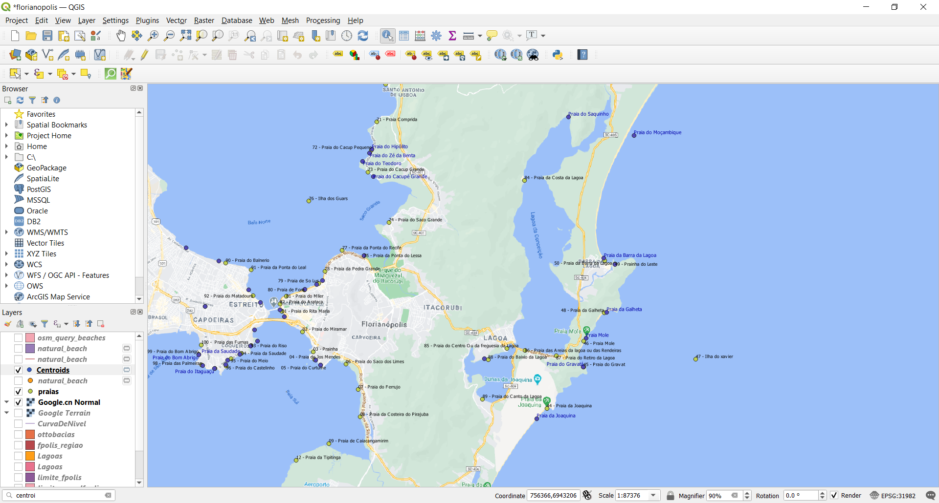

As one can see now through a visual comparison, the points differ from the reference OSM query (Blue points) and the data from the municipality (green points) no overlapping of any points, so the dataset for OSM is not accurate.

### Completeness:

As each table has a specific number of beaches (100 municipality and 96 in osm) we can evaluate the completeness as 96/100 = 96%! Considering that I made an assumption that the municipality is the true source.

To validate my thesis above, I joined the points as 2 km distance:

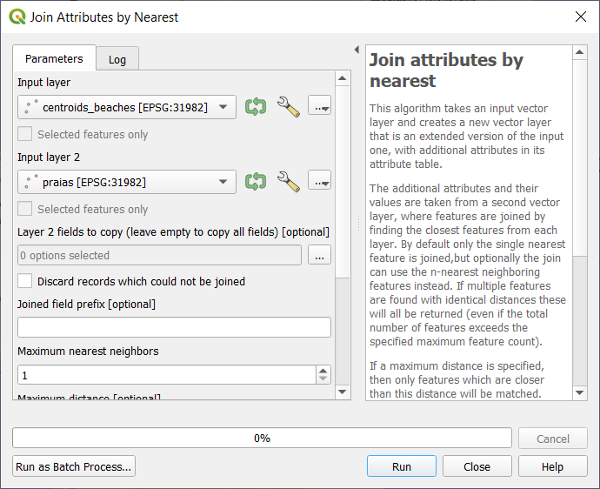

Result table (96 points, same as the osm_query)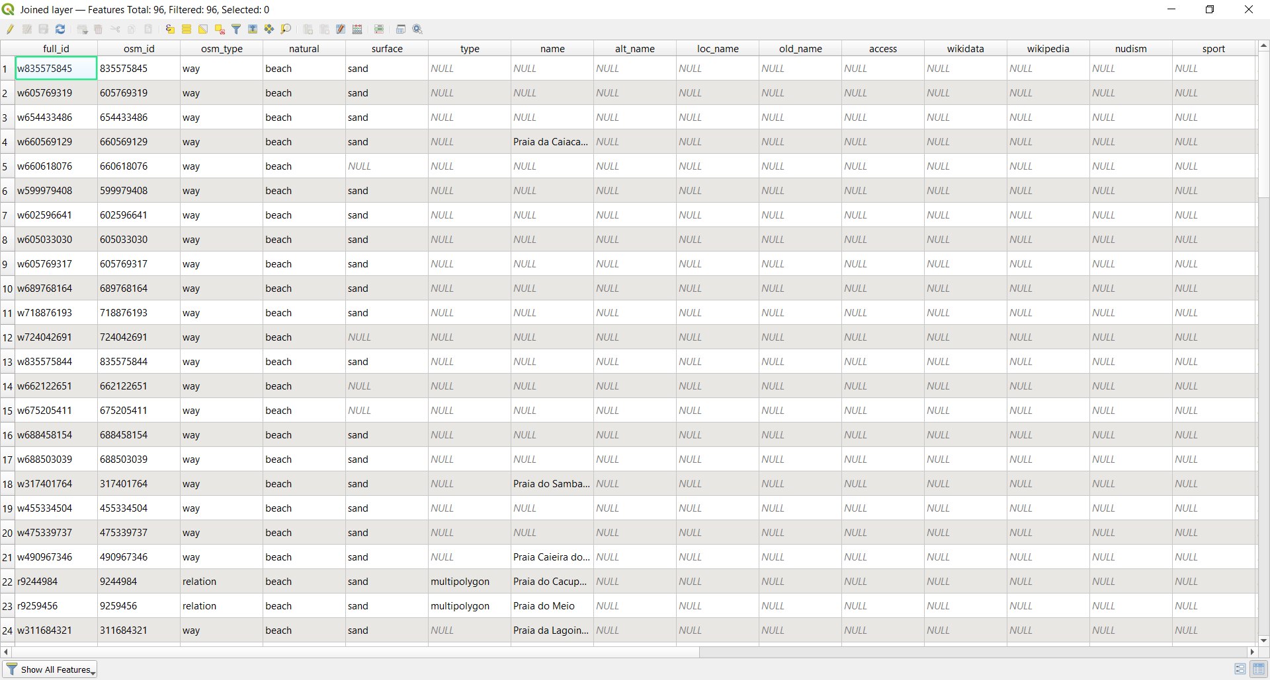

Average distance: 325 meters, in fact this is pretty accurate, once we have the maximum distance of 2km.

