# Hans Alberto Franke

## Date: 20/11/2020

## 2.1 Querying datasets

### Question: What is the total surface area given in the location layer?

### Question: What is the coordinate of the feature with the index 439774?

### Script:

## 2.2 Obtaining building properties

## 2.3 Computing building densities

### Question: What is the density of the district with feature id 54 (Museumkwartier)?

Looking in QGIS to check!

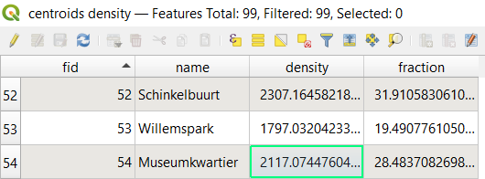

Script:

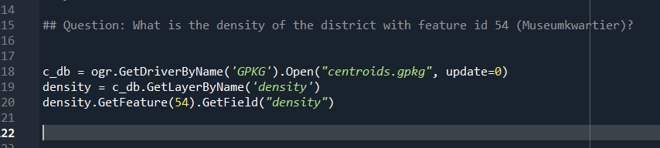

# 3.1 Retrieving school data

## 3.2 Constructing point geometries