# Hans Alberto Franke

## Spatial Data Analysis

## Date: 30/11/2020

# Assignment:

## Topic definition:

Looking in the database to decide which kind of land use type I would be motivated to use, I filter all unique rows (with English words side by side!).

**Dataset**: GRONDGEBRUIK_2017_RDNew.shp

|  |  |  |  |  |
| --- | --- | --- | --- | --- |
| AMScode | AMScode_Om | AMScode__1 | CBScode2 | CBScode2_O |
| 101 | Spoorterrein | Train-railway area | 10 | Spoorterrein |
| 102 | Metro, vrije trambanen | Metro-, free tramrail | 10 | Spoorterrein |
| 103 | Bedrijfsspoor | Railway at production site, harbour etc. | 10 | Spoorterrein |
| 110 | Wegverkeersterrein | Mainroad system, paved roads | 11 | Wegverkeersterrein |
| 111 | Wegverkeersterrein rijkswegen | Highways | 11 | Wegverkeersterrein |
| 112 | Wegverkeersterrein provinciale wegen | Regional ways (county; provinces) | 11 | Wegverkeersterrein |
| 120 | Vliegveld (NIET het gras!!) | Airport (not the grass lands) | 12 | Vliegveld |
| 200 | Woonterrein | Living areas (incl. facilities) | 20 | Woonterrein |
| 210 | Detailhandel, winkelcentra en horeca | Shops, malls and hotels-restaurants-pubs | 21 | Terrein voor detailhandel, winkelcentra en horeca |
| 222 | Overheid (nutsbedrijven/defensieterrein) | Public utility, army barracks | 22 | Terrein voor openbare voorzieningen |
| 221 | Overheid (kantoor/dienstverlening/openbare voorzieningen) | Public offices and services | 22 | Terrein voor openbare voorzieningen |
| 230 | Sociaal-culturele voorzieningen (incl. onderwijs, gezondheidszorg) | Cultural, social, medical, educational | 23 | Terrein voor sociaal-culturele voorzieningen |
| 241 | Bedrijventerrein (industrie, tentoonstellingsterrein, garagebedrijven) | Busines- industrial-areas | 24 | Bedrijventerrein |
| 242 | Bedrijventerrein (overwegend kantoren/kantoorachtig) | Busines- trade-areas | 24 | Bedrijventerrein |
| 300 | Stortplaats | Rubbish-dump | 30 | Stortplaats |
| 310 | Wrakkenopslagplaats | Automobile wreck dump areas and demontation | 31 | Wrakkenopslagplaats |
| 320 | Begraafplaats | Cemetery | 32 | Begraafplaats |
| 342 | Bouwterrein niet-woon bestemming | Development site non-residential area | 34 | Bouwterrein |
| 341 | Bouwterrein woonbestemming | Development site residential area | 34 | Bouwterrein |
| 343 | Tijdelijke opslag van grond | Temporary storage of ground | 34 | Bouwterrein |
| 350 | Semi verhard overig terrein | Other (not mentioned before) | 35 | Semi verhard overig terrein |
| 400 | Park en plantsoen | Parks and public gardens | 40 | Park en plantsoen |
| 412 | Golfterrein | Golf links | 41 | Sportterrein |
| 411 | Sportterrein | Sporting areas and sportbuildings | 41 | Sportterrein |
| 413 | Parkeerterrein ArenA | Arena area (Ajax Stadium) | 41 | Sportterrein |
| 420 | Volkstuin | Allotments, schoolallotments, childrenfarms | 42 | Volkstuin |
| 430 | Dagrecreatief terrein | Recreational areas (day) | 43 | Dagrecreatief terrein |
| 431 | Artis | Zoo | 43 | Dagrecreatief terrein |
| 440 | Verblijfsrecreatief terrein | Recreational areas (overnight) | 44 | Verblijfsrecreatief terrein |
| 500 | Terrein voor glastuinbouw | Glasshouses | 50 | Terrein voor glastuinbouw |
| 510 | Overig agrarisch terrein | Cattle breeding, agricultural land | 51 | Overig agrarisch terrein |
| 600 | Bos | Wood | 60 | Bos |
| 610 | Open droog-natuurlijk terrein | Natural areas (dry) | 61 | Open droog-natuurlijk terrein |
| 620 | Open nat-natuurlijk terrein | Natural areas (wet) | 62 | Open nat-natuurlijk terrein |
| 625 | Open nat-natuurlijk terrein waterpartijen | Natural areas (wet, the ponds/pools) | 62 | Open nat-natuurlijk terrein |
| 622 | Open nat-natuurlijk terrein met schotse hooglanders | Natural areas (wet with scottish oxes) | 62 | Open nat-natuurlijk terrein |
| 700 | IJsselmeer/Markermeer | IJselmeer (lakes very near to Amsterdam) | 70 | IJsselmeer/Markermeer |
| 750 | Recreatief binnenwater | Water with recreative mainfunction | 75 | Recreatief binnenwater |
| 753 | Water in golfterrein | Water within golflinks | 75 | Recreatief binnenwater |
| 752 | Water in park/plantsoen | Water within parks | 75 | Recreatief binnenwater |
| 751 | Recreatief binnenwater grote plas | Water with recreative mainfunction (lake) | 75 | Recreatief binnenwater |
| 780 | Overig water breder dan 6 m. | Other water wider than 6 meter | 78 | Overig water breder dan 6 m. |
| 782 | Overig water grote plassen | Other water wider than 6 meter lakes | 78 | Overig water breder dan 6 m. |
| 781 | Overig water `t IJ | Other water wider than 6 meter `t IJ | 78 | Overig water breder dan 6 m. |

When reading all the cool stuffs that the dataset, I decided for: the lakes very near of Amsterdam.

|  |  |  |  |  |
| --- | --- | --- | --- | --- |
| AMScode | AMScode_Om | AMScode__1 | CBScode2 | CBScode2_O |
| 700 | IJsselmeer/Markermeer | IJselmeer (lakes very near to Amsterdam) | 70 | IJsselmeer/Markermeer |

As I enjoy spend time in lake areas (even with this dutch weather), I tought to analyse wich region of amsterdam is close in the average to lake areas.

## Loading initial map

To load the areas of lakes, first we need to change in our model the attribute (from 40 = Parks, to 70 = lake areas)

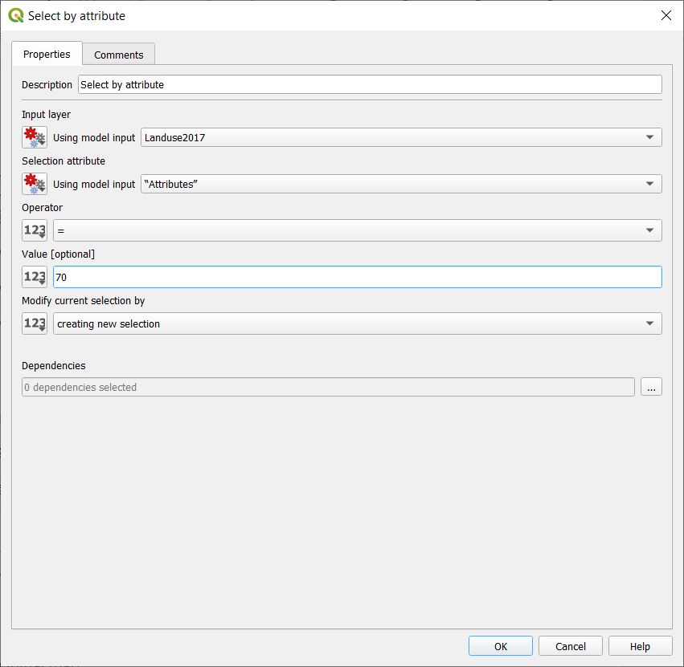

The map below is the project map of regions (delimited with red borders), and blue squares of 40x40 each, representing the lakes. I chose use google normal at background just to give some context to where we are.

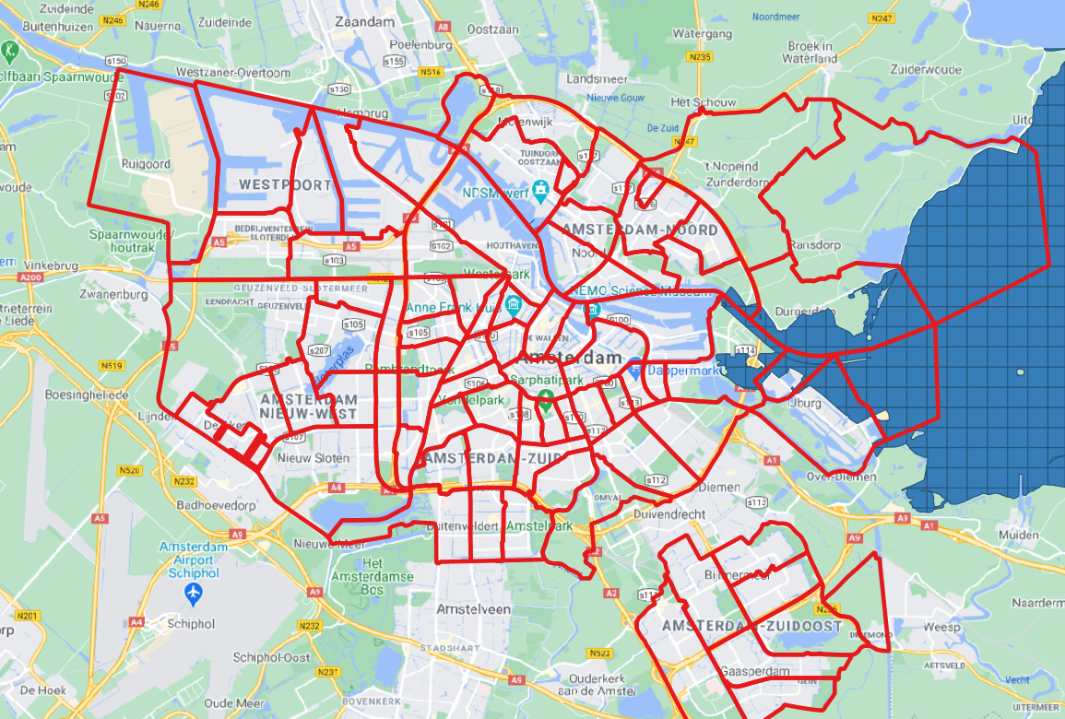

I had to save the PC4, to a new name just to input the new fields, and don’t mess with the tutorial files.

As expected just a few regions have distance to lake calculated.

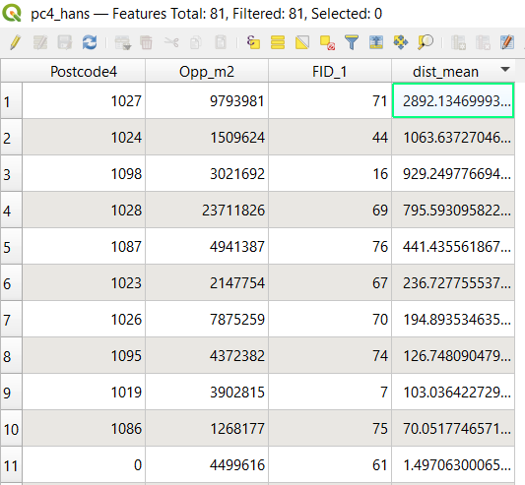

After classifying the regions by distance (granulated, or choropleth map), I decided for just 3 colors, representing: close, medium and faraway. Thus, the color is strong in regions closer to the lakes.

## Final map:

