# Hans Alberto Franke

## Spatial Data Analysis

## Date: 26/11/2020

# Lab 3.1 – Overlay and Aggregation

# Task 1 Simple area interpolation for (re-)aggregating statistics

Above there are the two maps generated by tutorial and to answer task 1. We can see there is differences in the some regions of the maps. The size of each polygon, and the legend of the maps (showing different attributes).

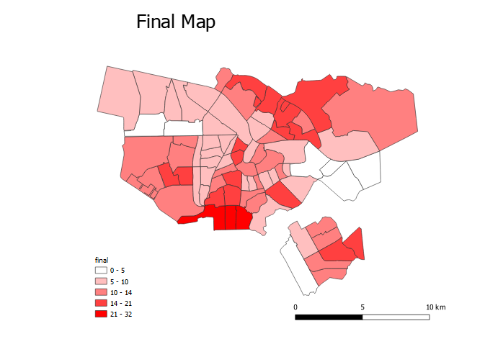

Print Version of the final map

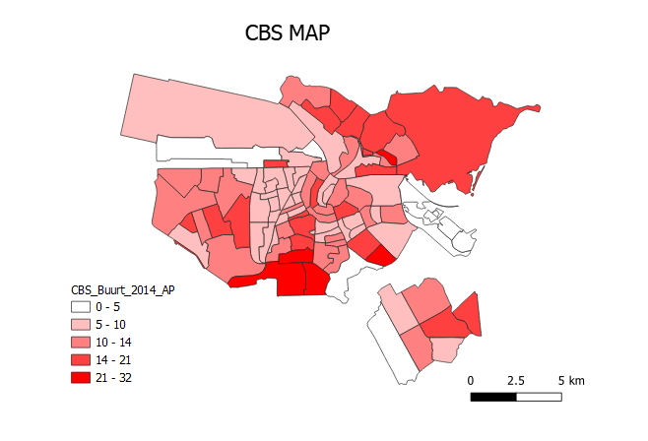print version of the CBS map

## Model layout: Generated in QGIS

The image of the model is attached as Lab 3.1.Model.pdf

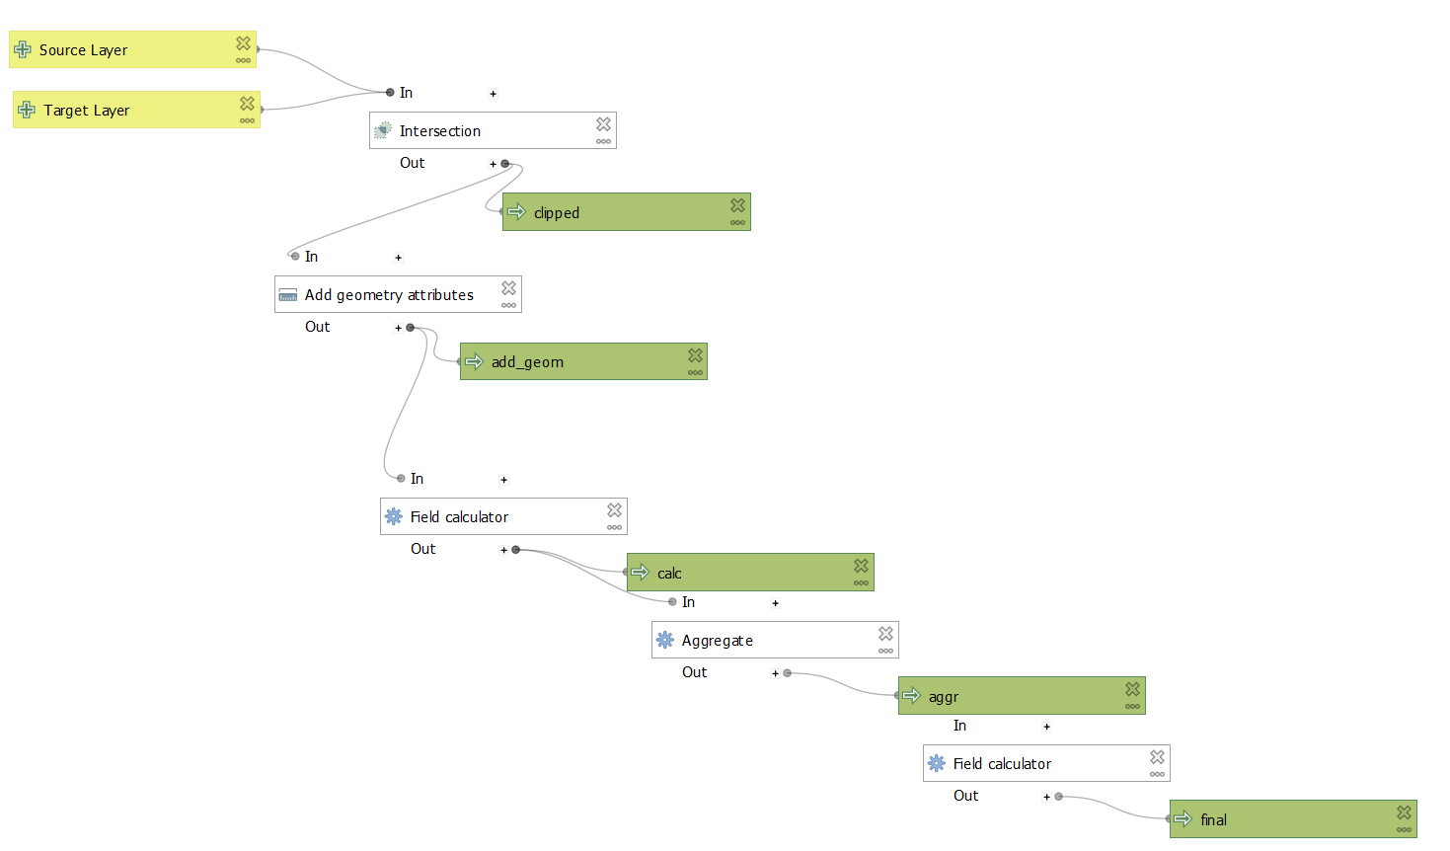

## Python Script: Generated in QGIS

Full code attached as Lab3.1.Task1.Script.py, above just a initial print of the code

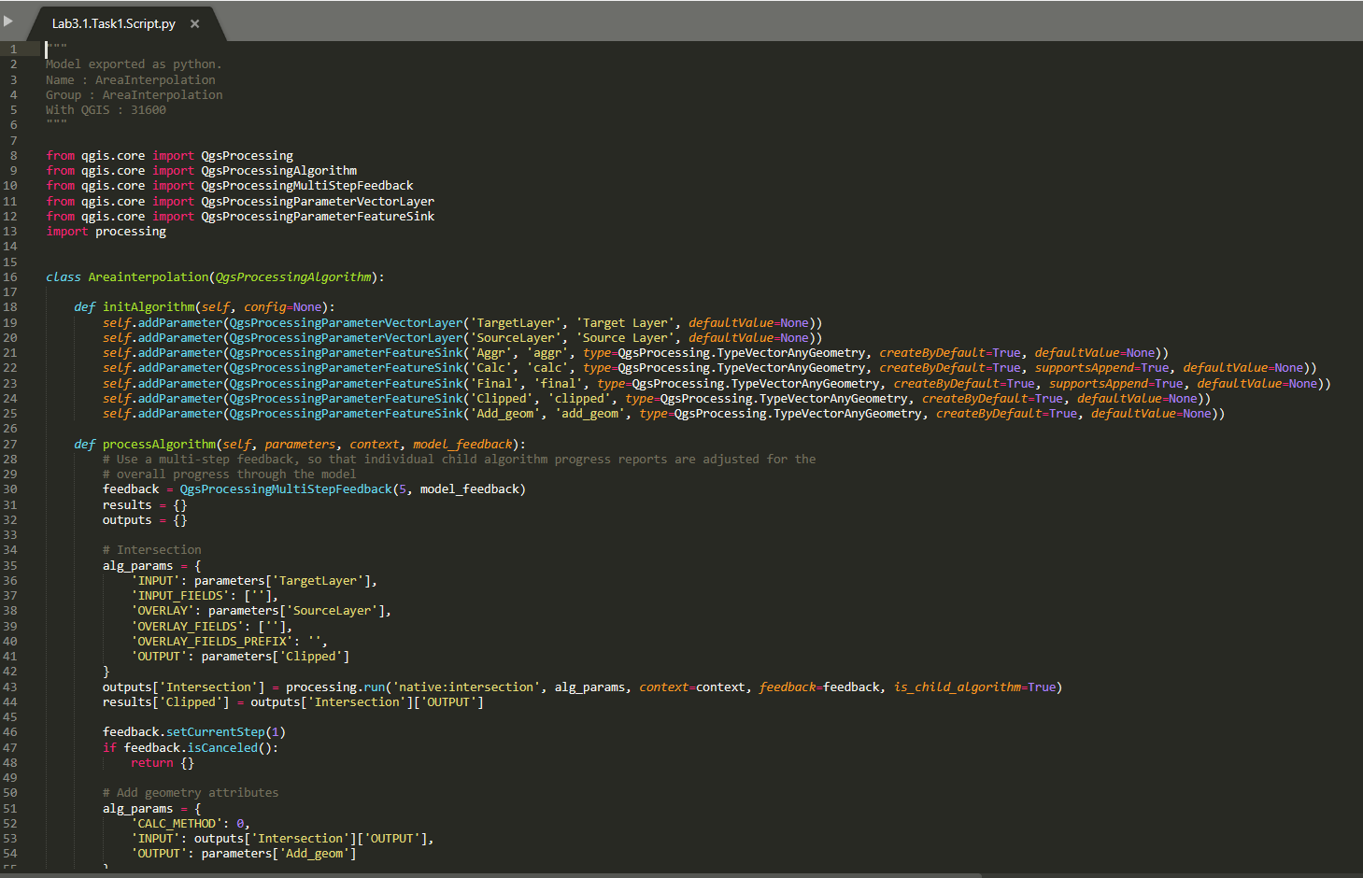

# Task 2: Map algebra for aggregating landuse areas

Above there is the map generated by tutorial and to answer task 2. I have different scales because my formula is missing the one parameter: Cell size, so it is:

*attribute($currentfeature, 'Park_cou_1') * MISSING ATTRIBUTE / attribute($currentfeature, 'Opp_m2')*

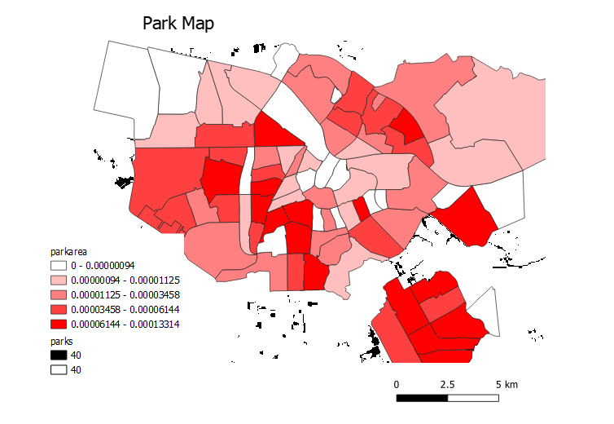

## Model layout: Generated in QGIS

The image of the model is attached as Lab 3.1.Task2Model.pdf

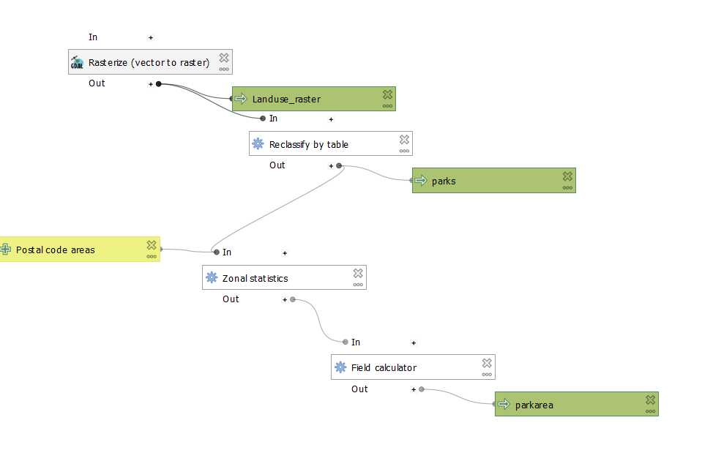

## Python Script: Generated in QGIS

Full code attached as Lab3.1.Task2.Script.py, above just a initial print of the code

