# Hans Alberto Franke

## Spatial Data Analysis

## Date: 30/11/2020

# Lab 3.2 – Distance Based Analysis

# Task 3 Distance-based analysis of park accessibility

Bellow there is the final map of the “mean” distances of each region to park areas. As you can see the color saturations if more dark in the regions closer to parks.

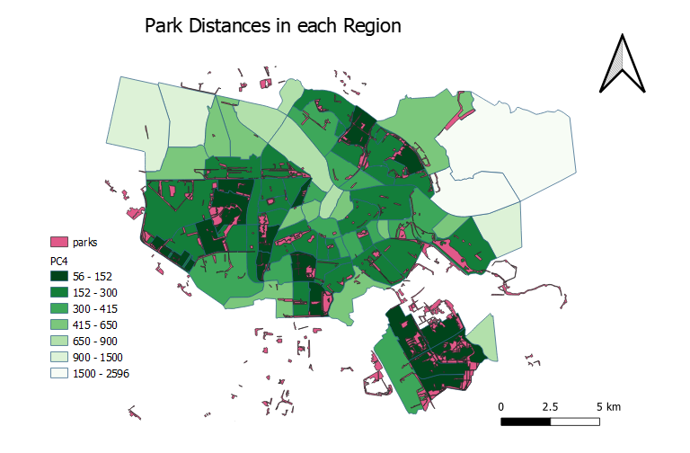

Map1. Distance of Park Areas.

## Model layout: Generated in QGIS

The image of the model is that results in the map above (Map1. Distance of park areas).

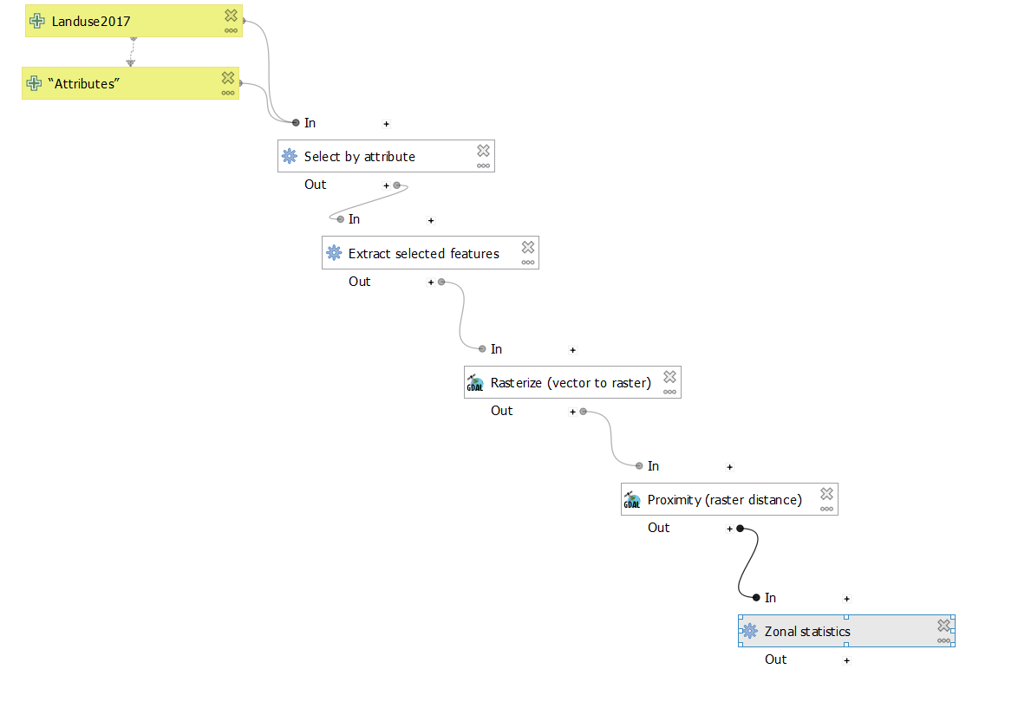

Task 4.

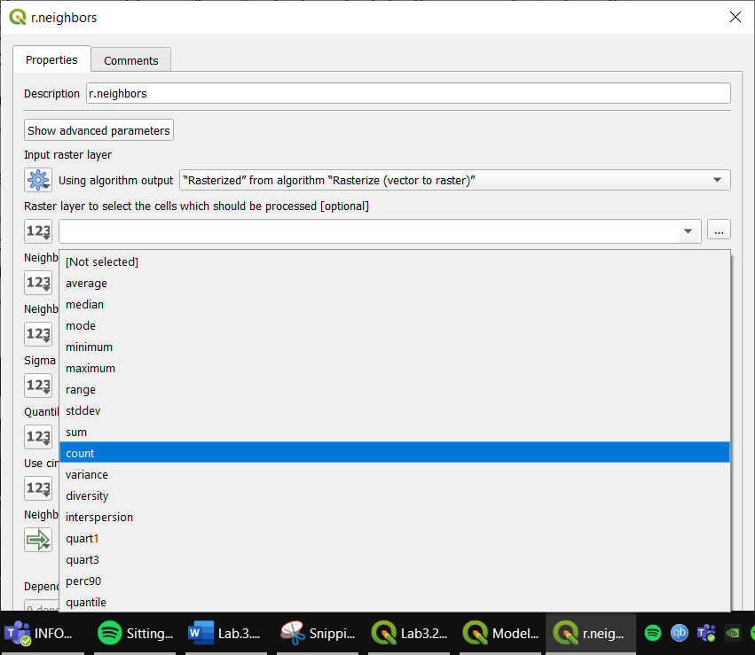

# Task 3 Distance-based analysis of park accessibility

Bellow there is the final map of the density area of greenness of each region. As you can see the color saturations if more darkness with great density.

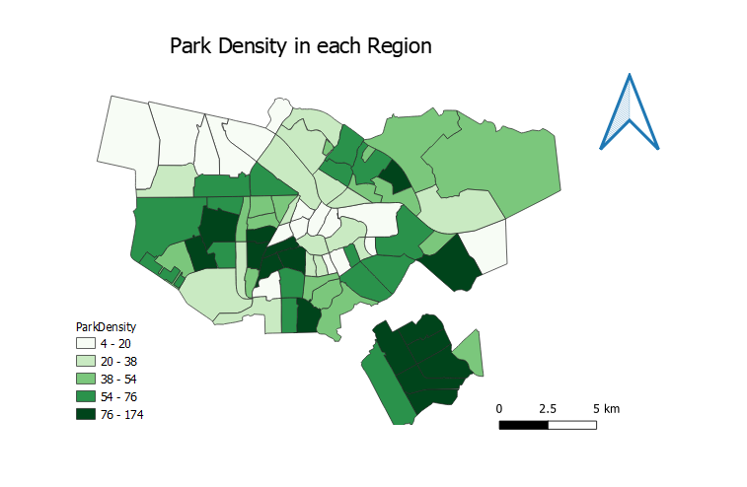**Map2.** Park Density of each region

## Model layout: Generated in QGIS

