# Hans Alberto Franke

## Spatial Data Analysis

## Date: 03/12/2020

# Lab 3.3 – Network Analysis

# Assignment

## Load Initial map

In the map, we can see police stations = green points, the regions of Amsterdam and network streets. As background I used google maps, just to give context.

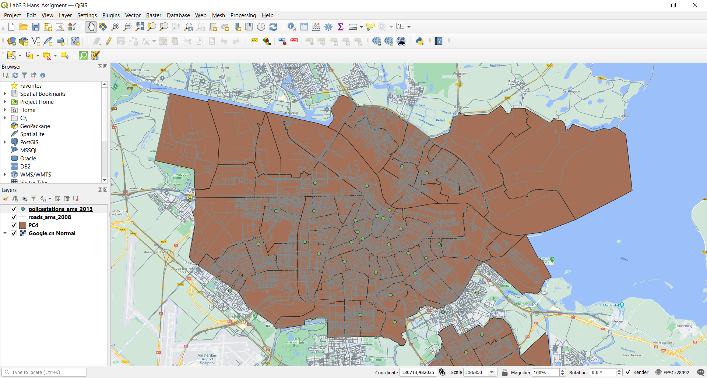

## OD Matrix Table

Below there is a snapshot of the full OD Matrix. The 2800 rows correspond to 35 (police stations) x 80 (PC4s regions) = 2800. The origin point is a police station, that’s why I used object_id there, and destination is one of PC4 region, there I used the POSTCode.

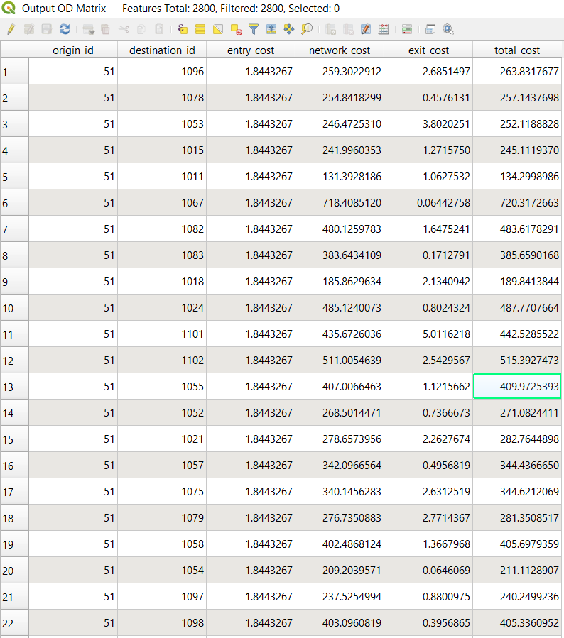

## Hub lines from Police stations to PC4 regions

First in the query part to look for the closest police stations I prefer group_by destinations, to ensure that every region has a linked police station. If I group by origin, so there is only 35 rows (one for each police station).

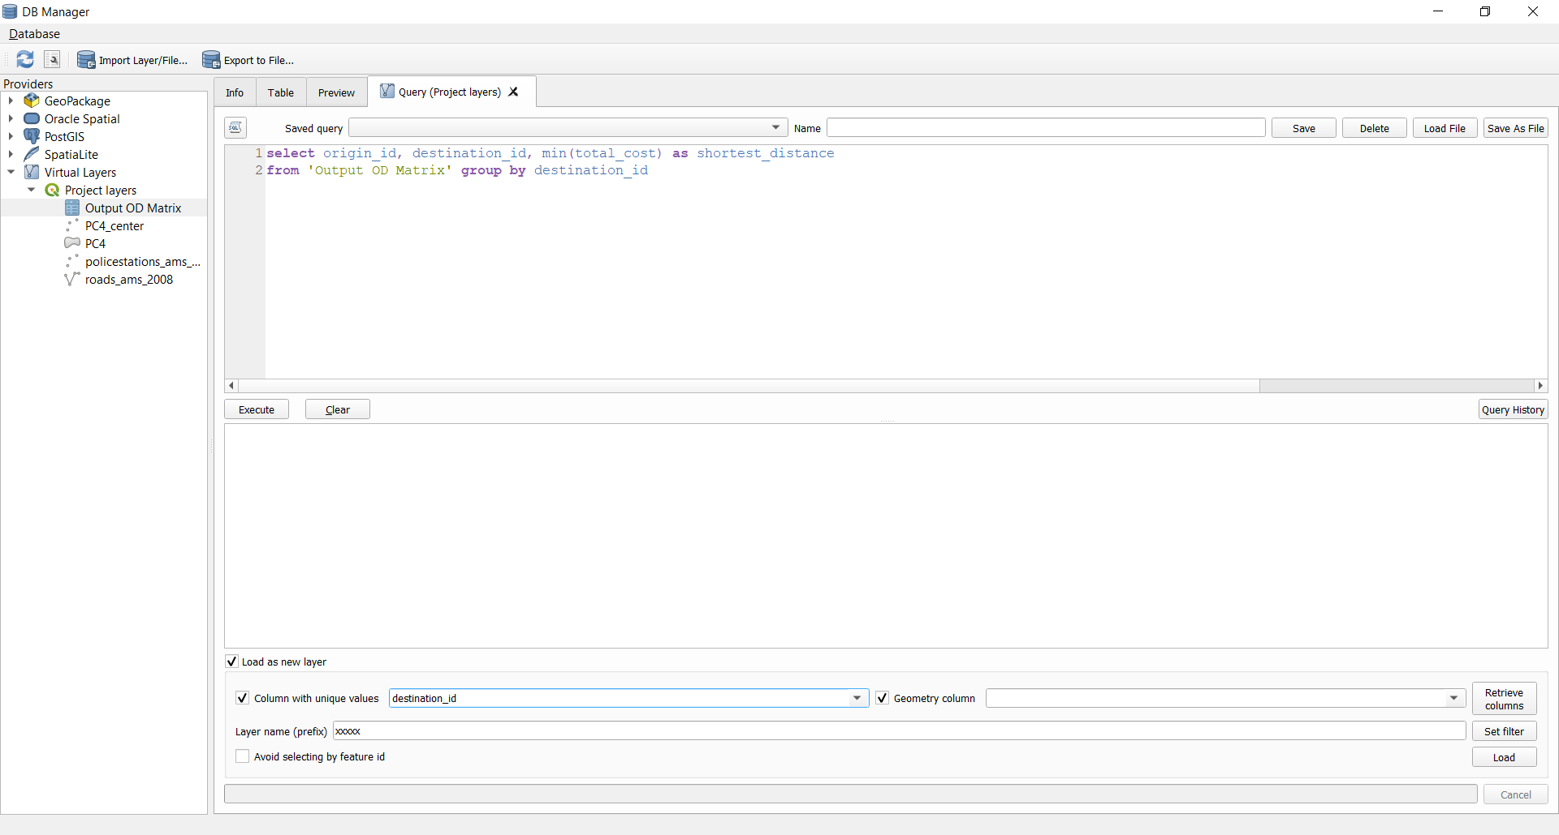

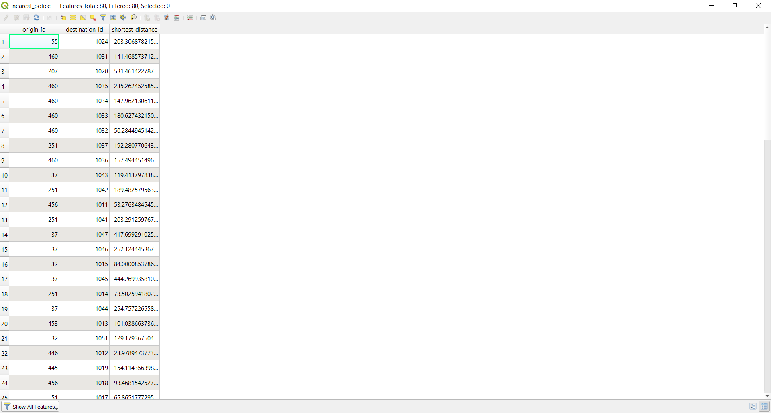

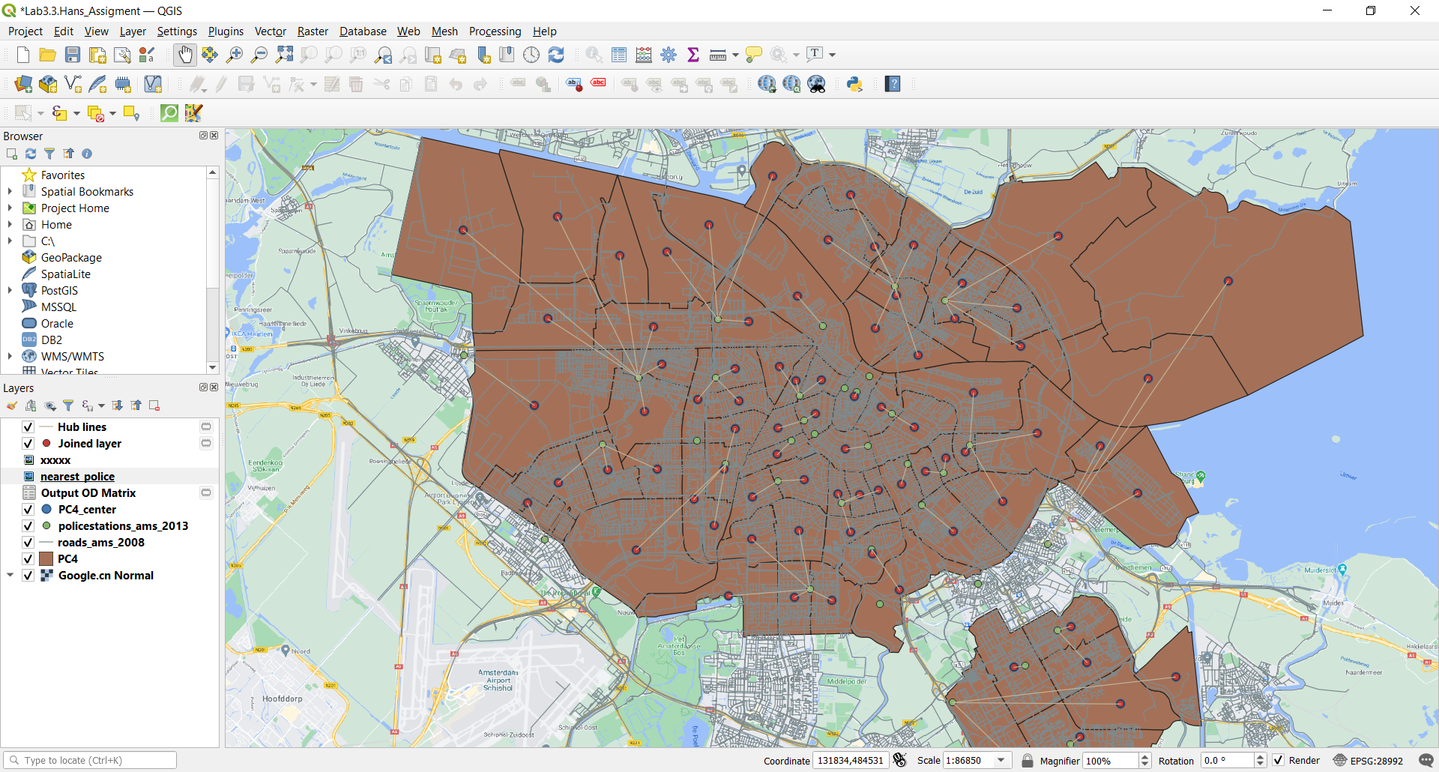

## Shortest route from one police station

I chose the police stations code=176

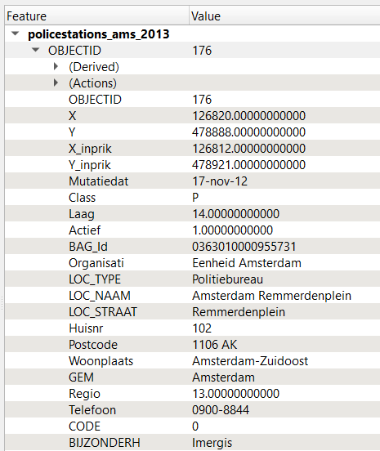

The code split in 2 layers, one for each region that police station(yellow dot) is connected.

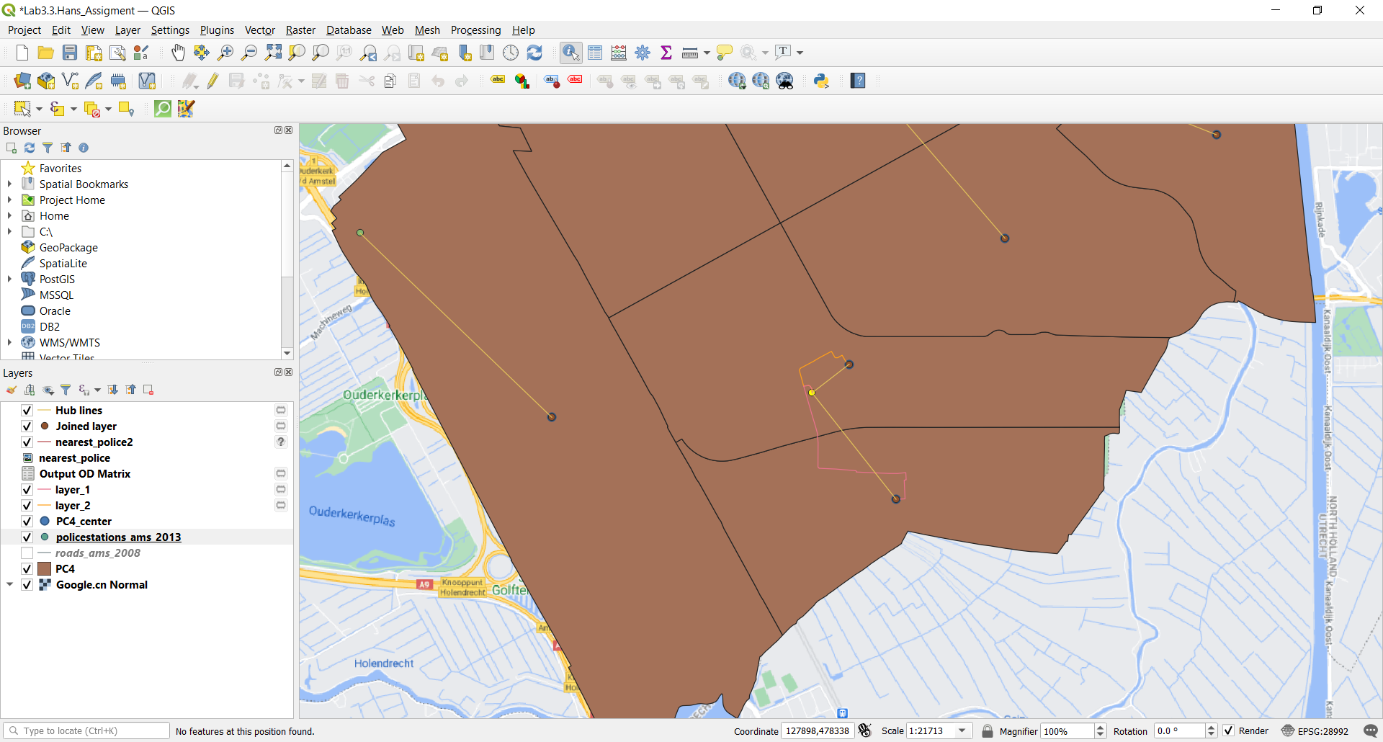

We can see the cost distance from the each region to the police station:

